**CHINOOK MUSIC DATA ANALYSIS**

1. Does any table have missing values or duplicates? If yes how would you handle it?

Ans: Missing values or null values can be checked by select statement and IS NULL condition in where column. While retrieving null values can be addressed by coalesce clause. Example: To find null values in customer table of chinook database. (Count(*) can aslo be used instead of * in select statement)

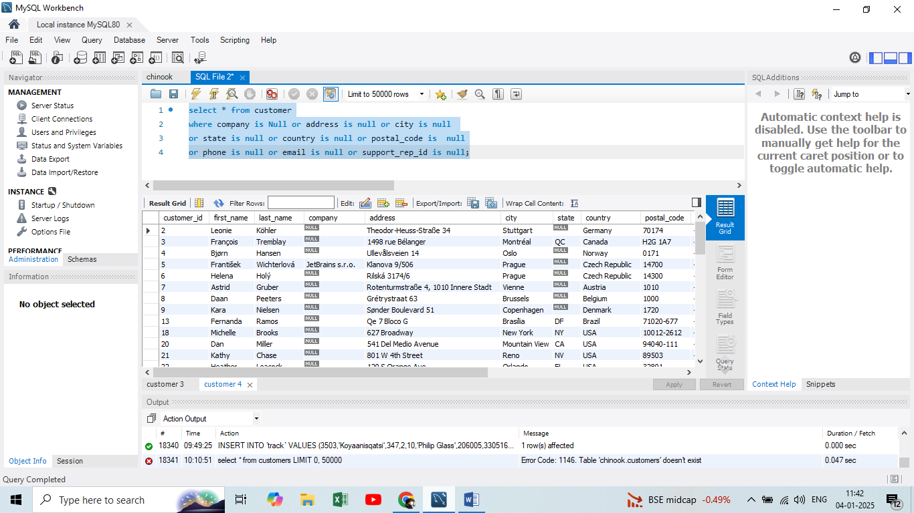

But null values can be permanently replaced by blank, average, mode etc. based on requirement by UPDATE statements.

Example:

Update customer set company = ‘default()’ where company is Null.

1. Find the top-selling tracks and top artist in the USA and identify their most famous genres.

Ans: Top selling tracks in USA by their total selling amount is calculated from invoice and incoice_line tables and then it is joined with track, album, artist, genre table to retrieve respective artist and genre and track names.

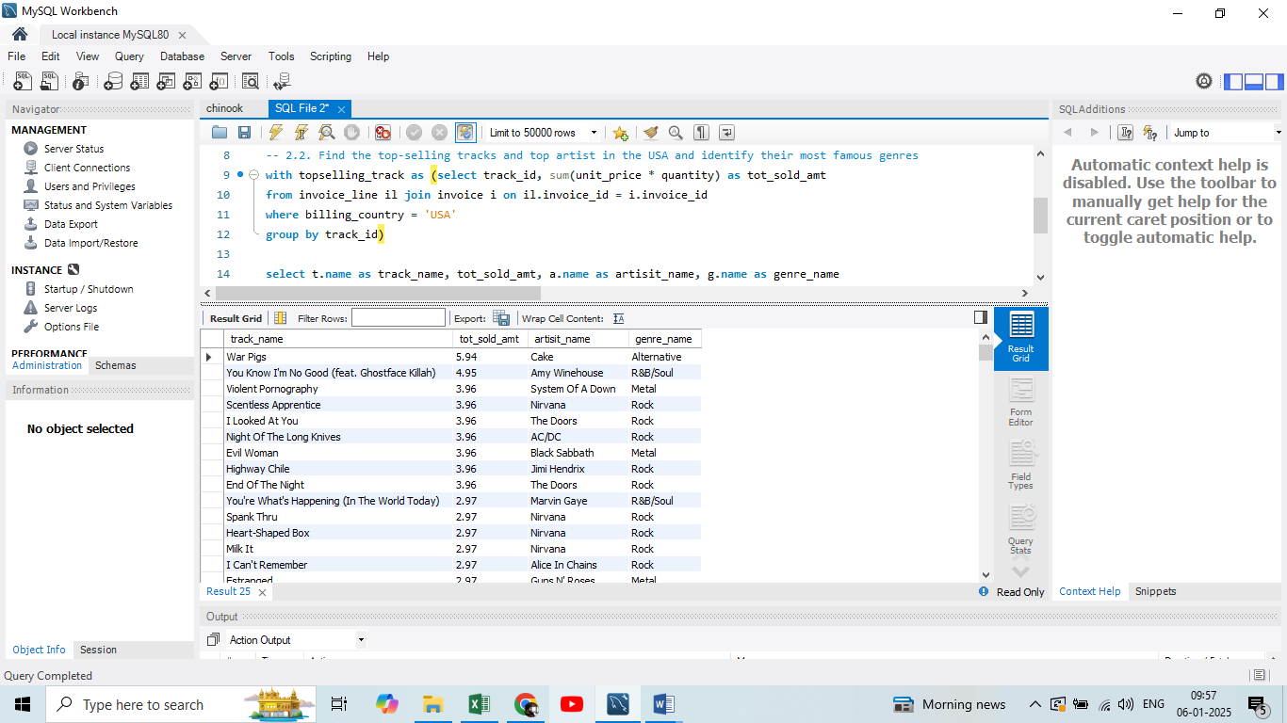

From the above inference top sold track in USA is “War Pigs”, the artist is “Cake” and genre is “Alternative”.

1. What is the customer demographic breakdown (age, gender, location) of Chinook's customer base?

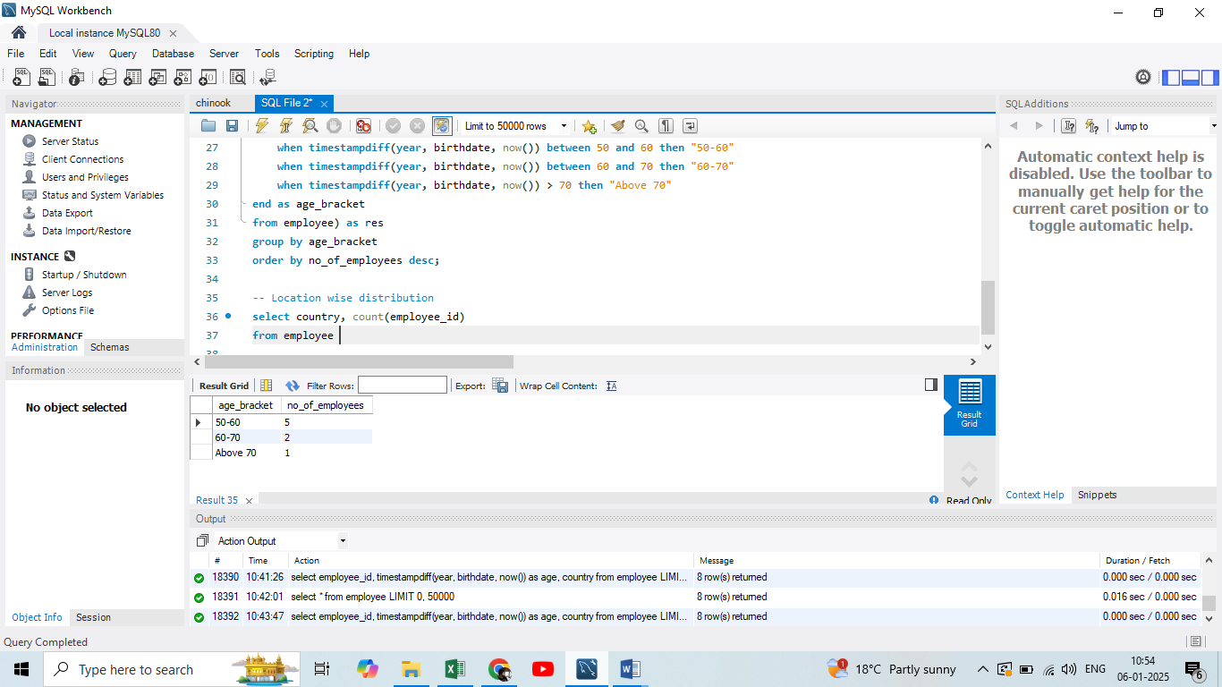 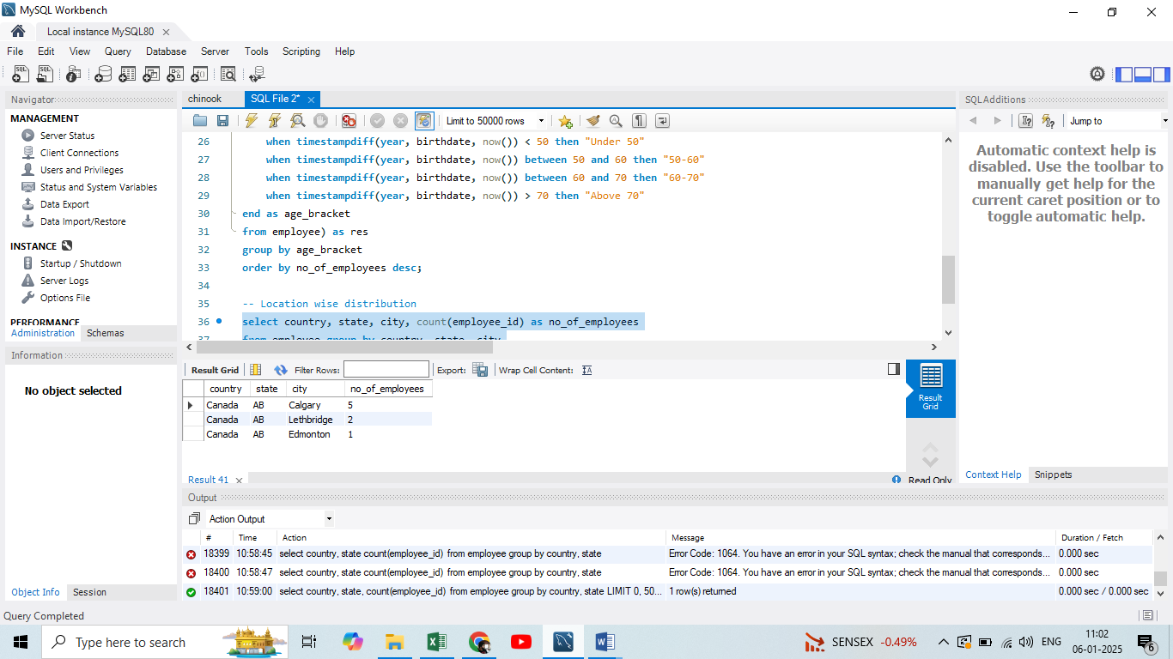

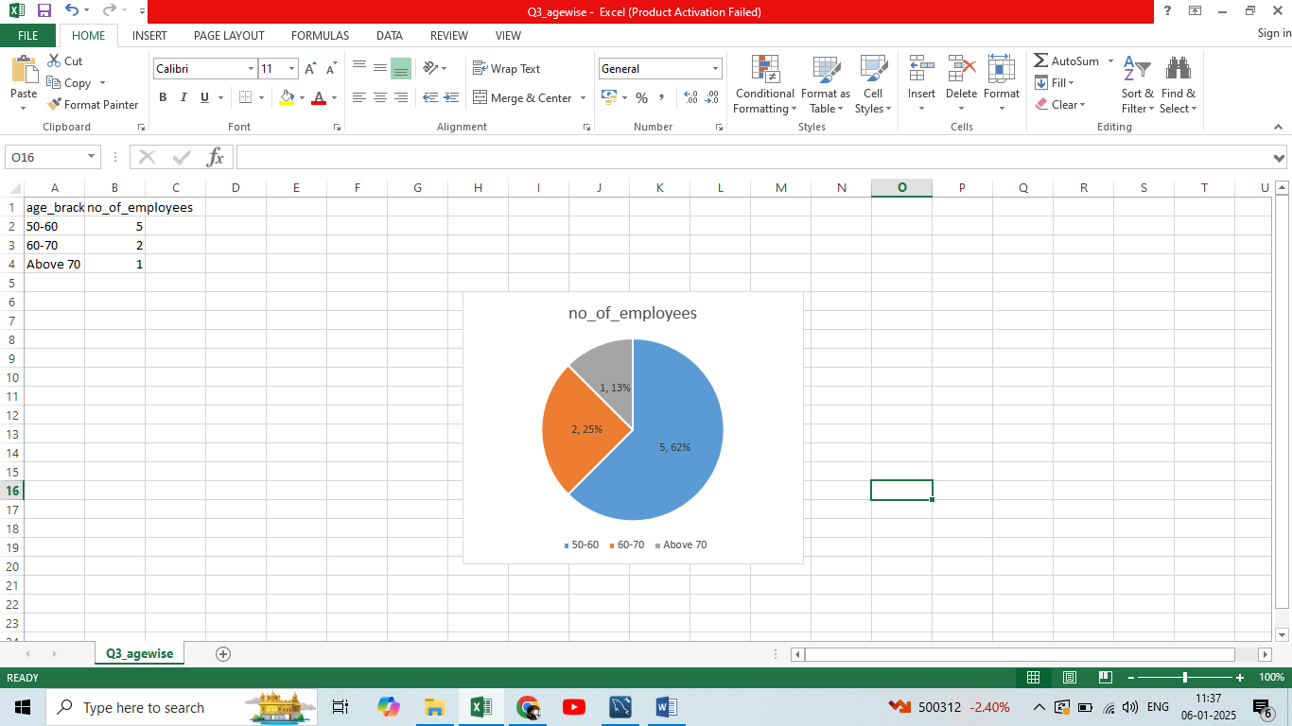 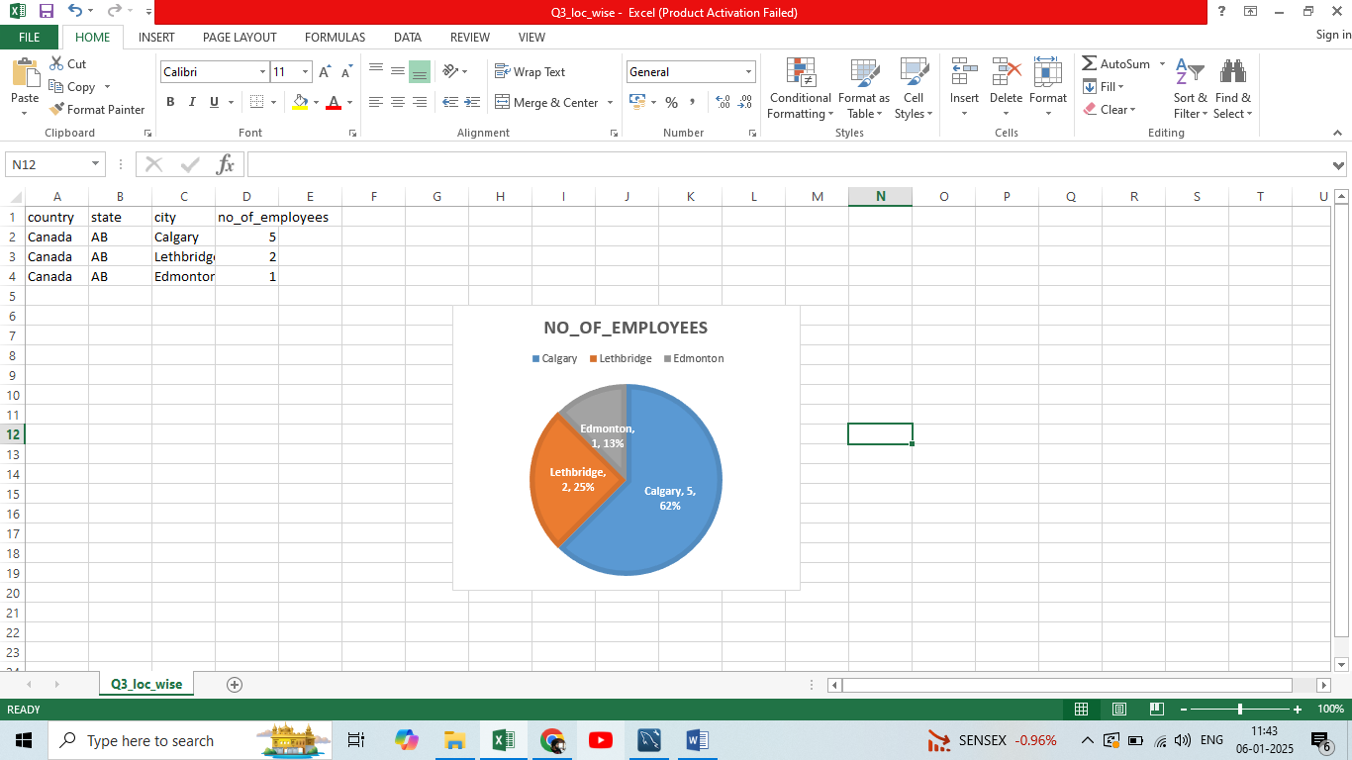Above information is a demographic distribution of employees in chinook. There are 8 employees in total and all of them are from Canada and 5 of them in 50 to 60 age group.

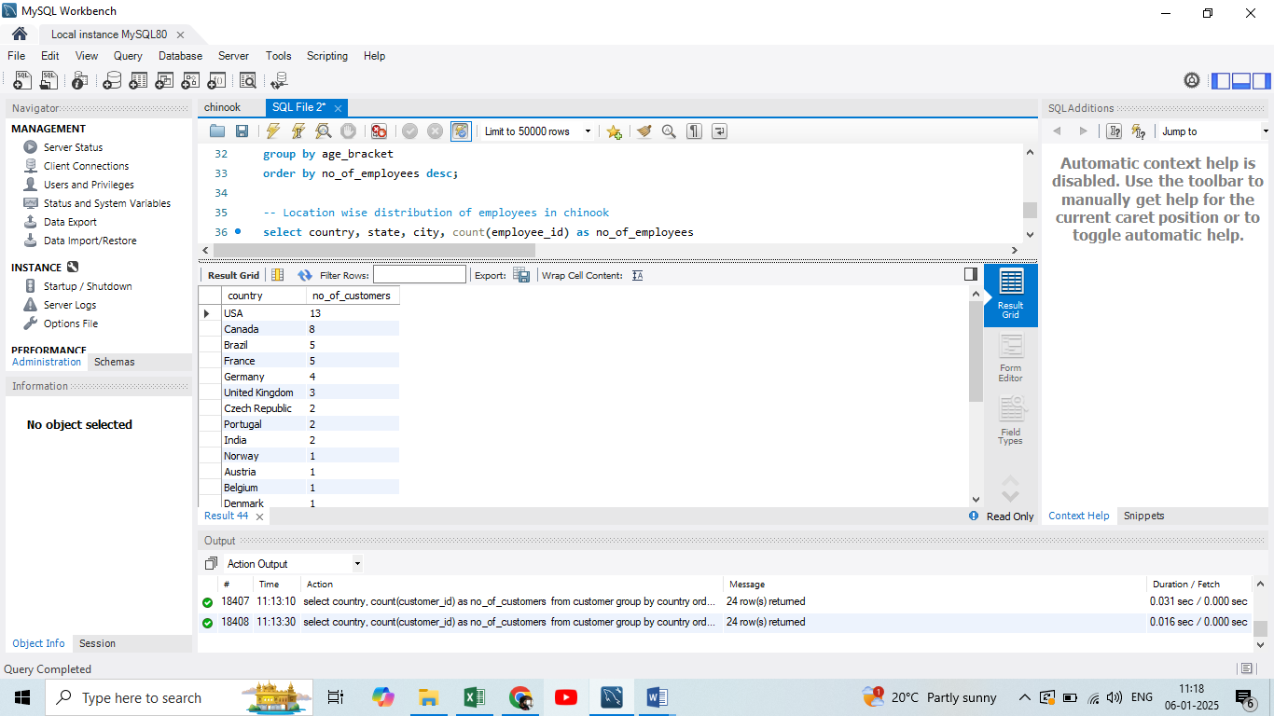

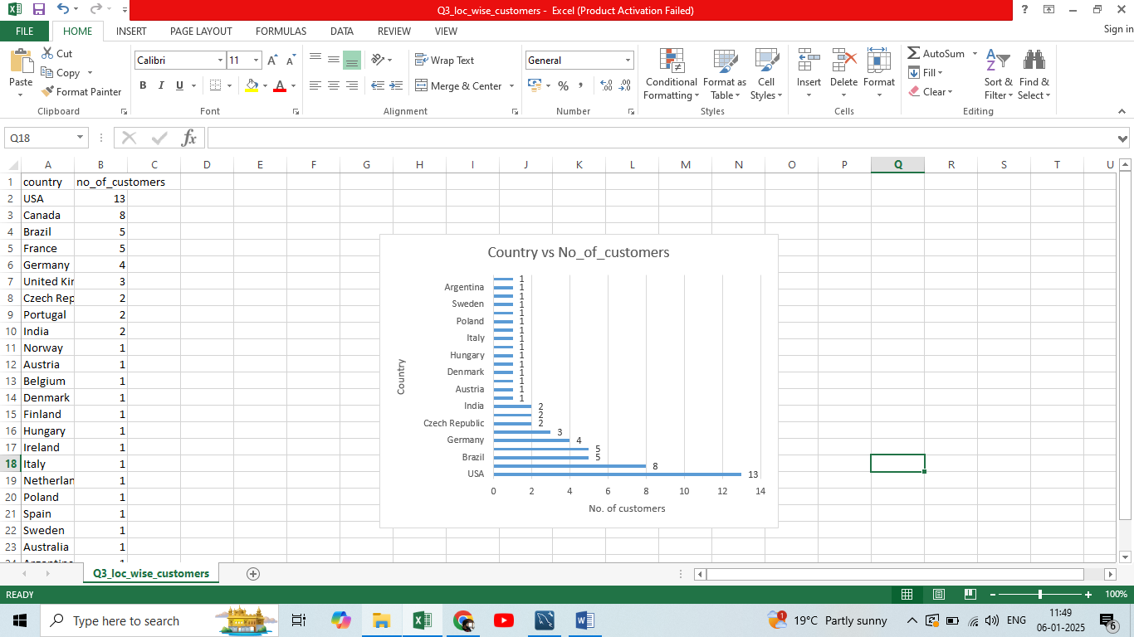

Above table is distribution of customers in chinook database and maximum number of customers are from USA followed by Canada.

1. Calculate the total revenue and number of invoices for each country, state, and city:

Ans:

Country wise analysis of total revenue and number of invoices:

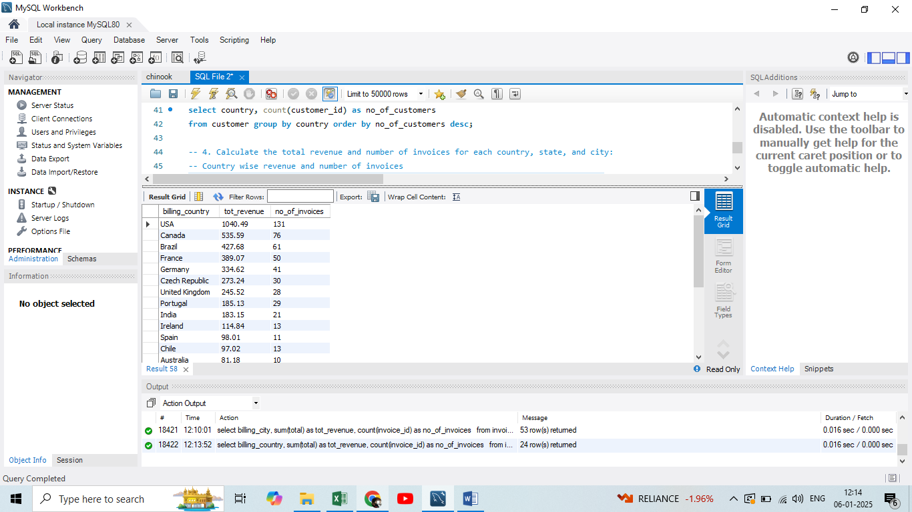

Visualisation of top 10 country’s revenue and number of invoices:

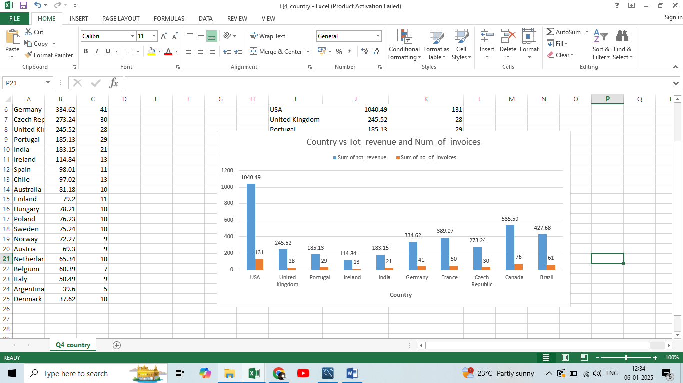

State wise analysis of total revenue and number of invoices:

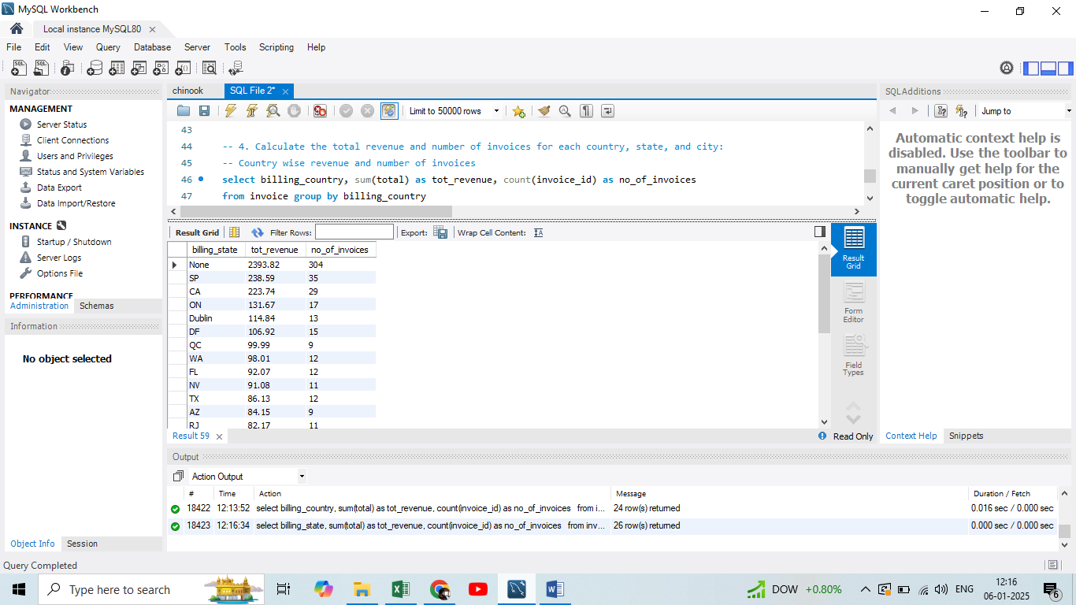

Visualisation of top 10 States’ revenue and number of invoices:

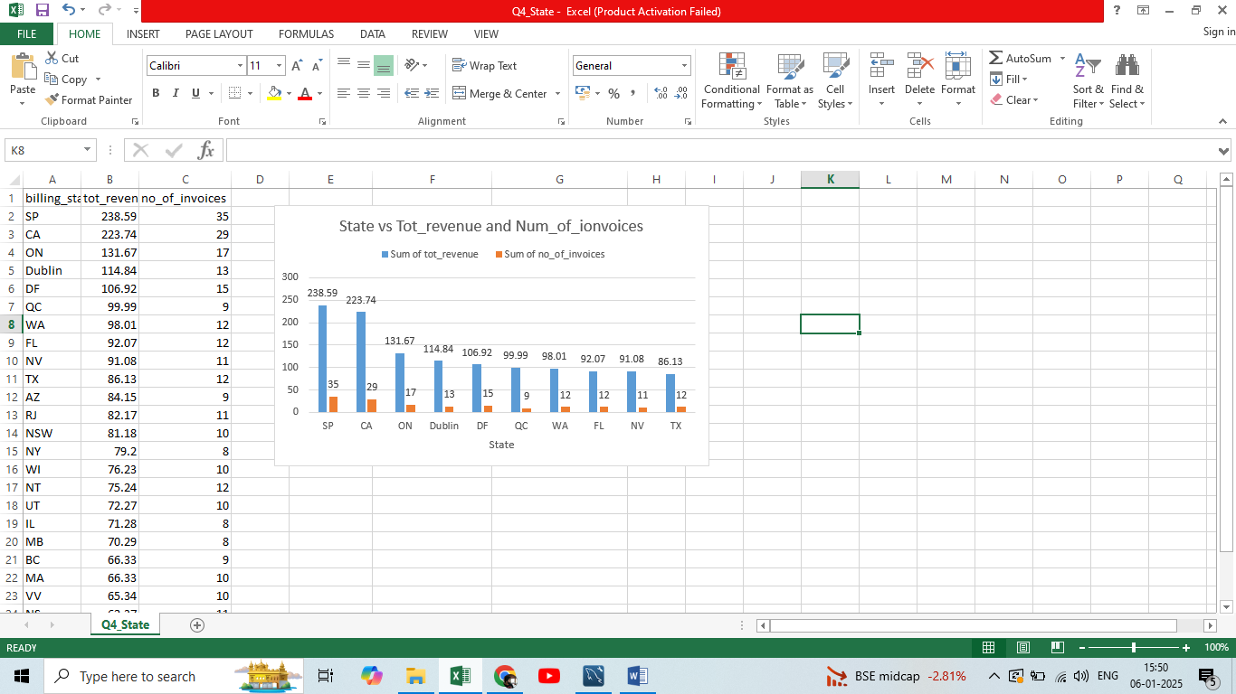

Country wise analysis of total revenue and number of invoices:

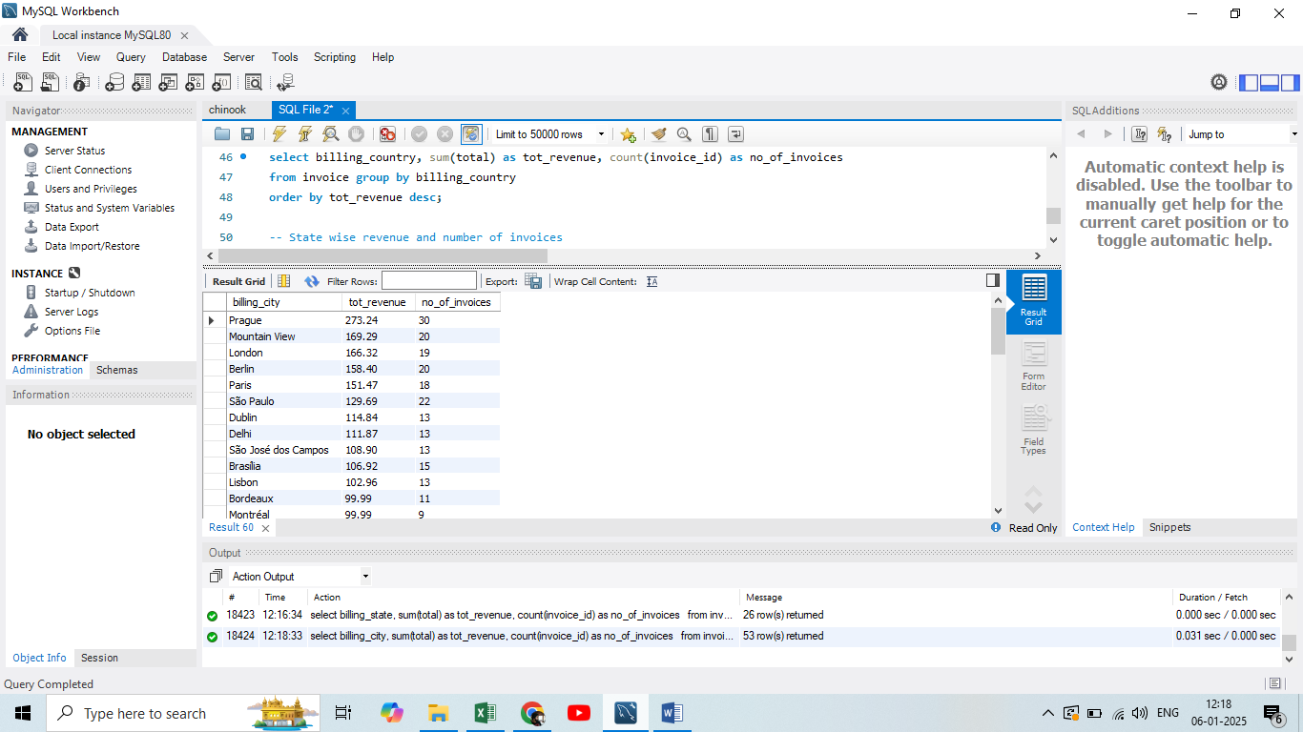

Visualisation of top 10 City’s revenue and number of invoices:

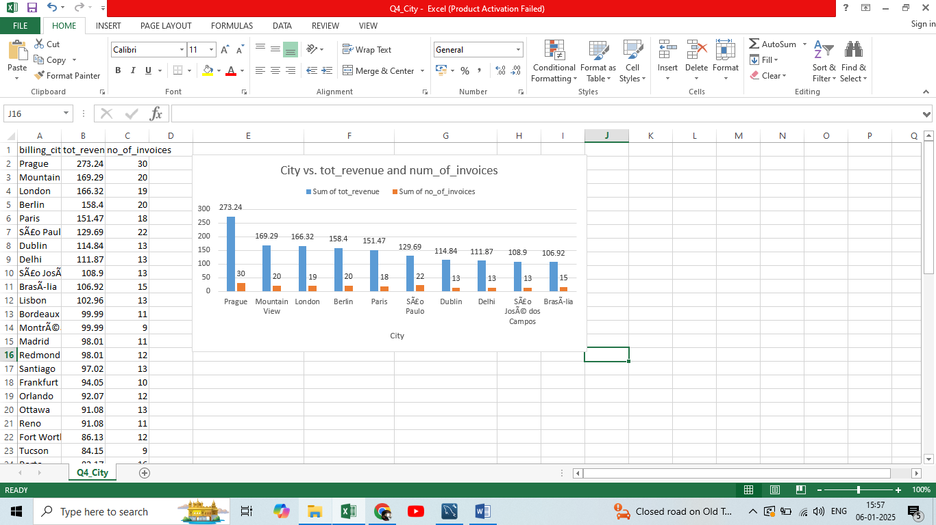

1. Find the top 5 customers by total revenue in each country:

Ans:

Top 5 customers in each country is retrieved by joining customer and invoice table and also using rank function.

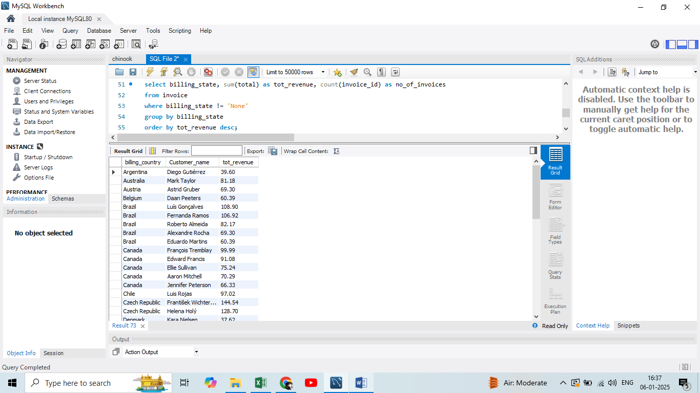

1. Identify the top-selling track for each customer

Ans:

By joining invoice and invoice_line table all the tracks purchased by each customer is retrieved.

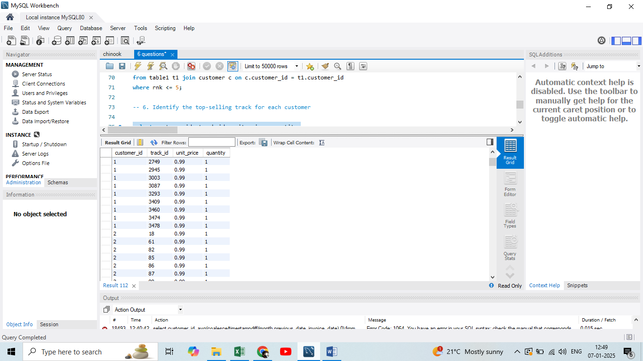

From the above output it is evident that one customer has purchased many tracks but one track only once and unit_cost of all tracks and quantity of all tracks being same top selling track fro each customer cannot be determined. The list of tracks purchased for each customer can be retrieved.

1. Are there any patterns or trends in customer purchasing behaviour (e.g., frequency of purchases, preferred payment methods, average order value)?

Ans:

Average order value analysis for chinook customers:

Average invoice value for each customer is retrieved from invoice table.

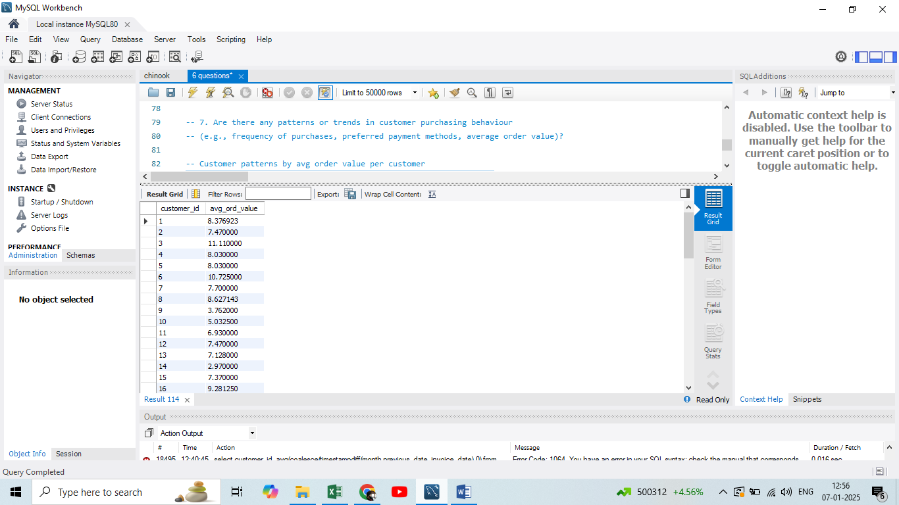

From the above table we can also retrieve the minimum, maximum and overall average value per invoice for entire customer base.

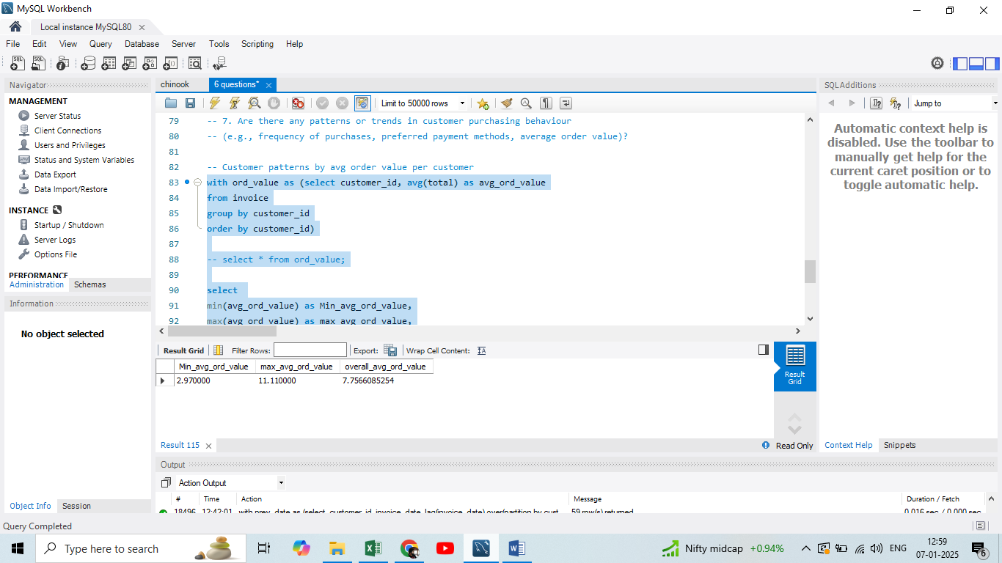

So for Chinook company average am amount per invoice per customer is 7.75

Invoice date analysis of chinook customers:

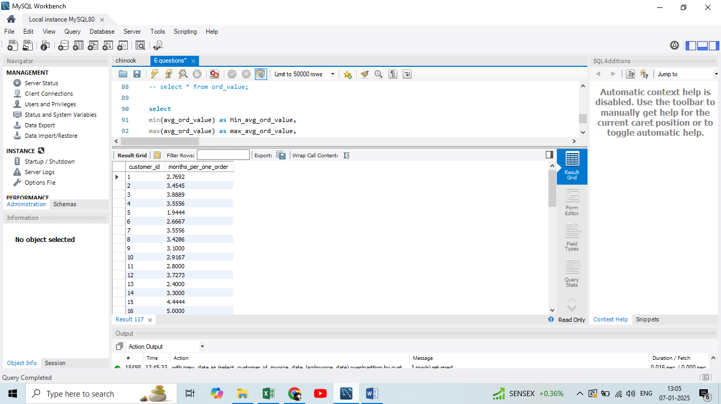

From the above figure it means that customer1 is placing one order per 2.7 months, customer2 in 3.4 months etc.

Likewise for chinook company every customers on an average are placing one order for 3.72 months.

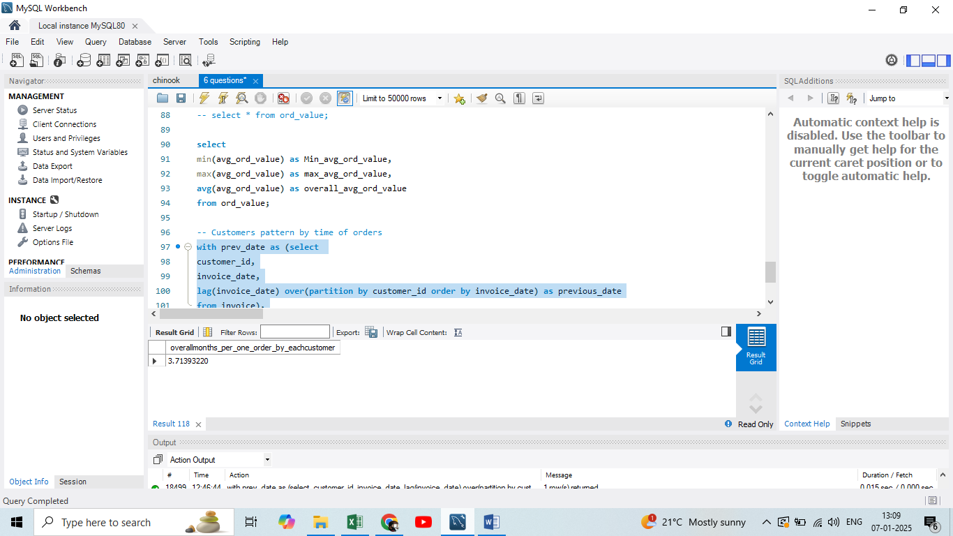

1. What is the customer churn rate?

Ans: Below is the number of customers purchasing tracks from chinook in a year.

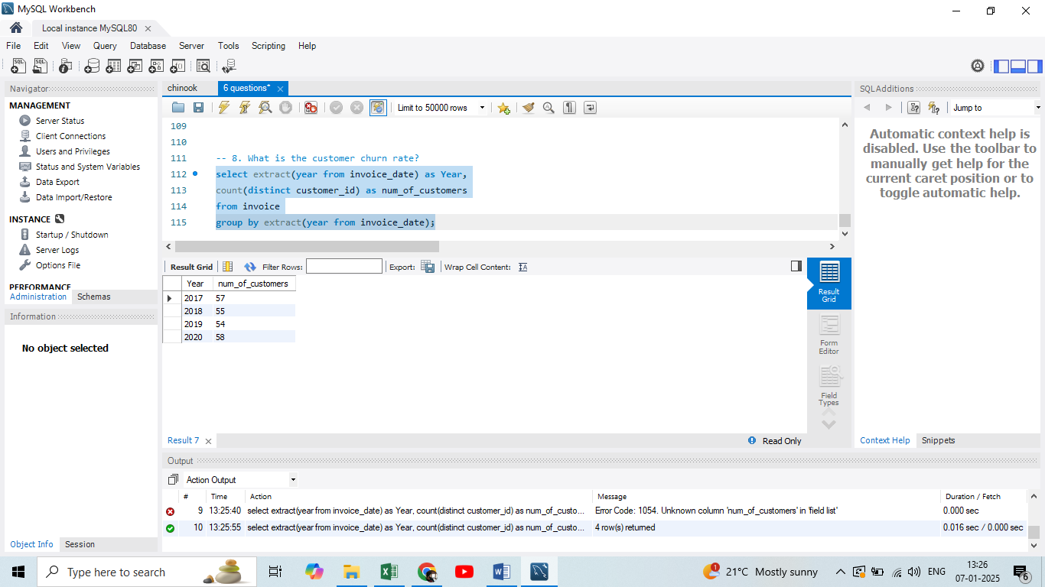

So from the above table year on year churn rate can be calculated as (lost_customers / initial_num_of_customers) * 100

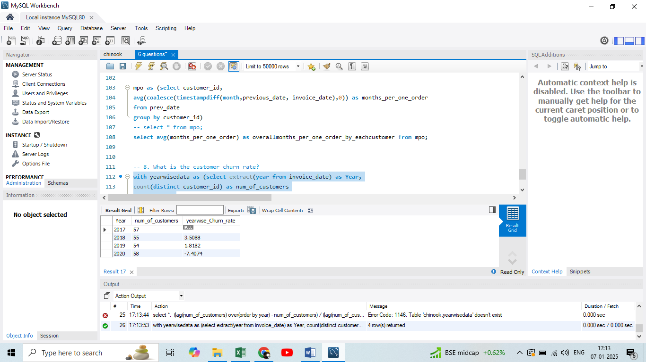

Positive churn rate is bad for company it means it has lost few customers and if churn rate is negative churn rate means it has gained customers than its previous year.

1. Calculate the percentage of total sales contributed by each genre in the USA.

Ans: First USA records are retrieved from Invoice table and then it is linked with track and genre table to retrieve the genres in USA.

Contribution of each genre is calculated by:

Sales_of_genre / Total_sales * 100.

