Introduction
Electrical power subsystem is cardinal subsystem of Parikshit student Satellite, which deals with harnessing solar energy from the Sun via Solar panels and distributing it, for optimum functioning of other subsystems. It involves regulation of voltage buses and conditioning of power getting stored in battery so that satellite could function in eclipse region. EPS is responsible in trading off weight and volume of our Nanosatellite, by efficient designing of PCBs without compromising efficiency. In addition, it designs algorithms of power management for different modes of satellite. Here are brief pointers, which would facilitate understanding of EPS.

Sourcing Power
Sun being main source of power, solar energy is extracted using solar panels which are on 3 sides of satellite. we will be using panels from spectrolab, which have efficiency of 26.8%.

Regulation of Power
The solar panels function fully during the sunlit phase, but during the eclipse period the entire power requirements falls on the batteries. The solar panel input, which varies from 0-5V, is conditioned to 4.4V, (which is the recommended charging voltage for the satellite batteries) by the Battery Charge Regulator. The regulation is done within a voltage ripple limit of 50mV/div, and with a maximum efficiency of 90%.

Conditioning of Power
Certain loads, such as the ODHS microcontroller and the Transceiver Chip run at 3.3V, which is lower than the standard 4.4V provided by the Battery Charge Regulator. Thus, the voltage must be stepped down to run these loads, along with others at the highest possible efficiency. For this, we use a buck converter, which reduces the standard bus voltage down to 3.3V, with an efficiency of 96%. Similarly GPS and payload camera operates at 5V , thus a buck boost converter is employed which does the required boosting of volatage.

Power Management
The satellite has to manage its power properly in order to provide sufficient power to run the sessional loads such as the Power Amplifier and the Camera, in addition to the essential loads. For this purpose, the satellite employs a power management algorithm, which runs on the main ODHS microcontroller. This algorithm switches loads on and off based on various predefined conditions. However, certain essential loads such as the H-Bridge and the Magnetorquer are never switched off as they are essential for the functioning of the satellite.

Protection of Loads
In order to protect the loads from current surges and latch ups(File_Latchup.html), the satellite has Overcurrent Protection
Circuits placed before components, in order to ensure that the ICs do not get damaged.

Requirements of EPS
The other satellite subsystems and their power requirements are explained as follows:

Payload
Our primary payload is the IR camera FLIR Quark 640. This camera requires 5 V. Hence a single bus line would be connected to it.

Communication and Ground Station
It is responsible for communication between the satellite and ground station. Three bus lines, 3.3V, 4.4V and 5V are given to the various components of the subsystem such as the receiver, power amplifier, etc.

ODHS
It is the brain of the satellite. It is linked with every subsystem of the satellite and ensures the successful running of all the components. Three bus lines of 5V, 3.3V and 4.4V are dedicated for the subsystem for various components like the micro-controller, NOR-Flash, Reset ICs etc.

ADCS
This system is responsible for the determination of the attitude of the satellite and its control. Three bus lines of 5V, 3.3V and 4.4V are dedicated for the subsystem for various components like the magnetometer, Magnetorquer, sun sensor etc.

Structures
The structure of the satellite provides a skeleton for the components of the satellite to be placed. The EPS relies on the structure mainly for the mounting of the solar panels, the panel PCB and the main PCB itself. Also, the entire power subsystem depends on the deployment of the kill switch mechanism to be carried out successfully.

The main objective of this article is to aid readers to discern about this subsystem.
So here are some key aspects of EPS, which would broadly cover what’s in this subsystem and why it is pivotal in trait.
Solar cells and panels
In Space , solar energy is extracted using solar panels. Potential advantages of collecting solar energy in space include a higher collection rate and a longer collection period due to the lack of a diffusing atmosphere, and the possibility of placing a solar collector in an orbiting location where there is no night.
Starting with solar cells and panel, just for quick revision, solar cells are semiconductor diodes that convert light energy to electrical energy. It works on photoelectric effect of light the top layer is n type, facing sun which is thin and heavily doped, while p type semiconductor lies at base which is relatively thick and lightly doped.The depletion region is large. The light rays break electron- hole pair in depletion layer, and thus electrons migrate to n type and holes migrate to p type semiconductor, and thus potential difference is generated. And dc current is produced.
Solar cells clutter to form solar panel, and solar panel in turn constitutes the formation of solar array. Solar arrays can be placed parallel or in series depending on requirement. Care must be taken that it doesn’t suffer from shadowing effect.

The solar panel can modelled as a circuit with a current emitter whose current is proportional to the irradiance on it, a diode and some resistors to account for the losses from contacts in circuit
(To understand the modelling, you can visit: -https://www.youtube.com/watch?v=rjLd6eJYMsI&t=84s ) R_{sh} , attached to make the circuit practical. (by connecting it in parallel with current generator)
R is connected in series, in order to regulate the current across the load.(but there occurs power dissipation across this resistance in series)
The main current I_{m} is generated and it gets divided into I_{d} , I_{sh ,} I.
Voltage across the shunt resister and diode is V_{d.} (V_{d} can be altered by adding or reducing the number of diodes)

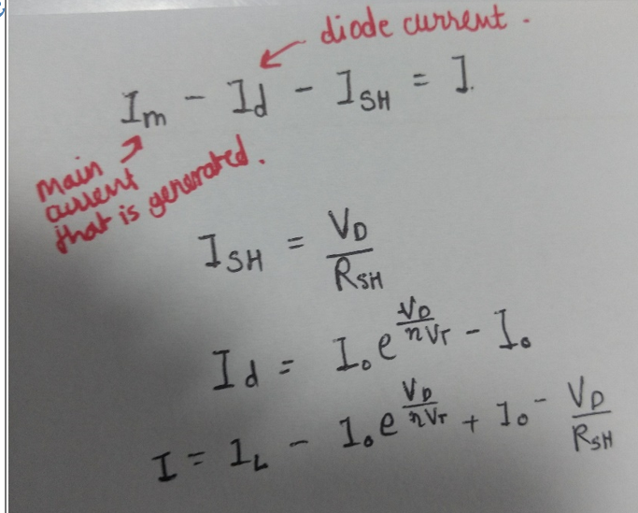
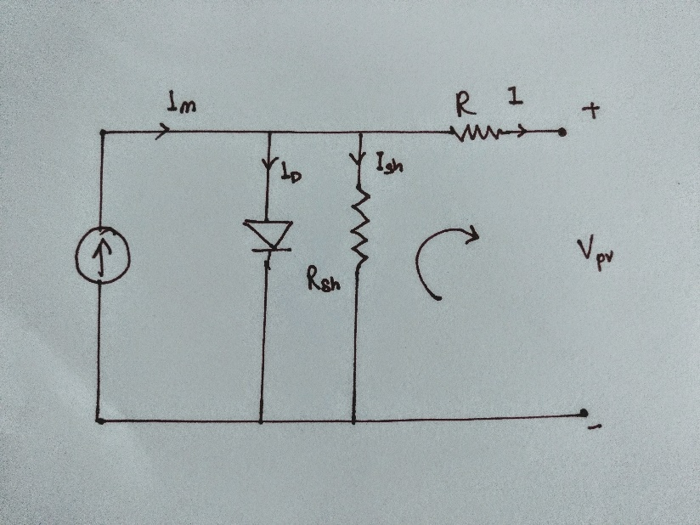
Solar panels can be deployable or non-deployable. But in nanosatellite, usually non-deployable panels are employed due to size restrictions. Typical solar panels for nano satellite consist of two solar cell strings serially wired with no redundancy in case of solar string failure.
In the given diagram,

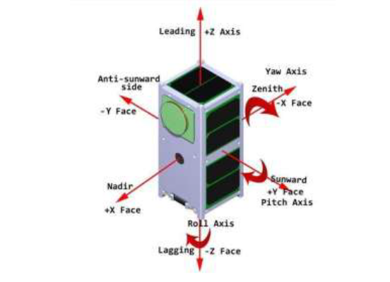
Leading , Sunward and Zenith side of the Satellite have Solar Panels attached to it. Ensuring maximum extraction of solar energy, throughout the mission. Solar panels will be fabricated by ISRO as per specifications required. The maximum power can be extracted using MPPT. It is technique to maximize the extraction of power.
Our solar panels use a high efficiency triple junction GaInP₂/GaAs/Ge from the Spectrolab Company. Triple junction solar cell are solar cells with multiple p–n junctions made of different semiconductor materials. Each material's p-n junction will produce electric current in response to different wavelengths of light. The use of multiple semiconducting materials allows the absorbance of a broader range of wavelengths, improving the cell's sunlight to electrical energy conversion efficiency.
Solar panels have inbuilt bypass diodes in order to prevent hotspot heating. Hot spots are areas of high temperature that affect only one zone of the solar panel and result in a localized decrease in efficiency, and therefore, lower output power and accelerated material degradation in the area affected by the high temperature.

Simplified Calculation of Accessible Energy
Most CubeSat projects use a very simplified way of how to calculate the amount of energy generated by solar cells. In such a case, the power generated by solar panel is given as follows:
Power Generation
The power generated by solar cells follows a cosine relationship
with the angle of incidence of sunlight as follows
P = րIAcosφ
Where I is the intensity of sunlight, ր is efficiency of the
cell, φ is angle of incidence and A is the area of the solar
cells. Acos φ gives the effective area exposed to the sunlight.
Further, the intensity, I can be expressed as
I=$\frac{P(sun)}{4π*distance*distance}$
where, distance is the instantaneous distance between the sun
and the satellite and Psun is power radiated by the sun.

Nominal efficiency is considered as constant without dependencies and its value is obtained from manufacturer documentation, typically measured in laboratory conditions at 25°C temperature. In reality, the efficiency is temperature dependent and is irradiance angle dependent due to surface refraction and losses in cover layers
Sunlight power density is approximately considered as 1350 W/m² (value is valid above the atmosphere near the Earth, related to AM0 model of the sunlight spectrum).

Power Management
Battery
During eclipse, the primary and only source of power in our satellite are the on-board batteries. We use three batteries connected in parallel to increase the net capacity and hence lower the percentage of discharge. The average load of the system should be such that there is a sufficient margin and we never fall out of power. Since the generated power itself is small, there is a need to manage the loads in a way to conceive a sufficient energy margin.The depth of discharge (DOD) is the amount to which the battery is discharged with respect to the total battery capacity. Keeping the DOD to a minimum ensures maximum cycle life, and thus maximum performance of the battery for the given time frame. The average DOD should not fall below 18% under any circumstance. The power management algorithm ensures this.

Battery Specifications
For the satellite, we will be using an LG battery due to its well suited operational characteristics and capacity, as related to our system. The batteries will be connected in a 3 parallel cell configuration. These 3 cells connected in parallel give a theoretical capacity of 7800mAh, which gives us a large margin for Depth of Discharge calculations. Also, the battery life, discharge voltage and charge voltage has also proven to be sufficient for usage in the satellites power bus.

We have opted for switched mode power conditioning ICs due to their high efficiency and low heat dissipation. Another benefit of opting for a switching mode supply over a linear one is the ability to achieve an output voltage level higher than the input which is not possible in the case of linear regulator.

Buck Converter
The function of the buck converter is to take the regulated input from the battery and step it down to 3.3V, to run the various loads that operate at that voltage level.
We use two bucks in parallel to increase the redundancy of the system, as well as reduce the current handled by each converter. In case of a buck failure, a single buck alone can handle the input, as the IC has a high current rating of 2A, which is more than sufficient for the satellite’s bus.

Buck Boost Converter
The STBB1 is a high efficiency, synchronous buck-boost converter. Two STBB1 ICs are used to derive the regulated 5V buses for the FLIR Tau 2 camera and the GPS, from the unregulated battery voltage. This converter is used to boost the voltage.

PCB design and Manufacturing
A Printed Circuit Board (PCB) is used to mechanically support and electrically connect electronic. Components using conductive pathways, tracks or signal traces etched from copper sheets laminated onto a non-conductive substrate. At Parikshit we manufacture in house PCBs.
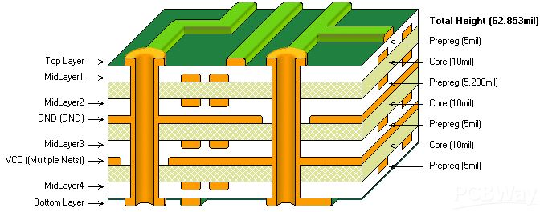
Layers in PCB ensure distribution of paths throughout, thus preventing crowding. Layer can be used as ground layer. The conducting paths can be made by chemical etching or photolithography.
Its designing is done on softwares like Altium , Orcad etc.
We are using FR-4 material for the preparation of our development boards. Fr-4 is a composite material composed of woven fiberglass cloth with epoxy resin, it is also flame resistant. The
material also have the feature of high Tg value and capable of having a lead free soldering.
Routing , track width, layer alignment etc are other areas of concern.

PCB Manufacturing Process

Step 1 – The Design
Before you begin manufacturing the PCB, you need to have a design of the board. These blueprints will be what you base the process off of. The design process is generally completed through computer software

Step 2 – Printing the Design
A special printer called a plotted printer is used to print the design of the PCB. It produces a film that shows the details and layers of the board. When printed, there will be two ink colors used on the inside layer of the board:
Step 3 – .Creating the Substrate
Now is when the PCB will start to form. The substrate, which is the insulating material (epoxy resin and glass fiber) that holds the components on the structure, begins forming by passing the materials through an oven to be semicured. Copper is pre-bonded to both sides of the layer and then etched away to show the design from the printed films.

Step 4 – Printing the Inner Layers
The design is printed to a laminate, the body of the structure. A photo-sensitive film made from photo-reactive chemicals that will harden when exposed to ultraviolet light (the resist) covers the structure. This will help align the blueprints and the actual print of the board. Holes are drilled into the PCB to help with the alignment process.

Step 5 – Ultraviolet Light
Once aligned, the resist and laminate go under ultraviolet lights to harden the photoresist. The light reveals the pathways of copper. The black ink from before prevents hardening in areas that will be removed later on. The board is then washed in an alkaline solution to remove the excess photoresist.

Step 6 – Removing Unwanted Copper
Now, it is time to remove any unwanted copper that remained on the board. A chemical solution, similar to the alkaline solution, eats away at the unwanted copper. The hardened photoresist remains intact.

Step 7 – Inspection
The newly-cleaned layers will need to be inspected for alignment. The holes drilled earlier help align the inner and outer layers. An optical punch machine drills a pin through the holes to keep the layers lined up.From here on out, you will not be able to correct any missed errors.

Step 8 – Laminating the Layers
Now, you will see the board take shape as the layers are fused together. Metal clamps hold the layers together as the laminating process begins. A prepreg (epoxy resin) layer goes on the alignment basin. Then, a layer of substrate goes over the prepreg followed by a copper foil layer and more prepreg resin. Lastly, there is on more copper layer applied, which is the press plate.

Step 9 – Pressing the Layers
A mechanical press is then used to press the layers together. Pins are punch through the layers to keep them properly aligned and secured, these pins can be removed depending on the technology. If correct, the PCB will go to the laminating press, which applies heat and pressure to the layers. The epoxy melts inside of the prepreg that, along with the pressure, fuses the layers together.

Step 10 – Drilling
Holes are drilled into the layers by a computer-guided drill to expose the substrate and inner panels. Any remaining copper after this step is removed.

Step 11 – Plating
The board is now ready to be plated. A chemical solution fuses all of the layers together. The board is then thoroughly cleaned by another series of chemicals. These chemicals also coat the panel with a thin copper layer, which will seep into the drilled holes.

Step 12 – Outer Layer Imaging
Next, a layer of photoresist, similar to Step 3, is applied to the outside layer before being sent for imaging. Ultraviolet light hardens the photoresist. Any undesired photoresist is removed.

Step 13 – Plating and Etching
Just like in Step 11, the panel is plated with a thin copper layer. After this, a thin tin guard is layered to the board. The tin is there to protect the copper of the outside layer from being etched off.
The same chemical solution from before removes any unwanted copper under the resist layer. The tin guard layer protects the needed copper. This step established the PCB’s connections.

Step 15 – Solder Mask Application
All of the panels should be cleaned before the solder mask is applied. An epoxy is applied with the solder mask film. The solder mask applies the green color you typically see on a PCB.

Step 16 – Silkscreening
Silkscreening is a vital step since this process is what prints critical information onto the board. Once applied, the PCB passes through one last coating and curing process.

Step 17 – Surface Finish
The PCB is plated with either a solderable finish, depending on the requirements, which will increase the quality/bond of the solder.

Step 18 – Testing
Before the PCB is considered complete, a technician will perform an electrical test on the board. This will confirm the PCB functions and follows the original blueprint designs.

Thus, this was attempt of condensing and presenting how EPS contribute.

