Long-Running Agents Platform

What this is
The platform schedules a follow-up, places a real phone call through Twilio, has an LLM-driven conversation with the client or provider, extracts a structured outcome from the transcript, decides when to follow up again, and escalates to a human whenever automation shouldn't continue on its own.
There's also a browser voice path built on LiveKit, where someone on the firm side can talk to an agent about a case and the agent records updates back into the same workflow.

The main idea: one engine, not two workflows
I deliberately did not build two bespoke automations. There is exactly one workflow engine, and each use case is just a definition object plugged into it:
WorkflowDefinition = {
stepTemplates, // what steps exist, retry limits
scheduleNextStep(), // when outreach happens next (null = done)
reviewPolicy(), // when automation must stop for a human
allowedActions, // what agents may do on this workflow
}

Medical-records follow-up ends when a provider says the records are ready; client check-in recurs every few days. Those are the only differences between them - everything else (scheduling, retries, review, audit, calling) comes from shared platform code. Adding something like lien verification would mean exporting one more object. No engine changes.
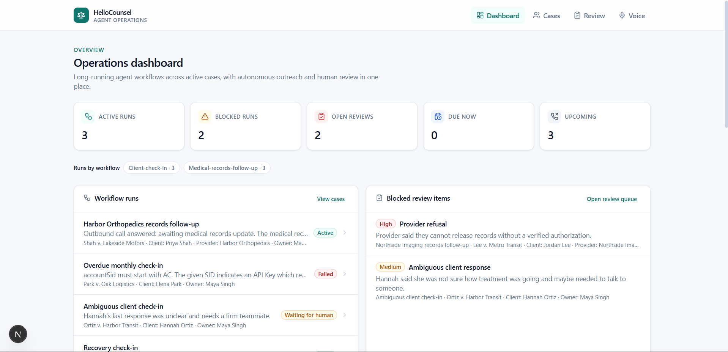
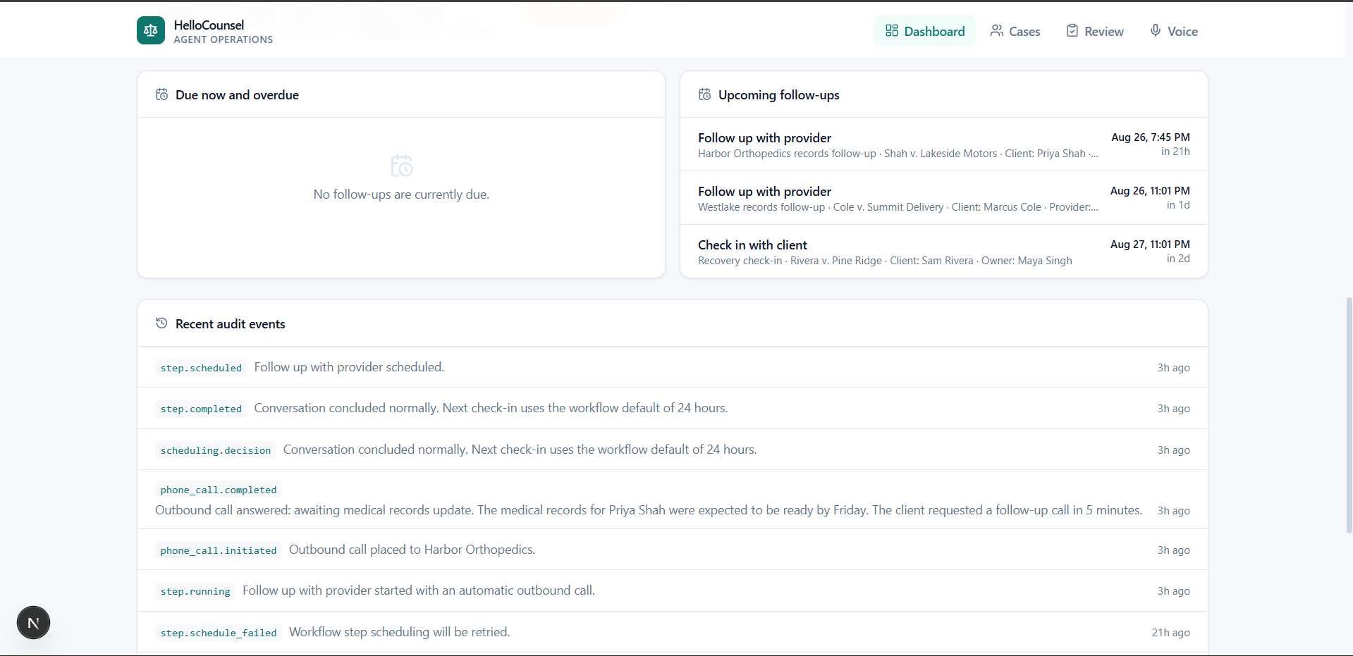

Architecture
Browser UI ──► Next.js server actions
│
WorkflowEngine ← single gateway for all mutations
│ │
Postgres pg-boss queue
(state authority) (delivery only)
│
Worker (60s reconcile loop + job runner)
│
┌──────────┴───────────┐
Twilio phone calls LiveKit voice sessions
(autonomous dialing, (browser mic → STT → LLM
LLM conversation, → structured tools → TTS)
outcome extraction)

Three processes run alongside each other: the Next.js app, a job worker, and the LiveKit agent worker.
One rule shapes the whole design: agents never touch workflow state directly. Whether it's the phone agent mid-call or the browser voice session, they can only emit a small set of structured actions (record an update, mark a contact attempt, schedule a follow-up, request human review, add a note). The router checks each action against the workflow's allowlist before the engine applies it. Approving or rejecting a blocked item is intentionally impossible by voice - that stays with humans.

The scheduling story
Since these workflows live on the calendar, scheduling got its own policy layer rather than being scattered through the code. It's timezone-aware (each client has an IANA timezone; instants are stored UTC): calls go out only during local weekday business hours, a no-answer gets retried twice on a ladder (2 hours later, then 10am next business day), a third failed connect escalates to human review instead of another call, and if a client says "stop calling," the platform stops. If the caller mentions something urgent like surgery or a court date, the next check-in moves up to 24 hours.
One thing I care about here: every scheduling decision writes an audit event containing not just the resulting timestamp but the reason and the policy rule behind it. When a lawyer asks "why didn't we call until Thursday?", the answer is in the timeline, not in someone's memory.
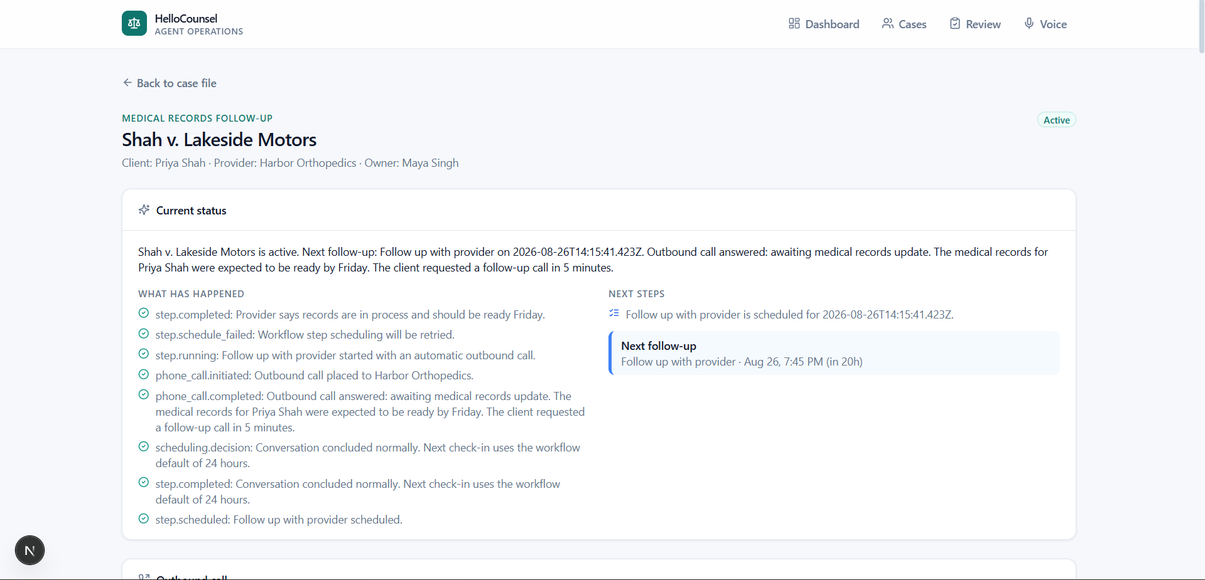
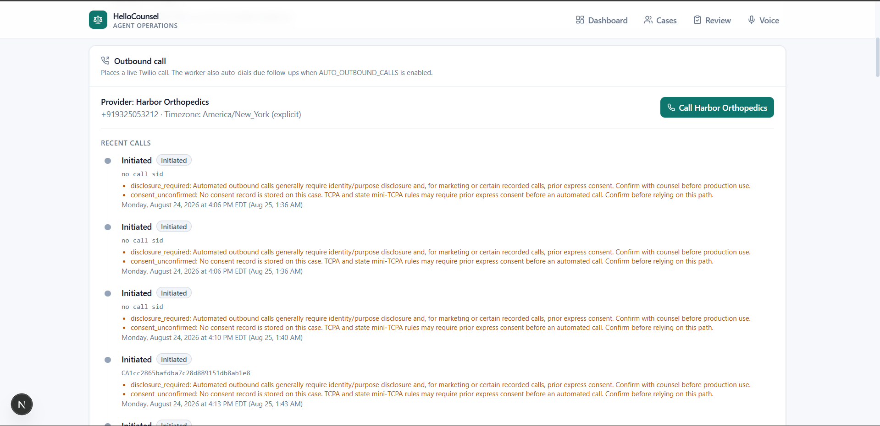

Decisions worth defending
Postgres owns the truth; the queue just delivers messages. A naive design makes the delayed-job queue the schedule itself, but queues lose jobs - retention limits, crashes, cleanups. Here, a follow-up that's due exists as a queryable database row no matter what happens to any message. A reconciliation pass runs every minute and re-enqueues anything the queue dropped, and claiming a step is a single atomic compare-and-swap update, so duplicate deliveries can't double-execute anything.
Real where it matters, loud where it fails. Due follow-ups place actual Twilio calls, and the worker refuses to start without a configured phone runtime. There is no simulated fallback that pretends we called someone - for a legal product, silently faking outreach felt like the worst possible default.
Human-in-the-loop lives in one place. A single policy function decides whether automation may proceed, checking for missing authorizations, provider refusals, ambiguous answers, requests for legal advice, and repeated failed contacts. Blocking results turn directly into review requests with a reason, severity, and recommended action, so the reviewer sees evidence rather than just an alert.
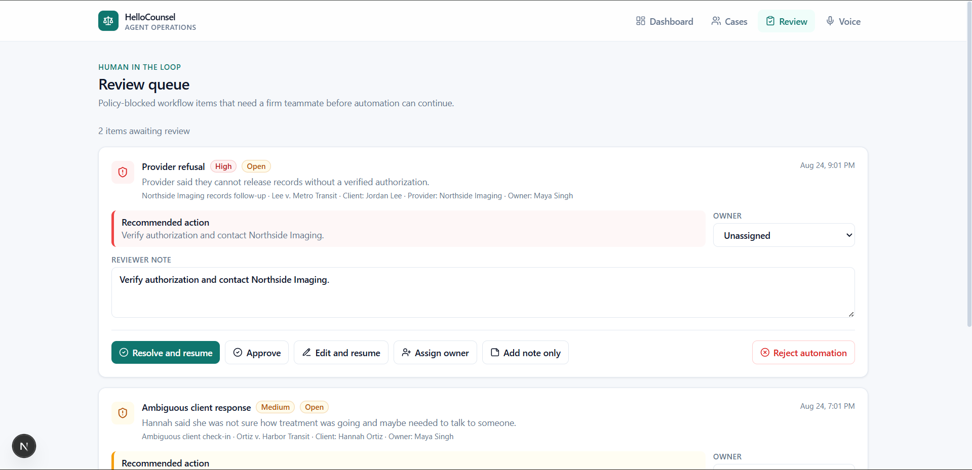
Framework around the voice agent, not the agent itself. The runtimes (Twilio media, LiveKit pipeline) sit behind seams. Session ingestion, tool routing, persistence, and audit don't know which channel produced them, so swapping either transport later doesn't ripple through the platform.

Planned change: DB-backed runner → Temporal
The current runner (Postgres as state authority, plus a reconciliation loop) was chosen so the platform primitives stay visible and testable at this scale. It will be replaced with Temporal as the orchestrator. The domain model was designed with that migration in mind: runs map to Temporal workflows, steps to activities and timers, review resolution to signals, status reads to queries. So it's a runner swap, not a redesign - definitions, policies, the review flow, voice tools, and the audit model all carry over unchanged.

