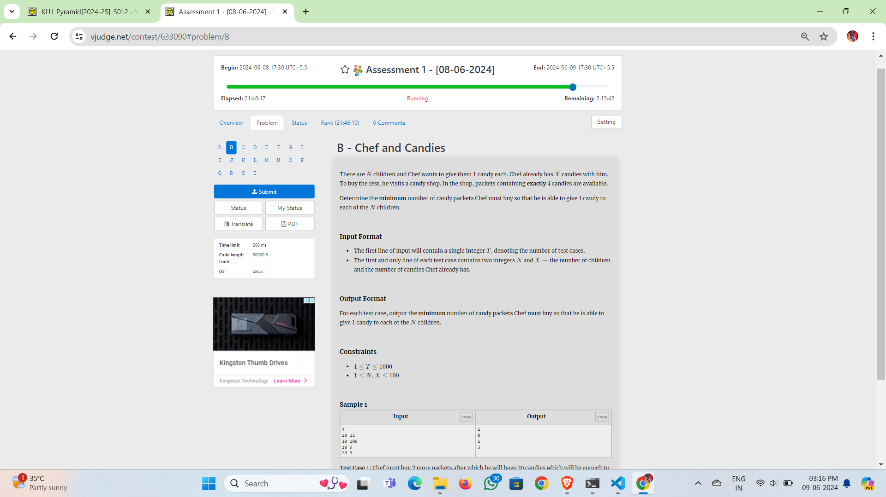

There are 𝑁*N* children and Chef wants to give them 11 candy each. Chef already has 𝑋*X* candies with him. To buy the rest, he visits a candy shop. In the shop, packets containing **exactly** 44 candies are available.

Determine the **minimum** number of candy packets Chef must buy so that he is able to give 11 candy to each of the 𝑁*N* children.

**Input Format**

* The first line of input will contain a single integer 𝑇*T*, denoting the number of test cases.
* The first and only line of each test case contains two integers 𝑁*N* and 𝑋*X* — the number of children and the number of candies Chef already has.

**Output Format**

For each test case, output the **minimum** number of candy packets Chef must buy so that he is able to give 11 candy to each of the 𝑁*N* children.

**Constraints**

* 1≤𝑇≤10001≤*T*≤1000
* 1≤𝑁,𝑋≤1001≤*N*,*X*≤100

**Sample 1**

| **Inputcopy** | **Outputcopy** |
| --- | --- |
| 4  20 12  10 100  10 9  20 9 | 2  0  1  3 |

**Test Case 11:** Chef must buy 22 more packets after which he will have 2020 candies which will be enough to distribute 11 candy to each of the 2020 children.

**Test Case 22:** Chef does not need to buy more packets since he already has 100100 candies which are enough to distribute 11 candy to each of the 1010 children.

**Test Case 33:** Chef must buy 11 more packet after which he will have 1313 candies which will be enough to distribute 11 candy to each of the 1010 children.

**Test Case 44:** Chef must buy 33 more packets after which he will have 2121 candies which will be enough to distribute 11 candy to each of the 2020 children.