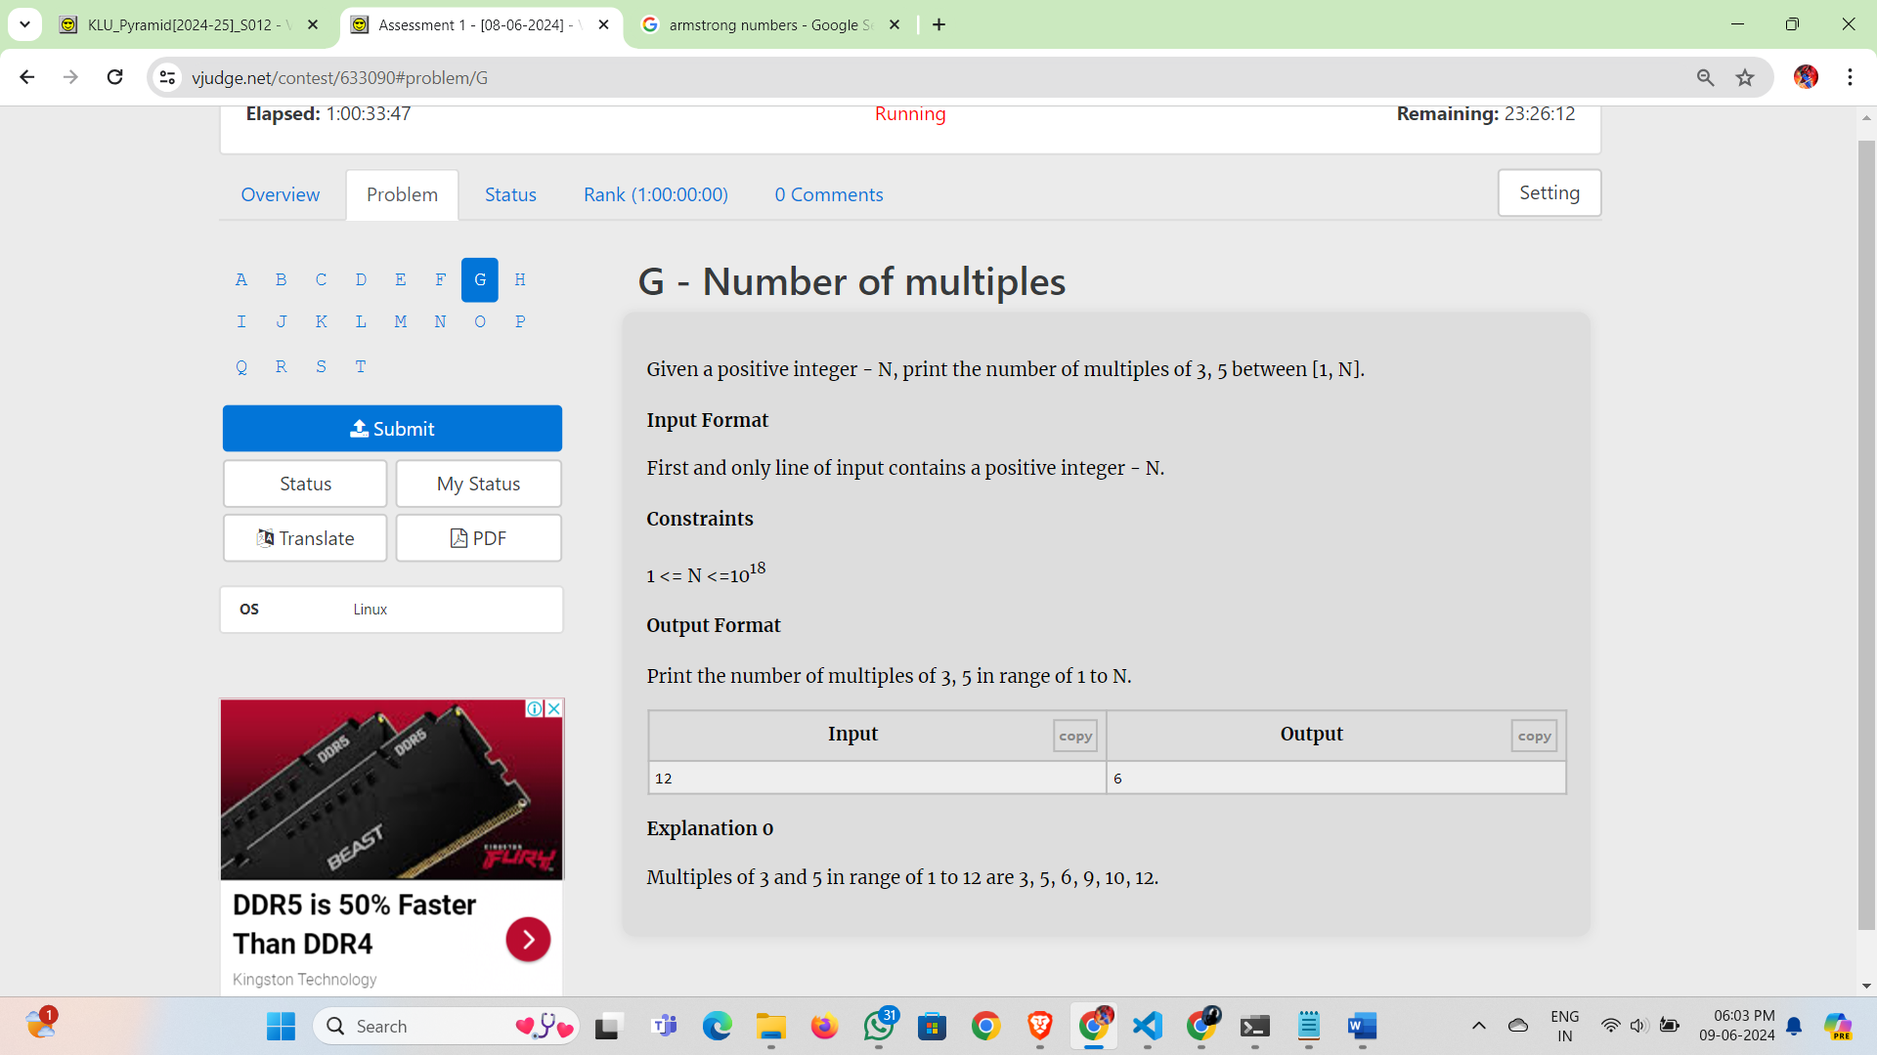

Given a positive integer - N, print the number of multiples of 3, 5 between [1, N].

**Input Format**

First and only line of input contains a positive integer - N.

**Constraints**

1 <= N <=1018

**Output Format**

Print the number of multiples of 3, 5 in range of 1 to N.

| **Inputcopy** | **Outputcopy** |
| --- | --- |
| 12 | 6 |

**Explanation 0**

Multiples of 3 and 5 in range of 1 to 12 are 3, 5, 6, 9, 10, 12.