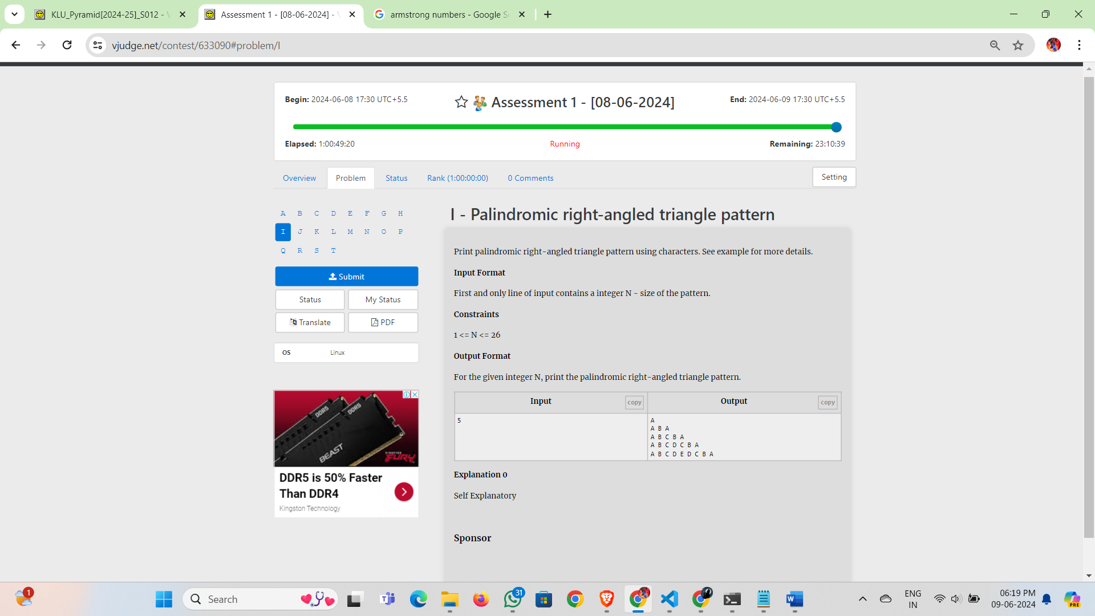

Print palindromic right-angled triangle pattern using characters. See example for more details.

**Input Format**

First and only line of input contains a integer N - size of the pattern.

**Constraints**

1 <= N <= 26

**Output Format**

For the given integer N, print the palindromic right-angled triangle pattern.

| **Inputcopy** | **Outputcopy** |
| --- | --- |
| 5 | A  A B A  A B C B A  A B C D C B A  A B C D E D C B A |

**Explanation 0**