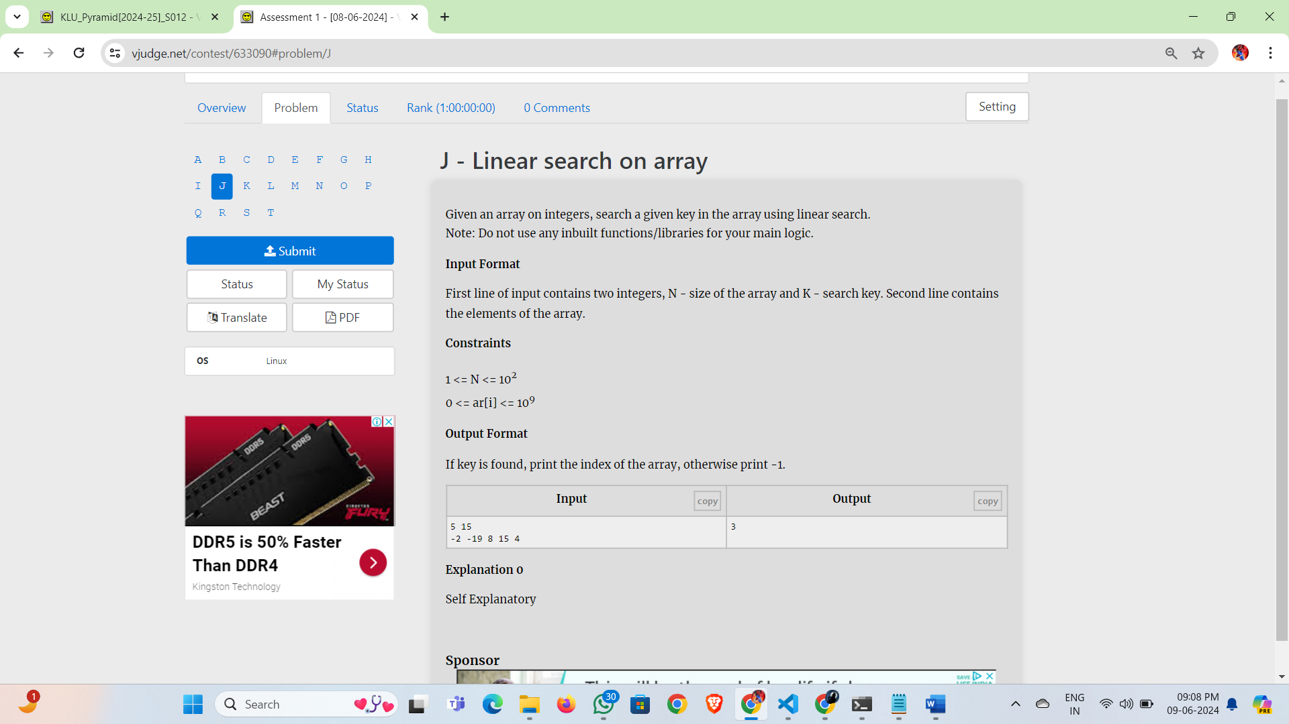

Given an array on integers, search a given key in the array using linear search.  
Note: Do not use any inbuilt functions/libraries for your main logic.

**Input Format**

First line of input contains two integers, N - size of the array and K - search key. Second line contains the elements of the array.

**Constraints**

1 <= N <= 102  
0 <= ar[i] <= 109

**Output Format**

If key is found, print the index of the array, otherwise print -1.

| **Inputcopy** | **Outputcopy** |
| --- | --- |
| 5 15  -2 -19 8 15 4 | 3 |