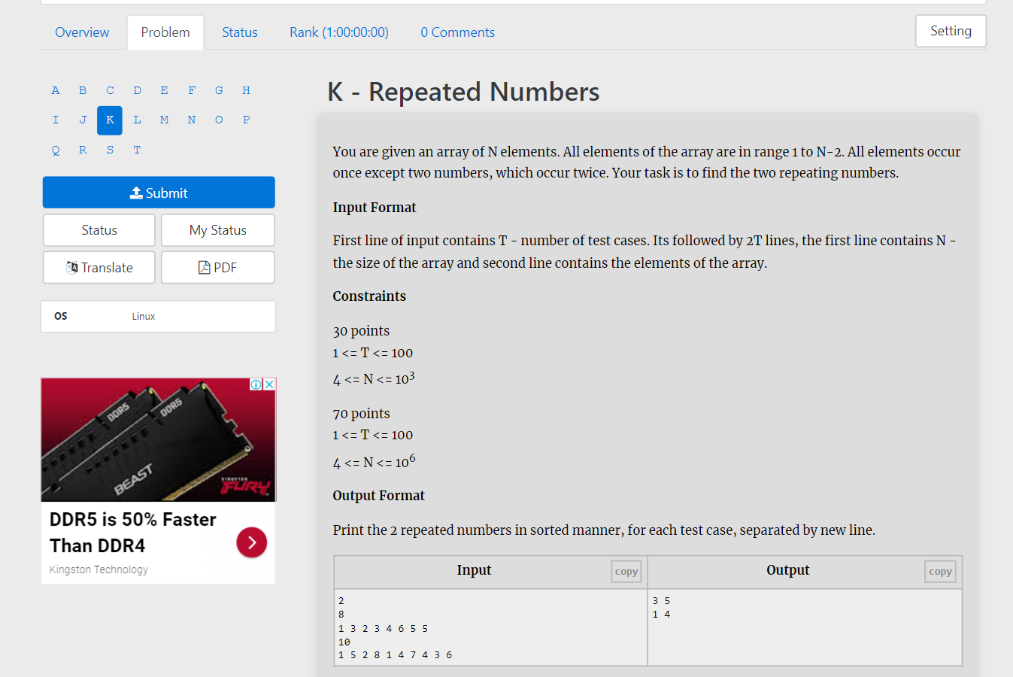

You are given an array of N elements. All elements of the array are in range 1 to N-2. All elements occur once except two numbers, which occur twice. Your task is to find the two repeating numbers.

**Input Format**

First line of input contains T - number of test cases. Its followed by 2T lines, the first line contains N - the size of the array and second line contains the elements of the array.

**Constraints**

30 points  
1 <= T <= 100  
4 <= N <= 103

70 points  
1 <= T <= 100  
4 <= N <= 106

**Output Format**

Print the 2 repeated numbers in sorted manner, for each test case, separated by new line.

| **Inputcopy** | **Outputcopy** |
| --- | --- |
| 2  8  1 3 2 3 4 6 5 5  10  1 5 2 8 1 4 7 4 3 6 | 3 5  1 4 |