* 1. **Launch the sample trade network in development mode**

6) $ ./trade.sh up -d true

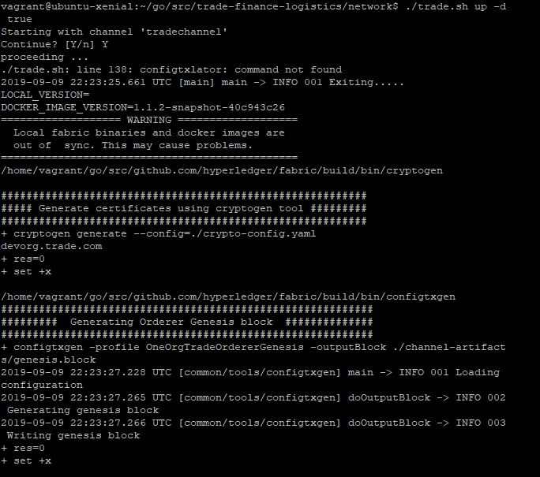

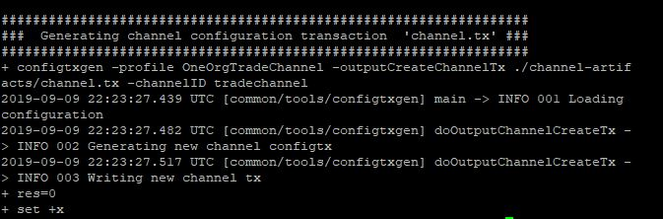

* 1. **Install and run the chaincode on the channel**

**4)** # peer chaincode install -p chaincodedev/chaincode/trade_workflow_v1 -n tw -v 0

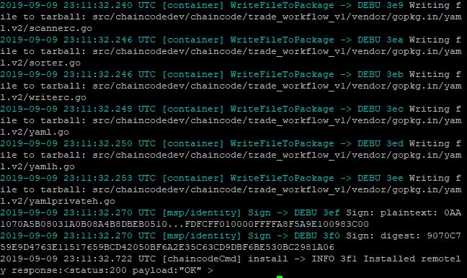

7) # peer chaincode invoke -n tw -c '{"Args": ["requestTrade",”trade-12”,"50000","Wood for Toys"]}' -C tradechannel

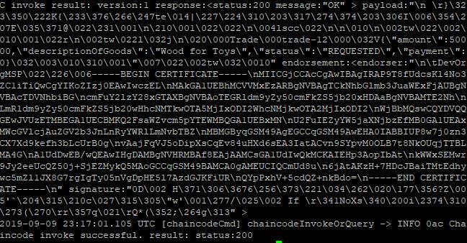

9) # peer chaincode invoke -n tw -c '{"Args": ["getTradeStatus","trade-12"]}' -C tradechannel

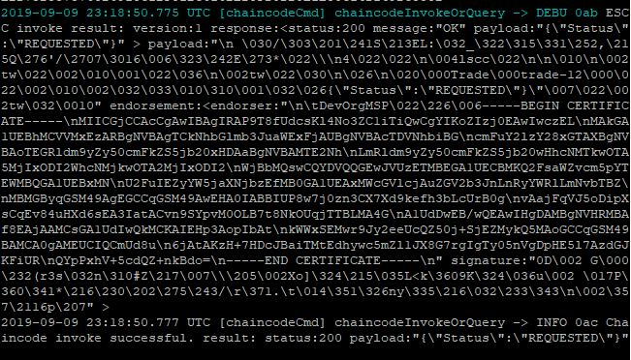

* 1. **Install and run the chaincode on the channel**

**5)** Find the Invoke() method in the editor. (Make sure the line starts with “func”.)

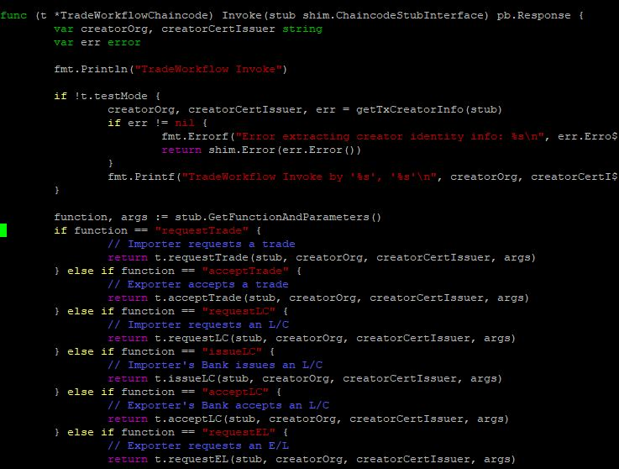

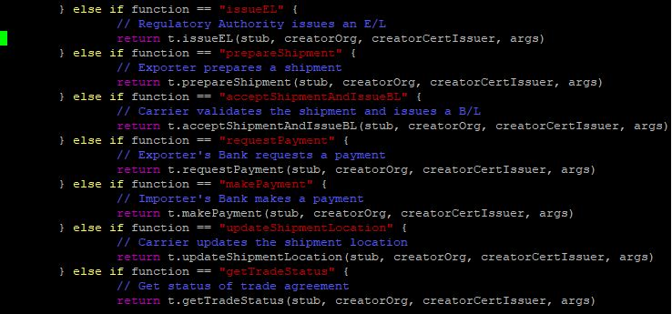

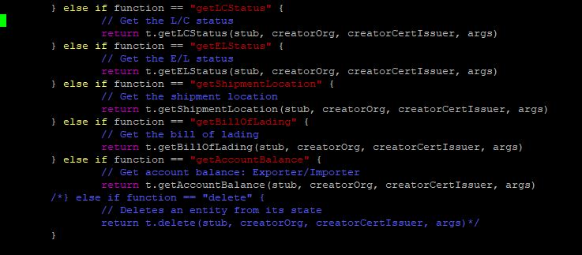



7) Find the requestTrade() method in the editor. (Make sure the line starts with “func”.)

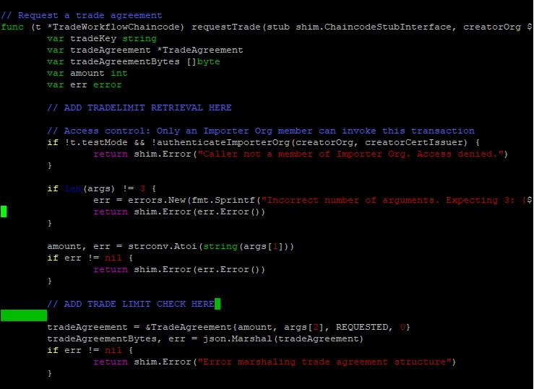

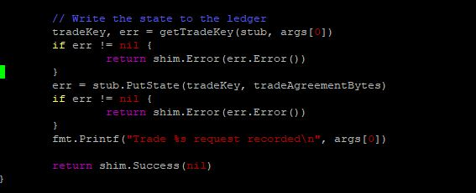

9) Find the getTradeStatus() method in the editor. (Make sure the line starts with “func”.) You invoked this method in the previous section (Step 1.4.9).

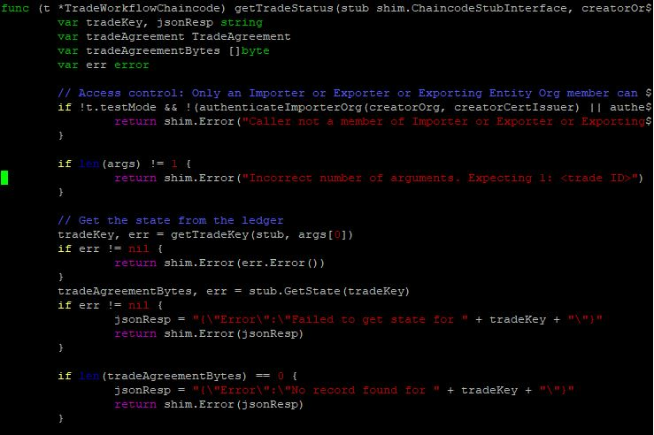

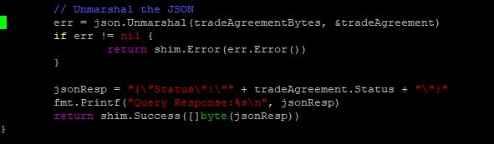

* 1. **Test the Chaincode**

3) Find the method that tests ShipmentInitiation

