Graphics and Animation Tools Viva-1

Task-1: Design of Mobile phone using GIMP.

**Steps to design a Mobile phone using GIMP-**

Step.1. Create a new project with image size 1080*2500.

Step.2. Open a Smartphone image as a new layer.

Step.3. Create a new layer. Select the Rectangle Select Tool and select a rectangular part around the menu image.

Step.4. Fill the space between rectangular portion and the menu image with black color.

Step.5. Select the rectangular portion and round the corners of the portion to 25%.

Step.6. Select a small rectangular portion at the top of Smartphone and fill it with gray color.

**Output-**

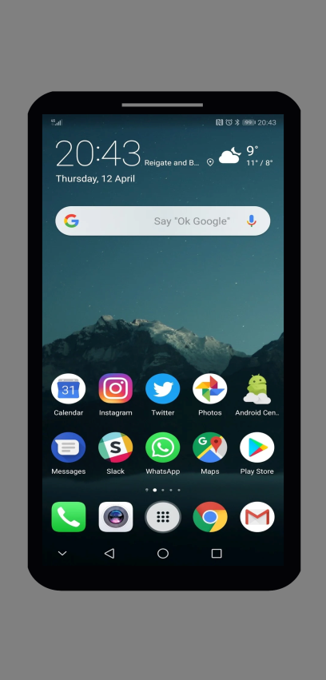

Task-2: Design of Fruit basket using Blender.

**Steps to design a Fruit basket using Blender-**

Step.1.Create a new project and remove everything from the interface.

Step.2. Go to add... Mesh... And select Ico sphere.

Step.3. Go to edit mode. Select upper faces and scale them.

Step.4. Go to object mode and add a cube.

Step.5. Scale the cube and place at the top of sphere.

Step.6.Now, select a UV sphere.

Step.7. Go to edit mode and select upper faces of UV sphere and scale them.

Step.8. Go to object mode and select a cube. Place this at the top of UV sphere and scale it.

Step.9. Select another UV sphere and repeat the steps 7 and 8.

Step.10. Select an Ico sphere.

Step.11. Go to edit mode and delete upper half of this sphere to form a basket.

Step.12. Extrude upper edges of the basket.

Step.13. Add desired color to all the objects.

**Output-**

