**Graphics and Animation Tools Viva-2**

**Task-1: Design of Mountain range with snowfall using GIMP.**

Steps to design a Mountain range with snowfall using GIMP-

Step.1. Go to File→Open as Layers and open the mountain image as a layer.

Step.2. Create a new layer and fill it with black as foreground color.

Step.3. Go to Filters→ Noise and select HSV Noise and set its Dulling and Value to maximum level.

Step.4. Go to Filters→ Blur→ Gaussian Blur and set blur to 1.0.

Step.5. Go to Colors→ Levels and adjust the color levels.

Step.6. Change the Layer mode to Screen.

**Output-**

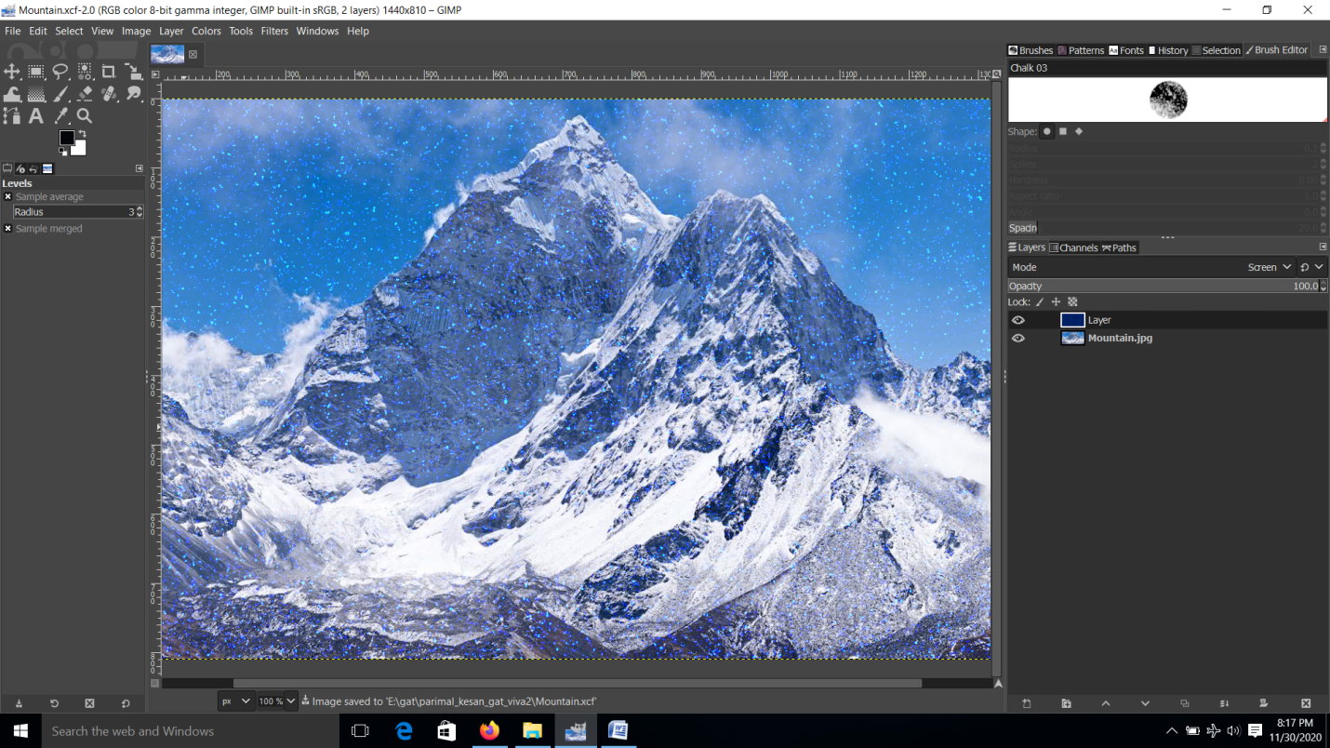

**Task-2: Design of Skyscraper using Blender.**

Steps to design a Skyscraper using Blender-

Step.1. Create a new project and scale out the default cube.

Step.2. Extrude the faces of the cube to get the desired shape of the base.

Step.3. Select the top faces and extrude the base in upward direction.

Step.4. Inset the faces a little bit and extrude it upwards again.

Step.5. Exclude some of the faces from the previous extrusion and extrude it upwards again.

Step.6. Repeat step-5 multiple times to get the desired height of the skyscraper.

Step.7. Bevel the topmost portion of the skyscraper.

Step.8. Inset and intrude the leftover faces to get a standard design.

Step.9. Make loop cuts in entire skyscraper to design the windows.

Step.10. Color the skyscraper with desired colors. Adjust the light source and render the file.

**Output-**



