**Tax Invoice/Bill of Supply/Cash Memo**



(Original for Recipient)

|  |  |
| --- | --- |
| **Sold By:** | **Billing Address:** |
| New Horizon Media Private Limited | Parimi Pradeep |
| 177/103, Ambals Building, Lloyds Road – Avvai | Flat No F2, Plot No.41, Opp. Color Homes |
| Shanmugam Salai, Royapettah, | Apartment,, Telephone Nagar Main Road |
| Chennai, TAMIL NADU, 600014 | CHENNAI, TAMIL NADU, 600096 |
| IN | IN |

|  |  |  |  |  |  |  |  |  |  |  |
| --- | --- | --- | --- | --- | --- | --- | --- | --- | --- | --- |
| **PAN No:** AABCN8818M | |  |  |  |  |  |  | **Shipping Address:** | |  |
| **GST Registration No:** NotApplicable | |  |  |  |  |  | Parimi Pradeep | | |  |
|  |  |  |  |  |  |  | Flat No F2, Plot No.41, Opp. Color Homes, Telephone Nagar Main Road CHENNAI | | | , |
|  |  |  |  |  |  | TAMIL NADU, 600096 | | | |  |
|  |  |  |  |  |  |  |  | IN | |  |
|  |  |  |  |  |  |  |  |  |  |  |
| **Order Number:** 406-2264535-7404325 | | |  |  |  |  | **Invoice Number:** IN-8370 | | |  |
| **Order Date:** 10.02.2019 | |  |  |  | **Invoice Details:** TN-137098601-3718 | | | | |  |
|  |  |  |  |  |  |  | **Invoice Date:** 10.02.2019 | | |  |
|  |  |  |  |  |  |  |  |  |  |  |
| **Sl.** | **Description** | **Unit** | **Quantity** | **Net** |  | **Tax** | **Tax** | **Tax** | **Total** |  |
| **No** |  | **Price** |  | **Amount** |  | **Rate** | **Type** | **Amount** | **Amount** |  |
| 1 | Data Structures using java  | 0471725048 (9780471725046 ) | ₹7,955.00 | 1 | ₹7,955.00 |  | 0% | IGST | ₹0.00 | ₹7,955.00 |  |
|  |  |  |  |
|  |  |  |  |  |  |  |  |  |  |
|  |  |  |  |  |  | 0% | CGST | ₹0.00 |  |  |
|  |  |  |  |  |  | 0% | IGST | ₹0.00 |  |  |
|  |  |  |  |  |  | 0% | None | ₹0.00 |  |  |
|  |  |  |  |  |  | 0% | SGST | ₹0.00 |  |  |
|  | Shipping Charges | ₹40.00 |  | ₹40.00 |  | 0% | IGST | ₹0.00 | ₹40.00 |  |
|  |  |  |  |  |  | 0% | CGST | ₹0.00 |  |  |
|  |  |  |  |  |  | 0% | IGST | ₹0.00 |  |  |
|  |  |  |  |  |  | 0% | None | ₹0.00 |  |  |
|  |  |  |  |  |  | 0% | SGST | ₹0.00 |  |  |
| **TOTAL:** | |  |  |  |  |  |  | ₹0.00 | ₹8,035.00 |  |
|  |  |  |  |  |  |  |  |  |  |  |

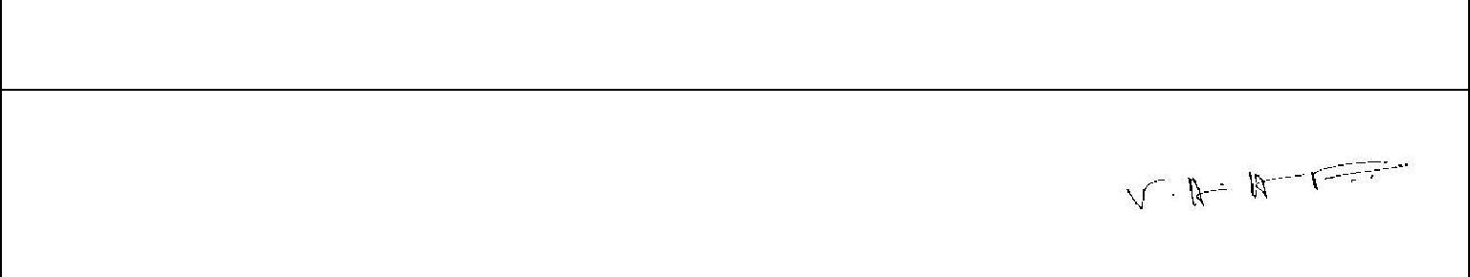

**Amount in Words:**

**Eight Thousand And Thirty Five only**

**For New Horizon Media Private Limited:**

**Authorized Signatory**



Please note that this invoice is not a demand for payment

Page 1 of 1