
Tax Invoice/Bill of Supply/Cash Memo

(Original for Recipient)

Sold By: | Billing Address:
New Horizon Media Private Limited | Parimi Pradeep
177/103, Ambals Building, Lloyds Road – Avvai | Flat No F2, Plot No.41, Opp. Color Homes
Shanmugam Salai, Royapettah, | Apartment,, Telephone Nagar Main Road
Chennai, TAMIL NADU, 600014 | CHENNAI, TAMIL NADU, 600096
IN | IN

PAN No: AABCN8818M |  |  |  |  |  |  |  | Shipping Address:
GST Registration No: NotApplicable |  |  |  |  |  |  | Parimi Pradeep
 |  |  |  |  |  |  | Flat No F2, Plot No.41, Opp. Color Homes, Telephone Nagar Main Road CHENNAI |  |  | ,
 |  |  |  |  |  | TAMIL NADU, 600096
 |  |  |  |  |  |  |  | IN
Order Number: 406-2264535-7404325 |  |  |  |  |  |  | Invoice Number: IN-8370
Order Date: 10.02.2019 |  |  |  |  | Invoice Details: TN-137098601-3718
 |  |  |  |  |  |  | Invoice Date: 10.02.2019
Sl. | Description | Unit | Quantity | Net |  | Tax | Tax | Tax | Total
No |  | Price |  | Amount |  | Rate | Type | Amount | Amount
1 | Data Structures using java  | 0471725048 (9780471725046 ) | ₹7,955.00 | 1 | ₹7,955.00 |  | 0% | IGST | ₹0.00 | ₹7,955.00
 |  |  |  |  |  | 0% | CGST | ₹0.00
 |  |  |  |  |  | 0% | IGST | ₹0.00
 |  |  |  |  |  | 0% | None | ₹0.00
 |  |  |  |  |  | 0% | SGST | ₹0.00
 | Shipping Charges | ₹40.00 |  | ₹40.00 |  | 0% | IGST | ₹0.00 | ₹40.00
 |  |  |  |  |  | 0% | CGST | ₹0.00
 |  |  |  |  |  | 0% | IGST | ₹0.00
 |  |  |  |  |  | 0% | None | ₹0.00
 |  |  |  |  |  | 0% | SGST | ₹0.00
TOTAL: |  |  |  |  |  |  |  | ₹0.00 | ₹8,035.00
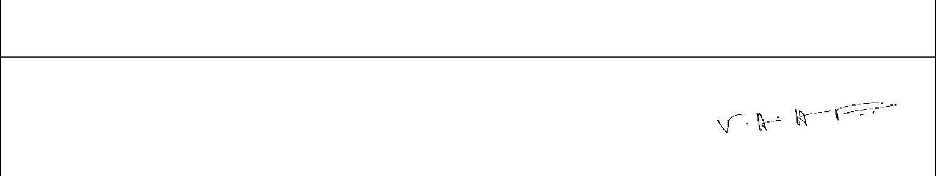
Amount in Words:

Eight Thousand And Thirty Five only

For New Horizon Media Private Limited:

Authorized Signatory

Please note that this invoice is not a demand for payment

Page 1 of 1

