**Id: 2100030293**

**Name: P. Kushal**

**Safertek BackEnd Exam**

1. List all customers.

**Query:** SELECT * FROM customers;

O/P:

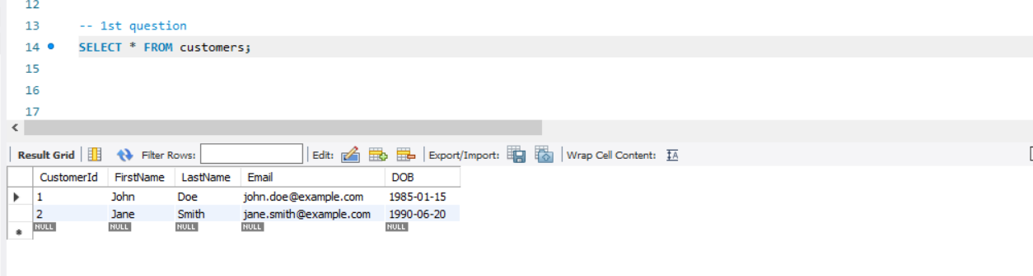

**2.** Find all orders placed in January 2023.

Query: SELECT p.ProductName as orders,o.orderdate,monthname(o.orderdate) as monthname FROM orders o join orderitems oi on oi.orderid=o.orderid join products p on p.productid=oi.productid

where YEAR(OrderDate)=2023 and MONTHNAME(OrderDate)="January";

O/P:

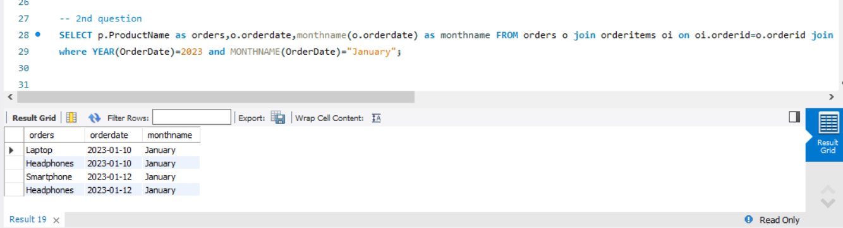

3. Get the details of each order, including the customer name and email.

Query: SELECT c.FirstName as CustomerFisrtName,c.lastname as CustomerLastName, c.Email as CustomerEmail,p.productname,oi.Quantity, o.OrderDate from customers c

inner join orders o on c.CustomerID=o.OrderId

join orderitems oi on oi.orderid=o.orderid

join products p on p.productid=oi.productid;

O/P:

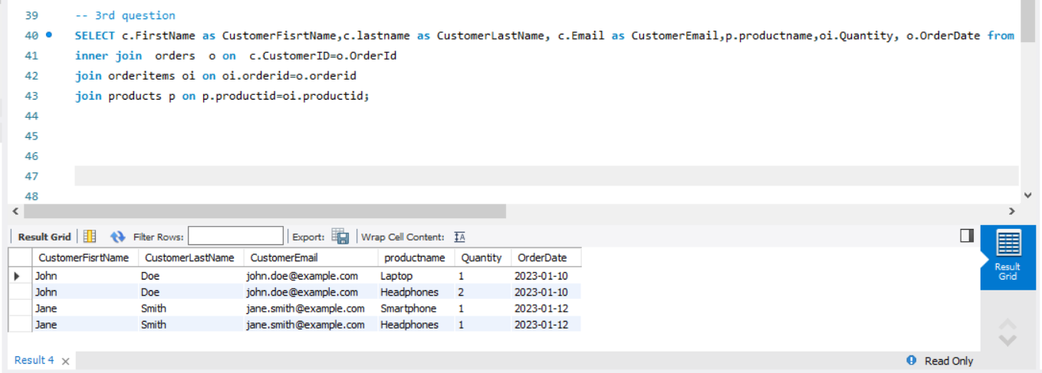

4. List the products purchased in a specific order (e.g., OrderID = 1).

Query: SELECT p.ProductName,p.Price,o.OrderId from products p left join orderitems o on p.ProductID=o.ProductID order by o.OrderId;

O/P:

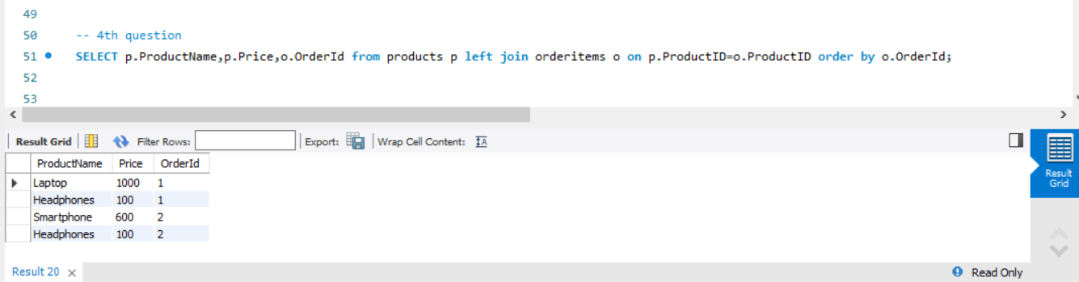

5. Calculate the total amount spent by each customer.

Query: SELECT c.FirstName,c.LastName,c.Email,sum(oi.Quantity*p.Price) as total

from customers c

join orders o on o.OrderID=c.CustomerID

join orderitems oi on o.OrderID=oi.OrderID

join products p on p.ProductID=oi.ProductID

GROUP BY c.FirstName,c.LastName,c.Email;

O/P:

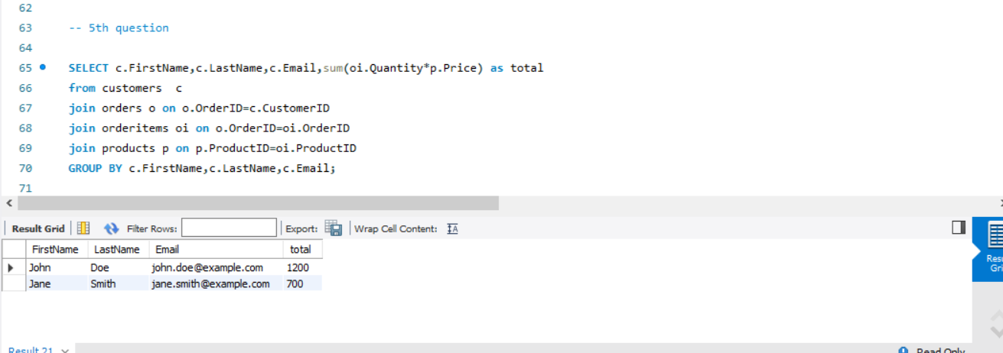

6. Find the most popular product (the one that has been ordered the most).

Query: SELECT p.productname,sum(oi.quantity) as total

from orderitems oi

join products p on oi.productid=p.productid

group by p.productname order by total desc limit 1;

O/P: 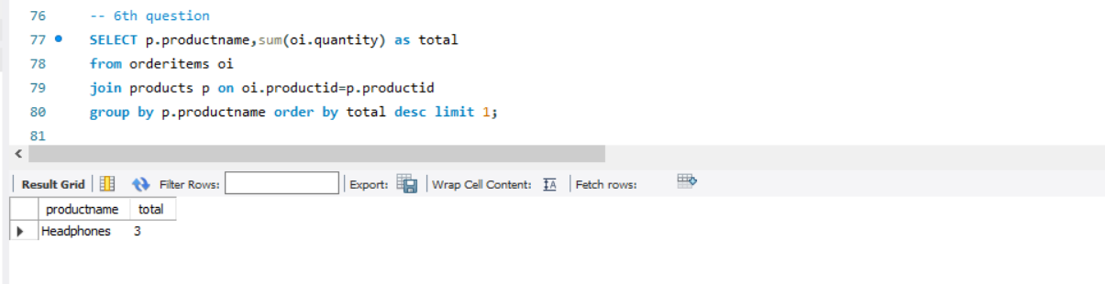

7. Get the total number of orders and the total sales amount for each month in 2023.

Query: select monthname(o.Orderdate),count(o.orderid) as totalOrders,sum(oi.quantity*p.price) as totalSalesAmount

from orders o

join Orderitems as oi on oi.orderid=o.orderid

join products as p on p.productid=oi.productid

where year(o.orderdate)=2023

group by monthname(o.Orderdate)

order by monthname(o.orderdate);

O/p:

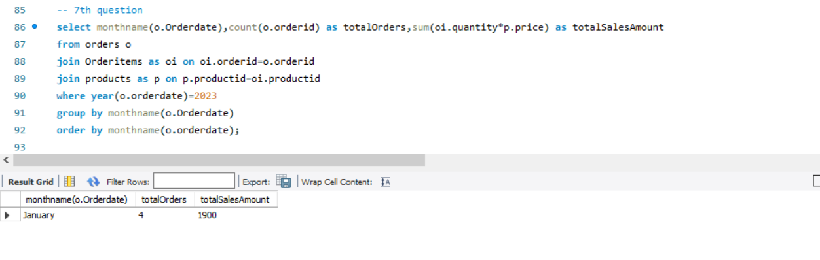

8. Find customers who have spent more than $1000.

Query: SELECT c.FirstName,c.LastName,c.Email,sum(oi.Quantity*p.Price) as total

from customers c

join orders o on o.OrderID=c.CustomerID

join orderitems oi on o.OrderID=oi.OrderID

join products p on p.ProductID=oi.ProductID

GROUP BY c.FirstName,c.LastName,c.Email

HAVING total>1000;

O/P:

