SECURE CODING REVIEW

Submitted By: Parimi Pujitha
Internship: CodeAlpha
Programming Language: Python
Project: Secure Login System Review

Introduction
Secure coding is the practice of developing software in a secure manner to reduce vulnerabilities and protect applications from cyber attacks. In this project, a Python login system was reviewed to identify common security issues and implement secure coding techniques.

Vulnerable Code Review
The vulnerable login system directly inserted user input into SQL queries. This created security risks such as SQL Injection attacks and insecure password handling.
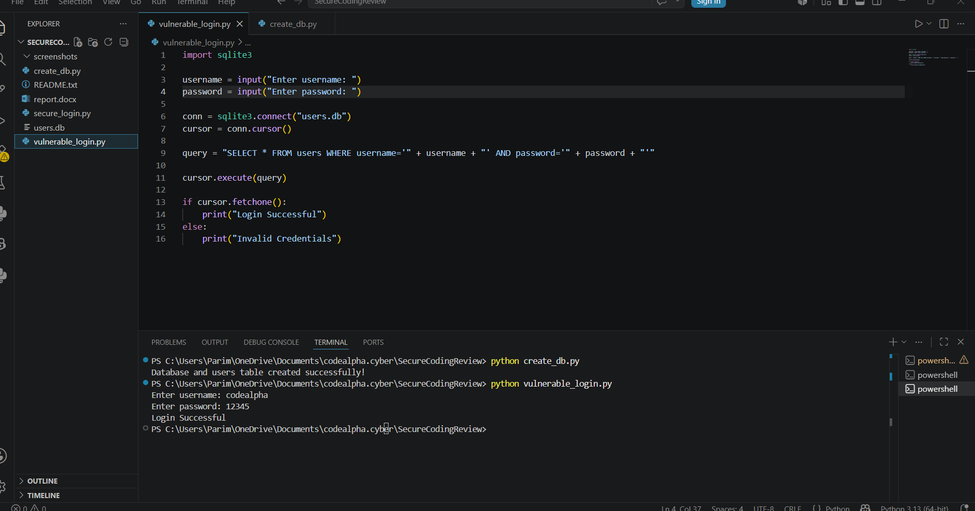

3. Vulnerabilities Identified
1. SQL Injection:
The application directly concatenated user input into SQL queries, allowing attackers to manipulate database operations.

2. Plain Text Password Storage:
Passwords were stored without encryption, making them vulnerable if the database was leaked.

3. Lack of Input Validation:
The application accepted all input without proper validation or sanitization.

Secure Code Implementation
The secure version of the application used parameterized queries and password hashing to improve security and prevent common cyber attacks.

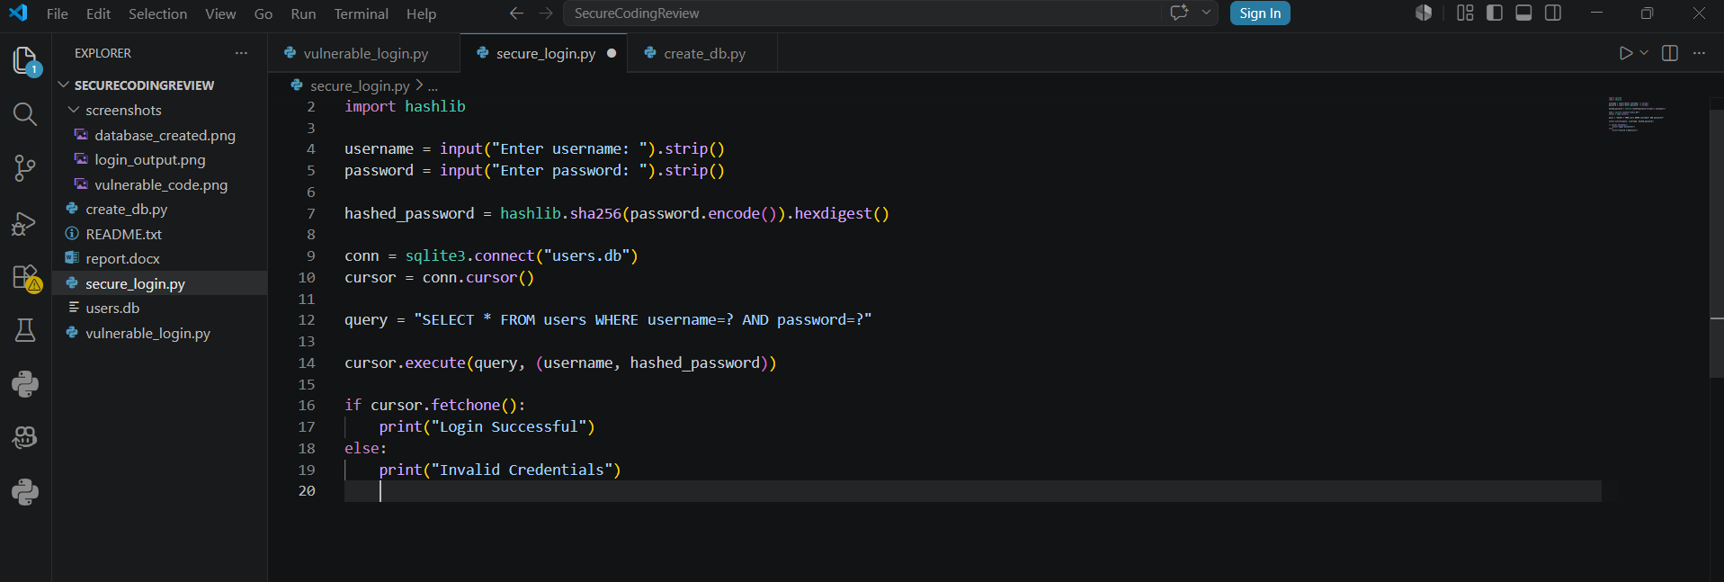
Vulnerability | Risk  Solutions
SQL Injection | Unauthorised acess | Parameterized queries
Plain Passwords | Password leakage | SHA-256 hashing
NO Validation | Unsafe input | Input sanitization

5. Recommendations
- Always validate user input.
- Use parameterized SQL queries.
- Store passwords securely using hashing.
- Perform regular security testing.
- Avoid exposing sensitive information.

6. Conclusion
This project successfully identified vulnerabilities in a Python login system and implemented secure coding practices to improve application security. The review demonstrated the importance of secure coding in protecting software from cyber threats.

