Assignment 2

# Spring Boot Setup Task

# Screenshots:

# Java version:

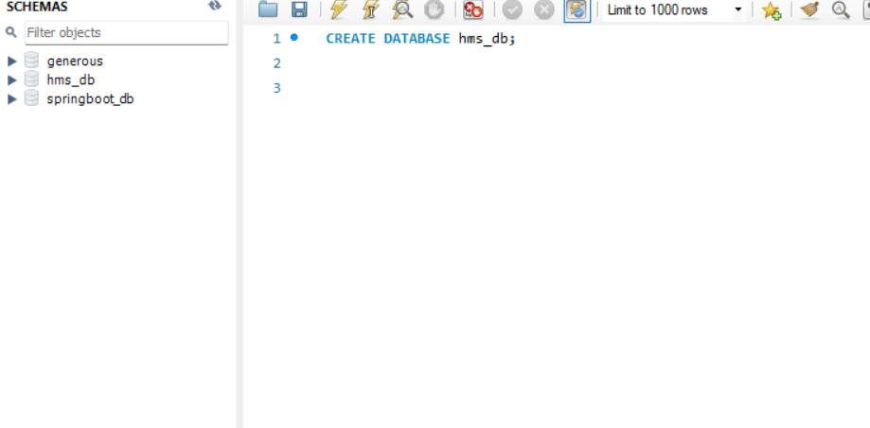

Figure 1: Java Version Screenshot

# Maven version:

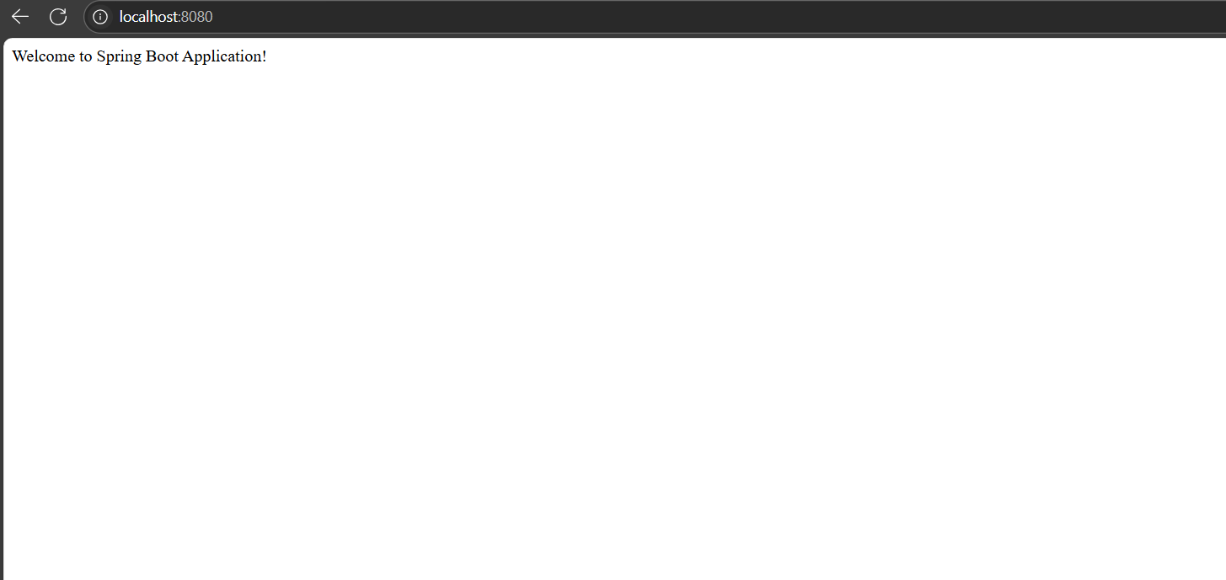

Figure 2: Maven Version Screenshot

# Running application on browser:

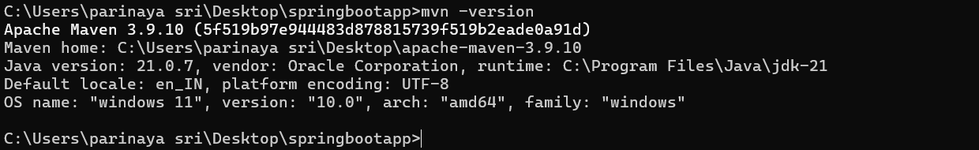

Figure 3: Running Application on Browser

# MySQL Workbench showing hms_db database:

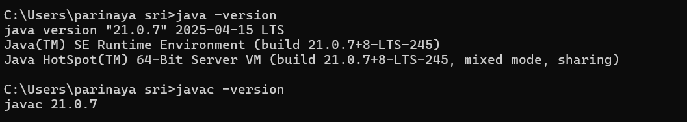

Figure 4: MySQL Workbench Showing hms_db Database