Server Room Security Using Facial Recognition

Project Report

Authors: Parinaz Yousefi and Sumaiya Faruq

Subject: Technology Project - TPJ655

Program: Computer Engineering Technology

Instructor: B. Shefler, rm. A4022,

Date: April 7, 2023

SENECA COLLEGE OF APPLIED ARTS AND TECHNOLOGY

School of Electronics and Mechanical Engineering Technology

1750 Finch Ave East, Toronto, Ontario, M2J 2X5. Tel. 416-491-5050 Fax 416-490-9839 [www.senecacollege.ca](http://www.senecacollege.ca/)

# Table of Contents

Table of Contents 2

Executive Summary 3

Introduction 3

Functional Features of the Product 5

Specifications of the product 6

System block-diagram 8

Schematic Diagram 9

Component images and component description 10

5V USB to TTL Serial Cable Adapter FT232 FTDI Chipset USB Download Cable 12

Captures of major GUIs 13

Theory of operation 18

Maintenance Requirements 21

Future Modifications: 22

Conclusion 22

Appendix: 24

BOM 24

List of Users and/or passwords 25

References 25

Contact Information 26

# Executive Summary

A sophisticated solution for safe access control to a server room is provided by the security system project that is the subject of this brief overview. The server room is safe and secure since facial recognition technology can be been used to grant authorized people the access they need. Only authorized people are allowed entrance to the room since the system can recognize human faces and compare them to the enrolled faces that have been preserved.

The product also successfully keeps logs of every time a person enters or attempts to enter the room. The product uses two main microcontrollers, and they are the ESP32-CAM and an Arduino UNO. Several modules used by these microcontrollers are responsible for the project to work. Overall, this security system project is an inventive way to ensure that only authorized people can enter a server room while maintaining a thorough log of all access attempts.

# Introduction

In recent years, facial recognition technology has grown in popularity and been utilized for a wide range of purposes, including social media platforms, access control systems, and security systems. Face traits including the space between an individual's eyes, the contours of their face, the shape of their nose and lips, and more are examined and compared by facial recognition technology. With better hardware and algorithms, this technology has advanced throughout time, resulting in higher accuracy rates and quicker processing times.

In our project, we want to use this technology to build a strong and dependable server room security system. A vital part of every organization's IT infrastructure is the server room, which houses the organization's servers.

Each employee will be given four chances to be recognised by the system in order to ensure its accuracy and dependability. An email message alerting the administrator of an attempted unauthorized entry will be sent if the system cannot recognise an employee after four tries. Every person who utilizes the system to access the server room will also be recorded, along with their names and the time and date of entry. This will give the company the ability to track and keep an eye on who enters the server room, as well as see any unwanted entry attempts.

In summary, the development of a facial recognition-based security system for a server room is a crucial project that will considerably improve an organization's overall security posture. The system that has been built is a system that is precise, dependable, and efficient, and that will give any company the right amount of control and oversight over access to its vital IT infrastructure. To that end, we use cutting-edge hardware and algorithms to build a user-friendly solution that is easy to acquire and easy to maintain.

# Functional Features of the Product

Turning on the system:

* The user will touch the LCD screen, and this triggers the system to turn on
* a set of instructions will also appear on the screen to guide them through the process

Facial recognition:

* The user will face the camera after reading the instructions presented to them earlier
* The camera will detect the person and authorize them to enter based on the registered list of personnel
* A message will be displaying the status of the authorization
* The authorized user will then be automatically logged into the system.

Notification:

* In case of a denial of access, an email will be sent to the administrator to notify them of the failed attempt.
* An email containing a log stating the exact time the individual was granted access will be sent to the administrator every day.

# Specifications of the product

ESP32:

Dimension: 27*40.5*4.5（±0.2）mm/1.06*1.59*0.18”

Wi-Fi: 802.11b/g/n/e/i Support

Interface: UART, SPI, I2C, PWM

IO port: 9 Serial Port

Power supply range: 5V

Weight: 10g

Arduino Uno:

Product Dimensions: 66.04mm x 50.80mm

Ports: 14 digital input/output pins

Weight: 25g

Power supply range: 2.7-5.5 volts

DAOKI 1 Channel DC 5V Relay Module:

Product Dimensions: 50.5mm x 38.5mm x 18.5mm

Ports: 1-Channel Relay interface board

Weight: 29g

Power supply: 5V

TFT ST7735 LCD Display Module

Product Dimensions: 10 x 7 x 3.2 cm

Weight: 20g

5V USB to TTL Serial Cable Adapter FT232 FTDI Chipset USB Download Cable

Connector: 6-way SIL, 0.1" connector  
Voltage: TTL levels is 3.3V  
The TTL-232R cables are a family of USB to TTL serial UART converter cables incorporating FTD's FT232RQ USB to Serial  
UART interface IC device which handles all the USB signal and protocols

Dimensions: 16.7 x 10.7 x 1.6 cm

Weight: 50 Grams

All hardware components combined:

Dimensions: 6” x 15” x 1.5”

Weight: 200g

# System block-diagram

# Schematic Diagram

# Component images and component description

|  |  |
| --- | --- |
| Components | Description |
| Arduino Uno   | The microcontroller will interface with the ESP32-CAM to get data from it and display the result on the TFT LCD shield.  Product Dimensions: 66.04mm x 50.80mm  Ports: 14 digital input/output pins  Weight: 25g  Power supply range: 2.7-5.5 volts |
|  | The ESP32-CAM is responsible to for capturing images of the user and detecting them as an authorized or unauthorized person.  Dimension: 27*40.5*4.5（±0.2）mm/1.06*1.59*0.18”  Wi-Fi: 802.11b/g/n/e/i Support  Interface: UART, SPI, I2C, PWM  IO port: 9 Serial Port  Power supply range: 5V  Weight: 10g |
| Tft LCD Shield   | The LCD display displays a set of instruction for the user and displays whether the user is allowed in.  Product Dimensions: 10 x 7 x 3.2 cm  Weight: 20g |
| DC 5V Relay Module   | Relay connected to Arduino Uno will be used to send signals to the door opener actuator (LED in our case) to allow the authorized user to enter the designated room  Product Dimensions: 50.5mm x 38.5mm x 18.5mm  Ports: 1-Channel Relay interface board  Weight: 29g  Power supply: 5V |
| 5V USB to TTL Serial Cable Adapter FT232 FTDI Chipset USB Download Cable | The cables provide a fast, simple way to connect devices with a TTL level serial interface to USB and helps interface between the Arduino Uno and the ESP32-CAM  RX and TX LEDs indicator The cables are available with a 6-way SIL, 0.1" connector TTL levels is 3.3V The TTL-232R cables are a family of USB to TTL serial UART converter cables incorporating FTD's FT232RQ USB to Serial UART interface IC device which handles all the USB signal and protocols  Dimensions: 16.7 x 10.7 x 1.6 cm  Weight: 50 Grams |

# Captures of major GUIs

Modern software and hardware systems must include graphic user interfaces (GUIs), which let users interact with appliances or any other hardware in a natural and user-friendly way. The TFT LCD shield's three main GUIs are made to help the user through the facial recognition procedure that will make the flow of the process seem seamless and uninterrupted. It makes it so that the user can perform the entire process without any assistance of any other individual.

On the first page of the GUI, the user is instructed to tap the screen to begin the process. The phrase "Please touch the screen" on the screen prompts the user to begin the facial recognition procedure. This initial step ensures that the user is ready to go and is aware of the necessity to interact with the device. The user is asked to start the process by tapping the screen on the GUI's initial page. The user is prompted to start the facial recognition process by seeing the message "Please touch the screen" on the screen. This first step makes sure the user is prepared to move forward and is aware of the requirement to engage with the gadget. The user is instructed to take off any masks or caps that cover their faces on the second screen of the GUI before pressing the START button to start the facial recognition procedure. The ESP32-CAM camera module is activated, and the user is asked to look at the camera after pressing the START button.

The outcomes of the facial recognition procedure are shown in subsequent photographs that are displayed on the screen. The screen will display a welcome message and the user's name along with the words "Welcome <UserName>" if the person is permitted. In case of the unsuccessful tries the first four tries will loop through the first two pages where it asks the user to press the screen to start and the START button and instructions appear. If the final attempt is unsuccessful, the word "Unauthorized" will appear on the screen.

Based on the facial recognition procedure, the display of these messages enables the user to determine if they are authorized to enter or not. The screen returns to the first page that reads, "Please touch the screen," once the facial recognition process for a specific person is finished. By touching the screen once more, the user can start the facial recognition procedure all over again for the subsequent person trying to enter the room.

In deduction, the GUIs on the TFT LCD shield offer a simple and natural method to engage with facial recognition technology. The GUIs aid in ensuring that the system is utilized correctly and effectively by giving clear instructions and showing the outcomes of the recognition process.

Fig: Initial Screen

Fig: Instruction Page

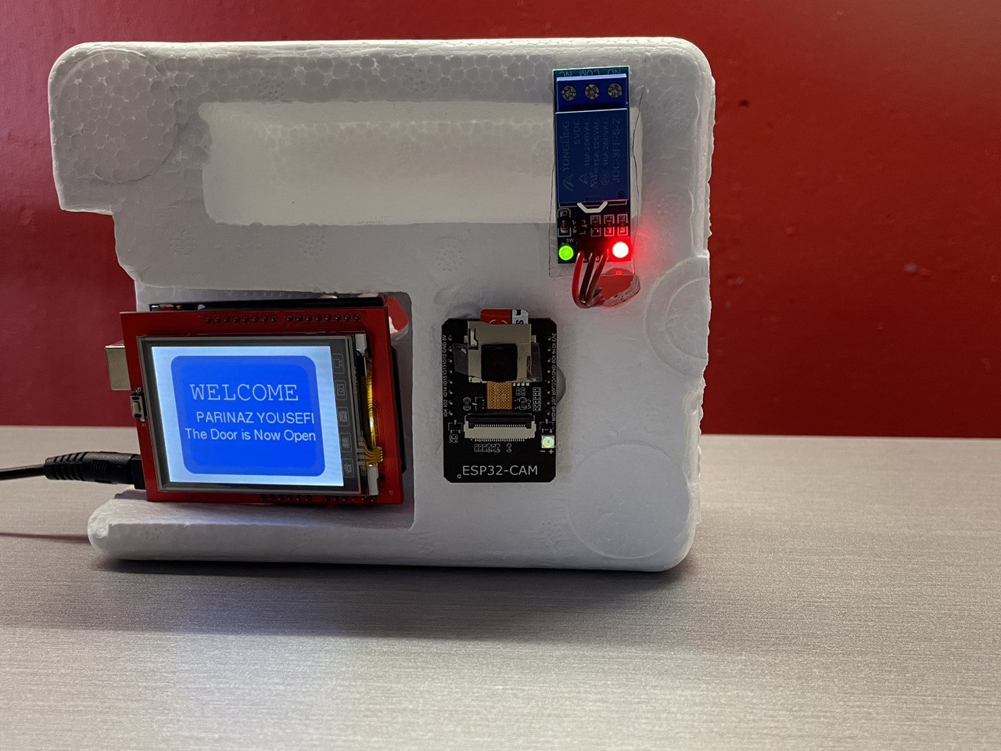

Fig: Display after user is authorized

Fig: Display when the user is Unauthorized

# Theory of operation

**HARDWARE**

TFT SHIELD:

In this project TFT 2.4-inch touchscreen has been used to interface with user. This is Arduino Uno shield which will be directly connected to it. The touchscreen communicates with Arduino by parallel 8-bit data bus. In addition 5 more pins will be connected to microcontroller (pin LCD_RST,LCD_CHIPSC,LCD_RS,LCD_WR,LCD_RD).Arduino pin 10 is connected to relay driver.

ARDUINO UNO:

Arduino Uno is connected to ESP32-CAM with serial connection and communicates through each RX and TX pins.

Microcontroller board has 5V regulator which allows  to have 6-10V input. The 5V output of microcontroller board supplies ESP32-CAM and relay.

**SOFTWARE:**

ESP32-CAM:

In ESP32-CAM these functions have been defined to do the following tasks:

creaetFile(),logFile(),readFile(),setupTime(),setupWifi(),getDataAsFileName(),setupSDCard(),sendEmail(),sendEmail2(),FaceRegocntion().

In the begging of the code the information in order to connect to SMTP server to send an email is mentioned. In order for ESP32-CAM to be able to connect to the server an app password must be generated. This can be done in Security Settings in google account.

Each user that is registered in the system should put five images of their face on SD card in order to be recognized. Then the number of registered users is defined which in our case is one. An array which contains the name and file path of the pictures on the SD card is defined. Image sizes will be defined in the next line. It is important the image size be exactly the same as define in this code which is 320*240.Otherwise the system wont be able to recognize the authorized user.

In the second array the name of each authorize user is defined according how the pictures are sorted in the first array.

In setupWifi() function SSID and password of the current Wi-Fi is defined. In this project,public Wi-Fi has been used so the password is commented out and later on in Wifi.begin() function only SSID is passed on.(For future use, if the company is using private Wi-Fi the password should be a parameter of this function too).

Time zone should be defined accordingly. This device is used in Toronto so the parameter is set to -5.This value is GMT time.

When the program starts it will create a directory in SD card named log which the log file will be stored in. log files are created with logFile() function. Then the date and time will be set through setupTime() function. After that the time data will be passed to getDataAsFileName function in order to name the log files accordingly. After that the process of serial communication between ESP32-CAM and Arduino Uno begins. When the user presses START on the screen,Serial.write(“Start”) will be sent to the ESP32-CAM and it will read it with Serial.read() method. Now the process of facial recognition begins. The FaceRecognition function will transfer the images on the SD card to RGB format to compare them with the image captured by ESP32-CAM. The methods for this function are available in <fd_forward.h> library. After this if the user is authorized FaceMatched() function will be called. It will then match the user ID to its defined array index at the beginning  of the code and send a data to Arduino to display the name of the user and message for the authorized user. This communication is again done by Serial method. Then logFile() function will be called to log this entry into the file.

If the user is not authorized the the FaceNotMatched() function will be called, and it will send a message to Arduino to indicate that the user is unauthorized. Then the sendEmail2() function will be called to send a notification to the designated email. In order to be able to create this function ESP Mail Server library must be installed. Timing of this event is done with a function called EmailTrigger().

It will compare 2 variables named L_day(last day) and N_day(new day).The value of each is initialized with the timeinfo_mday member of tm  struct in time library which will indicate the date. The program checks if the day has changed since last time being turned on and if the day has changed it will send an email to the administrator.

Arduino Uno:

Arduino is responsible for displaying ESP32-CAM messages through serial communication and communicating with relay. Serial communication is done with Serial. Read and Serial. Write methods which are explained above.

In first part of the code pins are defined. This section may be different for each Arduino and should be set accordingly. Other wise the touchscreen wont work properly.

Hex color codes of the colors used in this project is defined in the next section.

The relay is defined to be connected in Arduino pin 10.It is set to low active whenever it is supposed to indicate that the door is open.

Displaying is done with tft properties in Arduino.

# Maintenance Requirements

Any IT department in charge of overseeing the security of a network or system must perform regular maintenance on security systems. Protecting sensitive information and preventing unwanted access to essential resources depend on the security system being current and operating properly.

An IT department can gain a lot from simple security system maintenance by spending less time and effort keeping the system up and operating. IT employees can concentrate on other important activities, such as network monitoring and troubleshooting, without having to spend a lot of time managing the security system if it is simple to maintain.

Saving money is another advantage of a security system that is simple to maintain. That is exactly how our system functions.

The ESP32-CAM can only hold 4GB of data, because of which the administrator needs to be careful about the amount of data being saved on the SD card. Only seven faces can be enrolled at any time, which is one of the limitations of the ESP32-CAM. The administrator will have to enroll the faces of the authorized personnel on the SD card or unenroll the images when someone is no longer granted access to the server room.

Furthermore, for troubleshooting purposes, when the system boots everyday the administrator can see the logs for every step involved in the process. The logs start by printing the information about the images being enrolled from the SD card in the ESP32. The logs also display if the ESP connects to the Wi-Fi and the time server is running. The creation of the logs is also displayed with the right date. If the right date does not show up a simple reboot can fix the issue. The reboot process starts when the product is unplugged from and re-plugged to a power source.

# Future Modifications:

In the future the product can be further modified so that it also sends an SMS notification along with a printed one. The logs could be modified so that it gets directly uploaded to the cloud. Furthermore GUI can be modified according to the wishes of potential clients. The messages on the screen can also be customized and things like the company logo or moto could also be added.

# Conclusion

In conclusion, creating a server room security system based on facial recognition technology is essential in today's technologically advanced society. This project will offer the security measures required to safeguard sensitive information and IT infrastructure, both of which are essential to the efficient operation of any firm.

Technology that uses facial recognition has shown to be quite dependable and effective, with accuracy rates rising over time. The system we intend to construct will take advantage of the most recent innovations, such as top-notch cameras and sophisticated algorithms that examine and compare face traits to a database of authorized individuals. With the help of this system, we will be able to spot any unwanted attempts at access, and the logging of each user who gains access makes tracking and monitoring much easier.

The facial recognition technology will increase efficiency in addition to security by speeding up the process of granting or denying entry to the server room. Due to the lengthy identification verification process required by the manual processes now in use, entry to the server room may be delayed. But access will be allowed or denied virtually instantaneously using the facial recognition system, saving time and improving efficiency.

Furthermore, the facial recognition system will do away with the requirement for physical keys, key cards, or passwords, which are simple to lose, steal, or forget and might compromise the server room's security. Instead, the system will rely on biometric information, which is distinctive to every person and incredibly secure and challenging to hack or duplicate.

As the project develops even further, collaborating closely with a client’s  IT division, it can be made sure that the solution seamlessly interacts with their current IT infrastructure.

The creation of a facial recognition-based server room security system is a crucial project that will considerably improve the organization's security posture. The product is dedicated to providing the business with the essential level of control and oversight over access to its vital IT infrastructure through the delivery of a system that is precise, dependable, and effective.

# Appendix:

# BOM

|  |  |  |  |
| --- | --- | --- | --- |
| Components | Quantity | Unit Price (CAD) | Total Cost of Units (CAD) |
| Arduino Uno | 1 | 46.95 | 46.95 |
| ESP32-CAM | 1 | 18.37 | 18.37 |
| 2.4” TFT LCD | 1 | 18.59 | 16.59 |
| SunFounder 2 Channel DC 5V Relay Module | 1 | 9.89 | 9.89 |
| Power Adapter 5V 2A | 1 | 16.59 | 16.59 |
| Total | 5 | 220.61 | 220.61 |

# List of Users and/or passwords

Authorized user: Parinaz Yousefi, Sumaiya Faruq

Password: Not Applicable

# References

Zizi, M. (2019, October 7). *Council post: How facial recognition needs to improve to be effective*. Forbes. Retrieved February 2, 2023, from <https://www.forbes.com/sites/forbestechcouncil/2019/10/04/how-facial-recognition-needs-to-improve-to-be-effective/?sh=13590f722cdf>

*5V USB to TTL Serial Cable Adapter FT232 FTDI chipset USB download cable for Arduino ESP8266*. Amazon.ca: Electronics. (n.d.). Retrieved March 16, 2023, from https://www.amazon.ca/dp/B09Q34BTZM?ref=ppx_yo2ov_dt_b_product_details&th=1

# Contact Information

Name: Parinaz Yousefi Email Address: [pyousefi4@myseneca.ca](mailto:pyousefi4@myseneca.ca) Mobile Number: 6476166818

Name: Sumaiya Faruq Email Address: sfaruq@myseneca.ca Mobile Number: 5877788396