1.Write Java code to define List . Insert 5 floating point numbers in List, and using an iterator, find the sum of the numbers in List.
import java.util.ArrayList;
import java.util.Iterator;
public class Q1 {
public static void main(String[] args) {
ArrayList<Float> arr=new ArrayList<>();
arr.add(35.5f);
arr.add(40.0f);
arr.add(55.7f);
arr.add(72.85f);
System.out.println("Sum is: ");
Float sum=0.0f;
Iterator<Float> it=arr.iterator();
while (it.hasNext()) {
sum += it.next();
}
System.out.println(sum);
}
}
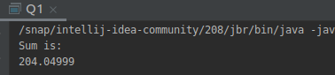
output:

2.Write a method that takes a string and returns the number of unique characters in the string.
import java.util.Collections;
import java.util.HashSet;
import java.util.LinkedHashSet;
import java.util.Set;
public class Q2 {
public static void main(String args[]) {
String str="Parineeta";
String[] chars = str.split("");
Set<String> unique = new LinkedHashSet<>();
int count=0;
for (String s : chars) {
unique.add(s);
}
System.out.println("Total number of unique Characters : "+unique.size()+ " unique Characters are: "+ unique);
}
}
output:
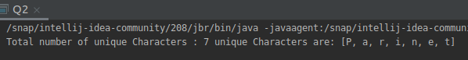

3.Write a method that takes a string and print the number of occurrence of each character characters in the string.
import java.util.HashMap;
import java.util.Map;
import java.util.Scanner;
public class Q3 {
public static void no_of_occurences(String str)
{
HashMap<Character, Integer> map = new HashMap<>();
char[] ch = str.toCharArray();
for (char c : ch) {
if (map.containsKey(c)) {
map.put(c, map.get(c) + 1);
} else {
map.put(c, 1);
}
}
for (Map.Entry entry : map.entrySet()) {
System.out.println("Key: " + entry.getKey() + " value: " + entry.getValue());
}
}
public static void main(String[] args) {
Scanner sc= new Scanner(System.in);
System.out.println("Enter the String: ");
String str=sc.nextLine();
no_of_occurences(str);
}
}
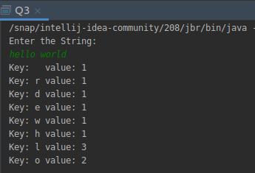

output:

4.Write a program to sort HashMap by value.
import java.util.*;
import java.util.Map.Entry;
public class Q4 {
public static void main(String[] args) {
HashMap<String, Integer> h = new HashMap<String, Integer>();
h.put("Parineeta", 23);
h.put("Ananya", 33);
h.put("Divya", 43);
h.put("Kashish", 61);
h.put("Aditi", 34);
h.put("Nidhi", 84);
Map<String, Integer> h2 = sorting(h);
for(Map.Entry<String,Integer> i: h2.entrySet())
{
System.out.println("key="+i.getKey()+" "+"Value="+i.getValue());
}
}
public static HashMap<String, Integer> sorting(HashMap<String, Integer> h) {
List<Map.Entry<String, Integer>> l = new LinkedList<Map.Entry<String, Integer>>(h.entrySet());
Collections.sort(l, new Comparator<Entry<String, Integer>>() {
@Override
public int compare(Map.Entry<String, Integer> t2, Map.Entry<String, Integer> t1) {
return (t1.getValue()).compareTo(t2.getValue());
}
});
HashMap<String,Integer> t=new LinkedHashMap<String,Integer>();
for(Map.Entry<String,Integer> i: l)
{
t.put(i.getKey(),i.getValue());
}
return t;
}
}

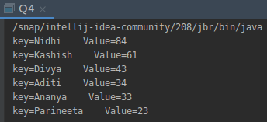
output:

5.Write a program to sort Employee objects based on highest salary using Comparator. Employee class{ Double Age; Double Salary; String Name}
import java.util.ArrayList;
import java.util.Collections;
import java.util.Comparator;
import java.util.List;
class Employee
{
double salary;
double age;
String name;
Employee(double salary,double age,String name)
{
this.salary=salary;
this.age=age;
this.name=name;
}
public double getSalary() {
return salary;
}
public void setSalary(double salary) {
this.salary = salary;
}
public double getAge() {
return age;
}
public void setAge(double age) {
this.age = age;
}
public String getName() {
return name;
}
public void setName(String name) {
this.name = name;
}
}
class compareEmployeeSalary implements Comparator<Employee>
{
@Override
public int compare(Employee e1, Employee e2) {
if(e1.getSalary()>e2.getSalary())
{
return -1;
}
else if(e1.getSalary()<e2.getSalary())
{
return 1;
}
else
{
return 0;
}
}
}
public class Q5 {
public static void main(String[] args) {
List<Employee> emp=new ArrayList<>();
emp.add(new Employee(15000.50,23,"Parineeta Jain"));
emp.add(new Employee(13500.50,24,"Mohit Chandani"));
emp.add(new Employee(12050.85,23,"Deepak Chauhan"));
emp.add(new Employee(15600.90,26,"Munish Kumar"));
emp.add(new Employee(11000.44,22,"Jai Sharma"));
Collections.sort(emp,new compareEmployeeSalary());
for(Employee emp1: emp)
{
System.out.println(emp1.getName()+" : "+ emp1.getSalary());
}
}
}
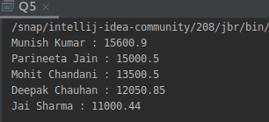

output:

6.Write a program to sort the Student objects based on Score , if the score are same then sort on First Name . Class Student{ String Name; Double Score; Double Age}
import java.util.ArrayList;
import java.util.Collections;
import java.util.Comparator;
import java.util.List;
class Student
{
double score;
double age;
String name;
Student(double score,double age,String name)
{
this.score=score;
this.age=age;
this.name=name;
}
public double getScore() {
return score;
}
public void setScore(double score) {
this.score = score;
}
public double getAge() {
return age;
}
public void setAge(double age) {
this.age = age;
}
public String getName() {
return name;
}
public void setName(String name) {
this.name = name;
}
}
class compareStudent implements Comparator<Student>
{
@Override
public int compare(Student s1, Student s2) {
if(s1.getScore()>s2.getScore())
{
return -1;
}
else if(s1.getScore()<s2.getScore())
{
return 1;
}
else
{
return s1.getName().compareTo(s2.getName());
}
}
}
public class Q6 {
public static void main(String[] args) {
List<Student> students=new ArrayList<>();
students.add(new Student(150.50,23,"Parineeta Jain"));
students.add(new Student(135.50,24,"Mohit Chandani"));
students.add(new Student(120.85,23,"Deepak Chauhan"));
students.add(new Student(150.50,26,"Munish Kumar"));
students.add(new Student(110.44,22,"Jai Sharma"));
Collections.sort(students,new compareStudent());
for(Student st1: students)
{
System.out.println(st1.getName()+" : "+ st1.getScore());
}
}
}
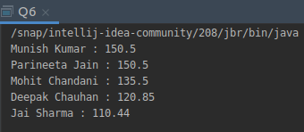

output:

7.Print the elements of an array in the decreasing frequency if 2 numbers have same frequency then print the one which came first.
import java.util.*;
public class Q7 {
public static void main(String[] args) {
int[] arr = new int[]{1,1,5,9,5,3,2,5,2,7,7};
LinkedHashMap<Integer, Integer> hashMap = new LinkedHashMap<>();
for (int i=0;i<arr.length;i++) {
if (hashMap.containsKey(arr[i])){
hashMap.put(arr[i],hashMap.get(arr[i])+1);
} else {
hashMap.put(arr[i],1);
}
}
List<Map.Entry<Integer,Integer>> list = new LinkedList<Map.Entry<Integer, Integer>>(hashMap.entrySet());
Collections.sort(list, new Comparator<Map.Entry<Integer, Integer>>() {
@Override
public int compare(Map.Entry<Integer, Integer> o1, Map.Entry<Integer, Integer> o2) {
if (o1.getValue() > o2.getValue()) {
return -1;
}
if (o2.getValue() > o1.getValue()) {
return 1;
}
return 0;
}
});
LinkedHashMap<Integer, Integer> map = new LinkedHashMap<>();
for(Map.Entry<Integer,Integer> entry:list) {
map.put(entry.getKey(),entry.getValue());
}
for(Map.Entry<Integer,Integer> entry: map.entrySet()) {
System.out.println("Value: "+entry.getKey() + " Frequency: " + entry.getValue());
}
}
}
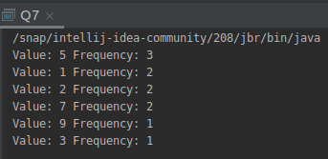

output:

8.Design a Data Structure SpecialStack that supports all the stack operations like push(), pop(), isEmpty(), isFull() and an additional operation getMin() which should return minimum element from the SpecialStack. (Expected complexity O(1))
class SpecialStack {
private int array[];
private static int top;
private int capacity;
int currentMinimumElement;
public SpecialStack(int size) {
array = new int[size];
capacity = size;
top =-1;
}
static boolean isEmpty() {
if (top == -1) {
System.out.println("SpecialStack is empty");
return true;
}
return false;
}
void isFull() {
if (top == capacity - 1) {
System.out.println("SpecialStack is full");
}
}
void getMin() {
if (isEmpty()) {
System.out.println("SpecialStack is empty");
} else {
System.out.println("Current Min element is " + currentMinimumElement);
}
}
void pop() {
if (isEmpty()) {
System.out.println("SpecialStack is empty");
return;
}
System.out.print("Top element popped ");
int top1 = array[top--];
if (top1 < currentMinimumElement) {
System.out.println(currentMinimumElement);
currentMinimumElement = currentMinimumElement*2 -top1;
}
else {
System.out.print(top1);
}
}
void push(int element) {
if (isEmpty()) {
currentMinimumElement = element;
array[++top] = element;
System.out.println(element + " is inserted");
return;
}
if (element < currentMinimumElement) {
array[++top] = 2*element - currentMinimumElement;
currentMinimumElement = element;
}
else {
array[++top] = element;
}
System.out.println(element + " is inserted");
}
}
public class Q8{
public static void main(String[] args) {
SpecialStack specialStack = new SpecialStack(10);
specialStack.push(33);
specialStack.push(53);
specialStack.getMin();
specialStack.push(21);
specialStack.push(11);
specialStack.getMin();
specialStack.pop();
specialStack.getMin();
specialStack.pop();
}
}

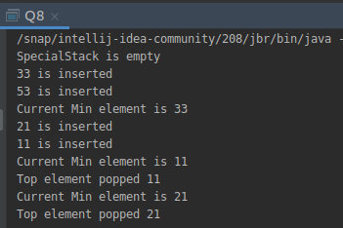
output:

