1. Create Java classes having suitable attributes for Library management system.Use OOPs concepts in your design.Also try to use interfaces and abstract classes.
import java.util.Date;
public class book {
private String ISBN;
private String title;
private String publisher;
private String authors;
private double price;
private Date dueDate;
public Date getDueDate() {
return dueDate;
}
public void setDueDate(Date dueDate) {
this.dueDate = dueDate;
}
public String getISBN() {
return ISBN;
}
public void setISBN(String ISBN) {
this.ISBN = ISBN;
}
public String getTitle() {
return title;
}
public void setTitle(String title) {
this.title = title;
}
public String getPublisher() {
return publisher;
}
public void setPublisher(String publisher) {
this.publisher = publisher;
}
public String getAuthors() {
return authors;
}
public void setAuthors(String authors) {
this.authors = authors;
}
public double getPrice() {
return price;
}
public void setPrice(double price) {
this.price = price;
}
}
import java.util.Date;
abstract class Login {
private String id;
private String password;
public String getId() {
return id;
}
public void setId(String id) {
this.id = id;
}
public String getPassword() {
return password;
}
public void setPassword(String password) {
this.password = password;
}
Login(String id,String password)
{
this.id=id;
this.password=password;
}
}
class librarian extends Login
{
librarian(String id, String password) {
super(id, password);
}
public void addBookItem(String bookItem)
{
//function to add books in the library
}
public void issueBook(String bookItem)
{
//function to issue books to member
}
public void calculateFine(Date duedate)
{
//function to issue fine for books returned after due date
}
}
class member extends Login
{
private Date dateOfMembership;
private int totalBooks;
member(String id, String password) {
super(id, password);
}
public void searchBook(String bookItem)
{
//member searches for book hhe wants to issue
}
public void requestBook(String bookItem)
{
//issue book from librarian
}
public void returnBook(String bookItem)
{
//return book to librarian
}
}
public class q1 {
public static void main(String[] args) {
book bookitem=new book();
member m=new member("pari","pari");
librarian lib=new librarian("abc","abc");
lib.addBookItem(bookitem.getTitle());
m.searchBook(bookitem.getTitle());
m.requestBook(bookitem.getTitle());
lib.issueBook(bookitem.getTitle());
m.returnBook(bookitem.getTitle());
lib.calculateFine(bookitem.getDueDate());
}
}
2. WAP to sorting string without using string Methods?.
public class q2 {
public static void main(String[] args) {
String str="parineeta";
char[] c=str.toCharArray();
char temp;
for (int i=0;i<c.length;i++)
{
for (int j=0;j<c.length;j++)
{
if(c[j]>c[i])
{
temp=c[i];
c[i]=c[j];
c[j]=temp;
}
}
}
for (int k = 0; k < c.length; k++)
{
System.out.println(c[k]);
}
}}
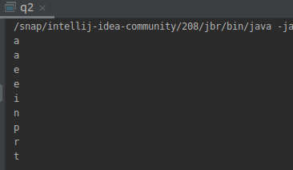
output:

3. WAP to produce NoClassDefFoundError and ClassNotFoundException exception.
public class q3 {
public static void main(String[] args) {
try
{
Class.forName("abc");
}
catch (ClassNotFoundException ex)
{
ex.printStackTrace();
}
}
}

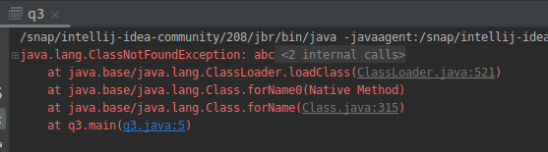
output:

class test1{
void welcome()
{
System.out.println("hello");
}
}
public class q3i {
public static void main(String[] args) {
test1 t =new test1();
t.welcome();
}
}
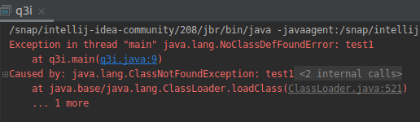
output:

4. WAP to create singleton class.
class Singleton {
private static Singleton singleton;
private Singleton() { }
public static Singleton getInstance( ) {
if(singleton==null)
{
System.out.println("object created");
singleton= new Singleton();
}
return singleton;
}
protected static void welcome( ) {
System.out.println("Hello from singleton class");
}
}
public class q4 {
public static void main(String[] args) {
Singleton tmp = Singleton.getInstance( );
Singleton tmp1= Singleton.getInstance();
tmp1.welcome();
tmp.welcome( );
}
}
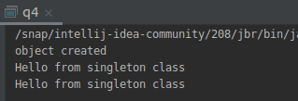
output:

5. WAP to show object cloning in java using cloneable and copy constructor both.
class cloning implements Cloneable{
int i,j;
@Override
public String toString() {
return "cloning{" +
"i=" + i +
", j=" + j +
'}';
}
@Override
public Object clone() throws CloneNotSupportedException{
return super.clone();
}
}
public class q5i {
public static void main(String[] args) throws CloneNotSupportedException {
cloning c=new cloning();
c.i=10;
c.j=15;
cloning c1=(cloning)c.clone();
c1.i=20;
System.out.println("value of i and j before cloning: "+c);
System.out.println("value of i and j after cloning: "+c1);
}
}
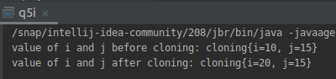
output:

public class q5 {
int a,b,copy_a,copy_b;
q5(){
a=3;
b=5;
}
q5(q5 q)
{
copy_a=q.a;
copy_b=q.b;
}
public static void main(String[] args) {
q5 obj=new q5();
q5 obj1=new q5(obj);
System.out.println("Value of obj: ");
System.out.println("a: "+obj.a+" & b: "+obj.b);
System.out.println("Value of obj1: ");
System.out.println("a: "+obj1.copy_a+" & b: "+obj1.copy_b);
}
}
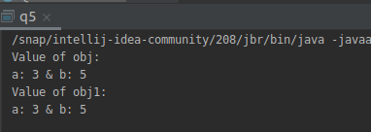

output:

6. WAP showing try, multi-catch and finally blocks.
public class q6{
public static void main(String[] args) {
try{
int[] a=new int[5];
a[5]=30/0;
}
catch(ArithmeticException e)
{
System.out.println("Arithmetic Exception occurred");
}
catch(ArrayIndexOutOfBoundsException e)
{
System.out.println("ArrayIndexOutOfBounds Exception occurred");
}
catch(Exception e)
{
System.out.println("Main Exception catch block");
}
finally {
System.out.println("Inside finally block");
}
}
}
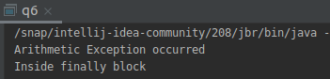
output:

7. WAP to convert seconds into days, hours, minutes and seconds.
import java.util.Scanner;
import java.util.concurrent.TimeUnit;
public class q7
{
public static void main(String[] args) {
Scanner sc=new Scanner(System.in);
System.out.println("Enter time in Seconds: ");
long seconds=sc.nextLong();
System.out.println("Time in Seconds: "+seconds);
TimeUnit time= TimeUnit.SECONDS;
long hours=time.toHours(seconds);
long days=time.toDays(seconds);
long minutes=time.toMinutes(seconds);
System.out.println("Time is Days: "+days+" , Hours: "+hours+" , Minutes: "+minutes);
}
}
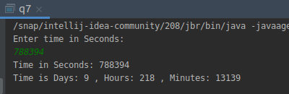
output:

8. WAP to read words from the keyboard until the word done is entered. For each word except done, report whether its first character is equal to its last character. For the required loop, use a
a)while statement
b)do-while statement
import java.util.Scanner;
public class q8 {
public static void main(String[] args) {
Scanner sc=new Scanner(System.in);
System.out.println("*******Using WHILE LOOP********");
System.out.println("Enter the word: ");
String str=sc.next();
while(!str.equals("done"))
{
if(str.charAt(0)==str.charAt(str.length()-1))
{
System.out.println("First and Last character of the word matched!");
}
else
{
System.out.println("First and Last character of the word do not match!");
}
System.out.println("Enter another word: ");
str=sc.next();
}
System.out.println("*******Using DO-WHILE LOOP********");
do {
if(str.charAt(0)==str.charAt(str.length()-1))
{
System.out.println("First and Last character of the word matched!");
}
else
{
System.out.println("First and Last character of the word do not match!");
}
System.out.println("Enter another word: ");
str=sc.next();
}while(!str.equals("done"));
}
}

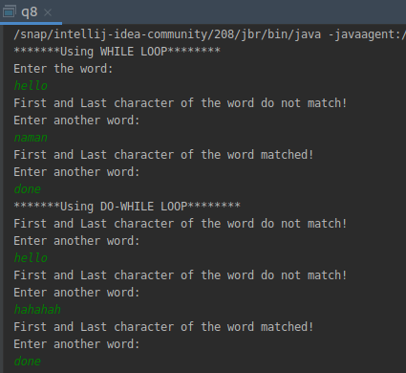

output:

9. Design classes having attributes for furniture where there are wooden chairs and tables, metal chairs and tables. There are stress and fire tests for each products.
import java.util.Scanner;
interface Furniture {
public void stressTest();
public void fireTest();
}
abstract class Chair implements Furniture
{
public abstract String chairType();
}
abstract class Table implements Furniture
{
public abstract String tableType();
}
class MetalTable extends Table {
@Override
public void stressTest()
{
System.out.println("Passed Stress Test");
}
@Override
public void fireTest()
{
System.out.println("Passed Fire Test");
}
@Override
public String tableType()
{
String s = "This is a metal Table";
return s;
}
}
class WoodenTable extends Table {
@Override
public void stressTest()
{
System.out.println("Failed Stress Test");
}
@Override
public void fireTest()
{
System.out.println("Failed Fire Test");
}
@Override
public String tableType()
{
String s = "This is a wooden Table";
return s;
}
}
class MetalChair extends Chair {
@Override
public void stressTest()
{
System.out.println("Passed Stress Test");
}
@Override
public void fireTest()
{
System.out.println("Passed Stress Test");
}
@Override
public String chairType()
{
String s = "This is a metal Chair";
return s;
}
}
class WoodenChair extends Chair {
@Override
public void stressTest()
{
System.out.println("Failed Stress Test");
}
@Override
public void fireTest()
{
System.out.println("Failed fire Test");
}
@Override
public String chairType()
{
String s = "This is a wooden chair";
return s;
}
}
public class q9
{
public static void main(String[] args) throws NullPointerException
{
Table table = null;
System.out.println("Enter the type of table you want: (wooden/metal): ");
Scanner input = new Scanner(System.in);
String str = input.next();
if(str.equals("wooden")){
table = new WoodenTable();
} else if (str.equals("metal")){
table = new MetalTable();
}
System.out.println(table.tableType());
table.stressTest();
table.fireTest();
Chair chair =null;
System.out.println("Enter the type of chair you want: (wooden/metal): ");
Scanner input1 = new Scanner(System.in);
String str1 = input.next();
if(str1.equals("wooden")){
chair = new WoodenChair();
} else if (str1.equals("metal")){
chair = new MetalChair();
}
System.out.println(chair.chairType());
chair.stressTest();
chair.fireTest();
}
}
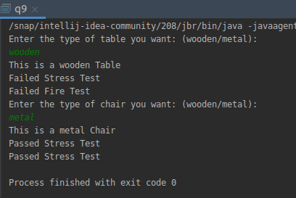

output:

10. Design classes having attributes and method(only skeleton) for a coffee shop. There are three different actors in our scenario and i have listed the different actions they do also below
* Customer
- Pays the cash to the cashier and places his order, get a token number back
- Waits for the intimation that order for his token is ready
- Upon intimation/notification he collects the coffee and enjoys his drink
( Assumption: Customer waits till the coffee is done, he wont timeout and cancel the order. Customer always likes the drink served. Exceptions like he not liking his coffee, he getting wrong coffee are not considered to keep the design simple.)
* Cashier
- Takes an order and payment from the customer
- Upon payment, creates an order and places it into the order queue
- Intimates the customer that he has to wait for his token and gives him his token
( Assumption: Token returned to the customer is the order id. Order queue is unlimited. With a simple modification, we can design for a limited queue size)
* Barista
- Gets the next order from the queue
- Prepares the coffee
- Places the coffee in the completed order queue
- Places a notification that order for token is ready
public class customer {
int tokenID;
int phoneNo;
String customer_name;
customer(String customer_name, int phoneNo)
{
this.customer_name=customer_name;
this.phoneNo=phoneNo;
}
public int getTokenID() {
return tokenID;
}
public void setTokenID(int tokenID) {
this.tokenID = tokenID;
}
public int getPhoneNo() {
return phoneNo;
}
public void setPhoneNo(int phoneNo) {
this.phoneNo = phoneNo;
}
public String getCustomer_name() {
return customer_name;
}
public void setCustomer_name(String customer_name) {
this.customer_name = customer_name;
}
public void placeOrder(String customer_name)
{
//customer places order
}
public void checkOrderStatus(int tokenID)
{
//customer can check his order status
}
public void payOrder(int tokenID)
{
//customer pays for his order
}
public void takeOrder(int tokenID)
{
//customer takes his order
}
}
public class cashier {
int cashier_ID;
String cashier_name;
public int getCashier_ID() {
return cashier_ID;
}
public void setCashier_ID(int cashier_ID) {
this.cashier_ID = cashier_ID;
}
public String getCashier_name() {
return cashier_name;
}
public void setCashier_name(String cashier_name) {
this.cashier_name = cashier_name;
}
public void getOrder(String name)
{
//cashier takes the order
}
public void getPayment(int tokeno)
{
//cashier takes order payment
}
public void addOrderToPendingQueue(int tokeno)
{
//cashier adds the order to the pending order queue
}
public void giveTokenID(int tokeno)
{
//cashier gives token ID to customer
}
}
public class Barista {
public void getOrder(int tokenID)
{
//Barista takes order from the customer
}
public void prepareOrder(int tokenID)
{
//Barista prepares the coffee
}
public void completeOrderQueue(int tokenID)
{
//Places the order in completed order queue
}
public void pushNotification(String Customer_name)
{
//Places a notification that the order is ready.
}
}
public class q10 {
public static void main(String[] args) {
customer cust=new customer("Parineeta",3697474);
cashier cash=new cashier();
Barista barista=new Barista();
cust.placeOrder(cust.getCustomer_name());
cash.getOrder(cust.getCustomer_name());
cash.giveTokenID(cust.getTokenID());
cust.payOrder(cust.getTokenID());
cash.getPayment(cust.getTokenID());
barista.getOrder(cust.getTokenID());
cash.addOrderToPendingQueue(cust.getTokenID());
cust.checkOrderStatus(cust.getTokenID());
barista.prepareOrder(cust.getTokenID());
barista.pushNotification(cust.getCustomer_name());
cust.takeOrder(cust.getTokenID());
barista.completeOrderQueue(cust.getTokenID());
}
}

11. Convert the following code so that it uses nested while statements instead of for statements:
int s = 0;
int t = 1
for (int i = 0; i < 10; i++)
{
s = s + i;
for (int j = i; j > 0; j−−)
{
t = t * (j - i);
}
s = s * t;
System.out.println("T is " + t);
}
System.out.println("S is " + s);
public class q11 {
public static void main(String[] args) {
int i=0,j;
int s = 0;
int t = 1;
while(i<10) {
s = s + i;
j=i;
while(j>0)
{
t = t * (j - i);
j--;
}
s = s * t;
System.out.println("T is " + t);
i++;
}
System.out.println("S is " + s);
}
}
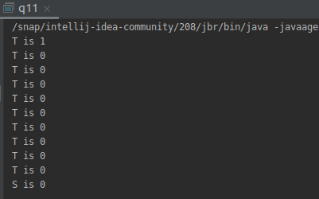
output:

12.What will be the output on new Child(); ?
class Parent extends Grandparent {
{
System.out.println("instance - parent");
}
public Parent() {
System.out.println("constructor-parent”);
}
static {
System.out.println("static - parent");
}
}
class Grandparent {
static {
System.out.println("static - grandparent");
}
{
System.out.println("instance - grandparent");
}
public Grandparent() {
System.out.println("constructor-Grandparent”);
}
}
class Child extends Parent {
public Child() {
System.out.println("constructor-child”);
}
static {
System.out.println("static - child");
}
{
System.out.println("instance - child");
}
}
class q12{
public static void main(String[] args) {
Grandparent gp=new Child();
System.out.println("*****************");

Parent p=new Child();
System.out.println("*****************");
Child c=new Child();

}
}

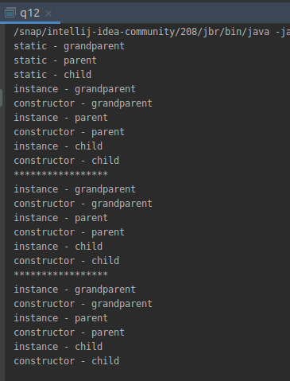
output:

Q13. Create a custom exception that do not have any stack trace.
class StringNotFoundException extends Exception
{
public StringNotFoundException(String s)
{
super(s);
}
}
public class q13
{
public static void main(String args[])
{
try
{
throw new StringNotFoundException("github");
}
catch (StringNotFoundException ex)
{
System.out.println("Caught exception");
System.out.println(ex.getMessage());
}
}
}
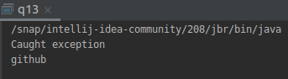
output:

