1.Write a program to demonstrate the use of volatile keyword.
class threadEx extends Thread
{
private volatile int counter = 0;
public void run()
{
System.out.println("Inside run method.Thread running..");
}
public void increaseCounter()
{
++counter;
System.out.println("Counter is: "+counter);
}
}
public class mq2
{
public static void main(String[] args) throws InterruptedException {
threadEx t1=new threadEx();
t1.start();
t1.increaseCounter();
}
}
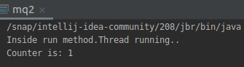
output:

2.Write a program to create a thread using Thread class and Runnable interface each.
class threadExample extends Thread
{
public void run()
{
System.out.println("Inside run method.Thread running..");
}
}
public class mq1
{
public static void main(String[] args) {
threadExample t1=new threadExample();
t1.start();
}
}
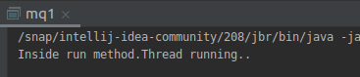
output:

class threadExample implements Runnable
{
public void run()
{
System.out.println("Inside run method.Thread running..");
}
}
public class mq1
{
public static void main(String[] args) {
threadExample te=new threadExample();
Thread t1=new Thread(te);
t1.start();
}
}
output:

3.Write a program using synchronization block and synchronization method.
import static java.lang.Thread.sleep;
class increment
{
private int count=0;
synchronized void increment() throws InterruptedException {
sleep(1000);
++count;
System.out.println("count: "+count);
}
}
class thread1 extends Thread
{
increment inc;
thread1(increment inc){
this.inc=inc;
}
public void run()
{
for(int i=0;i<5;i++) {
try {
inc.increment();
} catch (InterruptedException e) {
e.printStackTrace();
}
}
}
}
class thread2 extends Thread
{
increment inc;
thread2(increment inc){
this.inc=inc;
}
public void run()
{
for(int i=0;i<5;i++) {
try {
inc.increment();
} catch (InterruptedException e) {
e.printStackTrace();
}
}
}
}
public class mq3 {
public static void main(String[] args) throws InterruptedException {
increment in=new increment();
thread1 t1=new thread1(in);
thread2 t2=new thread2(in);
t1.start();
t2.start();
}
}
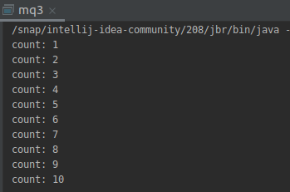

output:

import static java.lang.Thread.sleep;
class increment
{
private int count=0;
void increment() throws InterruptedException {
synchronized(this){
sleep(1000);
++count;
System.out.println("count: "+count);
}
}
}
class thread1 extends Thread
{
increment inc;
thread1(increment inc){
this.inc=inc;
}
public void run()
{
for(int i=0;i<5;i++) {
try {
inc.increment();
} catch (InterruptedException e) {
e.printStackTrace();
}
}
}
}
class thread2 extends Thread
{
increment inc;
thread2(increment inc){
this.inc=inc;
}
public void run()
{
for(int i=0;i<5;i++) {
try {
inc.increment();
} catch (InterruptedException e) {
e.printStackTrace();
}
}
}
}
public class mq3 {
public static void main(String[] args) throws InterruptedException {
increment in=new increment();
thread1 t1=new thread1(in);
thread2 t2=new thread2(in);
t1.start();
t2.start();
}
}

output:

4.Write a program to create a Thread pool of 2 threads where one Thread will print even numbers and other will print odd numbers.
import java.util.concurrent.ExecutorService;
import java.util.concurrent.Executors;
class evenThread implements Runnable{
public void run()
{
System.out.println("*************");
for(int i=0;i<20;i++)
{
if(i%2==0)
{
System.out.println(i);
}
}
}
}
class oddThread implements Runnable{
@Override
public void run() {
for(int j=0;j<20;j++)
{
if(j%2!=0)
{
System.out.println(j);
}
}
}
}
public class Q4
{
public static void main(String[] args) {
ExecutorService pool;
pool = Executors.newFixedThreadPool(2);
Runnable r1=new oddThread();
Runnable r2=new evenThread();
pool.execute(r1);
pool.execute(r2);
pool.shutdown();
}
}

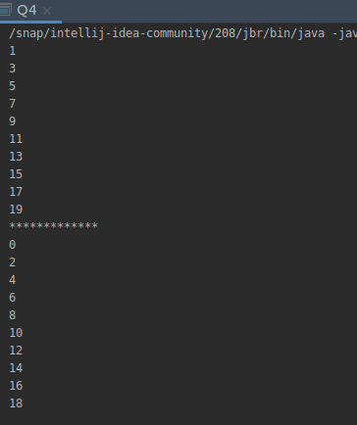
output:

5.Write a program to demonstrate wait and notify methods.
class Numbers
{
public void even() throws InterruptedException {
System.out.println("Entered into even function ...");
synchronized (this) {
for (int i = 1; i < 5; i++) {
System.out.println(2 * i);
wait(200);
}
}
System.out.println("resumed..");
}
public void odd() throws InterruptedException {
Thread.sleep(30);
synchronized (this){
System.out.println("Entered into odd function...");
for (int i=1;i<5;i++)
{
System.out.println(2*i-1);
}
System.out.println("completed");
notify();
}
}
}
public class mq5 {
public static void main(String[] args) throws InterruptedException {
Numbers numbers = new Numbers();
Thread t1=new Thread(new Runnable() {
@Override
public void run() {
try {
numbers.even();
} catch (InterruptedException e) {
e.printStackTrace();
}
}
});
Thread t2=new Thread(new Runnable() {
@Override
public void run() {
try {
numbers.odd();
} catch (InterruptedException e) {
e.printStackTrace();
}
}
});
t1.start();
t2.start();
}
}

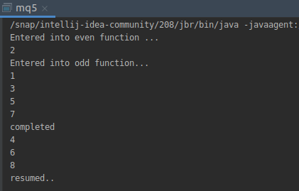
output:

6.Write a program to demonstrate sleep and join methods.
import static java.lang.Thread.sleep;
class increment
{
private int count=0;
void increment() throws InterruptedException {
synchronized(this){
++count;
System.out.println("count: "+count);
}
}
}
class thread1 extends Thread
{
increment inc;
thread1(increment inc){
this.inc=inc;
}
public void run()
{
for(int i=0;i<5;i++) {
try {
inc.increment();
} catch (InterruptedException e) {
e.printStackTrace();
}
}
}
}
class thread2 extends Thread
{
increment inc;
thread2(increment inc){
this.inc=inc;
}
public void run()
{
for(int i=0;i<5;i++) {
try {
Thread.sleep(500);
inc.increment();
} catch (InterruptedException e) {
e.printStackTrace();
}
}
}
}
public class mq3 {
public static void main(String[] args) throws InterruptedException {
increment in=new increment();
thread1 t1=new thread1(in);
thread2 t2=new thread2(in);
t1.start();
t1.join();
t2.start();
t2.join();
}
}

output:

7.Run a task with the help of callable and store it's result in the Future.
import java.util.concurrent.*;
class CallableImpl implements Callable<Integer> {
private int myName;
CallableImpl(int i) {
myName = i;
}
@Override
public Integer call() {
for (int i = 0; i < 10; i++) {
System.out.println("Thread : " + getMyName() + " value is : " + i);
}
return getMyName();
}
public int getMyName() {
return myName;
}
public void setMyName(int myName) {
this.myName = myName;
}
}
public class mq7 {
public static void main(String[] args) throws InterruptedException {
Callable<Integer> callable = new CallableImpl(2);
ExecutorService executor = new ScheduledThreadPoolExecutor(1);
Future<Integer> future = executor.submit(callable);
try {
System.out.println("Future value: " + future.get());
} catch (Exception ignored) {}
executor.shutdown();
executor.awaitTermination(1, TimeUnit.HOURS);
}
}
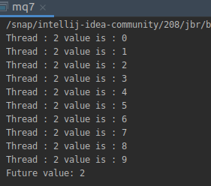

output:

8.Write a program to demonstrate the use of semaphore
import java.util.concurrent.ExecutorService;
import java.util.concurrent.Executors;
import java.util.concurrent.TimeUnit;
import java.util.concurrent.Semaphore;
class Connection {
private static Connection instance = new Connection();
private Semaphore sem = new Semaphore(5, true);
private int connections = 0;
private Connection() {
}
public static Connection getInstance() {
return instance;
}
public void connect() {
try {
sem.acquire();
doConnect();
} catch (InterruptedException ignored) {
} finally {
sem.release();
}
}
public void doConnect() {
synchronized (this) {
connections++;
System.out.println("Current connections (max 10 allowed): " + connections);
}
try {
System.out.println("Working on connections " + Thread.currentThread().getName());
Thread.sleep(2000);
} catch (InterruptedException ignored) {}
synchronized (this) {
connections--;
System.out.println("I'm done " + Thread.currentThread().getName() + " Connection is released , connection count: " + connections);
}
}
}
class Connect {
private static Connect instance = new Connect();
private Semaphore sem = new Semaphore(5, true);
private Connect() {
}
public static Connect getInstance() {
return instance;
}
public void connect() {
try {
sem.acquire();
System.out.printf("%s:: Current connections (max 10 allowed): %d\n",
Thread.currentThread().getName(),
sem.availablePermits());
System.out.printf("%s:: WORKING...\n",
Thread.currentThread().getName());
Thread.sleep(2000);
System.out.printf("%s:: Connection released. Permits Left = %d\n",
Thread.currentThread().getName(),
sem.availablePermits());
} catch (InterruptedException ignored) {
} finally {
sem.release();
}
}
}
public class mq8 {
public static void main(String[] args) throws Exception {
ExecutorService executor = Executors.newCachedThreadPool();
for (int i = 0; i < 5; i++) { //200 hundred times will be called
executor.submit(new Runnable() {
public void run() {
Connect.getInstance().connect();
}
});
}
executor.shutdown();
executor.awaitTermination(1, TimeUnit.DAYS);
}
}
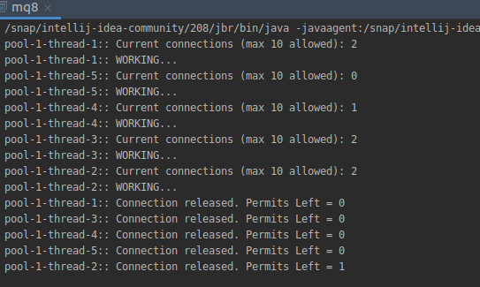
output:

9.Write a program to demonstrate the use of CountDownLatch
import java.util.concurrent.CountDownLatch;
import java.util.concurrent.ExecutorService;
import java.util.concurrent.Executors;
class Processor implements Runnable {
private CountDownLatch latch;
public Processor(CountDownLatch latch) {
this.latch = latch;
}
public void run() {
System.out.println("Started.");
try {
Thread.sleep(3000);
} catch (InterruptedException ignored) {}
latch.countDown();
}
}
public class mq9{
public static void main(String[] args) {
CountDownLatch latch = new CountDownLatch(3);
ExecutorService executor = Executors.newFixedThreadPool(3);
for (int i = 0; i < 3; i++) {
executor.submit(new Processor(latch));
}
executor.shutdown();
try {
latch.await();
} catch (InterruptedException e) {
e.printStackTrace();
}
System.out.println("Completed.");
}}

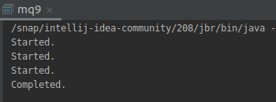
output:

10.Write a program which creates deadlock between 2 threads.
public class mq10 {
public static final Object lock1 = new Object();
public static final Object lock2 = new Object();
private int index;
public static void main(String[] args) {
Thread t1 = new Thread1();
Thread t2 = new Thread2();
t1.start();
t2.start();
}
private static class Thread1 extends Thread {
public void run() {
synchronized (lock1) {
System.out.println("Thread 1: Holding lock 1...");
try {
Thread.sleep(10);
} catch (InterruptedException ignored) {}
System.out.println("Thread 1: Waiting for lock 2...");
synchronized (lock2) {
System.out.println("Thread 2: Holding lock 1 & 2...");
}
}
}
}
private static class Thread2 extends Thread {
public void run() {
synchronized (lock2) {
System.out.println("Thread 2: Holding lock 2...");
try {
Thread.sleep(10);
} catch (InterruptedException ignored) {}
System.out.println("Thread 2: Waiting for lock 1...");
synchronized (lock1) {
System.out.println("Thread 2: Holding lock 2 & 1...");
}
}
}
}
}

output:
