- Write the following a functional interface and implement it using lambda:
(1) First number is greater than second number or not Parameter (int ,int ) Return boolean
(2) Increment the number by 1 and return incremented value Parameter (int) Return int
(3) Concatination of 2 string Parameter (String , String ) Return (String)
(4) Convert a string to uppercase and return . Parameter (String) Return (String)
//part1
interface greaterNumber
{
boolean findGreater(int a,int b);
}
//part2
interface IncrementNumber
{
int incrementNumber(int a);
}
//part3
interface ConcatString
{
String Concat(String s1,String s2);
}
//part4
interface ToUpper
{
String toUpper(String s);
}
public class Q1 {
public static void main(String[] args) {
//part1
greaterNumber gn = (int x, int y) -> {
if (x > y)
return true;
else
return false;
};
System.out.println("First Number>Second Number? : " + gn.findGreater(6, 2));
//part2
IncrementNumber in = x -> {
return x + 1;
};
System.out.println("Value after increment: " + in.incrementNumber(8));
//part3
ConcatString cs = (String s1, String s2) -> s1.concat(s2);
System.out.println("String after concatenation: " + cs.Concat("hello", "World"));
//part4
ToUpper tu = s -> {
return s.toUpperCase();
};
System.out.println("String in upper case: "+tu.toUpper("parineeta jain"));
}
}

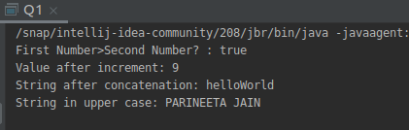
output:

- Create a functional interface whose method takes 2 integers and return one integer.
interface Number
{
int Num(int a,int b);
}
public class Q2 {
public static void main(String[] args) {
Number number=(int a,int b)->{
if(a>b)
return a;
else
return b;
};
System.out.println("Returned integer: "+number.Num(60,45));
}
}
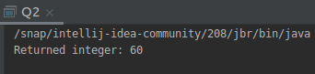
output:

- Using (instance) Method reference create and apply add and subtract method and using (Static) Method reference create and apply multiplication method for the functional interface created.
interface addNumber{
void add(int a,int b);
}
interface subtractNumber{
void subtract(int a,int b);
}
interface multiplyNumber{
void multiply(int a);
}
public class Q3 {
static void addMethod(int a,int b)
{
System.out.println("Addition: "+(a+b));
}
void subtractMethod(int a,int b)
{
System.out.println("Subtraction: "+(a-b));
}
void multiplyMethod(int a)
{
System.out.println("Multiplication: "+(a*5));
}
public static void main(String[] args) {
addNumber addNum=Q3::addMethod;
addNum.add(4,8);
subtractNumber subtractNum=new Q3()::subtractMethod;
subtractNum.subtract(20,7);
multiplyNumber multiplyNum=new Q3()::multiplyMethod;
multiplyNum.multiply(6);
}
}

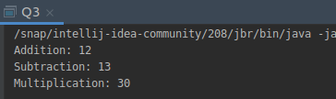
output:

- Create an Employee Class with instance variables (String) name, (Integer)age, (String)city and get the instance of the Class using constructor reference .
interface ConstRef
{
public Employee1 getEmp(int age,String name,String city);
}
class Employee1
{
private int age;
private String name;
private String city;
Employee1(int age,String name,String city)
{
this.age=age;
this.name=name;
this.city=city;
}
public int getAge() {
return age;
}
public void setAge(int age) {
this.age = age;
}
public String getName() {
return name;
}
public void setName(String name) {
this.name = name;
}
public String getCity() {
return city;
}
public void setCity(String city) {
this.city = city;
}
@Override
public String toString() {
return "Employee1{" +
"age=" + age +
", name='" + name + '\'' +
", city='" + city + '\'' +
'}';
}
}
public class Q4 {
public static void main(String[] args) {
ConstRef constRef=Employee1::new;
Employee1 e1=constRef.getEmp(23,"Parineeta","Delhi");
System.out.println(e1);
}
}

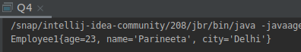
output:

- Implement following functional interfaces from java.util.function using lambdas:
(1) Consumer
(2) Supplier
(3) Predicate
(4) Function
import java.util.Arrays;
import java.util.List;
import java.util.function.Consumer;
import java.util.function.Function;
import java.util.function.Predicate;
import java.util.function.Supplier;
public class Q5 {
public static void printList(List<Integer> list1,Consumer<Integer> con)
{
for(int i: list1)
con.accept(i);
}
public static void main(String[] args) {
//part1
System.out.println("Consumer Printed: " );
Consumer<Integer> consumer=i-> System.out.println(" "+i);
List<Integer> list= Arrays.asList(2,6,7,9,5);
printList(list,consumer);
//part2
Supplier<Double> supplier=()->Math.random();
System.out.println("Supplier returned : "+supplier.get());
//part3
Predicate<Integer> predicate=i->(i>10);
System.out.println("Is number 40 more than 10?: "+predicate.test(40));
//part 4
Function<Integer,Integer> add = x -> x + 1;
Integer two = add.apply(7);
System.out.println("Function: "+two);
}

}
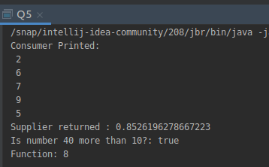
output:

- Create and access default and static method of an interface.
import javax.sound.midi.Soundbank;
interface TestInterface
{
static void square(int a)
{
System.out.println("Inside Static method!!");
System.out.println("Square is: "+a*a);
}
default void show()
{
System.out.println("Inside Default Method!!");
}
}
public class Q6 implements TestInterface{
public static void main(String[] args) {
Q6 q6=new Q6();
TestInterface.square(5);
q6.show();
}
}
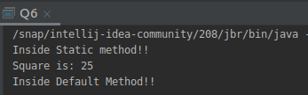
output:

- Override the default method of the interface.
interface Myinterface
{
default void show()
{
System.out.println("Default interface of interface1");
}
}
public class Q7 implements Myinterface{
public void show()
{
Myinterface.super.show();
}
public static void main(String[] args) {
Q7 q7=new Q7();
q7.show();
}
}
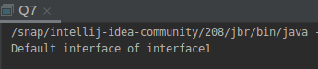
output:

- Implement multiple inheritance with default method inside interface.
interface interface1
{
default void show()
{
System.out.println("Default interface of interface1");
}
}
interface interface2
{
default void show()
{
System.out.println("Default interface of interface2");
}
}
public class Q8 implements interface1,interface2{
public void show()
{
interface1.super.show();
interface2.super.show();
}
public static void main(String[] args) {
Q8 q8=new Q8();
q8.show();
}
}

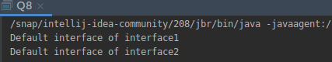
output:

- Collect all the even numbers from an integer list.
import java.util.Arrays;
import java.util.List;
import java.util.stream.Collectors;
public class Q9 {
public static void main(String[] args) {
List<Integer> list= Arrays.asList(1,2,3,3,4,5,6,8,9,12);
System.out.println(list
.stream()
.filter(e->e%2==0).collect(Collectors.toList()));
}
}
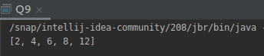
output:

- Sum all the numbers greater than 5 in the integer list.
import java.util.Arrays;
import java.util.List;
import java.util.stream.Collectors;
public class Q10 {
public static void main(String[] args) {
List<Integer> list4= Arrays.asList(1,20,3,5,10,6);
System.out.println(list4
.stream()
.filter(e->e>5)
.collect(Collectors.summingInt(e->e)));
}
}
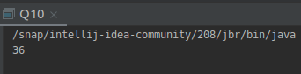
output:

- Find average of the number inside integer list after doubling it.
import java.util.Arrays;
import java.util.List;
import java.util.OptionalDouble;
public class Q11 {
public static void main(String[] args) {
List<Integer> list= Arrays.asList(1,2,4,6,8,3);
OptionalDouble op=list.stream().map(e->e*2).mapToInt(e->e).average();
System.out.println("Average is: "+op.getAsDouble());
}
}
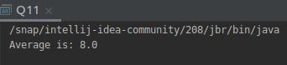
output:

- Find the first even number in the integer list which is greater than 3.
import java.util.Arrays;
import java.util.List;
import java.util.Optional;
public class Q12 {
public static void main(String[] args) {
List<Integer> list= Arrays.asList(1,2,4,6,7,2,7,1);
Optional<Integer> op= list.stream().filter((e)->e%2==0).filter((e)->e>3).findFirst();
System.out.println(op.get());
}
}
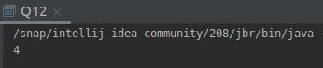
output:

