Q1. Write a program to replace a substring inside a string with other string ?

public class Q1 {
public static void main(String[] args) {
String str="Hello My Name is Parineeta Jain. I am in Android Competency.";
System.out.println(str);
String str1=str.replace("Android","JVM");
System.out.println(str1);
}
}
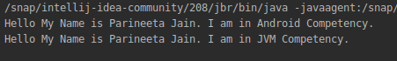
output:

Q2. Write a program to find the number of occurrences of the duplicate words in a string and print them ?

public class Q2 {
public static void main(String[] args) {
String str= "Today is monday. Monday is a boring day. Today we learnt java core 1.";
int count=0;
str=str.toLowerCase();
System.out.println(str);
String words[]=str.split( "\\s|\\. ");
System.out.println("Duplicate words are: ");
for(int i=0;i<words.length;i++)
{
count=1;
for (int j=i+1;j<words.length;j++)
{
if(words[i].equals(words[j]))
{
count++;
}
}
if(count>1)
{
System.out.println(words[i]+" : "+count);
}
}
}
}
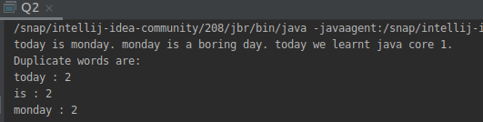

output:

Q3. Write a program to find the number of occurrences of a character in a string without using loop?
public class Q3 {
public static void main(String[] args)
{
String str = "Hello My Name is Parineeta Jain. I am in JVM Competency.";
int count = str.length() - str.replace("a", "").length();
System.out.println("Number of occurances of 'a' :"+count);
}
}

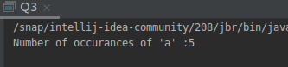
output:

Q4. Calculate the number & Percentage Of Lowercase Letters,Uppercase Letters, Digits And Other Special Characters In A String.

public class Q4 {
public static void main(String[] args) {
String str1=" My name IS Parineeta Jain. I am 23 Years Old. My EmailId is Parineeta.jain@tothenew.com";
int Upper_count=0;
int Lower_count=0;
int digit_count=0;
int special_count=0;
for(int i=0;i<str1.length();i++)
{
char[] str= str1.toCharArray();
if(str[i]>='A' && str[i]<='Z')
{
Upper_count++;
}
else if(str[i]>='a' && str[i]<='z')
{
Lower_count++;
}
else if(str[i]>='0' && str[i]<='9')
{
digit_count++;
}
else
special_count++;
}
System.out.println("Number of upper Case letters are: "+Upper_count);
System.out.println("Number of Lower Case letters are: "+Lower_count);
System.out.println("Number of digits are: "+digit_count);
System.out.println("Number of Special characters are: "+special_count);
}
}

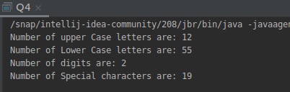

output:

Q5. Find common elements between two arrays.

public class Q5 {
public static void main(String[] args) {
int[] arr={1,2,3,4,5,6};
int[] arr1={1,4,8,9};
System.out.println("The Common elements are: ");
for(int i=0;i<arr.length;i++)
{
for (int j=0;j<arr1.length;j++)
{
if(arr[i]==arr1[j])
{
System.out.println(arr[i]);
}
}
}
}
}
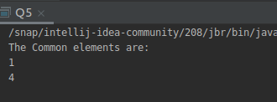

output:

Q6. There is an array with every element repeated twice except one. Find that element.

class Q6{
static int findSingle(int ar[], int ar_size)
{
int res = ar[0];
for (int i = 1; i < ar_size; i++)
res = res ^ ar[i];
return res;
}
public static void main (String[] args)
{
int arr[] = {2, 3, 5, 4, 9 ,6, 5, 3, 4, 9, 6};
int n = arr.length;
System.out.println("Element occurring once is " +
findSingle(arr, n) + " ");
}
}
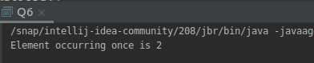

output:

Q7. Write a program to print your Firstname,LastName & age using static block,static method & static variable respectively.

public class Q7 {
// static variable
static int j = 23;
// static block
static
{
System.out.println("FirstName: Parineeta ");
}
// static method
static void n()
{
System.out.println("LastName: Jain");
}
public static void main(String[] args)
{
n();
System.out.println("Age : "+j);
}
}

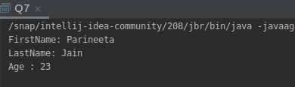
output:

Q8. Write a program to reverse a string and remove character from index 4 to index 9 from the reversed string using String Buffer.

public class Q8 {
public static void main(String[] args) {
String str="Hello World";
System.out.println("original string: "+str);
str = new StringBuffer(str).reverse().toString();
System.out.println("String after Reversing: "+str);
str= new StringBuffer(str).delete(4,10).toString();
System.out.println("String after Deletion: "+str);
}
}
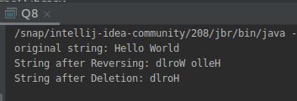

output:

Q9.Write a program to display values of enums using a constructor & getPrice() method (Example display house & their prices)

public class Q9 {
public enum houseName{
A(10000),B(20000),C(30500),D(15000),E(20500);
private int p;
houseName(int price)
{
p=price;
}
int getPrice()
{
return p;
}
}
public static void main(String[] args)
{
System.out.println("House Name : Price ");
System.out.println(houseName.A +": "+ houseName.A.getPrice()+" Rupees");
System.out.println(houseName.B +": "+ houseName.B.getPrice()+" Rupees");
System.out.println(houseName.C +": "+ houseName.C.getPrice()+" Rupees");
System.out.println(houseName.D +": "+ houseName.D.getPrice()+" Rupees");
System.out.println(houseName.E +": "+ houseName.E.getPrice()+" Rupees");
}
}

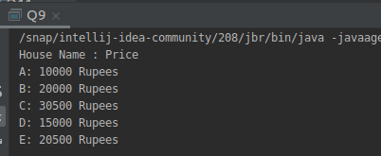

output:

Q10.Write a single program for following operation using overloading
A) Adding 2 integer number
B) Adding 2 double
C) multiplying 2 float
D) multiplying 2 int
E) concate 2 string
F) Concate 3 String

import java.util.Scanner;
public class Q10 {
public void add(int x,int y)
{
int sum=x+y;
System.out.println(sum);
}
public void add(double x, double y)
{
double sum=x+y;
System.out.println(sum);
}
public void mul(int x,int y)
{
int m=x*y;
System.out.println(m);
}
public void mul(double x,double y)
{
double m=x*y;
System.out.println(m);
}
public void concatenate(String str1,String str2)
{
String s=str1.concat(str2);
System.out.println(s);
}
public void concatenate(String str1,String str2,String str3)
{
String st=str1.concat(str2).concat(str3);
System.out.println(st);
}
public static void main(String[] args) {
Scanner sc =new Scanner(System.in);
Q10 obj=new Q10();
int a=0,b=0;
double a1=0.0,b1=0.0;
String str="",str1="",str2="";
System.out.println("1: Adding 2 integer number");
System.out.println("2: Adding 2 double number");
System.out.println("3: Multiplying 2 int number");
System.out.println("4: Multiplying 2 double number");
System.out.println("5: Concatenate 2 strings");
System.out.println("6: Concatenate 3 strings");
System.out.println("Select the operation to perform: ");
int op;
op=sc.nextInt();
if(op==1 || op==3)
{
System.out.println("Enter two numbers: ");
a=sc.nextInt();
b=sc.nextInt();
}
else if( op==2 || op==4)
{
System.out.println("Enter two numbers: ");
a1=sc.nextDouble();
b1=sc.nextDouble();
}
else if(op==5)
{
System.out.println("Enter two Strings: ");
str1=sc.next();
str2=sc.next();
}
else if(op==6)
{
System.out.println("Enter three Strings: ");
str=sc.next();
str1=sc.next();
str2=sc.next();
}
else
{
return;
}
switch (op) {
case 1:
System.out.println("The sum of two integers are: ");
obj.add(a,b);
break;
case 2:
System.out.println("The sum of two doubles are: ");
obj.add(a1,b1);
break;
case 3:
System.out.println("The multiplication of two integers are: ");
obj.mul(a,b);
break;
case 4:
System.out.println("The multiplication of two doubles are: ");
obj.mul(a1,b1);
break;
case 5:
System.out.println("The concatenation of two strings are: ");
obj.concatenate(str1, str2);
break;
case 6:
System.out.println("The concatenation of three strings are: ");
obj.concatenate(str, str1, str2);
break;
default:
System.out.println("Please Enter correct operation Number");
}
}
}

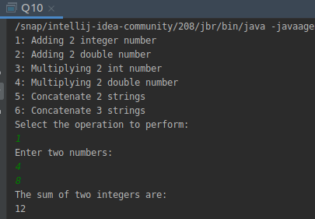
output:

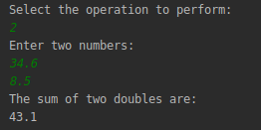
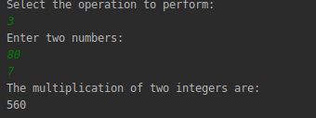

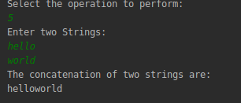
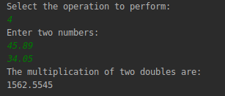

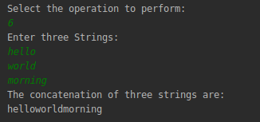

Q11.Create 3 sub class of bank SBI,BOI,ICICI all 4 should have method called getDetails which provide there specific details like rateofinterest etc,print details of every banks.

abstract class bank{
double rate_of_interest;
String BranchName;
String IFSC_Code;
public abstract void getDetails();
}
class SBI extends bank {
public void getDetails()
{
rate_of_interest=4.44;
BranchName="Noida Sector-144";
IFSC_Code="SBI144";
System.out.println("SBI Bank Details:");
System.out.println("Rate Of Interest: "+rate_of_interest);
System.out.println("Branch Name: "+BranchName);
System.out.println("IFSC_code"+IFSC_Code);
}
}
class BOI extends bank {
public void getDetails()
{
rate_of_interest=3.6;
BranchName="Noida Sector-18";
IFSC_Code="BOI18";
System.out.println("*****************************");
System.out.println("BOI Bank Details:");
System.out.println("Rate Of Interest: "+rate_of_interest);
System.out.println("Branch Name: "+BranchName);
System.out.println("IFSC_code"+IFSC_Code);
}
}
class ICICI extends bank {
public void getDetails()
{
rate_of_interest=2.5;
BranchName="Noida Sector-132";
IFSC_Code="ICICI132";
System.out.println("*****************************");
System.out.println("ICICI Bank Details:");
System.out.println("Rate Of Interest: "+rate_of_interest);
System.out.println("Branch Name: "+BranchName);
System.out.println("IFSC_code"+IFSC_Code);
}
}
public class Q11{
public static void main(String args[])
{
bank obj=new SBI();
obj.getDetails();
bank obj1=new BOI();
obj1.getDetails();
bank obj2=new ICICI();
obj2.getDetails();
}
}
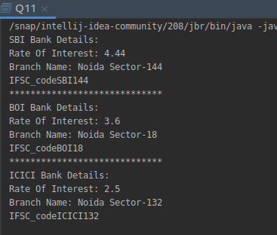
output:

