Project 26: Bandwidth Meter and Traffic Analyzer
Recorded Results and Graphs

1. Purpose
This document presents graphs generated from the available sender log files and flow-statistics CSV. It provides a visual summary of recorded sender throughput, transmitted payload, and byte-counter deltas grouped by switch.

2. Sender test summary
Test ID | Target (Mbps) | Final packets | Final payload (MB) | Mean interval (Mbps) | Drops / errors
1 | 5.0 | 6,250 | 6.25 | 5.000 | 0 / 0
2 | 5.0 | 6,250 | 6.25 | 5.000 | 0 / 0
3 | 5.0 | 6,250 | 6.25 | 4.766 | 0 / 0
5 | 5.0 | 6,250 | 6.25 | 5.209 | 0 / 0
Interpretation: The available sender logs show approximately 6.25 MB of payload across 6,250 packets per test, with a configured target of 5 Mbps. The measured mean interval rate varies slightly between tests.

3. Graph 1: Recorded network traffic by switch
This bar chart sums the recorded delta_bytes values in the available flowstats.csv, grouped by switch. It visualizes the counters recorded in the CSV and should not be interpreted as a verified end-to-end throughput comparison.
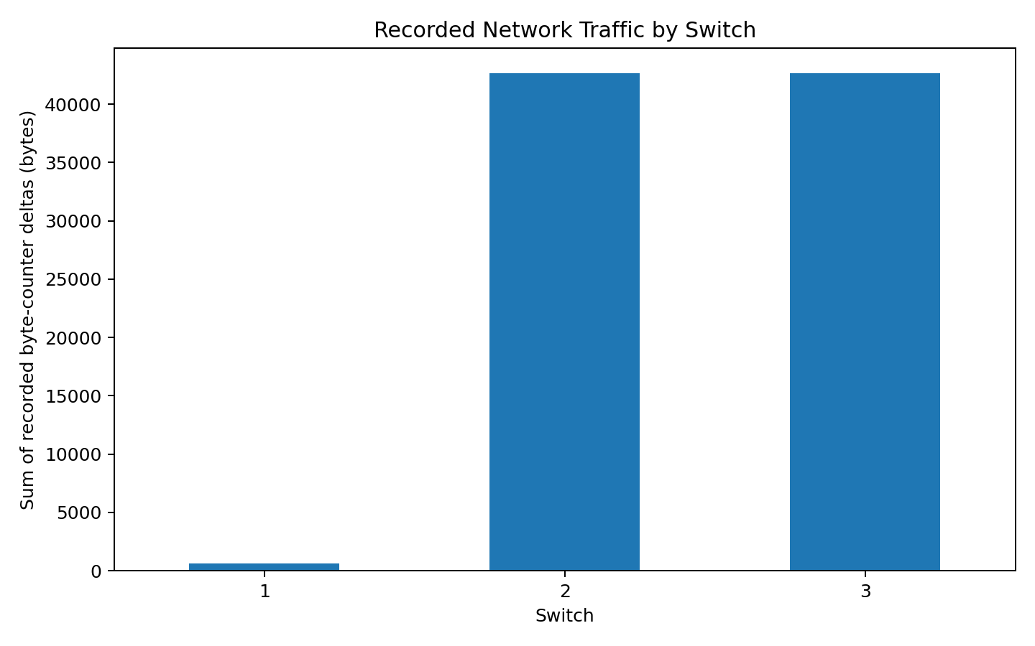

4. Graph 2: Sender throughput over time
This line chart plots interval_mbps from sender tests 1, 2, 3 and 5 against elapsed time. The dashed horizontal line represents the 5 Mbps target.
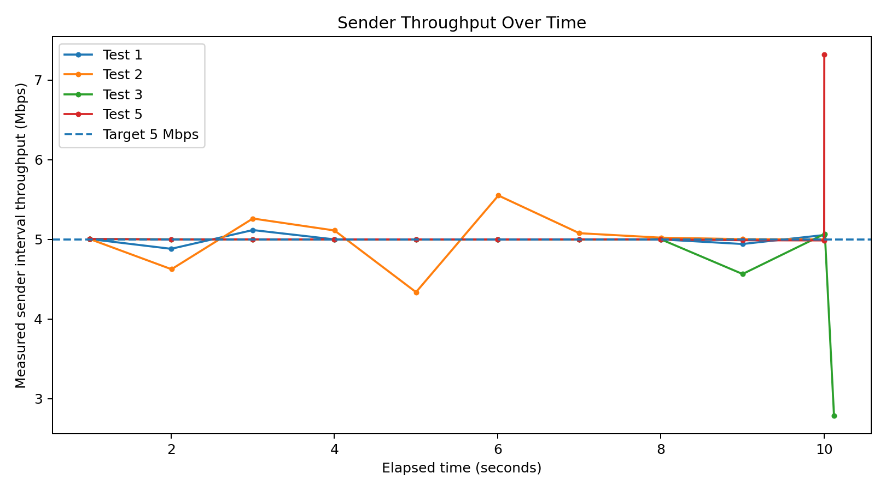

5. Graph 3: Total sender payload by test
This chart compares the maximum cumulative tx_bytes recorded for each available sender test, expressed in megabytes.
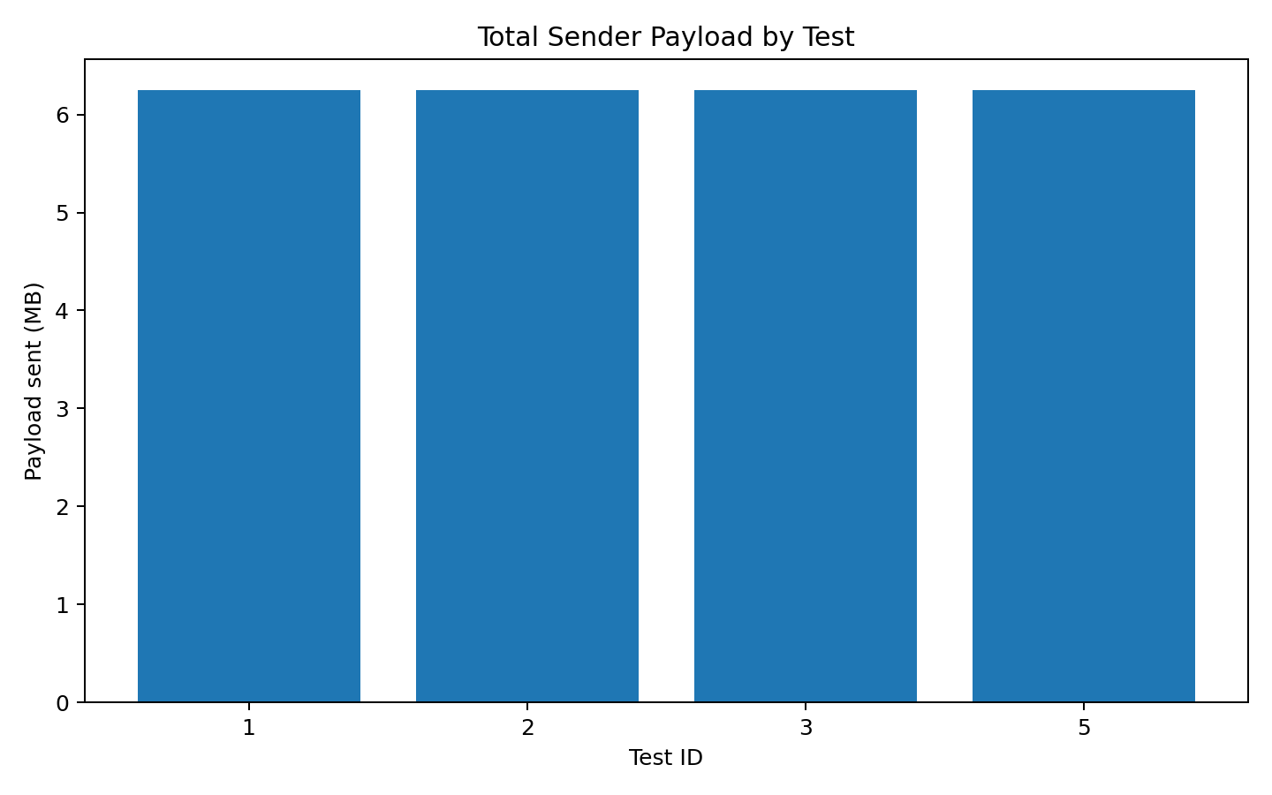

6. Data limitations and next validation
No receiver CSV files were available in the supplied results. Therefore, receiver-side packet counts, measured packet loss, and a complete application-versus-network comparison cannot be confirmed from these files alone. The controller_events.csv file was present but empty (0 bytes) in the previously inspected project results, so controller test_start/test_end logging also remains unverified.
For a complete end-to-end comparison, collect receiver logs and a flowstats.csv covering the same test interval, then compare sender packet/byte totals, receiver packet/byte totals, and switch counter deltas for the matching test.

7. Files included
The three graph images are also available separately in the accompanying Project26_Graphs.zip package. Place this Word document and/or the graph images in the project's docs folder as needed.

