**Solution Sheet**

1. Which model have you used for probability prediction? Explain your model.

The model that is used for prediction are

1.RandomForestRegressor: Output of random forests is the majority vote by a large number of independent decision trees. So by varying the parameter and getting to preferred value of n_estimators of about 170 and a random state of 20.

2.XGBoost: It’s a library of gradient boosting ,it will scales our result.

3.Pipelined model of ElasticNet, RandomForest, Lasso, GradientBoosting, LGBMRegressor:

In this ensemble all the models are pipelined together and given to the Average Model Function

Which will use column stack and gives back the average.

Final result fraction of each of these is taken

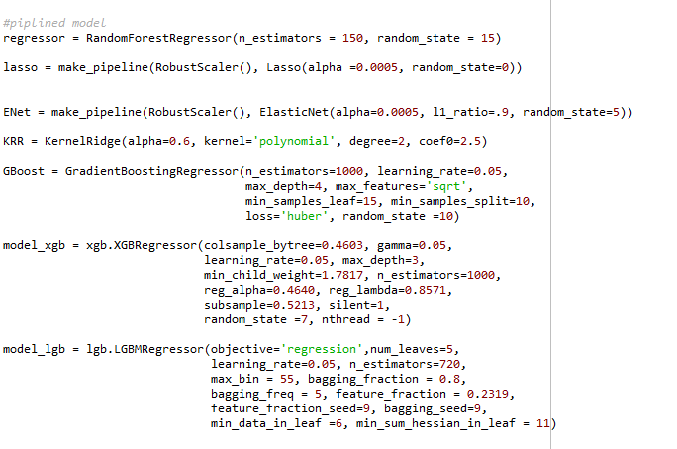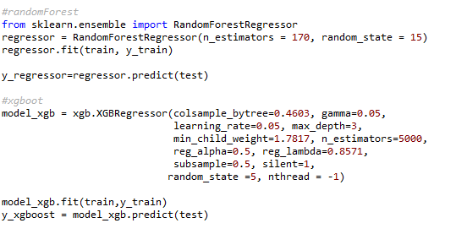

Model with parameters

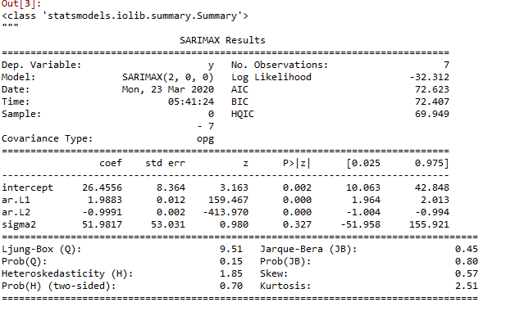

AUTOARIMA Summary

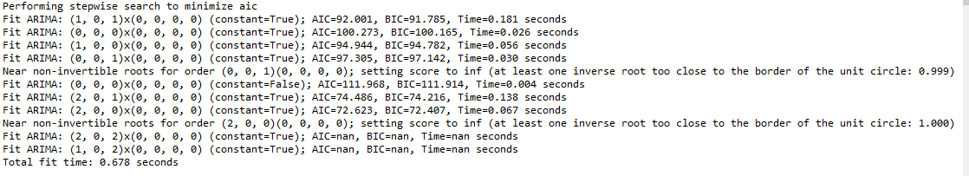

AUTO ARIMA TIMESERIES

1. Which model have you used for Diuresis Time series prediction? Explain your model

For the Diuresis Time series prediction, for finding

The values for date 27th the model used is called the auto ARIMA (Autoregressive integrated moving average ) .

After evaluating both ARIMA and SARIMAX I was able to find out that the auto Arima was better than other two . And this will also get the p , d, q values for the order by its own by evaluating itself as shown in the summary. After getting the value this was used to get the prediction of 27th.