#write a program for tables
for i in range(5,6):
for j in range(1,31):
print(i,"x",j,"=",i*j)

OUTPUT:
5 x 1 = 5
5 x 2 = 10
5 x 3 = 15
5 x 4 = 20
5 x 5 = 25
5 x 6 = 30
5 x 7 = 35
5 x 8 = 40
5 x 9 = 45
5 x 10 = 50
5 x 11 = 55
5 x 12 = 60
5 x 13 = 65
5 x 14 = 70
5 x 15 = 75
5 x 16 = 80
5 x 17 = 85
5 x 18 = 90
5 x 19 = 95
5 x 20 = 100
5 x 21 = 105
5 x 22 = 110
5 x 23 = 115
5 x 24 = 120
5 x 25 = 125
5 x 26 = 130
5 x 27 = 135
5 x 28 = 140
5 x 29 = 145
5 x 30 = 150

PROGRAM:(GRAPH-1)
import matplotlib.pyplot as plt
x=[2,4,6,8,10]
y=[4,8,12,16,20]
plt.plot(x,y)
plt.xlabel("X Axis")
plt.ylabel("Y Axis")
plt.title("My first graph")
plt.show()

OUTPUT:
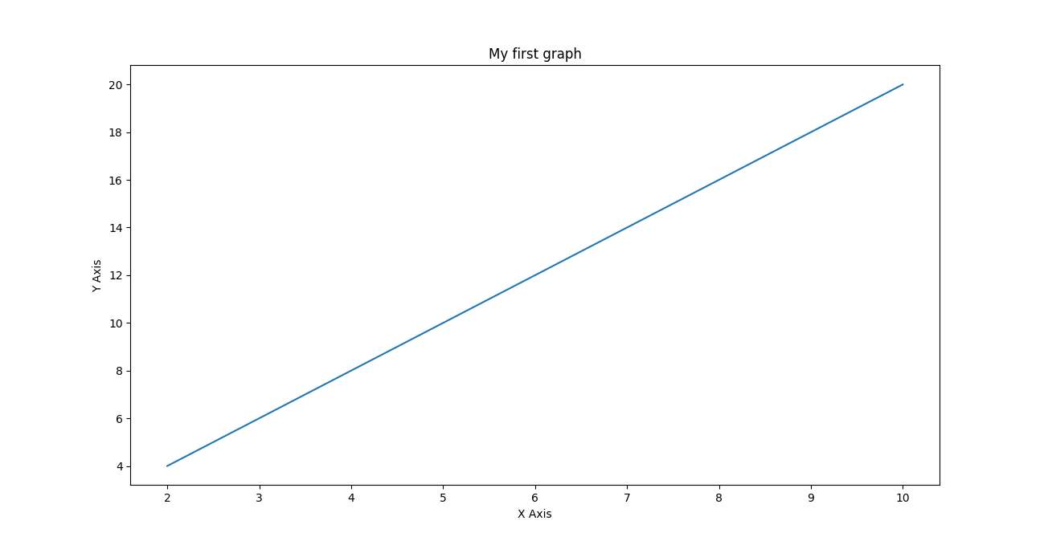

PROGRAM (GRAPH2)

import matplotlib.pyplot as plt
left=[1,2,3,4,5]
height=[10,20,30,40,25]

tick_label=['one','two','three','four','five']

plt.bar(left,height,tick_label=tick_label,width=0.5,color=['black','pink'])

plt.xlabel('x-axis')
plt.ylabel('y-axis')
plt.title('My bar chart')
plt.show()

OUTPUT:
