***In Silico* evaluation and drug-likeness prediction of some thiadiazole derivatives as ULK1/2 inhibitors**

Parin Sidat1*, Malleshappa Noolvi1, Raj Wagh2, Rahul Patil3, Vishal Beldar4

1Department of Pharmaceutical Chemistry, Shree Dhanvantary Pharmacy College, Kim-394110, Gujarat, India.

2Department of Chemical Engineering, Institute of Chemical Technology Mumbai, Marathwada Jalna.

3Department of Pharmaceutics, Shree Dhanvantary Pharmacy College, Kim-394110, Gujarat, India.

4Department of Pharmacognosy, Institute of Chemical Technology Mumbai, Marathwada Jalna.

**\*Corresponding Author-**

Parin Sidat (+91 9265554625)

**O**r**cid id-0000-0002-0583-8991**

pa[rinsidat12@gmail.com](mailto:rinsidat12@gmail.com)

**Outline**

1. Introduction
2. Rationale
3. Material and Methods
   1. Molecular docking studies
      1. Database for molecular modeling
      2. Ligands preparation
      3. Preparation of receptor
      4. Docking of the ligands with the receptor using auto dock version 4.0 of pyrex software
   2. Lipinski rule for Oral Availability
   3. Bioactivity score
   4. Galaxy 3D generator
   5. Ramachandran plot analysis
4. Result and Discussion
   1. Results of molecular docking studies of thiadiazole derivatives
   2. Character of amino acid and their interaction of protein
   3. LIPINSKI’S Rule of Five
   4. Bioactivity result
   5. Galaxy 3D Visualizer result
   6. Ramachandran Plot Result of PDB ID 4WNP (Crystal structure of ULK Protein)
5. Conclusion

**Abstract**

**Objective**

The current study focuses on the *in-silico* evaluation and molecular prediction of some thiadiazole derivatives as ULK (Human Autophagy Initiating Kinase) inhibitors.

**Methods**

Some thiadiazole derivatives were subjected to *in-silico* evaluation, molecular property prediction, and drug-likeness using the Lipinski rule of five and molinspiration software and molecular docking.

**Result and Discussion**

Among all proposed thiadiazole derivatives, we found a few ligands such as 2d, 4e and 4d with the lowest binding energy score (-11.3kcal/mol, -11.2kcal/mol and -11.0 kcal/mol), respectively. Drug likeness properties include an excellent lipophilic character with good permeability (1.97, 2.86 and 2.73) observed with the above derivatives. In addition, better binding specificity (94.79, 94.70 and 74.57) and better enzyme inhibitory activity (0.04, 0.00, 0.14) were noticed with ULK receptors in comparison to STD (Standard) molecules.

**Conclusion**

Compared to STD compounds, with no violation, the bioactivity and likeness score of ligands 2d, 4d, and 4e were relatively high, indicating that they are excellent ULK inhibitors. These ligands also have the lowest binding score, which may aid in determining the stability of ligands. Based on these parameters, the most promising candidates were selected for synthesis.

**Keywords:** Molecular modelling, Druglikness Properties, Thiadiazole derivatives, ULK1/2 inhibitors.

**Graphical Abstract**

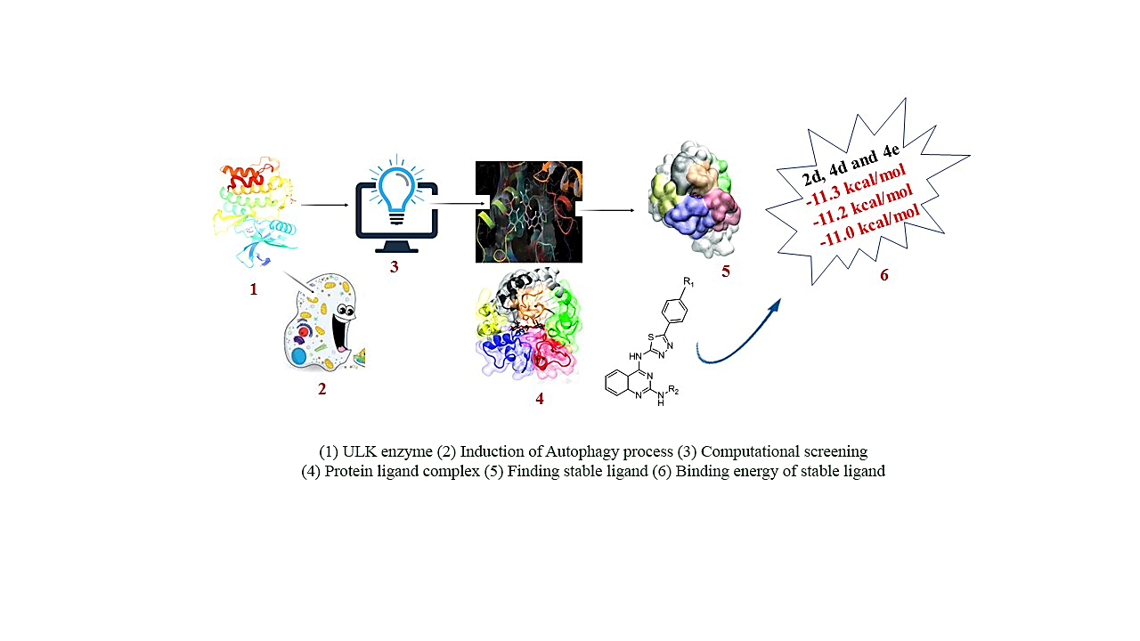

1. **Introduction:**

Cancer is a group of diseases distinguished by uncontrollable cell division. It is caused by multifactorial, multigenic, and multi-pathway (1). Many targeted therapies are effective in treating cancer. Four broad categories of targeted therapies include monoclonal antibodies, small molecule inhibitors, antibody-drug conjugates, and immunotherapy (1). It is critical to developing tumour-targeted molecular therapies successfully to avoid misidentifying ideal targets. Herein, we are employing autophagic cell death therapy to target tumor cells. Mostly, starvation triggers Autophagy, but various stressors can also induce it. Autophagy is a multi-step lysosomal degradation process in which some long-lived proteins or damaged organelles in cells are degraded (2). Many proteins are involved in the autophagy process, including ULK1, ULK2, PDK1, ATG4B, VPS34, and ATG (3). Autophagy is well known to be modulated by some autophagy-related (ATG) genes, particularly UNC-51-like kinase 1 (ULK1), and it's complex. Kinases play an essential role in signalling pathways that modulate many physiological functions, including cell growth, proliferation, migration, and angiogenesis (4). Unc-51-like Autophagy activating kinase (ULK1/2) is an enzyme with two isoforms encoded by the ULK1/2 genes in humans. It is a kinase that participates in Autophagy, particularly in response to amino acid deprivation. Ulk1/2, which is related to ATG1 in yeast, is a protein involved in Autophagy in mammalian cells. It is a component of the ULK1 complex, which is required for autophagosome biogenesis in the early stages. The ULK1 complex also includes the FAK family kinase interacting protein of 200 kDa (FIP200 or RB1CC1) and the HORMA (Hop/Rev7/Mad2) domain-containing proteins ATG13 and ATG101 (5). ULK1 appears to be the most important for Autophagy and is activated by several upstream signals during nutrient deprivation, followed by autophagy initiation (6). ULK1 and ULK2 have high functional redundancy; studies have shown that ULK2 can compensate for the loss of ULK1. When both ULK1 and ULK2 are mutated, nutrient-dependent Autophagy is completely inhibited. ULK1 has a slew of downstream phosphorylation targets that help to induce the isolation membrane/autophagosome (7). ULK1/2 is negatively regulated by [mTORC1](https://en.wikipedia.org/wiki/MTORC1) activity, active during anabolic-type environmental cues.

In contrast, ULK1/2 is activated by [AMPK](https://en.wikipedia.org/wiki/AMPK) activity from starvation signals (8). The protein ULK1 has a molecular weight of 112 kDa. It has an N-terminal kinase domain, a serine-proline-rich region, and a C-terminal interacting domain. Experiments have shown that the serine-proline-rich region is the site of phosphorylation by mTORC1 and AMPK, which are both negative and positive regulators of ULK1 activity. The C-terminal domain contains two microtubule-interacting and transport (MIT) domains and serves as a scaffold connecting ULK1, ATG13, and FIFP200 to form a complex required for Autophagy to begin. Early autophagy targeting/tethering (EAT) domains are composed of two three-helix bundles in the C-terminus and are organized as MIT domains. MIT domains also mediate interactions with membranes. The N-terminus contains a serine-threonine kinase domain. Between the N and C termini of ULK1, there is also a large positively charged activation loop. This region may be involved in kinase activity regulation and substrate recognition. ULK1 and ULK2 share significant homology in both the C-terminal and N-terminal domains (6). The heterocyclic moiety thiadiazole, quinazoline, and various aniline derivatives has been employed in this study to perform molecular docking against the "Human Autophagy Initiating Kinase” ULK. Heterocyclic compounds, like thiadiazole, are important pharmacologically active organic compounds with potential applications in medicinal chemistry. Some hybrid thiadiazole-based pharmacophore systems with anticancer activity have been reported in the literature. 2-Amino-1,3,4-thiadiazole has been identified as a promising scaffold for developing anticancer agents (9–11). Quinazoline has also shown potential anticancer activity (12–19). Some aniline derivatives, such as ortho phenylenediamine, para floro aniline, and pyrimidine, contain an amine group, which aids in forming hydrogen bonds during amino acid binding (20–22). We also utilized the benzimidazole ring at the R2 position, and it has shown good anticancer activity on various cancer cell lines (23–28). This study aimed to examine some hybrid structures containing thiadiazole and quinazoline and some aniline derivatives, using computational means as a molecular docking approach to perform a virtual screening to assess their potential biological activity. Altogether, we intend to design a proposed molecule that fulfils all pharmacophoric requirements so that we can utilize their potential application in medicinal chemistry.

1. **Rationale**

Wood and colleagues discovered a promising ULK inhibitor (30). All of them have a low IC50 value for the ULK protein. ULK protein has two terminal lobes, one on the N side chain and one on the C side chain, which are very specific for binding to the active side. The N-chain contains a serine-proline-rich region, which is the site of numerous regulatory phosphorylations by both mTORC1 and AMPK, which act as negative and positive regulators of ULK1 activity, respectively (6). Some amino acids, such as Cys95, Tyr94, Glu93, Lys38, and Met92, are required to initiate phosphorylation. All amino acids interact with ULK at the hinge region, causing the confirmation to change from inactive to active. These ULK play an essential role in the autophagy mechanism by inhibiting it via an active site containing the NH group of the benzimidazole moiety, which interacts with Gln142, and other benzene ring fragments, which interact with Gly98. In ULK-LN-1, the NH group between pyrazol and quinazoline forms an H bonding interaction with the carbonyl group of Cys95 amino acid. Glu93 and Lys38 were mutated at the N terminal side chain, and Lys162 is adjacent to this C terminal patch and is a known ULK1 regulatory site via acetylation by TIP60. The cyclopropyl substituent in the STD compound fits into a pocket adjacent to the gatekeeper methionine. This is the most fundamental pharmacophoric requirement for ULK inhibitory activity. We intend to design a proposed molecule containing thiadiazole, quinazoline, benzimidazole, and some aniline derivatives that fulfil all pharmacophoric requirements in the current research. The thiadiazole ring was selected for its dynamic role in pharmacokinetic and dynamic properties. Thiadiazole contains two N atoms with a high electron-donating ability and the ability to form H bonding interactions with Asn143 and Gln142, causing Gln142 to shift in position and reducing the transactivation mediated side effect.



**Figure 1:** ULK1/2 inhibitors and hypothetical model of the proposed molecule

**Figure 2:** The designed quinazoline- thiadiazole and aniline derivatives hybrids

1. **Material and Methods**
   1. **Molecular docking studies**
      1. **Database for molecular modelling**

Based on knowledge of various ULK analogues acting as an anticancer agent, we designed some molecules and named **1(a-e) to 8(a-e),** displayed in **Table 1.** To design these molecules, the dataset used for molecular docking contains 45 molecules in which 40 proposed molecules 1(a-e) to 8(a-e) and 05 standard molecules from literature **(STD-1 to STD-5)**. The chemical structure and name of molecules are listed below in **Table 1**.

Protein-Ligand docking studies on 40 thiadiazole derivatives were performed to study the interaction between the binding pocket of ULK enzyme and the ligands on Hp G62 computer system, with Intel CoreTM i3 Dual CPU, M330 @2.13 GHz 2.13 GHz, 4 GB of RAM using Auto dock vina 4.2 of pyrex virtual screening software, and Discovery studio software.

* + 1. **Ligands preparation**

The compounds involved in this study, ligands were studied for their binding activities to 4WNP receptor were sketched in Chem Draw ultra 8.0 software (Chemical Structure Drawing Standard; Cambridge Soft Corporation, USA (2003)). Then, these structures were converted to 3D structures using Chem3D ultra 8.0 software. Constructed 3D structures were energetically minimized by the energy minimization technique Allinger’s. Next, molecular Mechanics (MM2) force fields followed by geometry optimization using semi-empirical Quantum mechanics based on AM-1 (Austin Model-1). **Fig. 1** shows the prepared structure of the ligand.

* + 1. **Preparation of receptor**

The 3D structure of the ULK1 bound potent inhibitor with the PDB code 4WNP was retrieved from Protein Databank (PDB). Discovery studio software was to prepare the receptor by removing water molecules and cofactors and saving it as a PDB file format. **Fig. 2** shows the prepared structure of the receptor.

* + 1. **Docking of the ligands with the receptor using auto dock version 4.0 of pyrex software**

The docking was performed on the enzyme ‘Human Autophagy Initiating Kinase ULK1’ (RCSB PDB id: 4WNP) in the Auto Dock Vina version 12.0 of pyrex software. Chimera 1.10.2 software was used to build the complex (ligand-receptor) since the receptor and the ligand decoupled after carrying out docking with the autodock vina of pyrex. The ligand-receptor were visualized to view their interactions using the Discovery studio visualizer.

**Table 1:** Structure of ligands and their binding energy

|  |  |  |  |  |  |
| --- | --- | --- | --- | --- | --- |
| **Sr. No.** | **Structure of ligands with Binding energy (Kcal/mol)** | | | | |
|  |  |  |  |  |  |
| **Docking Score** | **1a**  **-10.3 Kcal/mol** | **1b**  **-10.2 Kcal/mol** | **1c**  **-10.4 Kcal/mol** | **1d**  **-10.9 Kcal/mol** | **1e**  **-9.5 Kcal/mol** |
| **2.** |  |  |  |  |  |
| **Docking Score** | **2a**  **-10.0 Kcal/mol** | **2b**  **-10.4 Kcal/mol** | **2c**  **-9.8 Kcal/mol** | **2d**  **-11.3 Kcal/mol** | **2e**  **-9.6 Kcal/mol** |
| **3.** |  |  |  |  |  |
| **Docking Score** | **3a**  **-9.1 Kcal/mol** | **3b**  **-10.7 Kcal/mol** | **3c**  **-9.2 Kcal/mol** | **3d**  **-10.8 Kcal/mol** | **3e**  **-10.0 Kcal/mol** |
| **4.** |  |  |  |  |  |
| **Docking Score** | **4a**  **-10.5 Kcal/mol** | **4b**  **-9.7 Kcal/mol** | **4c**  **-10.0 Kcal/mol** | **4d**  **-11.0 Kcal/mol** | **4e**  **-11.2 Kcal/mol** |
| **5.** |  |  |  |  |  |
| **Docking Score** | **5a**  **-10.0 Kcal/mol** | **5b**  **-10.6 Kcal/mol** | **5c**  **-10.6 Kcal/mol** | **5d**  **-10.7 Kcal/mol** | **5e**  **-9.7 Kcal/mol** |
| **6.** |  |  |  |  |  |
| **Docking Score** | **6a**  **-8.3 Kcal/mol** | **6b**  **-9.5 Kcal/mol** | **6c**  **-9.2 Kcal/mol** | **6d**  **-9.3 Kcal/mol** | **6e**  **-8.3 Kcal/mol** |
| **7.** |  |  |  |  |  |
| **Docking Score** | **7a**  **-10.3 Kcal/mol** | **7b**  **-10.7 Kcal/mol** | **7c**  **-9.6 Kcal/mol** | **7d**  **-10.4 Kcal/mol** | **7e**  **-9.7 Kcal/mol** |
| **8.** |  |  |  |  |  |
| **Docking Score** | **8a**  **-8.9 Kcal/mol** | **8b**  **-9.0 Kcal/mol** | **8c**  **-8.9 Kcal/mol** | **8d**  **-9.2 Kcal/mol** | **8e**  **-8.3 Kcal/mol** |
| **STD** |  |  |  |  |  |
| **Docking Score** | **STD1**  **-9.3 Kcal/mol** | **STD II**  **-8.9 Kcal/mol** | **STD III**  **-9.0 Kcal/mol** | **STD IV**  **-9.0 Kcal/mol** | **STD V**  **-9.0 Kcal/mol** |

* 1. **Lipinski rule for Oral Availability**

The rule was formulated by Christopher A Lipinski in 1997. The rule defines molecular properties essential for the pharmacokinetics of drugs in the human body, such as absorption, distribution, metabolism, and excretion (ADME). Following Lipinski's 'rule of five' Ro5 (31) is one of the best ways to find orally available drugs (32). The main goal of following Ro5 is to determine if a chemical compound will have the desired pharmacokinetic profile or not. We ran these tests on SWISS software to ensure that the molecules were viable. This methodology aids in reducing conventional waste, shortening the time required for laboratory experiment trial and error, and ensuring the oral bioavailability of molecules. The rule is significant in drug development, where a pharmacologically active lead structure is incrementally optimized for increased activity and selectivity and druglike properties. Drugs with higher molecular weight, more rings, more rotatable bonds, and higher lipophilicity are frequently the result of molecular structure modification. Physicochemical parameters are critical in generating and escalating the bioactivity of a chemical entity. To obtain parameters such as MiLogP, TPSA, and drug-likeness, web-based software called Molinspiration was used. MiLogP octanol/water partition coefficient) is calculated by Molinspiration as a sum of fragment-based contributions and correction factors and is used to predict molecule permeability across the cell membrane. The method is highly dependable, and it can handle virtually any organic or organometallic compound. Molecular Polar Surface Area (TPSA) was computed by Ertl etal as a sum of fragment-based contributions, in which O- and N-centered polar fragments were analysed, and surface areas occupied by oxygen and nitrogen atoms, as well as hydrogen atoms connected to them, were also considered in calculations (33).

TPSA is a good predictor of drug absorption, including intestinal absorption, bioavailability, Caco-2 permeability, and blood-brain barrier penetration. As a result, the TPSA is inextricably linked to the hydrogen bonding potential. Molinspiration developed a group-contributed method for calculating molecular volume. The number of rotatable bonds (nrotb) is a topological parameter that assesses molecular flexibility (29). It has been an excellent predictor of oral medication bioavailability. A rotatable bond is any single non-ring bond bound to a nonterminal heavy (i.e., non-hydrogen) atom. Amido C-N bonds are not considered due to their high rotational energy barrier. Drug likeness is a complex balance of various molecular properties and structural features that determine whether a molecule is similar to known drugs. Hydrophobicity, electronic distribution, hydrogen bonding characteristics, molecule size and flexibility, and the presence of various pharmacophoric features all influence molecule behaviour in a living organism, including bioavailability, transport properties, an affinity for proteins, reactivity, toxicity, metabolic stability, and many other factors. Lipinski's rule of five states that an orally active drug should have no more than 5 hydrogen bond donors (OH and NH groups), no more than 10 hydrogen bond acceptors (particularly N and O), a molecular weight of less than 500 g/mol, a partition coefficient log P of less than 5, and a number of violations of no more than 4.

* 1. **Bioactivity score**

The drugs are also evaluated for bioactivity by calculating activity scores for GPCR ligands, ion channel modulators, kinase inhibitors, and nuclear receptor ligands. The parameters were validated using the software Molinspiration drug-likeness score online (www. molinspiration.com). The drug-likeness score of each ligand was calculated and compared to the specific activity of each compound with standard drug.

* 1. **Galax**y **3D generator**

Galaxy Visualizer is a web tool that makes it simple to create 3D molecular structures from SMILES using the Molinspiration Galaxy 3D generator. Molecules can be examined interactively in various display modes, including visualising surface properties such as molecular lipophilicity potential (MLP) and polar surface area (PSA).

* 1. **Ramachandran plot analysis**

Ramachandran plot is used to visualize the backbone of amino acid residues (30). Used for structural validation and to calculate the possible Phi and Psi angles that account for the amino acid residues. Done by software, namely Discovery Studio Visualizer (BIOVIA) Ramachandran plot. Counting: 180 → +180 (vertical and horizontal axis). Allowed/Low Energy Region: the region on the plot with the highest density of dots.

1. **Result and Discussion**
   1. **Results of molecular docking studies of thiadiazole derivatives**

Molecular docking studies were performed on 40 thiadiazole derivatives (inhibitors) against ULK (receptor). As shown in **Table 1**, all ligands had high docking scores (low energy values) ranging from -8.2 to -11.3 kcal/mol. Ligands 2d,4e, and 4d have the highest docking scores of -11.3, -11.2, and -11.0 kcal/mol, respectively. The ligands with the highest docking scores from three interactions: hydrophobic, hydrogen bond, and carbon-hydrogen bond interactions, are ligands 2d and 4e. Hydroxyl groups of the phenyl ring of the ligand formed a hydrogen bond with Cys95(2.98 Aº) and also formed hydrophobic interactions with the residues His24, Phe27, Lew59, Ile46, Asn148, Pro149, Glu42, Gly25, Tyr94, Ala28, and in 4e ligand contains Hydroxyl groups of ethanolamine formed hydrogen bonds with Met92, Val176, Ala146, Gly23, The 2d ligand has the lowest binding energy, indicating the most excellent affinity for the enzyme. As a result, it can be regarded as a potential inhibitor. Our docking models predicted that this amine would form a new H-bond with Cys95 amide carbonyl in the ATP binding domain. Other amines capable of maintaining the interactions identified as important for binding in the oxygen-rich portion of the active site structures can maintain two H-bonding interactions, one with Lys46 and the second with Asn134 or a proximal residue were also considered. The best candidates were chosen for synthesis based on these criteria. We used biochemical data and docking poses to help validate hypotheses about structural changes that could improve ULK1 inhibitory activity in this compound series.

* 1. **Character of amino acid and their interaction on protein** (31)

**Charged amino acids**

It is easy to see which amino acids are charged simply because they contain a single charge at neutral pH (around 7). There are four of them, two basic amino acids, lysine (Lys) and arginine (Arg), with a positive charge at neutral pH, and two acidic, aspartate (Asp) and glutamate (Glu), carrying a negative charge at neutral pH. The so-called salt bridges, formed by the interaction between positively and negatively charged amino acid side chains, have been important for stabilising protein's three-dimensional structure.

**Polar amino acids**

Some amino acids are easy to assign, while others may cause misperception when it comes to polarity. Because they include a hydroxyl (-OH) group, serine (Ser), threonine (Thr), and tyrosine (Tyr) are polar. This polar group can donate or accept a proton to create a hydrogen bond with another polar group. Asparagine (Asn) and glutamine (Gln) are polar amino acids with a polar amide group attached to them. In contrast, histidine (His) can be both polar and charged depending on the environment and pH. It has two –NH groups, each with a pKa of about 6. The side chain has a charge of +1 when both groups are protonated. The protein environment can modify the side chain's pKa, causing it to give up a proton and become neutral or accept a proton and become charged. This property makes histidine useful in enzyme active sites when a chemical reaction necessitates proton extraction. Because of their potential to have polar and nonpolar properties, the aromatic amino acids tryptophan (Trp) and the previously mentioned Tyr and the non-aromatic methionine (Met) are frequently referred to as amphipathic. These residues can be found near a protein's and solvent's contact. The side chains of histidine, tyrosine, phenylalanine, and tryptophan can also create weak hydrogen bonds of OH and CHO by exploiting electron clouds within their ring structure.

**Hydrophobic amino acids**

Alanine (Ala), valine (Val), leucine (Leu), isoleucine (Ile), proline (Pro), phenylalanine (Phe), and cysteine (Cys) are all hydrophobic amino acids. Usually, these residues are found inside the protein core, away from the solvent. They participate in van der Waals interactions, which are necessary for protein structural stability. Furthermore, Cys residues aid in the stabilisation of three-dimensional structures by forming disulfide (S-S) bridges, which can connect distinct sections of a protein structure or even different subunits in a complex. It's worth noting that there's some debate about whether Cys belongs in the hydrophobic group or not. For example, some schemes classify it as hydrophobic, whereas others classify it as polar due to its polarity.

**Glycine & proline**

One of the most prevalent amino acids, glycine (Gly), lacks a side chain. Instead, it's commonly found on the surface of proteins in loop- or coil (non-defined secondary structure) regions, giving the polypeptide chain much flexibility. The ability to make sharp polypeptide twists in loop regions necessitates this flexibility. On the other hand, proline is nonpolar and has qualities that are the polar opposite of Gly; it imparts stiffness to the polypeptide chain by imposing particular torsion angles on the structure's segment. This is because its side chain makes a covalent bond with the main chain, limiting the phi-angle of the polypeptide in this location (see the section of the Ramachandran plot). Because it is frequently found at the ends of -helices and in turns, pro is also known as helix breaker.

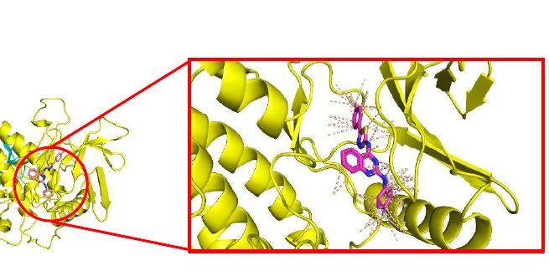

**(A)**

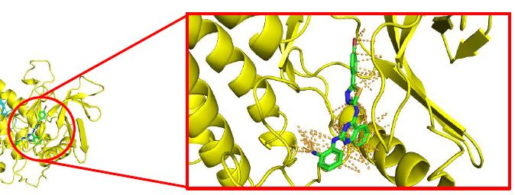

**(B)**

**Figure 3:** 3D image of protein ligand Complex (A) 2d ligand (-11.3 kcal/mol)) and (B) 4e ligand (-11.2 kcal/mol)

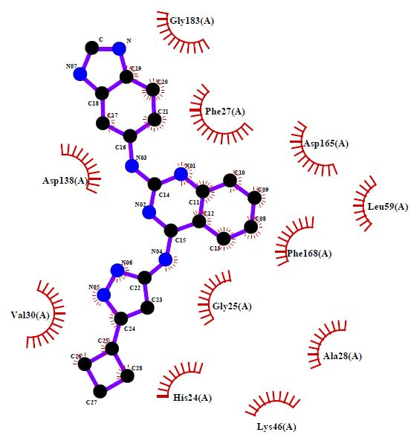 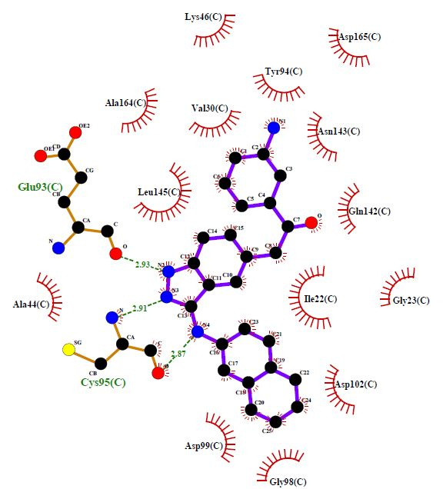

**1 2**

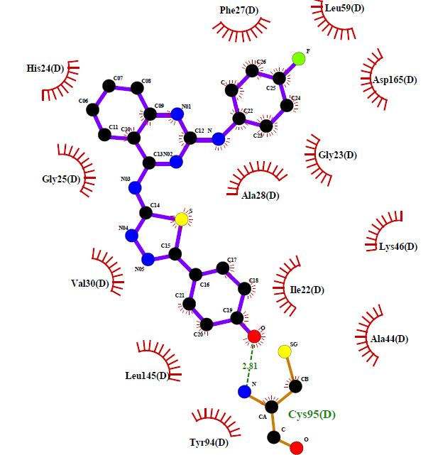 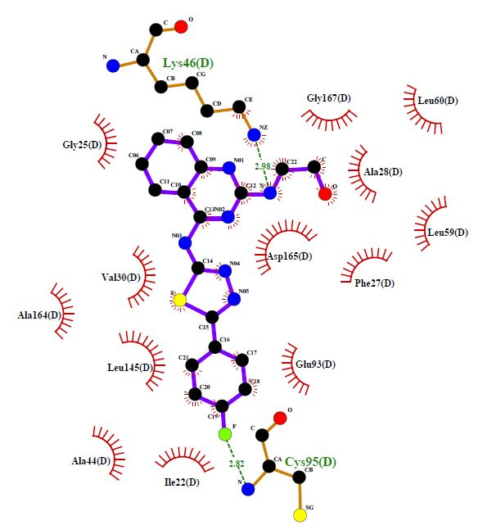

**3 4**

**Figure 4:** 2D images of (1) STD-III (-9.3 kcal/mol), (2) STD-I (-9.0 kcal/mol), (3) 2d ligand (-11.3 kcal/mol), and (4) 4e ligand (-11.2 kcal/mol) with protein 4WNP

* 1. **LIPINSKI’S Rule of Five**

The SWISS programme was used to calculate the drug-likeness property. This also aided in understanding how molecular weight and mlogP values affect enzyme activity. As a result, these molecules have an orally safe profile, as shown in **Table 3**.

**Table 3** lists essential molecular descriptors and properties to assess oral bioavailability using Lipinski's rule, where: MW is the molecular weight, which should be less than 500 Daltons, HBD is the number of hydrogen bond donors, which should be less than 5, HBA is the number of hydrogen bond acceptors, which should be less than 10, and logP is the water-octanol partition coefficient, which should be less than 5. The investigated 3a, 6a, and 8c ligand structures exhibit one Lipinski's violation, as indicated by MW > 500 and mlogP > 5, indicating their hydrophobic nature. Here, the number of violations of another ligand is zero, which indicates they easily bind with the receptor. The calculated values of the mlogP parameter suggest that all investigated 1,3,4-thiadiazoles are highly lipophilic, with poor aqueous solubility. **Fig. 5** shows the mlogP value of ligand/molecule (1-40). Ligand 2d, 4e, and 4d have the lowest value of mlogP, respectively 1.97, 2.73 and 2.86. this value indicates the good lipophilic character of the molecule and easily across the cell membrane, which in turn is needed for bioactivity. Generally, values of mlogP over 5 suggest poor absorption or permeation. In respect of TPSA, all ligands are within a limit, i.e. 160 Aº which implies the ligands ae fulfils the optimal drug absorption requirement. Therefore, these calculations can predict drug-likeness in drug candidates in virtual screening methodologies. Further optimization of such ligands containing thiadiazole, quinazoline, and some aniline moieties, are required to increase hydrophilicity and favour hydrophilic interactions employing NH/OH/N/O groups. As a result, the possibility of interacting with proteins and becoming biologically active can be realized. These calculations can be used to predict drug likeness in drug candidates in virtual screening methodologies. As a result, the possibility of interacting with proteins and becoming biologically active can be achieved.

**Figure 5:** mlogP value of molecule (ligand 1 to 40) (- x axis describe molecules and -y axix describe the value of mlogP)

* 1. **Bioactivity score**

The bioactivity score was calculated for GPCR ligand, ion channel modulator, kinase inhibitor, nuclear receptor ligand, protease inhibitor and enzyme inhibitor. For average organic molecule, the probability of bioactivity score is more than 0.00 then it is active, (−0.50 to 0.0) then moderately active and if less than −0.50, then inactive. In our study, all the proposed ligands were subjected to the bioactivity score presented in **Table 4**. Comparing the bioactivity score of STD molecule and proposed ligand have similar scores, especially in case of enzyme inhibition.

* 1. **Galaxy 3D Generator**

Galaxy Visualizer displays molecular lipophilicity potential (MLP) on the molecular surface, allowing us to see which parts of the surface are hydrophobic (encoded by violet and blue colours) and which are hydrophilic (orange and red). Some 3D Molecular Designs mini models and custom models follow the CPK color scheme for distinguishing atoms of different chemical elements. CPK Color Scheme for the Elements; carbon is grey or black, oxygen is red, nitrogen is blue, sulfur is yellow, and hydrogen is white. MLP is calculated using the same atomic hydrophobicity contributions used to compute the octanol-water partition coefficient (logP). MLP is useful for rationalising various molecular ADME properties (like membrane penetration or plasma-protein binding). Analysis of the 3-dimensional distribution of hydrophobicity on the molecular surface is especially useful for explaining differences in observed ADME properties of molecules with the same logP. The 3D parameter contains more information than logP expressed as a single value. The polar surface area (PSA) of a drug is a very useful parameter for predicting its transport properties. A molecule's polar surface area is defined as the sum of the surfaces of its polar atoms (typically oxygens, nitrogens, and attached hydrogens). This parameter has been shown to strongly correlate with human intestinal absorption, Caco-2 monolayer permeability, and blood-brain barrier penetration. And they are depicted in (**Fig. 6)**

  

**1 2 3**

**Figure 6:** Molinspiration Galaxy 3D Structure Generator v2021.01 beta

1. CPK (2) MLP (3) PSA
   1. **Ramachandran Plot Result of PDB ID 4WNP (Crystal structure of ULK Protein)**

To see the correctness of optimized protein. Generate a Ramachandran plot for ULK inhibitor, a protein that contains both β-sheet and α-helix (PDB ID 4WNP). The blue and pink regions **(Fig. 3)** represent the favoured and allowed regions defined by Discovery studio software.

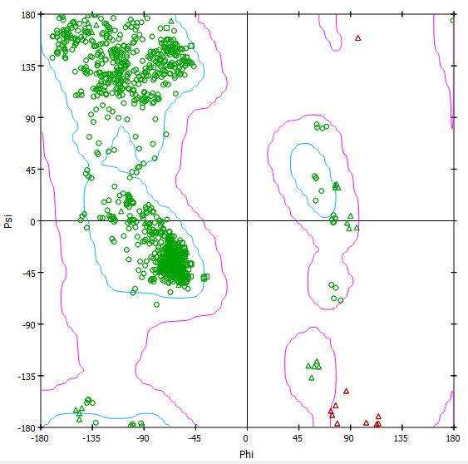

**Figure 4:** Ramachandran Plot of SR-20295 Protein PDB ID 4WNP

**Table 2:** Binding energy, hydrophobic interactions, Hydrogen bonds and Hydrogen bond distance of a ULK and the ligand.

|  |  |  |  |  |
| --- | --- | --- | --- | --- |
| **Ligand No.** | **Binding**  **Energy**  **(kcal/mol)** | **Hydrophobic Interactions** | **Hydrogen Bonds** | **Hydrogen Bond Distance (Å)** |
| **1a** | -10.3 | Asp102, Gly23, Lys140, Ile22, Asp143, Ala164, Val176, Met92. | Lys46, His24 | 2.99 and 3.30 |
| **1b** | -10.2 | Leu145, Val176, Asp99, Gly23, His24, Lys46, Asp146, Phe168 | - | - |
| **1c** | -10.4 | Leu59, Ala28, Phe27, Gly167 Lys46, Gln142, Lys46, Asn143, Asp165, Cys95, Val130, Glu93 Lys46, Lew145 | Lys64 | 3.12 |
| **1d** | -10.9 | Phe168, Al28, Lew59, Lys46, Glu143, Lys46, Asp165, Glu165, Gln142, Leu145, Val130. | - | - |
| **1e** | -9.5 | Ala28, Phe168, Asp165, Leu59, Glu160 Lys46, Leu60, Met92, Val130, Ala44 | - | - |
| **2a** | -10.0 | Leu59, Ala28, Phe27, Gly167 Lys46, Gln142, Asn143, Asp165, Cys95, Val130, Glu93, Lys46, Leu145 | Cys95 | 2.88 |
| **2b** | -10.4 | Tyr79, Arg255, Leu246, Ala249, Phe70, Gly151, Leu246, Glu73, Gln142, Lys162, Asn143, Asp165, Lys162, Val130, Glu93, Leu246, Pro250 | Ser147, Glu271 | 2.83, 3.29, 3.13 and 3.18 |
| **2c** | -9.8 | Glu73, Tyr79, Leu256, Lys256, Tyr94, Lew41, Arg160, Gln253, Gly42, Asn96, Pro149 | - | - |
| **2d** | -11.3 | His24, Phe27, Lew59, Ile46, Asn148, Pro149, Glu42, Gly25, Tyr94, Ala28, | Cys95 | 2.81 |
| **2e** | -9.6 | Gln253, Arg160, Tyr94, Ser147, Glu73, Asn148, Pro149, Glu42, Gly271 | Lys162, Asn96 | 3.02 and 3.03 |
| **3a** | -9.1 | Val176, Leu145, Gly98, Tyr94, Ile22, Val130, Met92, Asp165, His24, Ala28, Lys46 | Asn143 | 3.17 |
| **3b** | -10.7 | Lew59, Phe169, Ala26, Leu60, Lys146, Val130, Ile22 | - | - |
| **3c** | -9.2 | Phe168, Gly25, Lys46, Lew59, Ala28, Gly167, Val130, Ile22, Ala44 | - | - |
| **3d** | -10.8 | Lys140, Gly183, Asp138, Phe168, Lew59, Ala28, Asp165, Lew60, Val130, Ile22 | - | - |
| **3e** | -10.0 | Leu59, Phe168, Ala28, Asp165, Val130, Lew145, Ala164 | Lys140, Lys146 | 2.98 and 3.01 |
| **4a** | -10.5 | Ile22, Val130, Leu145, Asp120, His24, Lys146, Gly25, Ala28, Asp165, Gln142 | Asp99 | 3.28 |
| **4b** | -9.7 | Phe168, Ala28, His24, Asp165, Leu145, Gln142, Gly25, | Asn143 | 3.22 |
| **4c** | -10.0 | Phe168, Leu59, Asp165, His24, Ala164, Glu93, Leu145, Val167, | Lys64, Asn143 | 3.23 and 2.98 |
| **4d** | -11.0 | Leu145, Gly25, Glu93, Ala44, Ile22, Asp165, Ala28, Leu59, Val130 | Cys95 | 2.98 |
| **4e** | -11.2 | Met92, Val176, Ala146, Gly23, Leu145, Ile22, Asp99, Asp165, His24 | Lys46, Cys95 | 2.98 and 2.82 |
| **5a** | -10.6 | Gln142, Phe168, Ala28, Phe27, Asp165, Ala164, Leu59, Val130, Glu93 | Lys46 | 2.98 |
| **5b** | -10.6 | Lys140, Phe27, Leu59, Val130. Ala164, Val176, Asp165, Leu145, Glu93 | - | - |
| **5c** | -10.7 | Gly25, Asp165, Lys14, Glu142, Val130, Leu145, Ile22, Ala44, Cys95, Val130 | - | - |
| **5d** | -9.7 | Phe168, Asp165, Leu59, Ala28, Val130, Ala164, Leu145, Asp146 | Lys140, Lys46 | 3.20 and 3.25 |
| **5e** | -8.3 | Phe27, Ala126, Asp165, Lys140, Val130, Gly98, Asp99, Ile22. Cys95 | Asn143, Gln142, Tyr94 | 3.18, 3.29 and 2.78 |
| **6a** | -9.5 | Phe168, Asp165, Ala28, Gly25, Glu142, Val130, Lys46, Ala44, Met92 | - | - |
| **6b** | -9.2 | Leu60, Gly167, Lys46, His24, Ala28, Asp165, Val130, Ala44, Tyr94 | - | - |
| **6c** | -9.3 | Phe27, Ly46, Ala28, Gly25, His24, Leu59, Ala44, Val130 | - | - |
| **6d** | 8.3 | Leu59, Ala28, Leu60, Asp165, Gly25, His24, Lys46, Ile22 | Glu163 | 2.91 |
| **7e** | -10.3 | Lys46, Val130, Gs24, Phe27, Gly183, Phe168, Asp165, ly25, Leu60, His24, Cys182 | - | - |
| **7a** | -10.7 | Asp138, Glu59, Ala28, Val13 Lys140, Phe168, Asp165 | Ser184 | 3.24 |
| **7b** | -9.6 | Leu59, Phe168, Lys46, Gln142, Val130, Ala28 | - | - |
| **7c** | -10.4 | Lys162, Ala28, Leu41, Gln253, Asp40, Gly151, Arg152, Pro276 | Ser147, Glu142 | 3.32 and3.04 |
| **7d** | -9.7 | Phe27, Ala28, Asp146, Leu59, Val130, Ala164 | Lys140, Lys46 | 2.97 and 3.10 |
| **7e** | -8.9 | Ala26, Gln142, Phe27, His24, Asn143, Gly25, Asp146, Val130, Leu145, Lys46 | - | - |
| **8a** | -9.0 | Lys46, Ala44, Val176, Gln93, Gly25, Cys95, Ile22, Gly9 | Tyr94 | 2.81 |
| **8b** | -8.9 | Leu172, Asp199, Phe268, Ser174, His130, Gly133, His274 | Arg127, Asp270 | 3.25 and 3.06 |
| **8c** | -9.2 | Ala26, Gly25, His24, Phe168, Asn143, Leu59, Lys46, Ala44, Asp165, Met92, Val130 | - | - |
| **8d** | -8.3 | Ala28, Phe168, Gln142, Lys140, Gly23, Ile22, Ala44, Asp165, Tyr94 | Asn143, Cys95 | 3.17 and 3.16 |
| **8e** | -8.0 | Gly25, His24, Phe168, Asn143, Leu59, Lys46, Ala44, Asp165, Met92, Val130 |  |  |
| **STD1** | -9.3 | Ala26, Gly25, His24, Phe168, Asn143, Leu59, Lys46, Ala44, Asp165, Met92, Val130 | Glu95, Cys92 | 2.91 and 2.92 |
| **STD2** | -8.9 | Leu172, Asp199, Phe268, Ser174, His130, Gly133, His274 | - | - |
| **STD3** | -9.0 | Phe168, Asp165, Ala28, Gly25, Glu142, Val130, Lys46, Ala44, Met92 | - | - |
| **STD4** | -9.0 | Leu172, Asp199, Phe268, Ser174, His130, Gly133, His274 | - | - |
| **STD5** | -9.0 | Asp165, Ala28, Gly25, Glu142, Val130, Lys46, Ala44, Met92 | - | - |

**Table 3:** Calculated Physicochemical Parameters (Pfizer’s Rule)/Drug likeness score

|  |  |  |  |  |  |  |  |
| --- | --- | --- | --- | --- | --- | --- | --- |
| **Ligand** | **(MW) Molecular weight (g/mol)**  **<500** | **(HBA)**  **H-bond acceptors**  **<10** | **(HBD)**  **H-bond donors**  **<5** | **MLOGP**  **<5** | **Lipinski violations**  **<4** | **TPSA**  **<160 Aº** | **Nrot**  **Bond**  **<10** |
| **1a** | 478.57 | 5 | 2 | 3.41 | 0 | 92.39 | 7 |
| **1b** | 413.5 | 4 | 3 | 3.16 | 0 | 100.59 | 5 |
| **1c** | 400.46 | 6 | 2 | 2.07 | 0 | 100.35 | 5 |
| **1d** | 416.47 | 5 | 2 | 4.07 | 0 | 74.57 | 5 |
| **1e** | 366.44 | 5 | 3 | 1.94 | 0 | 94.79 | 6 |
| **2a** | 494.57 | 6 | 3 | 3.58 | 0 | 112.62 | 7 |
| **2b** | 429.5 | 5 | 4 | 3.05 | 0 | 120.82 | 5 |
| **2c** | 432.47 | 6 | 3 | 3.95 | 0 | 120.58 | 5 |
| **2d** | **416.46** | **7** | **3** | **1.97** | **0** | **94.79** | **5** |
| **2e** | 382.44 | 6 | 4 | 1.83 | 0 | 115.02 | 6 |
| **3a** | **513.02** | **5** | **2** | **5.88** | **1** | 92.39 | 7 |
| **3b** | 447.94 | 4 | 3 | 3.65 | 0 | 100.59 | 5 |
| **3c** | 434.9 | 6 | 2 | 2.97 | 0 | 100.35 | 5 |
| **3d** | 450.92 | 5 | 2 | 4.96 | 0 | 74.57 | 5 |
| **3e** | 400.89 | 5 | 3 | 2.44 | 0 | 94.79 | 6 |
| **4a** | 496.56 | 6 | 2 | 3.78 | 0 | 92.39 | 7 |
| **4b** | 431.49 | 5 | 3 | 3.95 | 0 | 100.59 | 5 |
| **4c** | 434.46 | 6 | 2 | 4.85 | 0 | 100.35 | 5 |
| **4d** | **418.45** | **7** | **2** | **2.86** | **0** | **74.57** | **5** |
| **4e** | **384.43** | **6** | **3** | **2.73** | **0** | **94.70** | **6** |
| **5a** | 478.57 | 5 | 2 | 3.41 | 0 | 92.39 | 7 |
| **5b** | 427.52 | 4 | 3 | 3.79 | 0 | 100.59 | 5 |
| **5c** | 414.49 | 6 | 2 | 2.7 | 0 | 100.35 | 5 |
| **5d** | 430.5 | 5 | 2 | 4.69 | 0 | 74.57 | 5 |
| **5e** | 380.47 | 5 | 3 | 2.58 | 0 | 94.79 | 6 |
| **6a** | **508.6** | **6** | **2** | **5.11** | **1** | 101.63 | 8 |
| **6b** | 427.52 | 4 | 3 | 3.79 | 0 | 100.59 | 5 |
| **6c** | 430.49 | 7 | 2 | 2.19 | 0 | 109.58 | 6 |
| **6d** | 446.5 | 6 | 2 | 3.75 | 0 | 83080 | 6 |
| **7e** | 396.47 | 6 | 3 | 1.65 | 0 | 92.39 | 7 |
| **7a** | **557.47** | **5** | **2** | **5.98** | **1** | 100.59 | 5 |
| **7b** | 492.39 | 4 | 3 | 3.75 | 0 | 100.35 | 5 |
| **7c** | 479.36 | 6 | 2 | 3.08 | 0 | 74.57 | 5 |
| **7d** | 495.37 | 5 | 2 | 4.66 | 0 | 94.79 | 6 |
| **7e** | 445.34 | 5 | 3 | 2.56 | 0 | 100.5 | 6 |
| **8a** | 523.57 | 7 | 2 | 2.59 | 2 | 138.22 | 8 |
| **8b** | 458.5 | 6 | 3 | 2.31 | 0 | 146.41 | 6 |
| **8c** | 445.46 | 8 | 2 | 2.47 | 0 | 146.17 | 6 |
| **8d** | 461.47 | 7 | 2 | 3.19 | 0 | 120.39 | 6 |
| **8e** | 411.44 | 7 | 3 | 1.09 | 0 | 140.62 | 7 |

**Table 4:** Bioactivity score of the Ligand (1a-e to 8a-e)

|  |  |  |  |  |  |  |
| --- | --- | --- | --- | --- | --- | --- |
| **Ligand No.** | **GPCR ligand** | **Ion channel modulator** | **Kinase inhibitor** | **Nuclear receptor ligand** | **Protease inhibitor** | **Enzyme inhibitor** |
| **1a** | -0.09 | -0.38 | -0.07 | -0.40 | -0.20 | 0.03 |
| **1b** | -0.10 | -0.46 | -0.02 | -0.44 | -0.11 | 0.14 |
| **1c** | -0.07 | -0.55 | -0.02 | -0.38 | -0.27 | 0.03 |
| **1d** | -0.09 | -0.47 | -0.07 | -0.36 | -0.16 | -0.00 |
| **1e** | 0.04 | -0.43 | -0.00 | -0.32 | 0.01 | 0.17 |
| **2a** | -0.06 | -0.36 | -0.04 | -.29 | -0.19 | 0.06 |
| **2b** | -0.06 | -0.41 | 0.01 | -0.32 | -0.10 | 0.17 |
| **2c** | -0.03 | -0.50 | 0.01 | -0.25 | -0.25 | 0.07 |
| **2d** | **-0.06** | **-0.42** | **-0.04** | **-0.23** | **-0.15** | **0.04** |
| **2e** | 0.07 | -0.39 | 0.03 | -0.20 | -0.00 | 0.19 |
| **3a** | -0.09 | -0.40 | -0.08 | -0.40 | -0.23 | 0.00 |
| **3b** | -0.09 | -0.45 | -0.03 | -0.45 | -0.14 | 0.10 |
| **3c** | -0.07 | -0.54 | -0.04 | -0.38 | -0.30 | 0.00 |
| **3d** | -0.09 | -0.46 | -0.08 | -0.36 | -0.19 | -0.03 |
| **3e** | -0.04 | -0.42 | -0.02 | -0.32 | -0.04 | 0.13 |
| **4a** | -0.09 | -0.40 | -0.04 | -0.37 | -0.22 | 0.01 |
| **4b** | -0.09 | -0.46 | 0.01 | -0.41 | -0.13 | 0.12 |
| **4c** | -0.06 | -0.54 | 0.00 | -0.35 | -0.28 | 0.02 |
| **4d** | **-0.09** | **-0.46** | **-0.07** | **-0.34** | **-0.16** | **0.00** |
| **4e** | **-0.04** | **-0.43** | **0.02** | **-0.28** | **-0.02** | **0.14** |
| **5a** | -0.09 | -0.38 | -0.07 | -0.40 | -0.20 | 0.03 |
| **5b** | -0.13 | -0.51 | -0.06 | -0.45 | -0.15 | 0.08 |
| **5c** | -0.10 | -0.59 | -0.07 | -0.39 | -0.31 | -0.02 |
| **5d** | -0.12 | -0.52 | -0.11 | -0.37 | -0.21 | -0.05 |
| **5e** | -0.00 | -0.49 | -0.05 | -0.33 | -0.05 | 0.10 |
| **6a** | -0.12 | -0.47 | -0.9 | -0.38 | -0.23 | -0.01 |
| **6b** | -0.13 | -0.51 | -0.06 | -0.45 | -0.15 | 0.08 |
| **6c** | -0.10 | -0.58 | -0.06 | -0.37 | -0.30 | -0.01 |
| **6d** | -0.13 | -0.51 | -0.10 | -.35 | -0.20 | -0.04 |
| **7e** | -0.16 | -0.45 | -0.10 | -0.46 | -0.28 | -0.03 |
| **7a** | -0.17 | -0.51 | -0.05 | -0.52 | -0.20 | 0.07 |
| **7b** | -0.15 | -0.59 | -0.06 | -0.46 | -0.36 | -0.03 |
| **7c** | -0.17 | -0.52 | -0.10 | -0.43 | -0.25 | -0.06 |
| **7d** | -0.05 | -0.49 | -0.05 | -0.41 | -0.10 | 0.09 |
| **7e** | -0.04 | -050 | -0.04 | -0.42 | -0.26 | 0.08 |
| **8a** | -0.19 | -0.48 | -0.17 | -0.43 | -0.28 | -0.06 |
| **8b** | -0.20 | -0.46 | -0.13 | -0.47 | -0.20 | 0.04 |
| **8c** | -0.19 | -0.55 | -0.14 | -0.43 | -0.36 | -0.06 |
| **8d** | 0.20 | -0.47 | -0.18 | -0.39 | -0.26 | -0.08 |
| **8e** | -0.11 | -0.44 | -0.13 | -0.37 | -0.13 | 0.05 |
| **STD1** | **0.44** | **0.24** | **0.69** | **-0.09** | **0.60** | **0.33** |
| **STD 2** | **0.06** | **0.22** | **0.33** | **-0.26** | **-0.14** | **0.13** |
| **STD 3** | **0.27** | **0.07** | **1.06** | **-0.96** | **-0.35** | **0.20** |
| **STD 4** | **0.27** | **-0.11** | **0.05** | **-0.08** | **0.03** | **0.10** |
| **STD 5** | **0.10** | **-0.01** | **0.60** | **-0.26** | **0.07** | **-0.10** |

1. **Conclusion**

The current study used molecular docking to investigate possible binding modes of thiadiazole derivatives as anticancer moieties into PDB ID-4WNP. The Auto dock vina version 12.0 software was used to dock thiadiazole derivatives as anticancer agents. Our docking results revealed that hydrogen bond interactions with Lys46, His24, Asn143, Cys95, Arg127, Asp270, Tyr94, Ser184, Glu 183, Asn143, Gln142, Tyr94, Asn143, Asp 143, and hydrophobic interactions with Phe168, Al28, Leu59, Lys46, Glu143, Lys46, Asp165, Glu165, Gln142, Leu145, Val130, Cys95, Glu93, Met92, Asp138, Gly25, and Lys295 are the required amino acids for the specific binding site to ULK. These are the basic pharmacophoric conditions for ULK activation. A novel class of thiadiazole derivatives has stepped in to fill the need. Our docking results suggested a possible conformation of the binding site of anticancer molecules thiadiazole derivatives to 4WNP. Furthermore, in silico modelling revealed that they had a good binding to the pocket of the fetched protein's active domain. The compounds' heterocyclic atoms and polar groups were important in exploiting polar interactions like hydrogen bonding. The proposed ligands (1a-e to 8a-e) compliance with the Lipinski's rule and its extension. Besides, we have also found the drug likeness properties in terms of (MiLog P value <5, TPSA 140, n violation = 0, molecular mass < 500, N rotb <5, n HBD < 5, and n HBA<8). Overall, these results suggested that all ligands follow drug-likenss properties and Lipinski's rule and extension. Therefore, tested compounds showed good permeability across cell membranes and could easily bind to receptors.

Furthermore, using Molinspiration software, all compounds' bioactivity toward G protein–coupled receptors (GPCR) ligands, ion channel modulators, kinase inhibitors, nuclear receptor inhibitors, and other enzyme targets were predicted. Compared to the standard, the compounds were found to have good to moderate bioactivities. Because of the molecular criteria analysis and their affinity into the active sites of all proteins, particularly ULK receptors (4WNP), the compounds 2d, 4d, and 4e are potentially interesting hit compounds. Based on these overall findings and in silico modelling studies, the compounds, mainly 2d, 4e, and 4e, could be considered as potential therapeutic agents. This research opens new opportunities for considering the synthesis and development of new structures derived from thiadiazole coupled with quinazoline and aniline moieties as potential anticancer agents. Further research is needed to determine a possible inhibitory action against "Human Autophagy Initiating Kinase ULK1" and hybrid structures containing skeletons similar to those used in the current study, which must be optimized to achieve high inhibitory activity against "Human Autophagy Initiating Kinase ULK."

**Credit Author Statement:**

Parin Sidat - Investigation, writing original draft, Malleshappa Noolvi - Writing, editing, Raj Wagh - Investigation, Rahul Patil - Investigation, Writing - review & editing, Vishal Beldar-editing.

**Conflict of interest:**

All authors have read and approved this submission. We declare no conflict of interest. This declaration is being made by the corresponding author on behalf of co-authors.

**REFERENCES**:

1. Liang Q, Zhang EH, Yan G, Yang YZ, Liu WF, Liu XG. A lithium ion-imprinted adsorbent using magnetic carbon nanospheres as a support for the selective recovery of lithium ions. Xinxing Tan Cailiao/New Carbon Mater [Internet]. 2020;35(6):696–706. Available from: http://dx.doi.org/10.1016/S1872-5805(20)60533-9

2. Ouyang L, Zhang L, Zhang S, Yao D, Zhao Y, Wang G, et al. Small-Molecule Activator of UNC-51-Like Kinase 1 (ULK1) That Induces Cytoprotective Autophagy for Parkinson’s Disease Treatment. J Med Chem. 2018;61(7):2776–92.

3. Limpert AS, Lambert LJ, Bakas NA, Bata N, Brun SN, Shaw RJ, et al. Autophagy in Cancer: Regulation by Small Molecules. Trends Pharmacol Sci [Internet]. 2018;39(12):1021–32. Available from: https://doi.org/10.1016/j.tips.2018.10.004

4. Lee YT, Tan YJ, Oon CE. Molecular targeted therapy: Treating cancer with specificity. Eur J Pharmacol [Internet]. 2018;834:188–96. Available from: https://doi.org/10.1016/j.ejphar.2018.07.034

5. Lin MG, Hurley JH. Structure and function of the ULK1 complex in Autophagy. Curr Opin Cell Biol. 2016;39:61–8.

6. Lazarus MB, Novotny CJ, Shokat KM. Structure of the human Autophagy initiating kinase ULK1 in complex with potent inhibitors. ACS Chem Biol. 2015;10(1):257–61.

7. Wang C, Wang H, Zhang D, Luo W, Liu R, Xu D, et al. Phosphorylation of ULK1 affects autophagosome fusion and links chaperone-mediated Autophagy to macroautophagy. Nat Commun [Internet]. 2018;9(1). Available from: http://dx.doi.org/10.1038/s41467-018-05449-1

8. Wong PM, Puente C, Ganley IG, Jiang X. The ULK1 complex sensing nutrient signals for autophagy activation. Autophagy. 2013;9(2):124–37.

9. Hassanzadeh F, Jafari E, Shojaei F, Sadeghi-Aliabadi H. Synthesis and cytotoxic activity evaluation of some new 1, 3, 4-oxadiazole, 1, 3, 4-thiadiazole and 1, 2, 4- triazole derivatives attached to phthalimide. Res Pharm Sci. 2021;16(6):634–42.

10. Pragathi YJ, Sreenivasulu R, Veronica D, Raju RR. Design, Synthesis, and Biological Evaluation of 1,2,4-Thiadiazole-1,2,4-Triazole Derivatives Bearing Amide Functionality as Anticancer Agents. Arab J Sci Eng [Internet]. 2021;46(1):225–32. Available from: https://doi.org/10.1007/s13369-020-04626-z

11. Hamdy NA, Abdel-Aziz HA, Farag AM, Fakhr IMI. Synthesis of some 1,3-thiazole, 1,3,4-thiadiazole, pyrazolo[5,1-c]-1,2,4- triazine, and 1,2,4-triazolo[5,1-c]-1,2,4-triazine derivatives based on the thiazolo[3,2-a]benzimidazole moiety. Monatshefte fur Chemie. 2007;138(10):1001–10.

12. Zheng H, Dai Q, Yuan Z, Fan T, Zhang C, Liu Z, et al. Quinazoline-based hydroxamic acid derivatives as dual histone methylation and deacetylation inhibitors for potential anticancer agents. Bioorganic Med Chem [Internet]. 2022;53(November 2021):116524. Available from: https://doi.org/10.1016/j.bmc.2021.116524

13. El-Zahabi M. Review on the Significance of Quinazoline Derivatives As Broad Spectrum Anti-Cancer Agents. Al-Azhar J Pharm Sci. 2021;64(2):21–40.

14. Karan R, Agarwal P, Sinha M, Mahato N. Recent advances on quinazoline derivatives: A potential bioactive scaffold in medicinal chemistry. ChemEngineering. 2021;5(4).

15. Abuelizz HA, Marzouk M, Ghabbour H, Al-Salahi R. Synthesis and anticancer activity of new quinazoline derivatives. Saudi Pharm J [Internet]. 2017;25(7):1047–54. Available from: https://doi.org/10.1016/j.jsps.2017.04.022

16. Selvam TP, Kumar PV. Quinazoline Marketed drugs – A Review. Res Pharm [Internet]. 2011;1(1):1–21. Available from: www.researchinpharmacy.com

17. Faraj FL, Zahedifard M, Paydar M, Looi CY, Majid NA, Ali HM, et al. Synthesis, characterization, and anticancer activity of new quinazoline derivatives against MCF-7 cells. Sci World J. 2014;2014.

18. Sumathy A. “Synthesis of Some Novel Quinazoline Derivatives Having Anti-Cancer Activity.” Glob J Pharm Pharm Sci. 2017;3(2):1–5.

19. Wdowiak P, Kozak J, Kuszta P, Szewc M, Niezabitowska E, Matysiak J, et al. MSCs as Tumor-Specific Vectors for the Delivery of Anticancer Agents — A Potential Therapeutic Strategy in Cancer Diseases : Perspectives for Quinazoline Derivatives. 2022;

20. Saedi AMRA, Farghaly TA, Shaaban MR. Fluorinated azole anticancer drugs: Synthesis, elaborated structure elucidation and docking studies. Arab J Chem [Internet]. 2022;15(5):103782. Available from: https://doi.org/10.1016/j.arabjc.2022.103782

21. Gangireddy MSR, Mantipally M, Badavath VN, Maddipati VC, Paidikondala K, Katari NK, et al. Design, synthesis and molecular docking of piperidin‐4‐amine linked pyrimidine derivatives as potent anticancer agents. Chem Data Collect. 2021;32:1–15.

22. Sheikh AS, Malik NS. Synthesis , Molecular Docking and Pharmacological Investigation of Heterocyclic Amine Derivatives as Potential Anticancer Agents. :1–19.

23. Siddig LA, Khasawneh MA, Samadi A, Saadeh H, Abutaha N, Wadaan MA. Synthesis of novel thiourea-/urea-benzimidazole derivatives as anticancer agents. Open Chem. 2021;19(1):1062–73.

24. Satija G, Sharma B, Madan A, Iqubal A, Shaquiquzzaman M, Akhter M, et al. Benzimidazole based derivatives as anticancer agents: Structure activity relationship analysis for various targets. J Heterocycl Chem. 2022;59(1):22–66.

25. Tahlan S, Kumar S, Kakkar S, Narasimhan B. Benzimidazole scaffolds as promising antiproliferative agents: a review. BMC Chem [Internet]. 2019;13(1):1–16. Available from: https://doi.org/10.1186/s13065-019-0579-6

26. Gellis A, Kovacic H, Boufatah N, Vanelle P. Synthesis and cytotoxicity evaluation of some benzimidazole-4,7-diones as bioreductive anticancer agents. Eur J Med Chem. 2008;43(9):1858–64.

27. Salahuddin, Shaharyar M, Mazumder A. Benzimidazoles: A biologically active compounds. Arab J Chem [Internet]. 2017;10:S157–73. Available from: http://dx.doi.org/10.1016/j.arabjc.2012.07.017

28. Yadav S, Narasimhan B, kaur H. Perspectives of Benzimidazole Derivatives as Anticancer Agents in the New Era. Anticancer Agents Med Chem. 2016;16(11):1403–25.

29. Veber DF, Johnson SR, Cheng HY, Smith BR, Ward KW, Kopple KD. Molecular properties that influence the oral bioavailability of drug candidates. J Med Chem. 2002;45(12):2615–23.

30. Hollingsworth SA, Karplus PA. A fresh look at the Ramachandran plot and the occurrence of standard structures in proteins. Biomol Concepts. 2010;1(3–4):271–83.

31. Scheiner S, Kar T, Pattanayak J. Comparison of various types of hydrogen bonds involving aromatic amino acids. J Am Chem Soc. 2002;124(44):13257–64.