KL UNIVERSITY
Koneru Lakshmaiah Education Foundation (Deemed to be University), Green Fields, Vaddeswaram
Database Systems Engineering & Distributed Backend Development
LABORATORY PRACTICAL - WEEK 3
Advanced MySQL Querying, Data Filtering, Indexing and Query-Plan Analysis
Field | Details
Student Name | KARKALA SHIVA REDDY
Roll Number | 2520030105
University | KL UNIVERSITY
Course | Database Systems Engineering & Distributed Backend Development
Laboratory | Database Systems (DB-DS) - Practical
Practical | Week-3 (Lab DB-DS)
Date of Experiment | 09 September 2026

Submitted to the Department in partial fulfilment of the Database Systems Engineering & Distributed Backend Development coursework.

1. Objective
The aim of this Week-3 laboratory practical is to develop the "BookFlow" library database in MySQL and to demonstrate the advanced SQL capabilities of the Database Systems syllabus: multi-condition filtering, pattern matching with REGEXP and LIKE, aggregation with GROUP BY, sorting, secondary and FULLTEXT indexing, and query-plan analysis with EXPLAIN. The specific objectives are:
- Create and prepare a MySQL database (DROP, CREATE, SHOW DATABASES) for the BookFlow library scenario.
- Define related tables (Books, Members, Reviews) with PRIMARY KEY, NOT NULL, UNIQUE and FOREIGN KEY constraints.
- Populate the tables with realistic records using compact multi-row INSERT statements.
- Retrieve data with comparison operators (=, >, IN, AND, >=) using WHERE.
- Perform pattern matching with REGEXP and LIKE.
- Analyse data with COUNT, AVG and GROUP BY, including an INNER JOIN between Reviews and Books.
- Sort query results with ORDER BY in ascending and descending order.
- Create a secondary BTREE index and a FULLTEXT index and inspect them with SHOW INDEX.
- Analyse execution plans with EXPLAIN and compare indexed (MATCH...AGAINST) versus REGEXP searches.
- Verify the final database state with SELECT queries on every table.

2. System and Software Environment
All commands in this practical were executed on the student's own Windows machine using the MySQL command-line client (mysql). The environment used is summarised below.
Item | Details
Operating System | Microsoft Windows 11 Home Single Language (64-bit), Version 10.0.26200 (Build 26200)
Computer | HP Laptop 15-fd0xxx, 16 GB RAM
Windows user account | shiva\karka (computer hostname: shiva)
Shell | Windows PowerShell (Microsoft Windows [Version 10.0.26200.8973])
Database Server | MySQL 8.0.46 Community Server - GPL (Windows service: MySQL80)
MySQL client | mysql Ver 8.0.46 for Win64 on x86_64
MySQL client path | C:\Program Files\MySQL\MySQL Server 8.0\bin\mysql.exe
Java Runtime | Java 25 LTS (build 25+37-LTS-3491)
Node.js / npm | v24.18.1 / 11.16.0
Git | git version 2.53.0.windows.1

Note: the MySQL root account is secured with a password. All connections used the MYSQL_PWD environment variable so that the password never appears in any command, log or screenshot.

3. Practical Scenario: BookFlow Database
A MySQL database named bookflow_db was designed for the "BookFlow" digital-library system. It maintains three related tables: Books (the library catalogue with price, rating and page count), Members (the registered library readers) and Reviews (reader feedback, which links each review to exactly one book and one member).
Table | Purpose | Primary Key | Foreign Keys
Books | Master catalogue of library books with category, price, rating and page count | book_id | None
Members | Registered library readers with a unique e-mail address | member_id | None
Reviews | Reader feedback linking a book to a member (rating, comment, review date) | review_id | book_id, member_id

Relationships: one Book can receive many Reviews (1:N), one Member can write many Reviews (1:N), and every Review must reference an existing Book and an existing Member. The searchable columns category and title are indexed in Section 4.10.

4. Step-by-Step Practical Execution

4.1 Connecting to MySQL from the System
The practical started by confirming the MySQL client version and then opening an interactive session as the root user. The connection-verification query was executed inside the MySQL session; its real output is shown in Figure 1.
SELECT VERSION() AS mysql_version, NOW() AS server_time;
SELECT CURRENT_USER() AS connected_as;
The server reported mysql version 8.0.46, the current server time, and the authenticated account root@localhost.
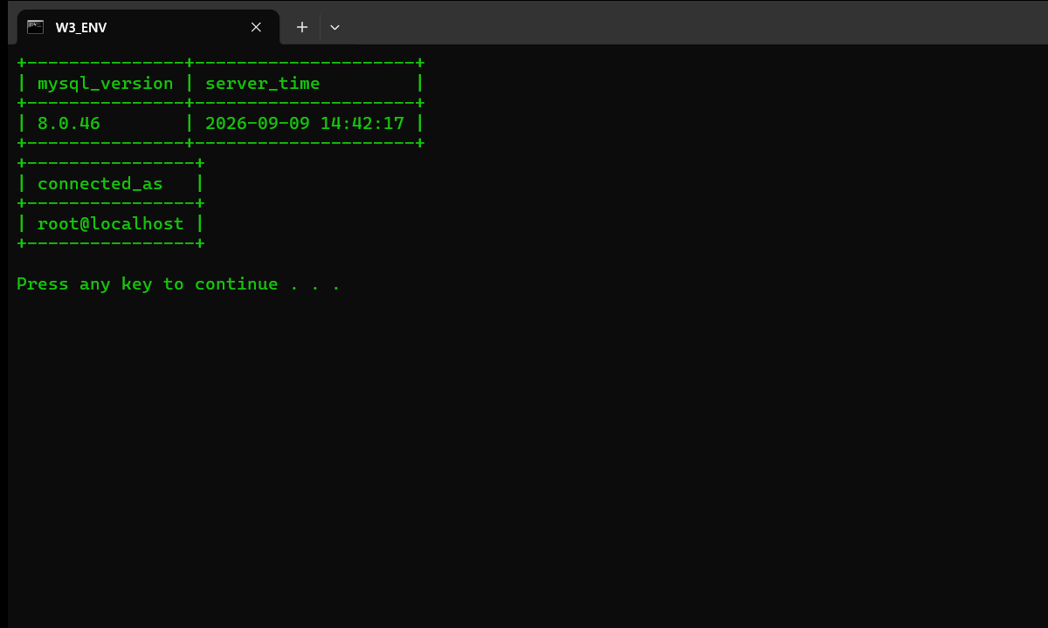
Figure 1: MySQL environment, connection and version verification

4.2 Creating and Selecting the BookFlow Database
A fresh database was created after dropping any previous version. The SHOW DATABASES listing confirms that bookflow_db exists alongside the server's own databases.
DROP DATABASE IF EXISTS bookflow_db;
CREATE DATABASE bookflow_db;
SHOW DATABASES;
Both DDL statements returned "Query OK". The SHOW DATABASES result (Figure 2) lists bookflow_db as one of the available databases.
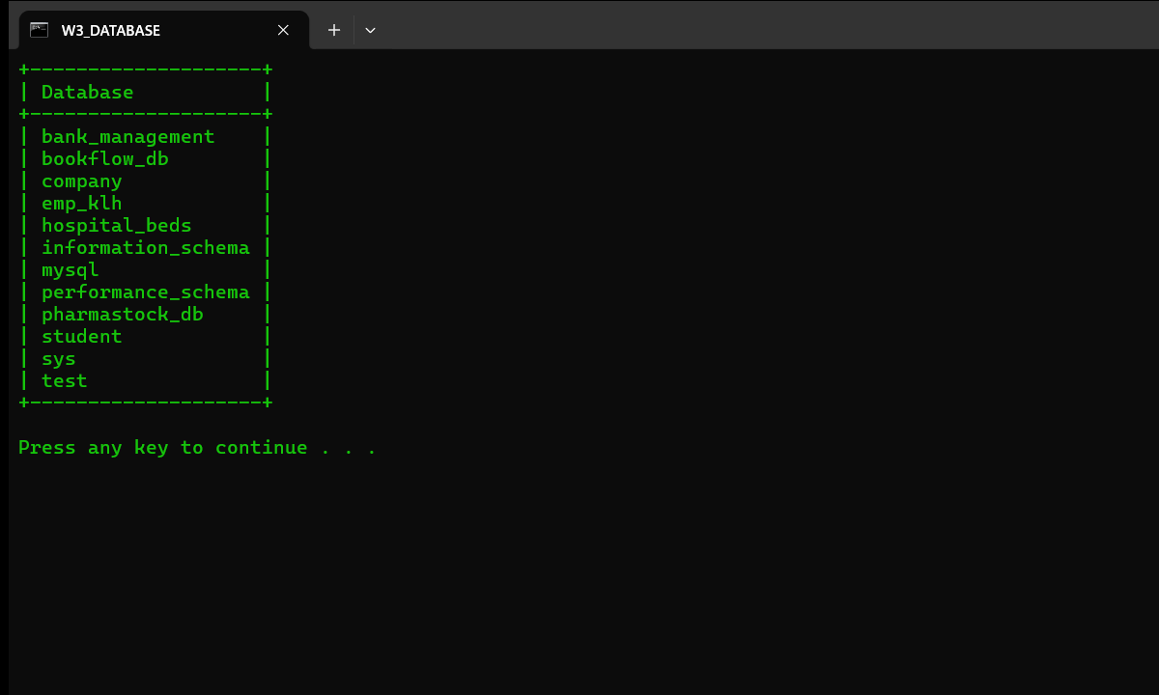
Figure 2: BookFlow database created and listed among the server databases

4.3 Creating Tables with Constraints
Three tables were created. The design uses PRIMARY KEY, NOT NULL, UNIQUE and FOREIGN KEY constraints so that the database itself enforces data integrity. The complete CREATE TABLE statements and the SHOW TABLES confirmation are shown below.
CREATE TABLE IF NOT EXISTS Books (
book_id INT PRIMARY KEY,
title VARCHAR(120) NOT NULL,
author VARCHAR(100) NOT NULL,
category VARCHAR(60) NOT NULL,
publication_year SMALLINT NOT NULL,
price DECIMAL(8,2) NOT NULL,
rating DECIMAL(3,1) NOT NULL DEFAULT 0.0,
page_count INT NOT NULL DEFAULT 0
);
CREATE TABLE IF NOT EXISTS Members (
member_id INT PRIMARY KEY,
member_name VARCHAR(100) NOT NULL,
email VARCHAR(120) NOT NULL UNIQUE,
membership_date DATE NOT NULL
);
CREATE TABLE IF NOT EXISTS Reviews (
review_id INT PRIMARY KEY,
book_id INT NOT NULL,
member_id INT NOT NULL,
rating TINYINT NOT NULL,
comment VARCHAR(255),
review_date DATE NOT NULL,
CONSTRAINT fk_reviews_book FOREIGN KEY (book_id) REFERENCES Books(book_id),
CONSTRAINT fk_reviews_member FOREIGN KEY (member_id) REFERENCES Members(member_id)
);
SHOW TABLES;
SHOW TABLES returned exactly the three expected tables: books, members and reviews (Figure 3).
Table | Constraints enforced
Books | PRIMARY KEY (book_id); NOT NULL on title, author, category, publication_year, price, rating and page_count
Members | PRIMARY KEY (member_id); NOT NULL on all columns; UNIQUE (email)
Reviews | PRIMARY KEY (review_id); NOT NULL on rating and review_date; FOREIGN KEY (book_id) references Books, (member_id) references Members

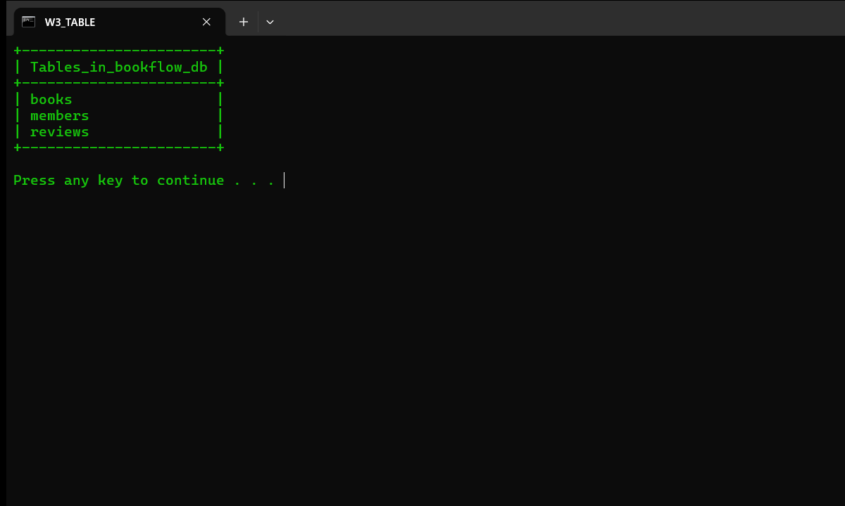
Figure 3: Books, Members and Reviews tables created (SHOW TABLES)

4.4 Inserting Records
Realistic library records were inserted into the three tables using compact multi-row INSERT statements. Each INSERT returned "Query OK, N rows affected".
INSERT INTO Books (book_id, title, author, category, publication_year, price, rating, page_count) VALUES
(1, 'The Martian', 'Andy Weir', 'Science Fiction', 2014, 499, 4.6, 369),
(2, 'Dune', 'Frank Herbert', 'Science Fiction', 1965, 599, 4.5, 412),
(3, 'Clean Code', 'Robert C. Martin', 'Programming', 2008, 899, 4.7, 464),
(4, 'Artificial Intelligence Basics', 'Tom Tauber', 'Digital Learning', 2019, 749, 4.2, 320),
(5, 'Digital Signal Processing', 'John G. Proakis', 'Digital Learning', 2013, 1099, 4.3, 1024),
(6, 'Data Structures and Algorithms', 'Michael T. Goodrich', 'Programming', 2014, 829, 4.4, 720),
(7, 'Digital Fortress', 'Dan Brown', 'Digital Learning', 1998, 399, 3.9, 510);
INSERT INTO Members (member_id, member_name, email, membership_date) VALUES
(101, 'Aditya Rao', 'aditya.rao@example.com', '2025-01-15'),
(102, 'Sneha Verma', 'sneha.verma@example.com', '2025-02-20'),
(103, 'Rohan Gupta', 'rohan.gupta@example.com', '2025-03-10'),
(104, 'Priya Nair', 'priya.nair@example.com', '2025-04-05'),
(105, 'Karthik Menon', 'karthik.menon@example.com', '2025-05-18'),
(106, 'Divya Sharma', 'divya.sharma@example.com', '2025-06-22');
INSERT INTO Reviews (review_id, book_id, member_id, rating, comment, review_date) VALUES
(1, 1, 101, 5, 'Brilliant survival story, very engaging.', '2025-07-01'),
(2, 1, 102, 4, 'Great science, slightly slow mid-section.', '2025-07-10'),
(3, 2, 103, 5, 'A sci-fi masterpiece.', '2025-07-05'),
(4, 2, 104, 4, 'Rich world-building, dense at times.', '2025-08-02'),
(5, 3, 101, 5, 'Essential for every software developer.', '2025-08-15'),
(6, 3, 105, 5, 'Practical and clearly written.', '2025-08-20'),
(7, 4, 102, 4, 'A solid introduction to AI concepts.', '2025-09-01'),
(8, 5, 106, 4, 'Comprehensive coverage of DSP topics.', '2025-09-12'),
(9, 6, 105, 5, 'Well-structured algorithms reference.', '2025-09-18'),
(10, 6, 103, 4, 'Great examples and exercises.', '2025-10-01'),
(11, 7, 104, 3, 'Entertaining but predictable.', '2025-10-10');
SELECT COUNT(*) AS total_books FROM Books;
SELECT COUNT(*) AS total_members FROM Members;
SELECT COUNT(*) AS total_reviews FROM Reviews;
In total 7 books, 6 members and 11 reviews were inserted. The three COUNT(*) verification queries confirmed exactly these totals, as summarised in the table below and shown in Figure 4.
Table | Rows inserted | Primary key column
Books | 7 | book_id
Members | 6 | member_id
Reviews | 11 | review_id


Figure 4: Records inserted into Books, Members and Reviews with COUNT verification

4.5 Verification of the Inserted Data
Every row of every table was then displayed to verify the inserted data in full.
SELECT * FROM Books;
SELECT * FROM Members;
SELECT * FROM Reviews;
The complete result sets (Figure 5) show the seven books with their categories, ratings and page counts, the six members with unique e-mail addresses and membership dates, and all eleven reviews linking books to members.
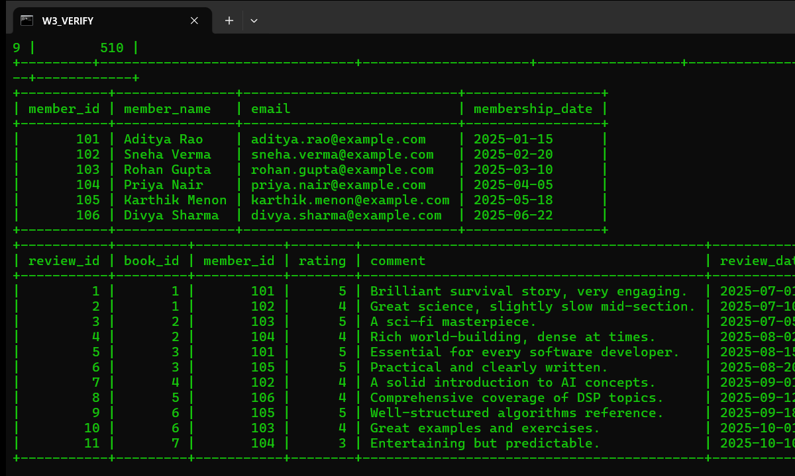
Figure 5: Complete data verification of Books, Members and Reviews

4.6 Comparison Queries
The WHERE clause was used with comparison operators to filter rows: greater-than on price, the IN list operator on category, and a combined AND condition on publication_year and rating.
SELECT title, price FROM Books WHERE price > 500;
SELECT title, category FROM Books WHERE category IN ('Programming', 'Science Fiction');
SELECT title, publication_year, rating FROM Books WHERE publication_year > 2000 AND rating >= 4.5;
The three queries returned 5, 4 and 2 rows respectively, as summarised below; the real result sets appear in Figure 6.
Comparison query | Rows returned
price > 500 | 5
category IN ('Programming', 'Science Fiction') | 4
publication_year > 2000 AND rating >= 4.5 | 2

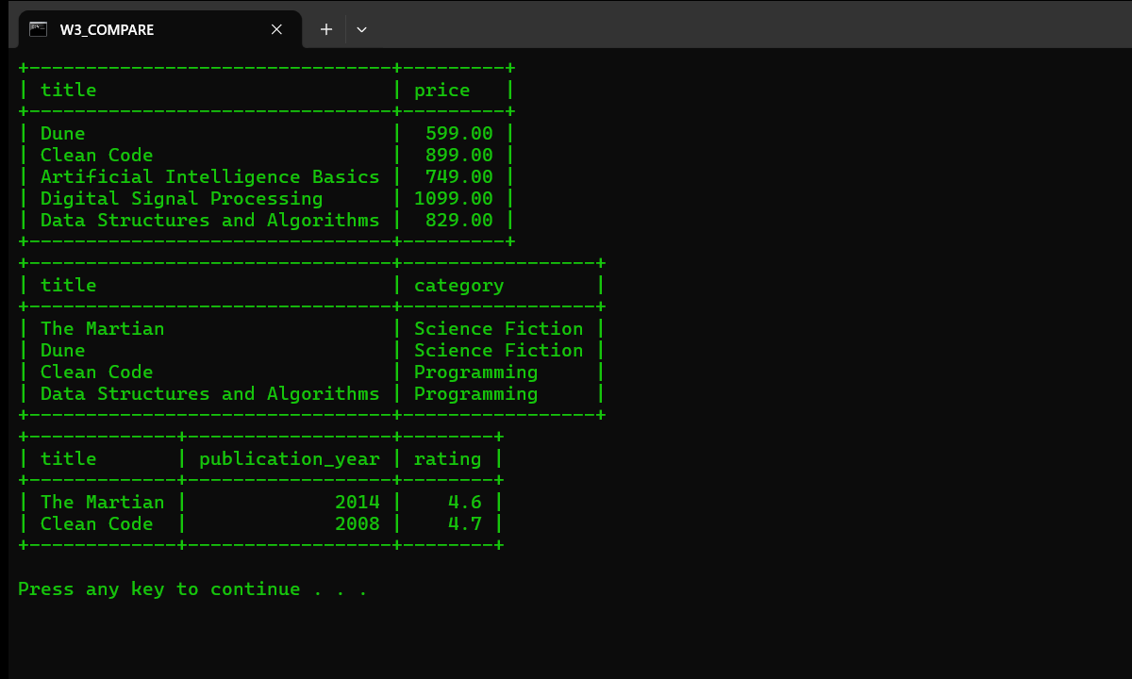
Figure 6: Comparison queries (price, category IN, year AND rating)

4.7 Pattern Matching Queries (REGEXP and LIKE)
MySQL's REGEXP operator matched every title containing the character sequence "Digital" using a regular expression, while LIKE matched the fixed pattern "%Learning%" in the category column.
SELECT book_id, title, category FROM Books WHERE title REGEXP 'Digital';
SELECT book_id, title, category FROM Books WHERE category LIKE '%Learning%';
REGEXP found both titles containing "Digital" (Digital Signal Processing and Digital Fortress), and LIKE found the three "Digital Learning" titles (Figure 7).
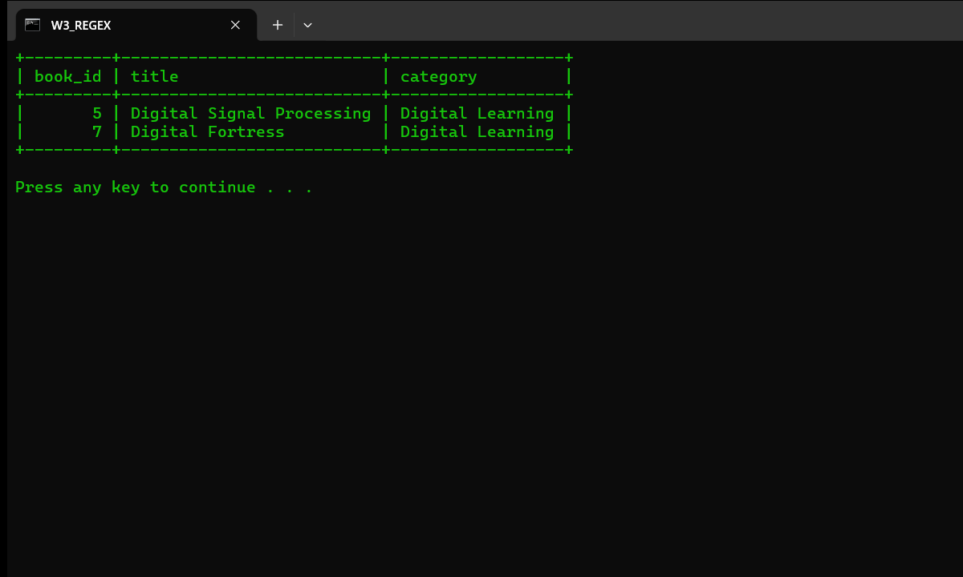
Figure 7: Pattern-matching queries with REGEXP and LIKE

4.8 Aggregation Queries
COUNT, AVG and GROUP BY summarised the catalogue: the average rating per category, the review count and average review rating per book (computed through an INNER JOIN between Reviews and Books), and a filtered grouping of books rated at least 4.0.
SELECT category, COUNT(*) AS no_of_books, AVG(rating) AS avg_rating
FROM Books GROUP BY category ORDER BY avg_rating DESC;
SELECT b.title, COUNT(r.review_id) AS review_count, AVG(r.rating) AS avg_review_rating
FROM Reviews r INNER JOIN Books b ON r.book_id = b.book_id
GROUP BY b.title ORDER BY avg_review_rating DESC;
SELECT category, COUNT(*) AS total, AVG(rating) AS avg_rating
FROM Books WHERE rating >= 4.0 GROUP BY category ORDER BY avg_rating DESC;
The results show that Science Fiction and Programming average 4.55 while Digital Learning averages 4.13; the per-category figures are summarised below and the full output appears in Figure 8.
Category | No. of books | Average rating
Science Fiction | 2 | 4.55
Programming | 2 | 4.55
Digital Learning | 3 | 4.13

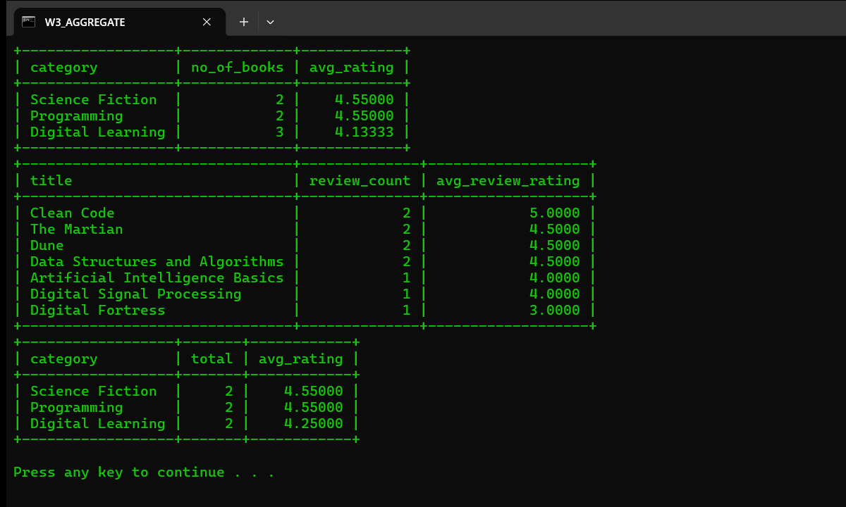
Figure 8: Aggregation queries with COUNT and AVG using GROUP BY

4.9 Sorting and Ordering the Results
ORDER BY sorted the results in descending (DESC) and ascending (ASC) order.
SELECT title, category, price FROM Books WHERE price > 400 ORDER BY price DESC;
SELECT member_name, membership_date FROM Members ORDER BY membership_date;
The first query lists the books priced above 400 from the most expensive to the least, and the second lists the members from the earliest to the most recent membership date (Figure 9).
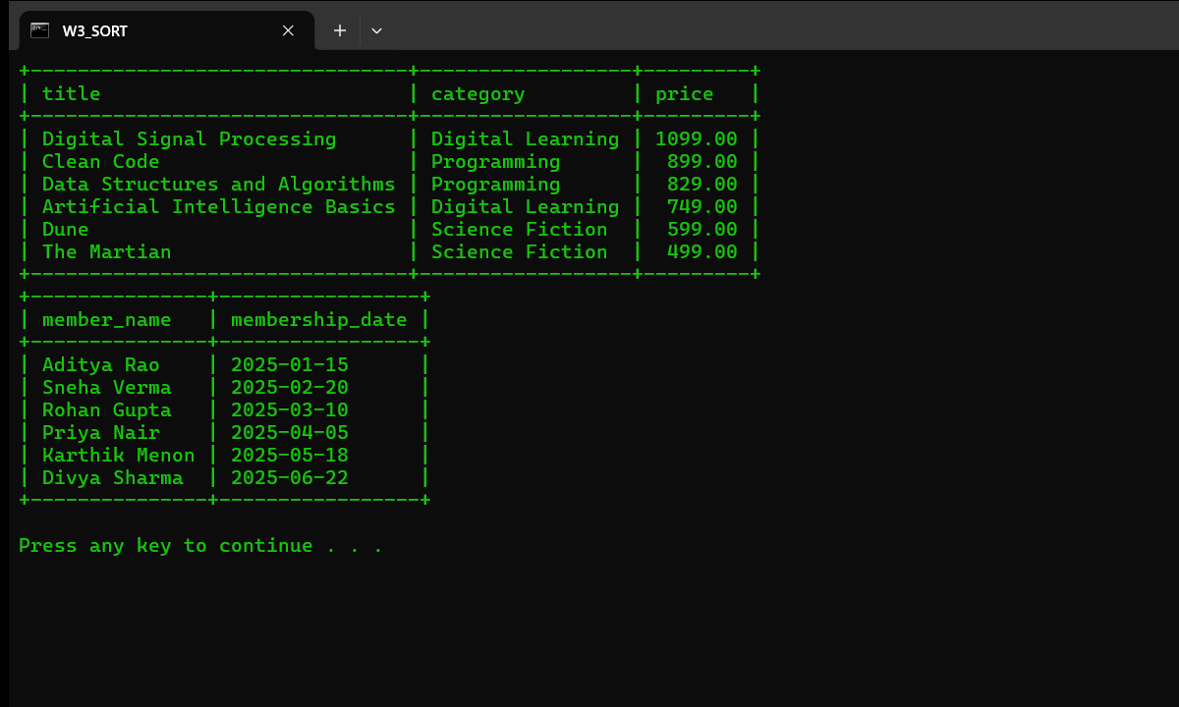
Figure 9: Sorting queries with ORDER BY (DESC and ASC)

4.10 Index Creation and Query-Plan Analysis
Two secondary indexes were created: a regular BTREE index on the frequently filtered column category, and a FULLTEXT index on title to support full-text searches with MATCH...AGAINST. SHOW INDEX was used to inspect the resulting indexes.
CREATE INDEX idx_books_category ON Books(category);
CREATE FULLTEXT INDEX idx_books_title_ft ON Books(title);
SHOW INDEX FROM Books;
SHOW INDEX FROM Books (Figure 10) lists the PRIMARY BTREE index on book_id, the secondary BTREE index idx_books_category on category, and the FULLTEXT index idx_books_title_ft on title.
Index name | Column | Non-unique | Index type
PRIMARY | book_id | 0 | BTREE
idx_books_category | category | 1 | BTREE
idx_books_title_ft | title | 1 | FULLTEXT

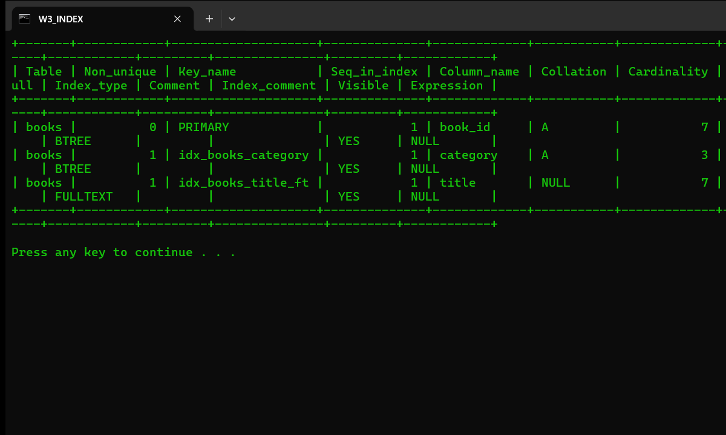
Figure 10: Index creation and SHOW INDEX result
EXPLAIN then revealed the execution plans used by three equivalent searches: an equality search on the indexed category column, a REGEXP scan of the title, and a full-text MATCH...AGAINST search on the FULLTEXT index.
EXPLAIN SELECT * FROM Books WHERE category = 'Digital Learning';
EXPLAIN SELECT * FROM Books WHERE title REGEXP 'Digital';
EXPLAIN SELECT title FROM Books WHERE MATCH(title) AGAINST('Digital');
The equality search on the indexed column category used the idx_books_category index (type ref), the REGEXP search had to scan the whole table (type ALL), and the FULLTEXT search used the idx_books_title_ft index (Figure 11).
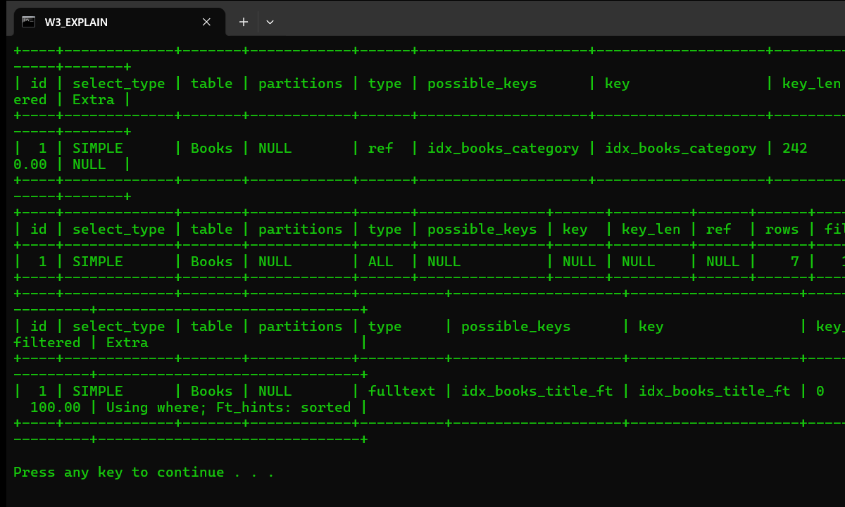
Figure 11: EXPLAIN query-plan analysis for indexed and REGEXP searches

5. Result
The Week-3 practical was completed successfully on MySQL 8.0.46. The bookflow_db database was created with three related tables (Books, Members, Reviews) enforcing PRIMARY KEY, NOT NULL, UNIQUE and FOREIGN KEY constraints. Seven books, six members and eleven reviews were inserted and verified. Comparison queries with WHERE (>, IN, AND, >=), pattern matching with REGEXP and LIKE, aggregation with COUNT and AVG using GROUP BY (including an INNER JOIN between Reviews and Books), and ascending and descending ordering were all demonstrated with real query results. Secondary BTREE and FULLTEXT indexes were created, inspected with SHOW INDEX, and their effect on the execution plan was analysed with EXPLAIN.

6. Conclusion
This practical established the full relational-database workflow in MySQL with an emphasis on querying and performance: data definition with integrity constraints, bulk data insertion, filtering, pattern matching, aggregation, sorting, index-based performance support and execution-plan analysis. All operations produced verified results on the student's own Windows 11 machine (MySQL 8.0.46). The same relational constructs and indexing techniques underpin the book-catalogue database used for the course project.

