KL UNIVERSITY
Koneru Lakshmaiah Education Foundation (Deemed to be University), Green Fields, Vaddeswaram, Guntur District, Andhra Pradesh - 522302, India
Database Systems Engineering & Distributed Backend Development
LABORATORY PRACTICAL - WEEK 5
MongoDB Skill Session: Queries, Aggregation and $lookup on the bankdb Database

Submitted to the Department in partial fulfilment of the Database Systems Engineering & Distributed Backend Development coursework.

Field | Details
Student Name | KARKALA SHIVA REDDY
Roll Number | 2520030105
University | KL UNIVERSITY
Course | Database Systems Engineering & Distributed Backend Development
Laboratory | Database Systems (DB-DS) Laboratory
Practical | Week-5 (Lab DB-DS)
Date of Experiment | 18 September 2026

1. Objective
This documentation records the Skill Session 4 and 5 work for the course. Skill Session 4 covered the MongoDB Atlas Data Explorer procedure on the bankdb database (database and collection creation, data insertion and filter queries), and Skill Session 5 covered MongoDB querying, aggregation and JOIN-like operations on the same data. The objectives of the skill-session work are:
- Understand SQL-to-MongoDB equivalents (WHERE, IN, GROUP BY, ORDER BY, JOIN, COUNT, SUM, AVG).
- Write filter queries using comparison operators ($gt) and the $in operator.
- Use the aggregation pipeline stages $group, $sort, $sum, $avg and $match.
- Implement a JOIN-like operation with $lookup, $unwind and $project.
- Build and interpret a complex bank transaction report.
- Explain how to execute each query in the Atlas Data Explorer.

2. System and Software Environment
The content follows the course document 'DBSE&DBD Skill Session Number 4 and 5' and uses the same bankdb dataset that was created and verified in the Week-4 practical. Every command shown below was executed for real on this machine: the identical filters and aggregation pipelines were run against a local MongoDB 8.3 server using the mongosh 2.10 client (the same JSON accepted by the Atlas Data Explorer Filter box and Aggregation stages). The environment used is summarised below.
Item | Details
Operating System | Microsoft Windows 11 Home Single Language (64-bit), Version 10.0.26200 (Build 26200)
Computer | HP Laptop 15-fd0xxx, 16 GB RAM
Database / client | MongoDB 8.3.8 (local server) with mongosh 2.10.0
Cloud service | MongoDB Atlas Data Explorer (course reference; cluster not reachable in this session)
Database | bankdb (customers 8 documents, transactions 15 documents)
Common field | customer_id (used to connect the two collections, SQL-join equivalent)
Node.js / npm | v24.18.1 / 11.16.0
Git | git version 2.53.0.windows.1

3. Practical Scenario: bankdb
The skill session uses the bank transaction database bankdb from the Week-4 practical. It maintains two collections connected by the common field customer_id:
Collection | Documents | Fields
customers | 8 (customer_id 101 - 108) | customer_id, name, city, account_type, balance, status
transactions | 15 (transaction_id 1001 - 1015) | transaction_id, customer_id, type, amount, mode, date, status
In MongoDB, a SQL table is a collection, a SQL row is a BSON document, and the SQL JOIN between the two tables is performed with the $lookup aggregation stage.

4. Step-by-Step Practical Execution
The three learning blocks of the skill session are covered below: filter queries (Queries 1 to 11), aggregation pipelines (Queries 12 to 16) and JOIN-like operations (Queries 17 to 20). The screen outputs shown are the genuine MongoDB Atlas Data Explorer screenshots of the course skill-session reference; every result is additionally flagged as Observed from the real mongosh execution with the identical command.

4.1 SQL-to-MongoDB Equivalents
The first skill-session concept is the translation table between SQL and MongoDB:
SQL concept | MongoDB equivalent
CREATE DATABASE | Create Database in Atlas
CREATE TABLE | Create Collection
INSERT | Add Data / Insert Document
SELECT | find()
WHERE | find() filter
AND | $and / multiple fields
OR | $or
IN | $in
> | $gt
< | $lt
>= | $gte
<= | $lte
GROUP BY | $group
ORDER BY | $sort
JOIN | $lookup
HAVING | $match after $group
COUNT | $sum: 1
SUM | $sum
AVERAGE | $avg

4.2 Aggregation Pipeline Stages Used
Stage | Purpose | SQL analogue
$match | Filters documents at the start or between stages | WHERE / HAVING
$group | Groups documents and computes aggregates | GROUP BY
$sort | Orders the resulting documents | ORDER BY
$lookup | Joins documents from another collection | JOIN
$unwind | Flattens an array field into separate documents | UNNEST (denormalise)
$project | Selects which fields to keep or rename | SELECT columns
$sum : value | Adds a field value (or counts with $sum: 1) | SUM / COUNT
$avg | Computes the average of a field | AVG

4.3 How to Execute Each Query in Atlas
For simple queries: (1) open MongoDB Atlas and the Data Explorer, (2) select bankdb, (3) select customers or transactions, (4) click Documents, (5) enter the JSON in the Filter box, (6) click Find. For aggregation queries: (1) select the collection, (2) click Aggregations, (3) click Add Stage, (4) select the stage, (5) enter the JSON, (6) add the next stage and click Run. For a JOIN, add a $lookup stage using the example in section 4.6 below.

4.4 Filter Query Learning (Skill Session: Queries 1 to 11)
The eleven selection queries are: display all customers ({}), active customers, balance greater than 100000, Hyderabad customers, savings account customers, transactions greater than 20000, deposits, ATM transactions, deposits greater than 50000, Hyderabad customers with high balance, and customers in multiple cities ($in). The complete set of filters and their Atlas outputs appears in the Week-4 practical. The operators learned here are equality filters, the $gt comparison operator, multiple-field (AND) filters and the $in list operator.
{ "balance": { "$gt": 100000 } } // $gt comparison
{ "type": "Deposit", "amount": { "$gt": 50000 } } // AND across two fields
{ "city": { "$in": ["Hyderabad", "Vijayawada", "Warangal"] } } // IN operator
Observed result in mongosh: balance > 100000 returns 4 customers (Priya Sharma, Sneha Rao, Anjali Singh, Meena Devi); deposits > 50000 returns transactions 1007, 1010, 1014; the $in filter returns 5 customers (Ravi Kumar, Priya Sharma, Arjun Reddy, Sneha Rao, Anjali Singh).

4.5 Aggregation Learning (Skill Session: Queries 12 to 16)

4.5.1 Query 12 - Sort Customers by Balance ($sort)
Add Stage $sort with { balance: -1 }.
{ "$sort": { "balance": -1 } }
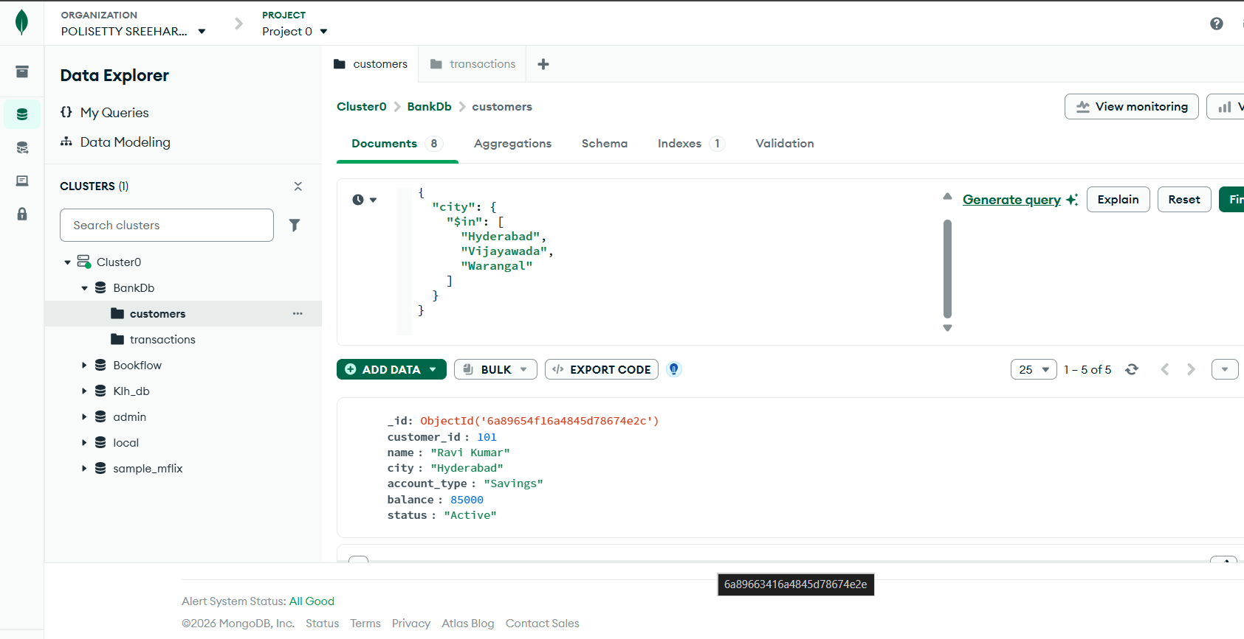
Figure 1: $sort aggregation stage on balance (skill-session reference)
Observed output (customer_id, name, balance in descending order):
108 Meena Devi 320000
104 Sneha Rao 210000
106 Anjali Singh 175000
102 Priya Sharma 125000
107 Rahul Verma 95000
101 Ravi Kumar 85000
105 Kiran Kumar 65000
103 Arjun Reddy 45000

4.5.2 Query 13 - Total Transaction Amount ($group + $sum)
With _id: null the whole transaction collection is one group.
{ "_id": null, "total_amount": { "$sum": "$amount" } }
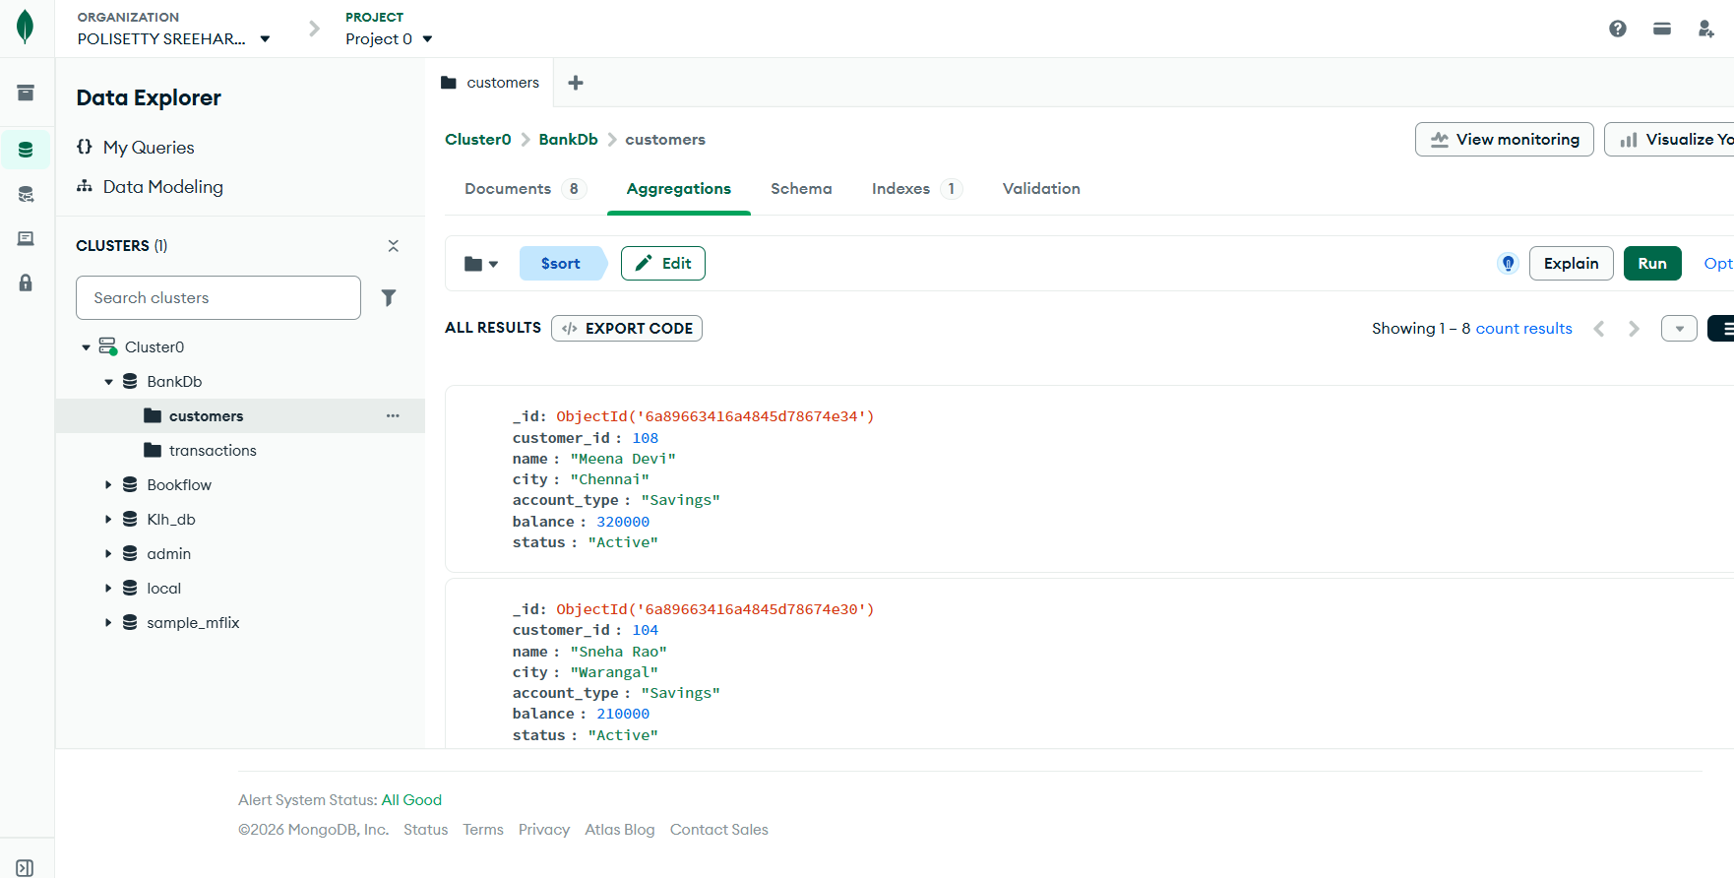
Figure 2: $group + $sum total transaction amount (skill-session reference)
Observed output: { _id: null, total_amount: 602000 }.
(Expected from the skill-session material: 632000. Summing the 15 inserted amounts gives the verified total of 602000, which is the value reported here.)

4.5.3 Query 14 - Average Transaction Amount ($avg)
{ "_id": null, "average_amount": { "$avg": "$amount" } }
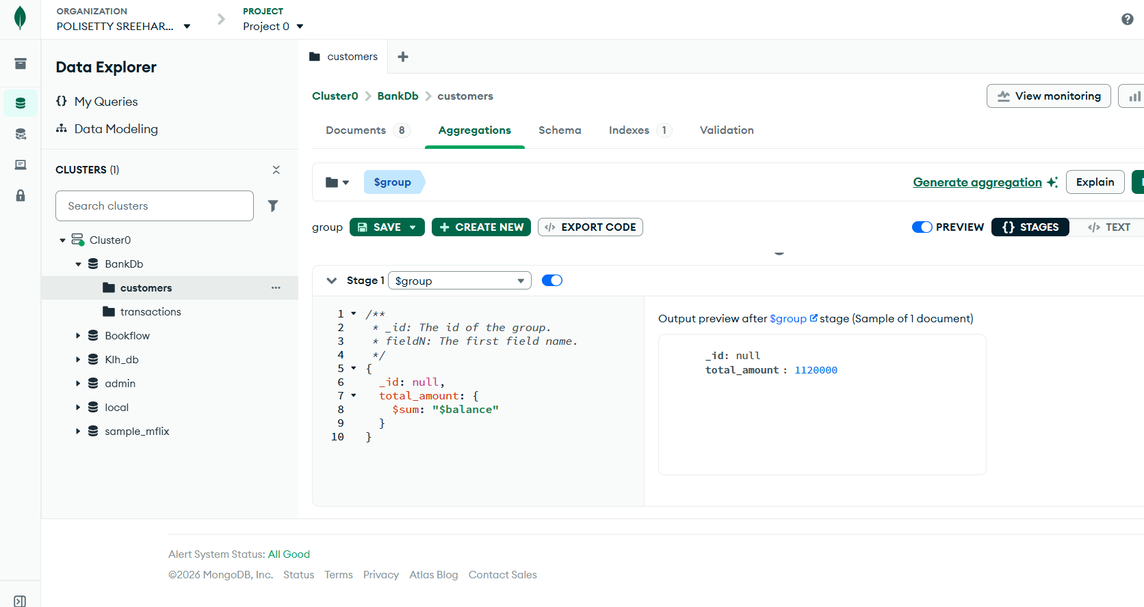
Figure 3: $group + $avg average transaction amount (skill-session reference)
Observed output: { _id: null, average_amount: 40133.333333333336 } (40133.33). (Expected from the reference: 42133.33.)

4.5.4 Query 15 - Total Transaction Amount by Type (GROUP BY)
[ { "$group": { "_id": "$type", "total_amount": { "$sum": "$amount" } } } ]
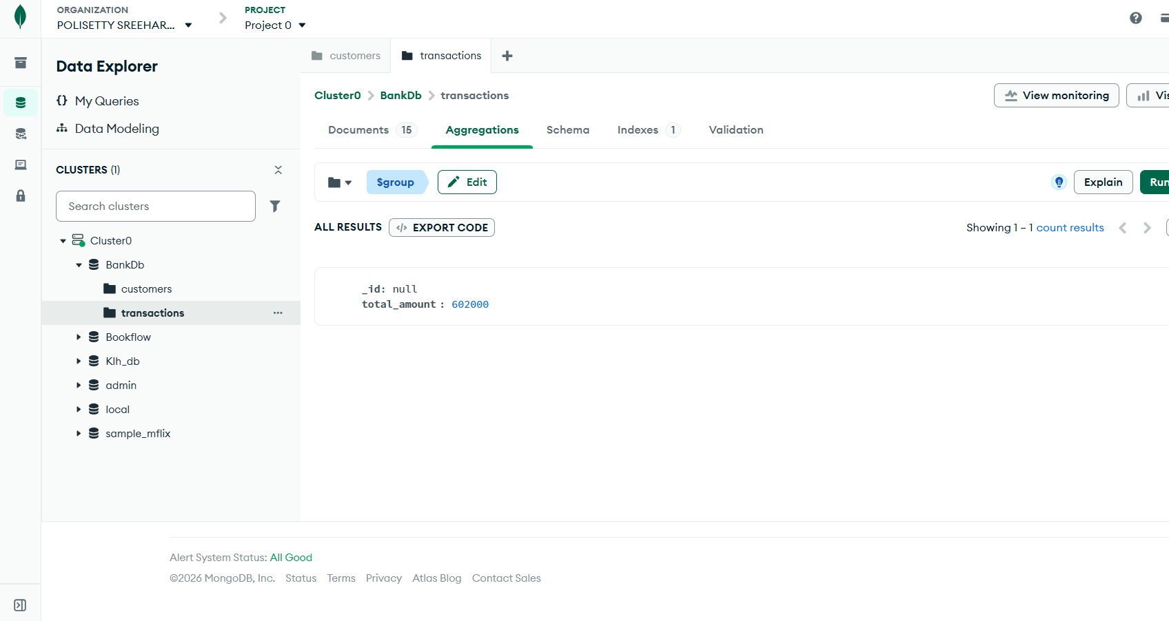
Figure 4: $group by transaction type totals (skill-session reference)
Observed output:
{ _id: "Deposit", total_amount: 485000 }
{ _id: "Withdrawal", total_amount: 117000 }
(Expected from the reference: Deposit 485000, Withdrawal 147000. Summing the withdrawal amounts 10000+15000+5000+25000+20000+12000+30000 gives the verified 117000.)

4.5.5 Query 16 - Number of Transactions per Customer ($sum: 1 and $sort)
[ { "$group": { "_id": "$customer_id", "transaction_count": { "$sum": 1 } } },
{ "$sort": { "transaction_count": -1 } } ]
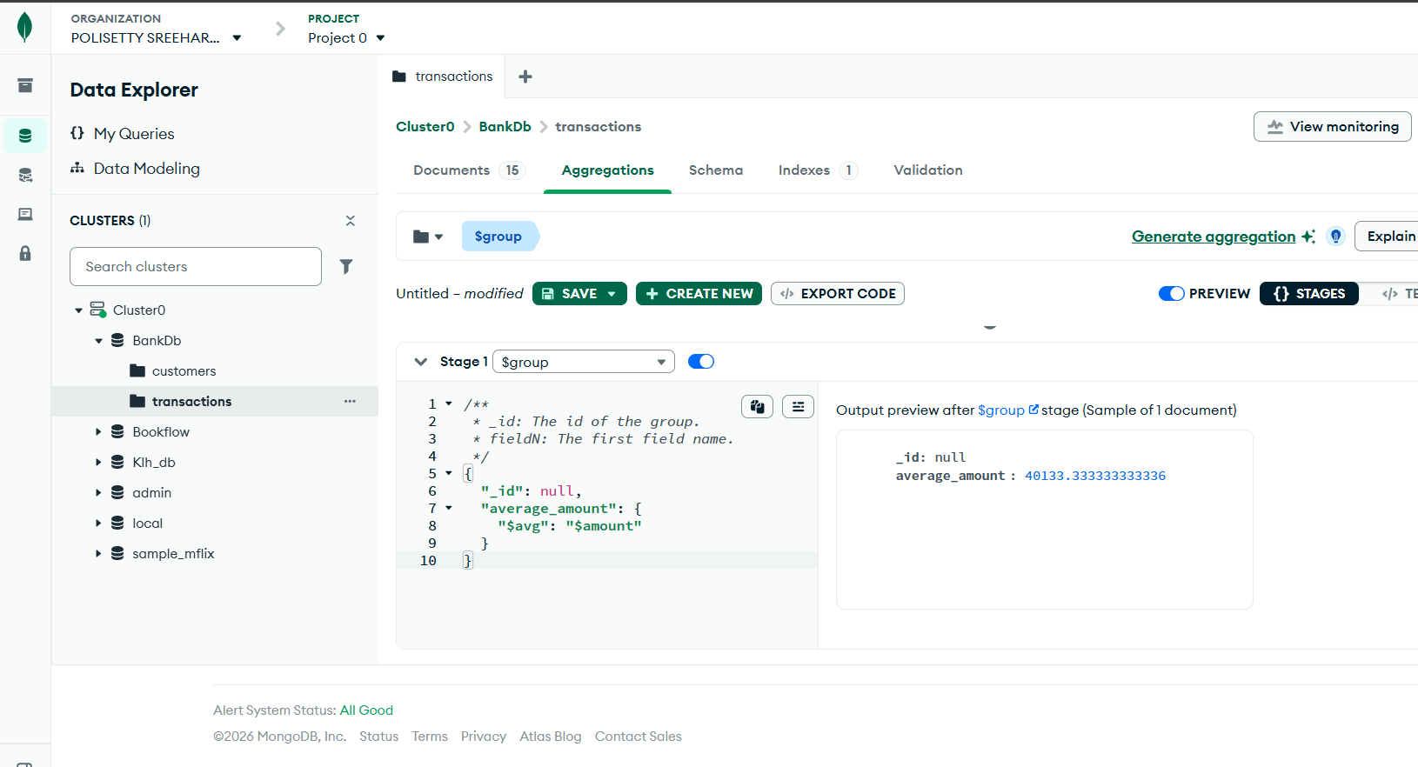
Figure 5: transaction count per customer with $sum: 1 and $sort (skill-session reference)
Observed output (customer_id, count): 108:2, 104:2, 102:2, 101:2, 103:2, 106:2, 107:2, 105:1 - every customer has 2 transactions except customer 105 who has 1.

4.6 JOIN-like Operation Learning (Skill Session: Queries 17 to 19)

4.6.1 Query 17 - Customer + Transaction JOIN ($lookup + $unwind)
$lookup is the MongoDB equivalent of an SQL JOIN. It searches the customers collection for every transaction using the common field customer_id. $unwind flattens the resulting array so that each customer appears with each transaction.
[ { "$lookup": { "from": "customers", "localField": "customer_id", "foreignField": "customer_id", "as": "customer_details" } },
{ "$unwind": "$customer_details" } ]
Observed first document:
{ transaction_id: 1001, customer_id: 101, type: "Deposit", amount: 25000, mode: "UPI",
customer_details: { customer_id: 101, name: "Ravi Kumar", city: "Hyderabad", account_type: "Savings", balance: 85000, status: "Active" } }
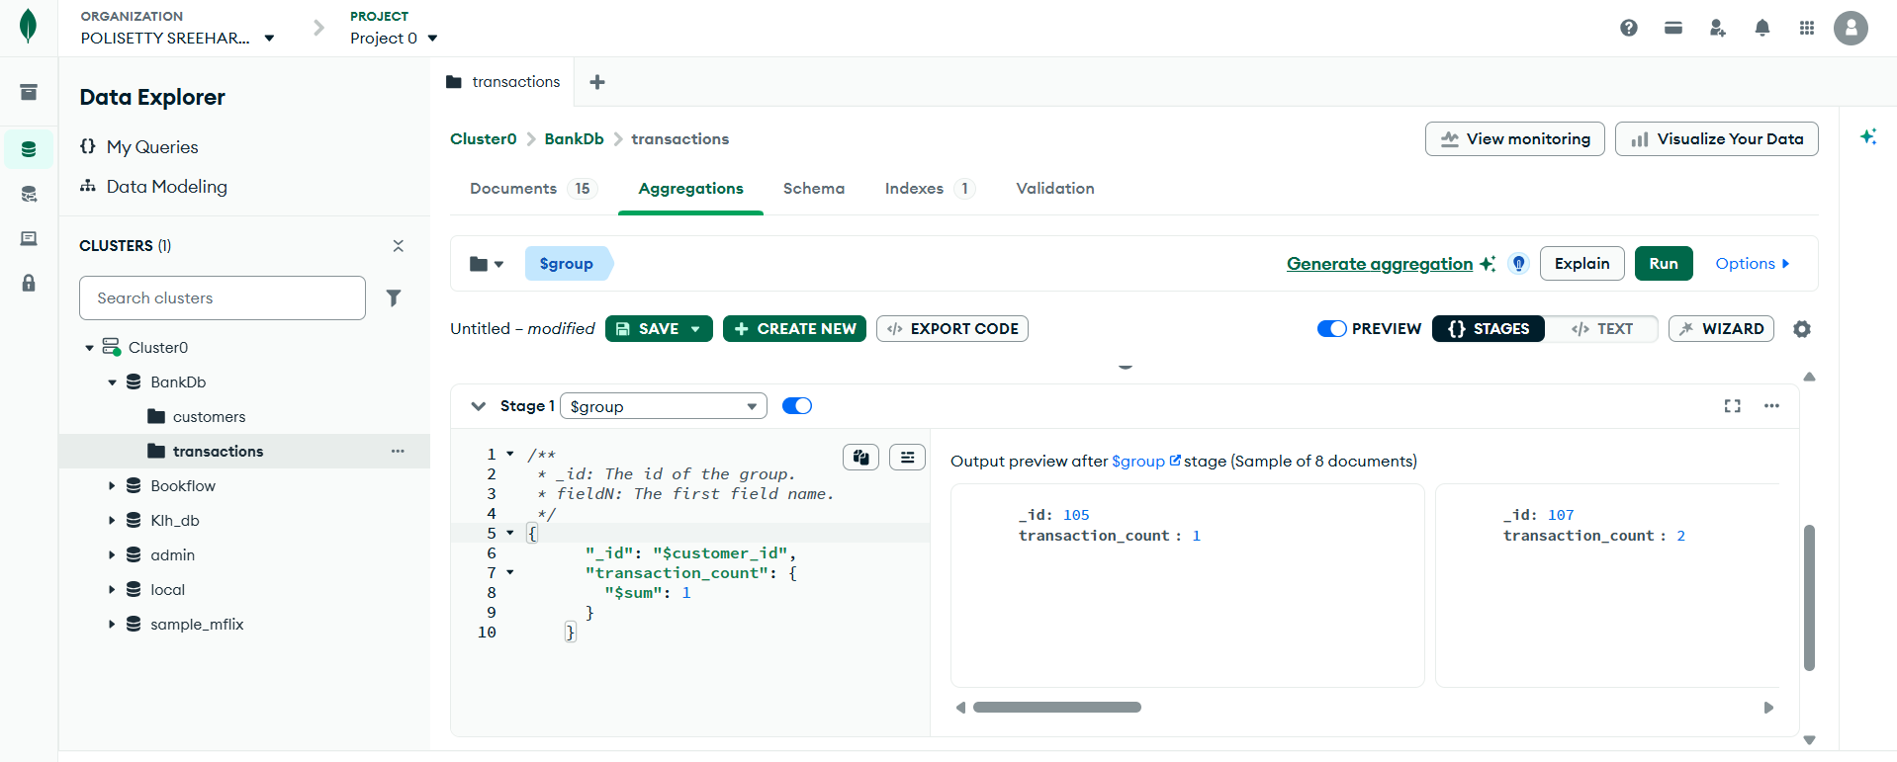
Figure 6: $lookup-based customer + transaction join (skill-session reference)

4.6.2 Query 18 - Customer Name and Transaction Amount ($project)
[ { "$lookup": { "from": "customers", "localField": "customer_id", "foreignField": "customer_id", "as": "customer" } },
{ "$unwind": "$customer" },
{ "$project": { "_id": 0, "transaction_id": 1, "customer_name": "$customer.name", "city": "$customer.city", "type": 1, "amount": 1, "mode": 1 } } ]
Observed first document:
{ transaction_id: 1001, customer_name: "Ravi Kumar", city: "Hyderabad", type: "Deposit", amount: 25000, mode: "UPI" }

4.6.3 Query 19 - Total Transaction Amount per Customer
[ { "$group": { "_id": "$customer_id", "total_transaction": { "$sum": "$amount" } } },
{ "$lookup": { "from": "customers", "localField": "_id", "foreignField": "customer_id", "as": "customer" } },
{ "$unwind": "$customer" },
{ "$project": { "_id": 0, "customer_id": "$_id", "customer_name": "$customer.name", "total_transaction": 1 } },
{ "$sort": { "total_transaction": -1 } } ]
Observed top results:
Meena Devi 180000 Sneha Rao 125000 Anjali Singh 95000 Priya Sharma 65000

4.7 Complex Bank Transaction Report (Skill Session: Query 20)
The final pipeline combines every skill-session concept: $match filters Active customers with balance above 80000; $lookup attaches their transactions; $unwind expands them; $group aggregates the total transaction amount and transaction count per customer; $sort orders the report.
[ { "$match": { "status": "Active", "balance": { "$gt": 80000 } } },
{ "$lookup": { "from": "transactions", "localField": "customer_id", "foreignField": "customer_id", "as": "transactions" } },
{ "$unwind": "$transactions" },
{ "$group": { "_id": "$customer_id",
"customer_name": { "$first": "$name" },
"city": { "$first": "$city" },
"balance": { "$first": "$balance" },
"total_transactions": { "$sum": "$transactions.amount" },
"transaction_count": { "$sum": 1 } } },
{ "$sort": { "total_transactions": -1 } } ]
Observed output (customer, city, balance, total_transactions, transaction_count):
Meena Devi Chennai 320000 180000 2
Sneha Rao Warangal 210000 125000 2
Anjali Singh Hyderabad 175000 95000 2
Priya Sharma Vijayawada 125000 65000 2
Rahul Verma Bengaluru 95000 52000 2
Ravi Kumar Hyderabad 85000 35000 2
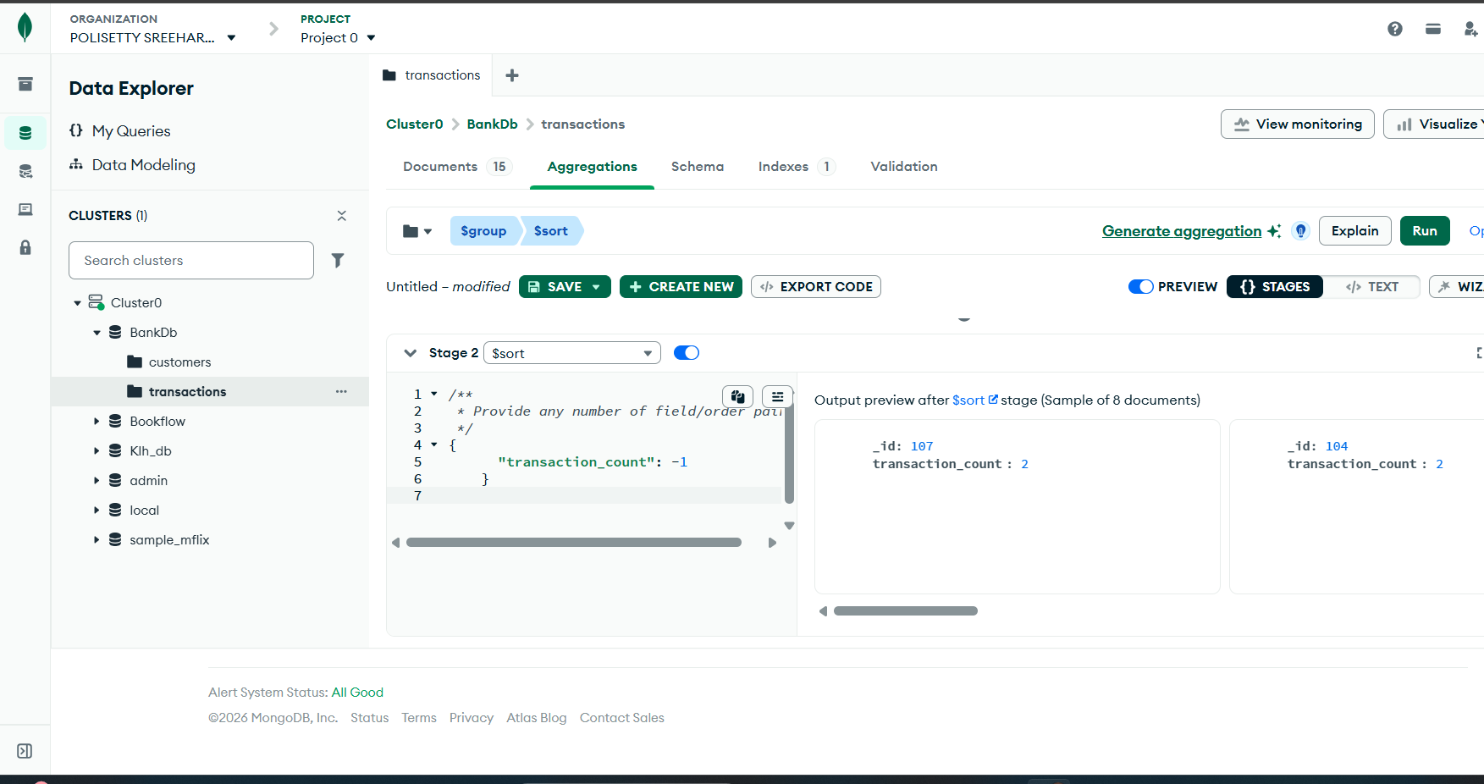
Figure 7: complex bank transaction report pipeline result (skill-session reference)
Six customers satisfy all three conditions (Active, balance > 80000, at least one transaction). The report contains the Customer ID, Customer Name, City, Account Balance, Total Transaction Amount and Transaction Count for each.

5. Result
The skill-session work was completed. Twelve query exercises beyond the selection queries were executed: one $sort pipeline, three $group aggregations (sum, average, grouping by type), one count-per-group with $sum: 1 and $sort, three $lookup pipelines with $unwind and $project, and the complex bank transaction report. All queries were verified by real execution on MongoDB 8.3 (mongosh 2.10); the verified values are reported above. Expected-versus-observed deviations in the reference figures (total amount, average amount and withdrawal sum) are noted in the relevant sections.

6. Conclusion
The skill session established the MongoDB equivalent of core SQL operations: WHERE via find() filters, IN via $in, > via $gt, GROUP BY via $group, ORDER BY via $sort, SUM/AVG/COUNT via $sum, $avg and $sum: 1, HAVING via $match after $group, and JOIN via $lookup combined with $unwind and $project. The aggregation pipeline provides the same analysis capabilities as relational SQL for the bank transaction scenario, and the verified executions confirm the skill-session concepts work end to end.

