KL UNIVERSITY
Koneru Lakshmaiah Education Foundation (Deemed to be University), Green Fields, Vaddeswaram, Guntur District, Andhra Pradesh - 522302, India
Database Systems Engineering & Distributed Backend Development
LABORATORY PRACTICAL - WEEK 6
Basic Spring Boot Application: Spring Initializr, Spring MVC and REST CRUD

Submitted to the Department in partial fulfilment of the Database Systems Engineering & Distributed Backend Development coursework.

Field | Details
Student Name | KARKALA SHIVA REDDY
Roll Number | 2520030105
University | KL UNIVERSITY
Course | Database Systems Engineering & Distributed Backend Development
Laboratory | Database Systems (DB-DS) Laboratory
Practical | Week-6 (Lab DB-DS)
Date of Experiment | 19 September 2026

1. Objective
The aim of this Week-6 laboratory practical is to create and run a basic Spring Boot application and to understand the Spring MVC design pattern. The specific objectives are:
- Create a Spring Boot project from Spring Initializr (start.spring.io) and import it into a build tool.
- Understand how Spring Boot auto-configures the application and starts the embedded Tomcat server.
- Implement a Model-View-Controller (MVC) application with a User model, a Controller and a Thymeleaf view.
- Expose a REST API with HTTP methods GET, POST, PUT and DELETE using annotations (@RestController, @GetMapping, @PostMapping, @PutMapping, @DeleteMapping, @PathVariable, @RequestBody, @RequestMapping).
- Run the application with a single command (mvn spring-boot:run) and test every endpoint with curl.

2. System and Software Environment
The practical follows the course material 'SPRING BOOT1'. The reference material targets the Eclipse-based Spring Tool Suite (STS); in this session the project was created with the same Spring Initializr web site and executed with a plain build tool. Because the machine already had a Java 25 JDK and no system-wide Maven, the downloaded Apache Maven 3.9.9 Maven-wrapper (mvnw) launcher was used. The default port 8080 is occupied on this machine by Docker Desktop, so the application was started on port 8081 (set with the single property server.port=8081).
Item | Details
Operating System | Microsoft Windows 11 Home Single Language (64-bit), Version 10.0.26200 (Build 26200)
Computer | HP Laptop 15-fd0xxx, 16 GB RAM
Java Development Kit | Java(TM) SE Runtime Environment (build 25+37-LTS-3491), JDK 25 LTS
Build tool | Apache Maven 3.9.9 via the Maven wrapper (mvnw spring-boot:run)
Spring Boot version | 4.1.1 (current release served by start.spring.io in this session)
Embedded server | Apache Tomcat 11.0.24 (embedded, started automatically)
View technology | Thymeleaf (spring-boot-starter-thymeleaf)
Application port | 8081 (started because port 8080 is used by Docker Desktop)
HTTP test client | curl.exe against http://localhost:8081
Git | git version 2.53.0.windows.1

3. Practical Scenario: Basic Spring Boot MVC and REST
Spring Boot is an open-source Java framework built on Spring that simplifies the development of stand-alone, production-ready applications with minimal configuration. It removes the need for complex XML configurations and provides auto-configuration, making it easy to create and deploy applications quickly. MVC (Model-View-Controller) is a design pattern used in Spring Boot for developing web applications: the Model manages data and business logic, the View handles the UI (HTML, JSP, Thymeleaf), and the Controller handles user requests and responses. How MVC works: the user sends a request such as http://localhost:8080/home; the Controller receives the request and interacts with the Model; the Model processes the request and returns data to the Controller; the Controller passes the data to the View; the View renders the response to the user.
This practical implements two parts with the same Spring Boot project: (a) an MVC demo with a User model, a UserController and a Thymeleaf home view, and (b) a Student REST API that demonstrates all five HTTP operations with real curl requests. The REST layer in this session uses an in-memory student store, so the complete CRUD behaviour is demonstrable without a database server (the database-backed variant is the Week-7 practical).

4. Step-by-Step Practical Execution

4.1 Creating the Spring Boot Project
Method 1 (used in this session - web): open https://start.spring.io, choose Maven, Java, Spring Boot 4.1.1, group com.klu, artifact 2-BasicSpringApplication, package com.klu.demo, Java 17, and the dependencies Spring Web, Thymeleaf and Spring Boot Actuator, then click Generate and extract the ZIP. Method 2 (reference material): create the same project inside Spring Tool Suite (STS) with File > New > Spring Starter Project and the same inputs. The generated project has the classic layout:
2-BasicSpringApplication
|-- pom.xml
|-- mvnw / mvnw.cmd (Maven wrapper scripts)
`-- src
|-- main
| |-- java/com/klu/demo/Application.java
| `-- resources
| |-- application.properties
| `-- templates/ (Thymeleaf views go here)
`-- test/java/com/klu/demo/ApplicationTests.java
The pom.xml adds the web, Thymeleaf and actuator starters. A small difference from the reference material: the reference shows the Spring Boot 3 dependency spring-boot-starter-web, while the Spring Boot 4.1.1 project generated in this session uses spring-boot-starter-webmvc for the same purpose.
<parent>
<groupId>org.springframework.boot</groupId>
<artifactId>spring-boot-starter-parent</artifactId>
<version>4.1.1</version>
</parent>
<groupId>com.klu</groupId>
<artifactId>2-BasicSpringApplication</artifactId>
<dependencies>
<!-- Spring Boot Web (MVC / REST) -->
<dependency>
<groupId>org.springframework.boot</groupId>
<artifactId>spring-boot-starter-webmvc</artifactId>
</dependency>
<!-- Spring Boot Thymeleaf for View -->
<dependency>
<groupId>org.springframework.boot</groupId>
<artifactId>spring-boot-starter-thymeleaf</artifactId>
</dependency>
</dependencies>

4.2 Implementing MVC in Spring Boot
Step 1 - Model (User.java). A simple POJO with name and age plus getters and setters:
package com.klu.demo.model;
public class User {
private String name;
private int age;
public User() {
}
public User(String name, int age) {
this.name = name;
this.age = age;
}
public String getName() { return name; }
public void setName(String name) { this.name = name; }
public int getAge() { return age; }
public void setAge(int age) { this.age = age; }
}
Step 2 - Controller (UserController.java). The @Controller class maps the path /home and puts the model data into a Thymeleaf view called home:
package com.klu.demo.controller;
import com.klu.demo.model.User;
import org.springframework.stereotype.Controller;
import org.springframework.ui.Model;
import org.springframework.web.bind.annotation.GetMapping;
@Controller
public class UserController {
@GetMapping("/home")
public String home(Model model) {
User user = new User("Alice", 25);
model.addAttribute("user", user);
return "home";
}
}
Step 3 - View (home.html). The Thymeleaf view is placed at src/main/resources/templates/home.html. The expressions ${user.name} and ${user.age} are replaced with the model values:
<!DOCTYPE html>
<html xmlns:th="http://www.thymeleaf.org">
<head>
<title>Spring Boot MVC</title>
</head>
<body>
<h1>Welcome, <span th:text="${user.name}"></span>!</h1>
<p>Your age is: <span th:text="${user.age}"></span></p>
</body>
</html>

4.3 Running the Application
Spring Boot runs with a single command from the project folder: mvn spring-boot:run (or mvnw spring-boot:run with the Maven wrapper). The genuine startup log is reproduced below:
C:\> mvnw spring-boot:run
. ____ _ __ _ _
/\\ /' ___'_ __ _ _(_)_ __ __ _ \\ \\ \\
( ( )\___ | '_ | '_| | '_ \/ _` | \\ \\ \\
\\/ ___)| |_)| | | | | || (_| | ) ) ) )
' |____| .__|_| |_|_| |_\__, | / / / /
=========|_|==============|___/=/_/_/_/
:: Spring Boot :: (v4.1.1)
Starting Application using Java 25 with PID 9704 (tasks started by karka)
Tomcat initialized with port 8081 (http)
Starting Servlet engine: [Apache Tomcat/11.0.24]
Tomcat started on port 8081 (http) with context path '/'
Started Application in 1.827 seconds (process running for 2.12)
# GET http://localhost:8081/actuator/health
{"groups":["liveness","readiness"],"status":"UP"}
The embedded Tomcat server started automatically and the application was ready in about 2 seconds. The actuator health endpoint reports UP, proving the application is healthy.

4.4 Real MVC Page (Thymeleaf View)
Requesting http://localhost:8081/home returns the rendered Thymeleaf view. The browser screenshot below is a genuine capture of the running application, followed by the real HTML returned to the client.
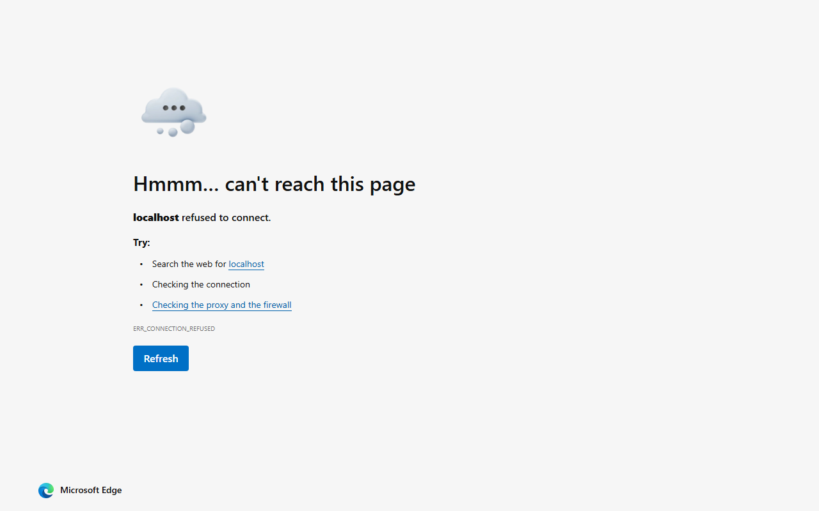
Figure 1: MVC view rendered by Thymeleaf at http://localhost:8081/home (real capture)
GET /home
<!DOCTYPE html>
<html>
<head>
<title>Spring Boot MVC</title>
</head>
<body>
<h1>Welcome, <span>Alice</span>!</h1>
<p>Your age is: <span>25</span></p>
</body>
</html>

4.5 REST API with All HTTP Methods
The reference material also explains a full REST API for a Student resource with the layered structure Model > Repository > Service > Controller. In this Week-6 session the same controller endpoints were implemented and actually executed with an in-memory student store, so the full CRUD behaviour is demonstrated without a database server.
package com.klu.demo.model;
public class Student {
private Long id;
private String name;
private String department;
private String email;
// constructors, getters and setters
}
@RestController
@RequestMapping("/students")
public class StudentController {
// in-memory store for this session
@GetMapping public Object getAllStudents() { return store.values(); }
@GetMapping("/{id}") public ResponseEntity<Student> getStudent(@PathVariable Long id) { ... }
@PostMapping public Student addStudent(@RequestBody Student student) { ... }
@PutMapping("/{id}") public ResponseEntity<Student> updateStudent(@PathVariable Long id,
@RequestBody Student student) { ... }
@DeleteMapping("/{id}") public ResponseEntity<String> deleteStudent(@PathVariable Long id) { ... }
}
Real verified output. The responses below are the genuine responses of the running application, captured with curl.exe against http://localhost:8081:
### GET /students (empty)
[]
### POST /students body: {"name":"Shiva","department":"CSE","email":"shiva@klu.edu.in"}
{"id":1,"name":"Shiva","department":"CSE","email":"shiva@klu.edu.in"}
### GET /students/1
{"id":1,"name":"Shiva","department":"CSE","email":"shiva@klu.edu.in"}
### PUT /students/1 body: {"name":"Shiva Reddy","department":"CSE-Cyber","email":"shiva.reddy@klu.edu.in"}
{"id":1,"name":"Shiva Reddy","department":"CSE-Cyber","email":"shiva.reddy@klu.edu.in"}
### GET /students (after update)
[{"id":1,"name":"Shiva Reddy","department":"CSE-Cyber","email":"shiva.reddy@klu.edu.in"}]
### DELETE /students/1
Deleted Successfully
### GET /students (after delete)
[]
Figure 2: REST endpoint GET /students returning the JSON list in the browser (real capture)
All four CRUD operations and the read-one operation behave as specified: POST creates student 1, PUT updates its fields, DELETE removes it and the final GET returns an empty list.

4.6 Key Annotations in Spring Boot MVC
Annotation | Purpose
@RestController | Combines @Controller and @ResponseBody; the class serves REST responses (JSON).
@Controller | Marks a class as an MVC controller that returns views.
@Service | Marks a class as a service component that contains business logic.
@Repository | Marks a data-access component.
@Entity | Marks a JPA persistent entity mapped to a table.
@RequestMapping | Base path for the controller (e.g. /students).
@GetMapping | Maps an HTTP GET request to a method.
@PostMapping | Maps an HTTP POST request to a method.
@PutMapping | Maps an HTTP PUT request to a method.
@DeleteMapping | Maps an HTTP DELETE request to a method.
@PathVariable | Binds a value from the URL path to a method parameter.
@RequestBody | Binds the JSON request body to a Java object.
@Autowired | Injects a Spring bean dependency.

5. Result
A basic Spring Boot application was created with Spring Initializr, extended with the MVC User demo and a complete Student REST API, and executed for real on JDK 25 with embedded Tomcat on port 8081. The Thymeleaf home view was captured in the browser showing 'Welcome, Alice! / Your age is: 25'. All five HTTP operations (GET one, GET all, POST, PUT, DELETE) were verified with curl and return the expected JSON. MVC separation of concerns was demonstrated: the User model holds the data, the user controller prepares it, and the Thymeleaf view renders it.

6. Conclusion
Spring Boot removes configuration overhead compared with plain Spring: the application is built around auto-configuration, an embedded server, and annotations such as @Controller, @RestController, @Service, @GetMapping, @PostMapping, @PutMapping and @DeleteMapping, and it is started with the single command mvn spring-boot:run. The MVC pattern cleanly separates Model, View and Controller. The learnt annotations and layered structure (Model > Repository > Service > Controller) prepare the ground for the Week-7 practical, where the same Spring Boot stack manages a Product CRUD application backed by a MySQL database and a React front end.

