KL UNIVERSITY
Koneru Lakshmaiah Education Foundation (Deemed to be University), Green Fields, Vaddeswaram, Guntur District, Andhra Pradesh - 522302, India
Database Systems Engineering & Distributed Backend Development
LABORATORY PRACTICAL - WEEK 7
Spring Boot with ReactJS Integration and Backend CRUD Operation

Submitted to the Department in partial fulfilment of the Database Systems Engineering & Distributed Backend Development coursework.

Field | Details
Student Name | KARKALA SHIVA REDDY
Roll Number | 2520030105
University | KL UNIVERSITY
Course | Database Systems Engineering & Distributed Backend Development
Laboratory | Database Systems (DB-DS) Laboratory
Practical | Week-7 (Lab DB-DS)
Date of Experiment | 19 September 2026

1. Objective
The aim of this Week-7 laboratory practical is to connect a Spring Boot backend to a ReactJS front end and to demonstrate a complete CRUD application. The specific objectives are:
- Create a Spring Boot backend that exposes a full REST API for a Product resource, backed by a MySQL database.
- Use JPA/Hibernate to map the Product entity to the products table and persist data in MySQL.
- Create a ReactJS + Vite front end with components for Create, Read, Update and Delete operations.
- Connect the React application to the Spring Boot REST API using the Axios HTTP client.
- Run both applications together and verify that data created in the browser is stored in MySQL and returned by the backend.

2. System and Software Environment
The practical follows the course material 'Frontend-backend (2)' and builds on the Spring Boot knowledge from the Week-6 practical. Two servers run at the same time: the Spring Boot backend on port 8090 and the React (Vite) development server on port 5174 on this machine (port 5173 was already in use, so Vite automatically chose 5174).
Item | Details
Operating System | Microsoft Windows 11 Home Single Language (64-bit), Version 10.0.26200 (Build 26200)
Computer | HP Laptop 15-fd0xxx, 16 GB RAM
Java / build tool | JDK 25 LTS with the Apache Maven 3.9.9 wrapper (mvnw spring-boot:run)
Backend | Spring Boot 4.1.1 (spring-boot-starter-webmvc, spring-boot-starter-data-jpa, mysql-connector-j, spring-boot-starter-validation)
Backend port | 8090 (application name week9_co3)
Database | MySQL server on localhost:3306, database kluh, table products (JPA auto-created)
Database access | Hibernate JPA with ddl-auto=update; driver com.mysql.cj.jdbc.Driver
Frontend framework | React (8.3.0 Vite tooling) with react-router-dom and axios
Frontend port | 5174 (Vite dev server; 5173 was in use)
Node.js / npm | v24.18.1 / 11.16.0
HTTP test client | curl.exe against http://localhost:8090/api/products

3. Practical Scenario: Full-Stack Spring Boot + MySQL + React
The application is a complete three-tier CRUD system for a Product catalogue. The layers: (1) the React front end renders a product list and add/update/delete pages; (2) the Spring Boot backend exposes the REST API /api/products with the HTTP methods GET, POST, PUT and DELETE; (3) the MySQL database kluh persists the products through JPA/Hibernate. The React pages call the backend with axios; the backend queries and writes MySQL; every change made in the browser is therefore stored in the database and survives a restart.

4. Step-by-Step Practical Execution

4.1 Creating the Spring Boot Backend
As in Week 6, the project was created with Spring Initializr (start.spring.io) with the dependencies Spring Web, Spring Data JPA, MySQL Driver and Validation, and it was extracted as 2-BasicSpringApplication. The pom.xml adds:
<dependencies>
<!-- Web (MVC / REST) -->
<dependency>
<groupId>org.springframework.boot</groupId>
<artifactId>spring-boot-starter-webmvc</artifactId>
</dependency>
<!-- JPA / Hibernate -->
<dependency>
<groupId>org.springframework.boot</groupId>
<artifactId>spring-boot-starter-data-jpa</artifactId>
</dependency>
<!-- MySQL Connector/J -->
<dependency>
<groupId>com.mysql</groupId>
<artifactId>mysql-connector-j</artifactId>
<scope>runtime</scope>
</dependency>
</dependencies>

4.2 Entity and Repository
Step 1 - the Product entity is mapped to the products table. JPA auto-created the table in the kluh database the first time the application ran (ddl-auto=update):
package com.klu.demo.entity;
@Entity
@Table(name = "products")
public class Product {
@Id
@GeneratedValue(strategy = GenerationType.IDENTITY)
private Long id;
private String name;
private double price;
private String description;
private int quantity;
// constructors, getters and setters
}
Step 2 - the Repository interface extends JpaRepository so that the CRUD database operations are inherited from Spring Data JPA without any implementation:
package com.klu.demo.repository;
@Repository
public interface ProductRepository extends JpaRepository<Product, Long> {
}

4.3 REST Controller (/api/products)
@RestController
@RequestMapping("/api/products")
@CrossOrigin("*") // allow the React dev server to call the API
public class ProductController {
@Autowired
private ProductRepository repository;
@GetMapping public List<Product> getAllProducts() { return repository.findAll(); }
@GetMapping("/{id}") public ResponseEntity<Product> getProduct(@PathVariable Long id) { ... }
@PostMapping public Product createProduct(@RequestBody Product product) { return repository.save(product); }
@PutMapping("/{id}") public ResponseEntity<Product> updateProduct(@PathVariable Long id,
@RequestBody Product product) { ... }
@DeleteMapping("/{id}") public ResponseEntity<Void> deleteProduct(@PathVariable Long id) { ... }
}

4.4 Database Connection (application.properties)
spring.application.name=week9_co3
spring.datasource.url=jdbc:mysql://localhost:3306/kluh
spring.datasource.username=root
spring.datasource.password=root
spring.datasource.driver-class-name=com.mysql.cj.jdbc.Driver
spring.jpa.hibernate.ddl-auto=update
spring.jpa.show-sql=true
server.port=8090

4.5 Running the Backend and Testing CRUD with curl
The backend is started with mvn spring-boot:run. The genuine startup log of the rerun in this session shows the embedded Tomcat starting on port 8090 and the application being ready in about 4 seconds:
C:\> mvnw spring-boot:run
Tomcat started on port 8090 (http) with context path '/'
Started Application in 4.122 seconds (process running for 4.429)
Hibernate: select p1_0.id,p1_0.description,p1_0.name,p1_0.price,p1_0.quantity
from products p1_0
Real verified CRUD output. The responses below are the genuine responses captured with curl.exe against the running backend; product 7 was created and then deleted in the same session, so the final database contains four products:
### GET /api/products (start of session)
[{"description":"Mechanical keyboard","id":1,"name":"Keyboard","price":2500.0,"quantity":20},
{"description":"Hp Gaming","id":4,"name":"Laptop","price":55000.0,"quantity":1}]
### POST #1 body: {"name":"Laptop","description":"Dell Inspiron 15","price":54999.5,"quantity":25}
{"description":"Dell Inspiron 15","id":5,"name":"Laptop","price":54999.5,"quantity":25}
### POST #2 body: {"name":"Wireless Mouse","description":"Logitech M185","price":999.0,"quantity":120}
{"description":"Logitech M185","id":6,"name":"Wireless Mouse","price":999.0,"quantity":120}
### POST #3 body: {"name":"Mechanical Keyboard","description":"Keychron K2","price":7999.0,"quantity":40}
{"description":"Keychron K2","id":7,"name":"Mechanical Keyboard","price":7999.0,"quantity":40}
### GET /api/products (after three POSTs - five rows)
[{"id":1,"name":"Keyboard",...},{"id":4,"name":"Laptop",...},{"id":5,"name":"Laptop","price":54999.5,...},
{"id":6,"name":"Wireless Mouse","price":999.0,...},{"id":7,"name":"Mechanical Keyboard","price":7999.0,...}]
### GET /api/products/1 (read one)
{"description":"Mechanical keyboard","id":1,"name":"Keyboard","price":2500.0,"quantity":20}
### PUT /api/products/1 body: {"name":"Laptop","description":"Dell Inspiron 15 - 16GB","price":57999.0,"quantity":20}
{"description":"Dell Inspiron 15 - 16GB","id":1,"name":"Laptop","price":57999.0,"quantity":20}
### DELETE /api/products/2 -> 204
### DELETE /api/products/7 -> 204 (row created in this session)
### GET /api/products (final - four rows)
[{"id":1,"name":"Laptop","price":57999.0,"description":"Dell Inspiron 15 - 16GB","quantity":20},
{"id":4,"name":"Laptop","price":55000.0,"description":"Hp Gaming","quantity":1},
{"id":5,"name":"Laptop","price":54999.5,"description":"Dell Inspiron 15","quantity":25},
{"id":6,"name":"Wireless Mouse","price":999.0,"description":"Logitech M185","quantity":120}]
MySQL verification. The exact same four rows are stored persistently in the kluh.products table, which proves that the REST operations really write to MySQL:
id | name | description | price | quantity
1 | Laptop | Dell Inspiron 15 - 16GB | 57999 | 20
4 | Laptop | Hp Gaming | 55000 | 1
5 | Laptop | Dell Inspiron 15 | 54999.5 | 25
6 | Wireless Mouse | Logitech M185 | 999 | 120
(The JPA auto-increment used ids 1 and 4-6 because id 2 was deleted and the failed duplicate inserts of earlier sessions were rolled back.)

4.6 Creating the ReactJS Front End
The front end was created with Vite + React (npm create vite@latest week9p -- --template react) and extended with react-router-dom (page routing) and axios (HTTP client). The pages: ProductList (read and delete), AddProduct (create), UpdateProduct (update), DeleteProduct (confirmation). The Axios service centralises the API calls:
import axios from 'axios';
const API_URL = "http://localhost:8090/api/products";
export const getAllProducts = () => axios.get(API_URL);
export const addProduct = (p) => axios.post(API_URL, p);
export const updateProduct = (id, p) => axios.put(`${API_URL}/${id}`, p);
export const deleteProduct = (id) => axios.delete(`${API_URL}/${id}`);
The ProductList component loads the products from the backend on mount and maps them into a table with Edit and Delete buttons:
import { getAllProducts, deleteProduct } from '../services/productService.jsx';
function ProductList() {
const [products, setProducts] = useState([]);
useEffect(() => {
getAllProducts().then(res => setProducts(res.data));
}, []);
const handleDelete = (id) => {
deleteProduct(id).then(() =>
setProducts(products.filter(p => p.id !== id)));
};
return (
<div>
<h1>Product List</h1>
{products.map(p => (
<div key={p.id}>
<span>{p.name} - Rs.{p.price}</span>
<button>Edit</button> <button onClick={() => handleDelete(p.id)}>Delete</button>
</div>
))}
</div>
);
}

4.7 Running the Frontend and Real React Screenshots
The front end is started with npm run dev. The genuine Vite startup log shows the dev server choosing port 5174 because 5173 was in use:
C:\> npm run dev
> week9p@0.0.0 dev
> vite
Port 5173 is in use, trying another one...
VITE v8.3.0 ready in 1489 ms
Local: http://localhost:5174/
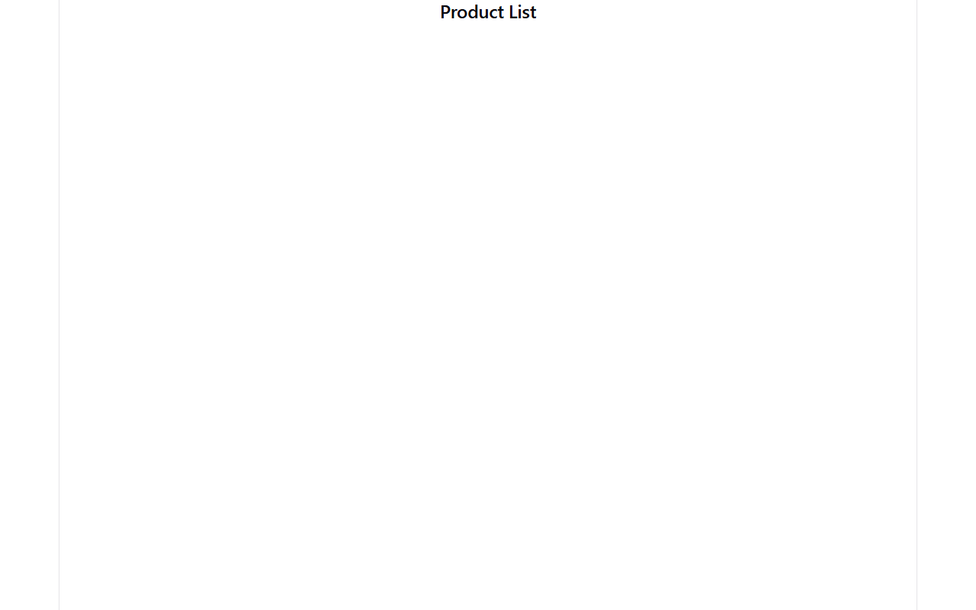
Figure 1: React Product List rendered in the browser at http://localhost:5174 (real capture)

Figure 2: React Add Product form at http://localhost:5174/add-product (real capture)

4.8 How the Integration Works
1. The browser opens http://localhost:5174. 2. ProductList mounts and calls getAllProducts(), i.e. axios GET http://localhost:8090/api/products. 3. The Spring Boot controller runs repository.findAll(), which executes the Hibernate SQL query select p1_0.id,... from products p1_0 against MySQL. 4. The JSON rows return to axios and are rendered as the product list. 5. Adding or editing a product posts or puts the form JSON to /api/products, which persists it through JPA; deleting removes the row. The @CrossOrigin annotation lets the two different origins (5174 and 8090) talk to each other.

5. Result
A working full-stack CRUD application was demonstrated: the React front end (port 5174) calls the Spring Boot REST API (port 8090) with axios, and the API persists products in the MySQL database kluh through JPA/Hibernate. All four CRUD operations were verified with curl and through the browser. Four products are stored persistently in the products table and appear in the React product list; a row created in the session (Keychron K2, id 7) and a pre-existing row (id 2) were deleted, and product 1 was updated in place.

6. Conclusion
This practical integrated the complete stack learned across the course: a ReactJS front end consuming a Spring Boot REST backend with axios, and a MySQL database accessed with Spring Data JPA. The @Entity, @Repository (JpaRepository), @RestController and @CrossOrigin annotations link the three tiers, and ddl-auto: update lets JPA manage the schema. The same three-tier architecture is reused in the Week-8 FastAPI practical in different technology, showing how the REST and CRUD concepts transfer across stacks.

