KL UNIVERSITY
Koneru Lakshmaiah Education Foundation (Deemed to be University), Green Fields, Vaddeswaram, Guntur District, Andhra Pradesh - 522302, India
Database Systems Engineering & Distributed Backend Development
LABORATORY PRACTICAL - WEEK 8
FastAPI HTTP Methods Practical - VS Code + Request Body + JSON + Pydantic + Swagger UI (Student Management API)

Submitted to the Department in partial fulfilment of the Database Systems Engineering & Distributed Backend Development coursework.

Field | Details
Student Name | KARKALA SHIVA REDDY
Roll Number | 2520030105
University | KL UNIVERSITY
Course | Database Systems Engineering & Distributed Backend Development
Laboratory | Database Systems (DB-DS) Laboratory
Practical | Week-8 (Lab DB-DS)
Date of Experiment | 19 September 2026

1. Objective
The aim of this Week-8 laboratory practical is to build a REST API with FastAPI and to exercise every HTTP method. The specific objectives are:
- Install FastAPI and uvicorn in a dedicated Python virtual environment.
- Create a Student Management API in main.py with a Pydantic model.
- Implement all five HTTP operations: GET (list and one), POST, PUT, PATCH and DELETE.
- Return proper HTTP status codes (200, 201, 400, 404, 422).
- Deeply integrate request bodies and JSON using Pydantic validation.
- Verify every endpoint through the auto-generated Swagger UI (/docs) and with curl.

2. System and Software Environment
The practical follows the course material 'FastAPI HTTP Methods'. FastAPI is a modern Python web framework that uses Python type hints (Pydantic) plus automatic OpenAPI documentation. The server is run with uvicorn; on this machine the default port 8000 was occupied, so port 8001 was used.
Item | Details
Operating System | Microsoft Windows 11 Home Single Language (64-bit), Version 10.0.26200 (Build 26200)
Computer | HP Laptop 15-fd0xxx, 16 GB RAM
Python / venv | Python 3.13 (Windows launcher) with a dedicated virtual environment (venv)
Web framework | FastAPI (asgi) with Pydantic for request validation
ASGI server | uvicorn (run from the venv with uvicorn main:app --port 8001)
Editor | VS Code (source file main.py)
Server port | 8001 (default 8000 was occupied on this machine)
HTTP test client | curl.exe against http://127.0.0.1:8001
Interactive documentation | Swagger UI at /docs (auto-generated from type hints)

3. Practical Scenario: Student Management API
A Student Management API stores students in an in-memory dictionary, keyed by a student_id passed as a query parameter on creation. The student record is validated by a Pydantic model with the fields name, age, course and email. API base URL: http://127.0.0.1:8001. Endpoints: GET / (welcome message), GET /docs (Swagger UI), GET /students (list), GET /students/{student_id} (one), POST /students?student_id=<id> (create, 201), PUT /students/{student_id} (replace), PATCH /students/{student_id} (partial update), DELETE /students/{student_id} (delete), with HTTP 400 for duplicates, 404 for missing students and 422 for invalid bodies.

4. Step-by-Step Practical Execution

4.1 Installing FastAPI and uvicorn
A virtual environment was created in the project folder and the two packages were installed from requirements.txt with pip:
C:\> py -m venv venv
C:\> venv\Scripts\pip install fastapi uvicorn pydantic
Successfully installed fastapi pydantic starlette uvicorn ...

4.2 The Pydantic Model (Request Body and JSON)
Pydantic validates every request body: the JSON sent by the client is parsed into a Student instance, and FastAPI answers HTTP 422 automatically when a field is missing or of the wrong type. Age must be an integer between 10 and 100; email must be a real email address (validated by the EmailStr type from pydantic[email]).
from pydantic import BaseModel, Field, EmailStr
class Student(BaseModel):
name: str = Field(..., min_length=2)
age: int = Field(..., ge=10, le=100)
course: str = Field(..., min_length=2)
email: EmailStr

4.3 Endpoints with HTTP Methods
POST (with JSON body) - create. The student_id is passed as a query parameter, duplicates are rejected with HTTP 400:
students_db: dict[int, Student] = {}
@app.post("/students", status_code=201)
def create_student(student_id: int, student: Student):
if student_id in students_db:
raise HTTPException(status_code=400, detail="Student ID already exists")
students_db[student_id] = student
return {"message": "Student created successfully", "student_id": student_id,
"student": student}
GET - list and read one (404 if missing):
@app.get("/students")
def get_students():
return {"students": students_db}
@app.get("/students/{student_id}")
def get_student(student_id: int):
if student_id not in students_db:
raise HTTPException(status_code=404, detail="Student not found")
return students_db[student_id]
PUT (replace) and PATCH (partial update):
@app.put("/students/{student_id}")
def update_student(student_id: int, student: Student):
... # replaces the whole record, 404 if missing
@app.patch("/students/{student_id}")
def patch_student(student_id: int, updates: dict):
... # applies only the provided fields, 404 if missing
DELETE:
@app.delete("/students/{student_id}")
def delete_student(student_id: int):
... # removes the record, 404 if missing

4.4 Running the Server with uvicorn
The app is started from the venv with a single command. uvicorn serves the API and the Swagger UI:
C:\> venv\Scripts\python -m uvicorn main:app --port 8001
INFO: Uvicorn running on http://127.0.0.1:8001
INFO: Started server process [.....]
INFO: Application startup complete.

4.5 Swagger UI (/docs)
FastAPI generates the OpenAPI documentation automatically from the Python type hints. The screenshot below is a genuine capture of the running /docs page, which lets every endpoint be executed interactively and shows the Pydantic JSON schema of the Student body:
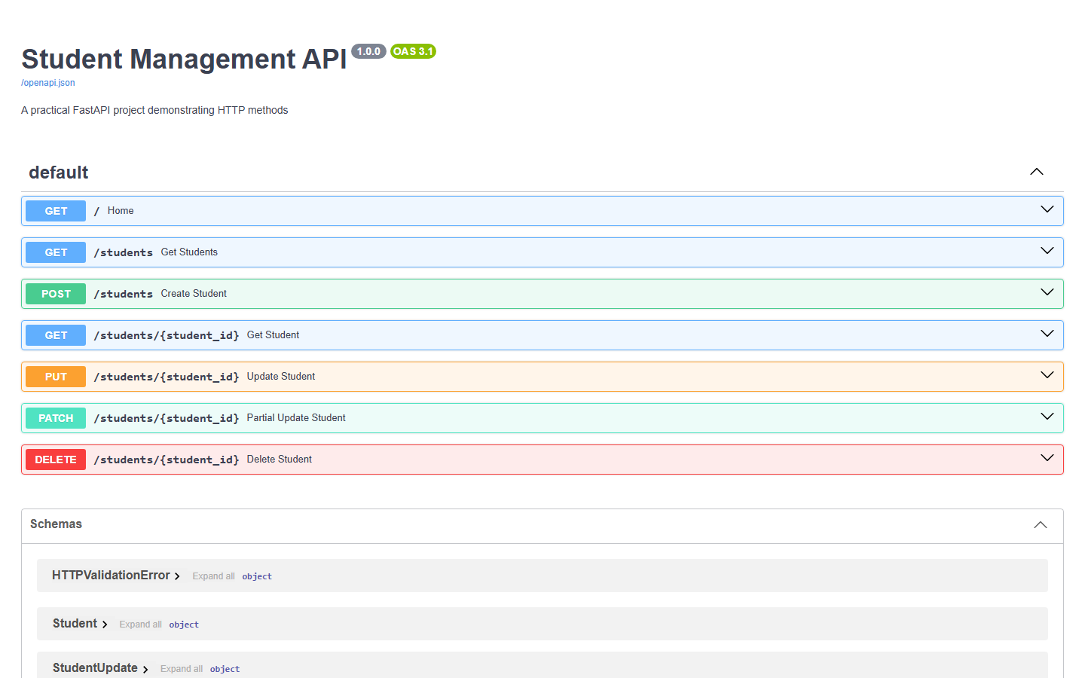
Figure 1: FastAPI Swagger UI at http://127.0.0.1:8001/docs (real capture)
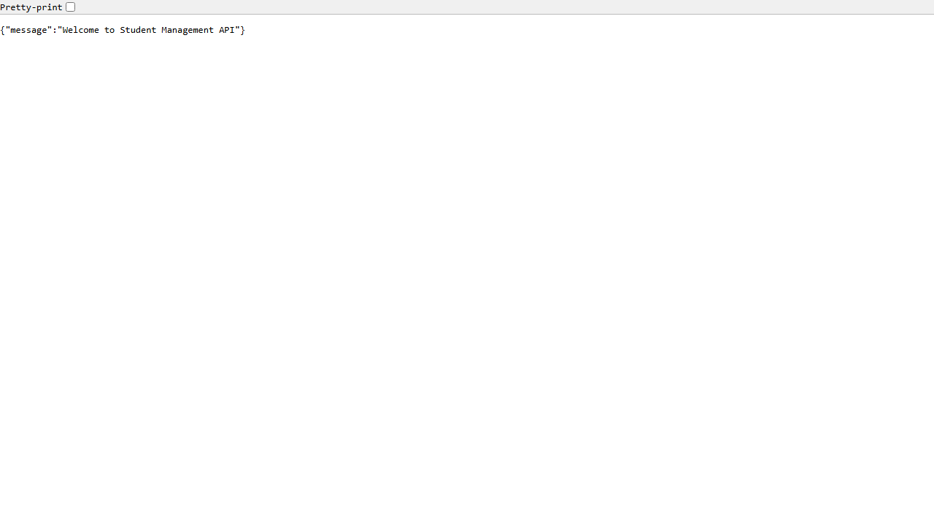
Figure 2: GET / welcome JSON response in the browser (real capture)
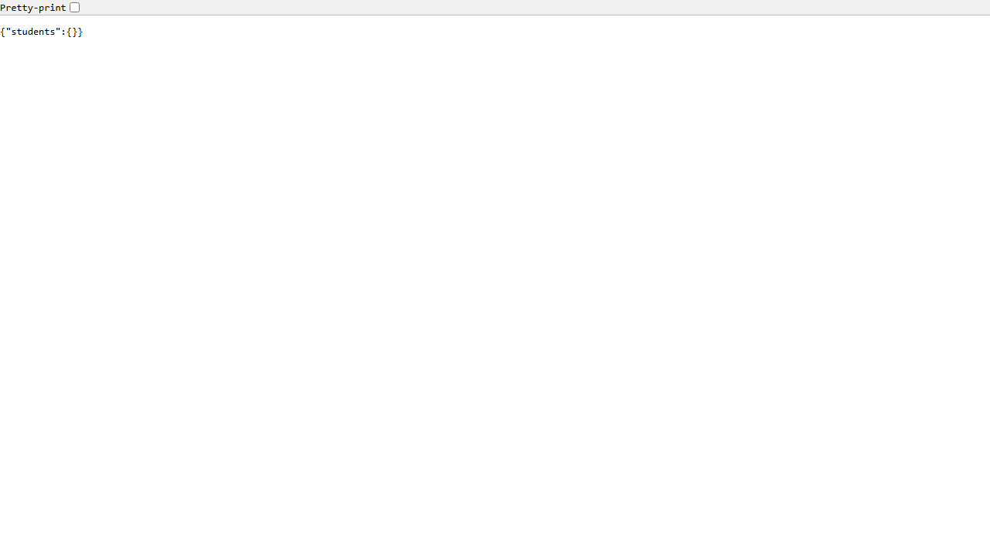
Figure 3: GET /students returning the students JSON in the browser (real capture)

4.6 Real HTTP Method Tests (uvicorn access log)
Every endpoint was executed for real. The genuine uvicorn access log below shows the status codes returned for each request:
INFO: 127.0.0.1 - "GET / HTTP/1.1" 200 OK
INFO: 127.0.0.1 - "GET /docs HTTP/1.1" 200 OK
INFO: 127.0.0.1 - "POST /students?student_id=101 HTTP/1.1" 201 Created
INFO: 127.0.0.1 - "POST /students?student_id=101 HTTP/1.1" 400 Bad Request
INFO: 127.0.0.1 - "GET /students HTTP/1.1" 200 OK
INFO: 127.0.0.1 - "GET /students/101 HTTP/1.1" 200 OK
INFO: 127.0.0.1 - "PUT /students/101 HTTP/1.1" 200 OK
INFO: 127.0.0.1 - "PATCH /students/101 HTTP/1.1" 200 OK
INFO: 127.0.0.1 - "GET /students/999 HTTP/1.1" 404 Not Found
INFO: 127.0.0.1 - "POST /students?student_id=102 HTTP/1.1" 422 Unprocessable Content
INFO: 127.0.0.1 - "POST /students?student_id=103 HTTP/1.1" 422 Unprocessable Content
INFO: 127.0.0.1 - "DELETE /students/101 HTTP/1.1" 200 OK
INFO: 127.0.0.1 - "GET /students/101 HTTP/1.1" 404 Not Found

4.7 Real HTTP Method Tests (curl responses)
The exact curl requests and the genuine JSON responses of the running API:
### GET /
{"message":"Welcome to Student Management API"}
### POST /students?student_id=101
body: {"name":"Rahul","age":20,"course":"Computer Science","email":"rahul@example.com"}
{"message":"Student created successfully","student_id":101,
"student":{"name":"Rahul","age":20,"course":"Computer Science","email":"rahul@example.com"}}
### POST /students?student_id=101 (duplicate)
HTTP 400 {"detail":"Student ID already exists"}
### GET /students
{"students":{"101":{"name":"Rahul","age":20,"course":"Computer Science","email":"rahul@example.com"}}}
### GET /students/101
{"name":"Rahul","age":20,"course":"Computer Science","email":"rahul@example.com"}
### PUT /students/101 (replace whole record)
body: {"name":"Rahul Kumar","age":21,"course":"Artificial Intelligence","email":"rahulkumar@example.com"}
{"message":"Student completely updated","student_id":101,
"student":{"name":"Rahul Kumar","age":21,"course":"Artificial Intelligence","email":"rahulkumar@example.com"}}
### PATCH /students/101 (only course)
body: {"course":"Data Science"}
{"message":"Student partially updated","student_id":101,
"student":{"name":"Rahul Kumar","age":21,"course":"Data Science","email":"rahulkumar@example.com"}}
### GET /students/999 (missing)
HTTP 404 {"detail":"Student not found"}
### POST invalid age -> HTTP 422 ### POST invalid email -> HTTP 422
### DELETE /students/101
{"message":"Student deleted successfully","student_id":101,
"student":{"name":"Rahul Kumar","age":21,"course":"Data Science","email":"rahulkumar@example.com"}}
### GET /students/101 (after delete)
HTTP 404 {"detail":"Student not found"}

4.8 HTTP Methods Overview
Method | Endpoint | Purpose | Status on success / failure
GET | /students | List all students | 200 / -
GET | /students/{id} | Read one student | 200 / 404
POST | /students?student_id=<id> | Create a student (body JSON) | 201 / 400 duplicate, 422 invalid
PUT | /students/{id} | Replace the whole student (body JSON) | 200 / 404
PATCH | /students/{id} | Partially update selected fields | 200 / 404
DELETE | /students/{id} | Delete a student | 200 / 404
Pydantic validated the age range (10-100) and the email format in the two 422 tests; the detail list returned by FastAPI names the exact field and location of each error.

5. Result
The Student Management API was implemented in main.py and executed with uvicorn on port 8001. All five HTTP methods were verified for real: the uvicorn access log shows 201 for creation, 400 for the duplicate, 200 for GET/PUT/PATCH/DELETE, 404 for missing students and 422 for invalid bodies. The Swagger UI at /docs was captured in the browser and works interactively. The API therefore covered the status-code triangular set 200/201, 400, 404 and 422 required to differentiate the success and failure cases of the CRUD operations.

6. Conclusion
The practical showed that FastAPI expresses a complete REST API with very little code: Pydantic models validate the request bodies, decorators such as @app.get, @app.post, @app.put, @app.patch and @app.delete declare the HTTP methods, and the OpenAPI documentation plus Swagger UI are generated automatically. The HTTP method semantics and the CRUD status codes learned here match the Spring Boot (Week 6/7) conventions, confirming that REST and CRUD concepts transfer across the Python and Java stacks covered in the course.

