DSC 430: Python Programming  
Assignment 0702: Overlapping Ellipses

In this problem you will use pseudo random numbers to estimate the area of two overlapping ellipses. An ellipse is a curve in a plane surrounding two focal points such that the sum of the distances to the two focal points is constant for every point on the curve. – Wikipedia.

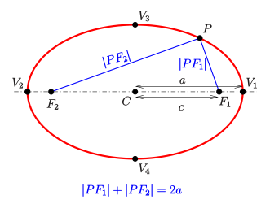

Create a Point class that takes the x and y coordinates of the point:

p1 = Point(2,3)  
 p2 = Point(4,3)

Create an Ellipse class that takes two points and the width of the long axis:

e1 = Ellipse(p1,p2,4)

Write a function that takes two ellipses and returns the area of the overlap:

overlap = computeOverlapOfEllipses(e1,e2)

This function should leverage the pseudo random number generator you built in the previous assignment.

Record a three minute video in which you run the code. Then, present your code. Specifically, answer the following questions:

* Briefly show your code working on a simple case. (e.g. two circles at the origin)
* Briefly show your code working on a more complicated example you came up with.
* Show the main loop of your algorithm.

Submission: Submit a single .py file containing all the code to the D2L. Do not zip or archive the file. Your code must include comments at the top including your name, date, video link, and the honor statement, “I have not given or received any unauthorized assistance on this assignment.” Each function must include a docstring and be commented appropriately.