 

# Placement Empowerment Program

***Cloud Computing and DevOps Centre***

***Deploy a Web Application on the CloudWrite a Python Flask application and deploy it on your cloud VM. Configure the firewall to allow HTTP traffic***.

Name : Paripurani S P Department: IT



# Introduction

Cloud computing has revolutionized the way applications are developed and deployed, offering scalability, flexibility, and cost- effectiveness. This PoC focuses on deploying a Python-based Flask web application on an AWS EC2 instance. Flask, a lightweight web framework, is ideal for building simple yet powerful web applications. Through this project, you will learn how to set up a virtual machine in AWS, configure it, and deploy a web application, making it accessible to users globally.

# Overview

In this project, a Flask application is developed and deployed on an Amazon EC2 instance. The application runs on a cloud-hosted Linux server with an accessible HTTP endpoint. The steps include:

1. Launching an EC2 instance.
2. Configuring the instance environment (Python, Flask, and dependencies).
3. Writing a Flask web application.
4. Setting up the firewall to allow HTTP traffic.
5. Testing the application on a browser.

The PoC demonstrates a simple yet effective way to understand deploying web applications in a cloud environment.

# Objectives

1. **Understand Flask Framework**: Learn the basics of Flask and how to write a simple web application.
2. **Cloud Deployment**: Gain hands-on experience deploying an application on AWS EC2.
3. **Security Configuration**: Configure inbound rules in AWS to allow HTTP traffic securely.
4. **Application Accessibility**: Ensure the application is accessible globally via a public IP.
5. **Real-World Skills**: Develop skills in cloud computing and web application deployment.

# Importance

1. **Practical Exposure**: Provides real-world experience in deploying applications to the cloud, an essential skill in modern IT infrastructure.
2. **Skill Development**: Improves your understanding of cloud services, virtual machines, and web development.
3. **Scalability**: Demonstrates how applications can be deployed and scaled easily using cloud infrastructure.
4. **Career Advancement**: Builds foundational knowledge in cloud computing, a highly sought-after skill in the tech industry.
5. **Problem-Solving**: Encourages troubleshooting skills by resolving deployment issues and configuring environments.

# Step-by-Step Overview

## Step 1:

* 1. Go to [AWS Management Console](https://aws.amazon.com/console/).
  2. Enter your username and password to log in.

1. 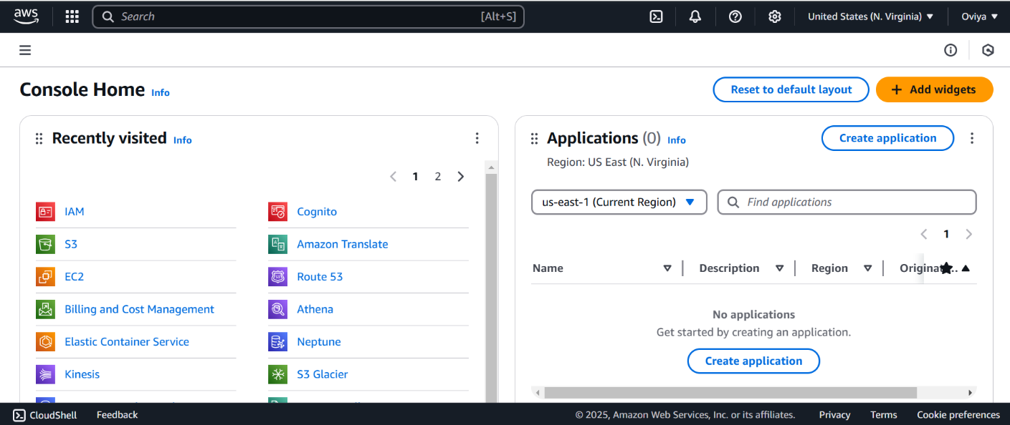

## Step 2:

On the EC2 Dashboard, click on **Launch Instances** and enter a name for your instance (e.g., "Flask Server") and select Ubuntu as OS and create a key pair. Leave other settings as default and Click **Launch Instance**.

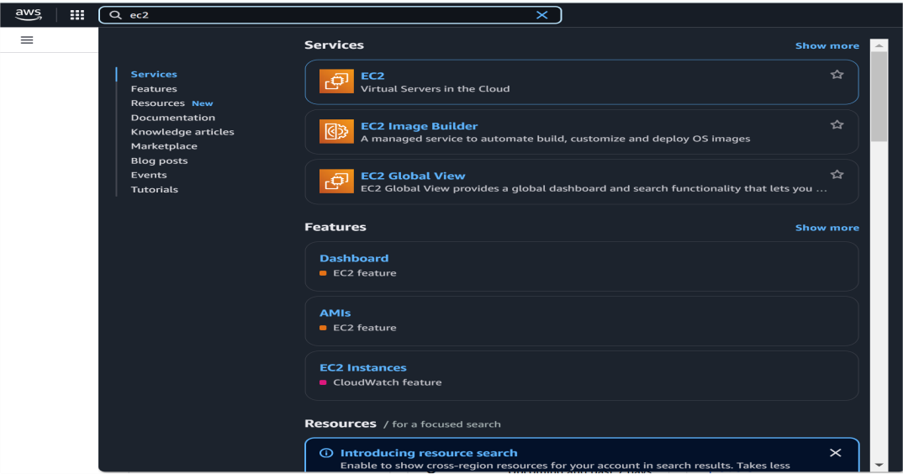

## Step 3:

Click the 'Connect' option on your launched instance, go to the SSH client section, and copy the command provided under the 'Example' section.

## Step 4:

Open PowerShell, navigate to the 'Downloads' directory where the downloaded key pair is located using the **cd Downloads** command

Paste the command copied from the EC2 Connect's SSH client section, replace the key pair name with your downloaded key (e.g., new.pem), press Enter, and type 'yes' when prompted.

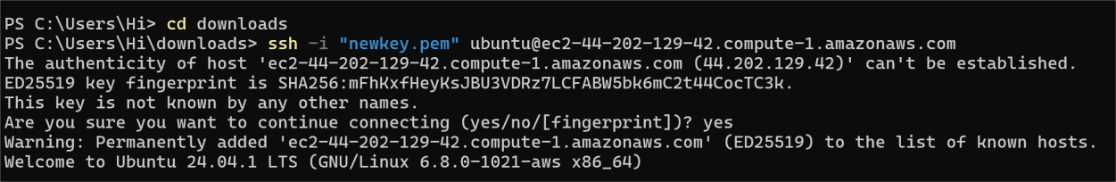

## Step 5:

Update the Package List :

Screenshot 2025-02-01 123237.png

## Step 6:

Install Python3 and pip

Screenshot 2025-02-01 123256.png

## Step 7:

Install Virtual Environment Tools : This helps keep your app’s dependencies separate.

Screenshot 2025-02-01 123435.png

## Step 8:

Create and Activate a Virtual Environment and install Flask

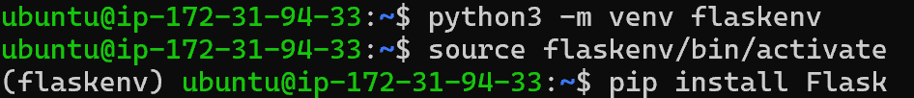

## Step 9:

Create a Directory for Your App and Create a file called app.py using a text editor (like nano).



## Step 10:

Write this code into the editor and press **Ctrl + O** (to write out) and then

**Enter**, then **Ctrl + X** to exit.

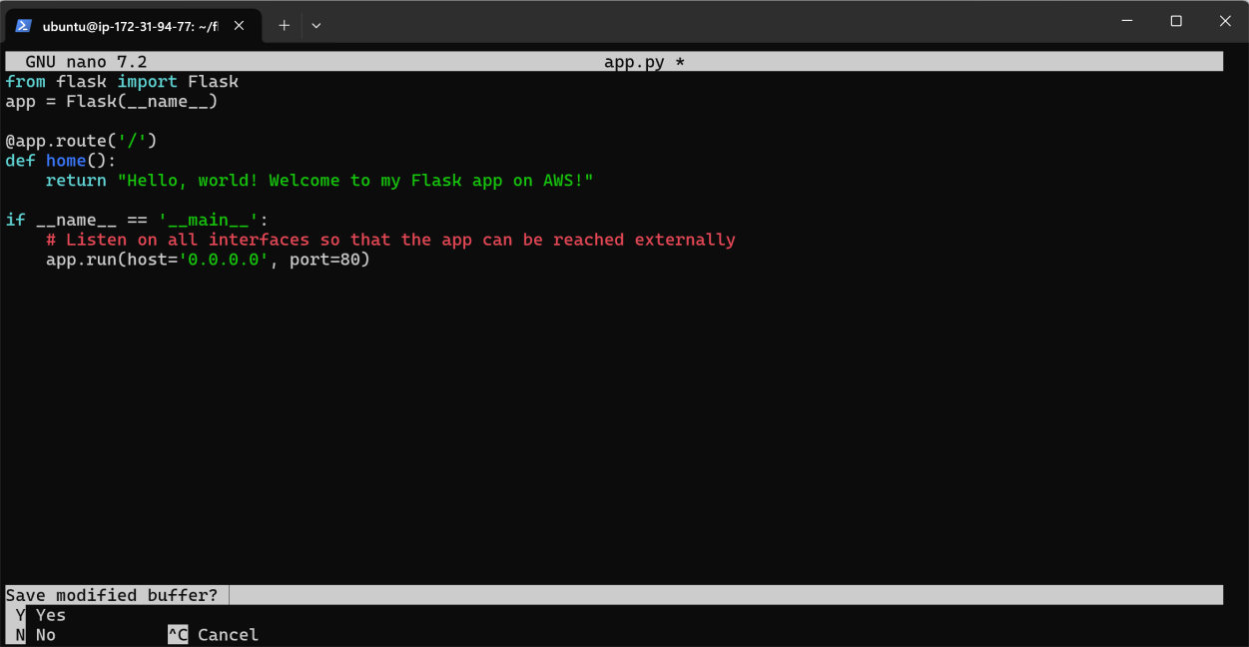

## Step 11:

Exit the virtual environment:

Screenshot 2025-02-01 123540.png

## Step 12:

Add your virtual environment’s Python path to the sudo command and Run the application using the virtual environment's Python:

Screenshot 2025-02-01 123607.png

## Step 13:

Your Flask app is now running!

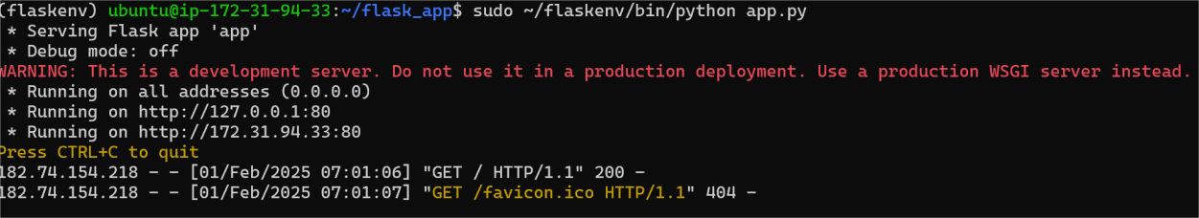

## Step 14:

Go to the **EC2 Dashboard** > **Instances**.

Find your instance and note the **Security Group** attached to it. Navigate to **Security Groups** under the **Network & Security**

section.

Select the Security Group associated with your EC2 instance.

Under the **Inbound Rules** tab, ensure there is a rule for **HTTP (port 80)**:

**Type:** HTTP **Protocol:** TCP **Port Range:** 80

**Source:** Anywhere (0.0.0.0/0, ::/0)

If there isn't an HTTP rule, click **Edit inbound rules** and add it.

## Step 15:

Open your browser and navigate to:

http://<Your-Instance-Public-IP>/

Replace <Your-Instance-Public-IP> with the Public IPv4 address of your EC2 instance (e.g., <http://54.123.45.67/>).

Public IPv4 address can be found in your Ec2 instance dashboard.

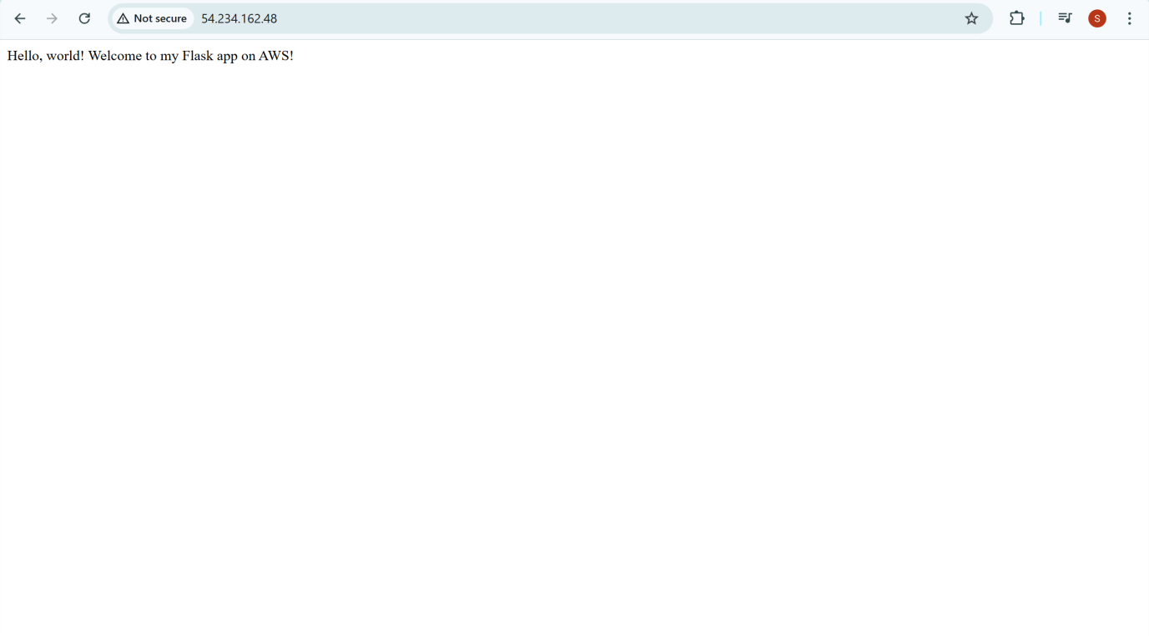

# Outcome

By completing this PoC of deploying a Flask web application using an EC2 instance, you will:

Set Up EC2 Instance: Start an EC2 instance on AWS with Ubuntu as your OS.

Configure Python and Flask: Install Python and the Flask framework on your instance.

Build a Flask App: Create a simple Flask application (app.py) that shows a message in a web browser.

Deploy the App: Host your Flask app on the EC2 instance and adjust the security settings to permit HTTP traffic.

Go Live: Use the public IP address or DNS of your EC2 instance to access your Flask app on the web.