 

**Placement Empowerment Program**

***Cloud Computing and DevOps Centre***

Set Up a Virtual Machine in the Cloud

Create a free-tier AWS account. Launch a virtual machine and SSH into it.

Name: Paripurani S P Department : IT



**Introduction and Overview**

In this POC, Set Up a Virtual Machine in the Cloud Set Up a Virtual Machine in the Cloud Set Up a Virtual Machine in the Cloud Setting up a virtual machine in the cloud is essential for running applications, hosting websites, or learning cloud computing. AWS provides a Free Tier, allowing users to launch and use an EC2 (Elastic Compute Cloud) instance at no cost for the first 12 months. This guide will walk you through creating an AWS account, launching an EC2 instance, and connecting to it via SSH.

**Objective**

The goal of this project is to:

1. How to create an AWS Free Tier account.

2. How to launch an EC2 instance (Virtual Machine) using AWS

3. How to connect to the instance via SSH

4. Basic management of an EC2 instance

**Requirements**

**A valid email address and phone number** – Required for AWS account registration and verification.

**A computer with an SSH client** – Used to connect to the EC2 instance. Options include:

Linux/macOS: Terminal (built-in SSH client).

Windows: PowerShell (built-in SSH) or PuTTY (third-party SSH client).

**A stable internet connection** – Ensures smooth access to AWS services and SSH connectivity.

**Step-by-Step Overview**

Step1:

1. Go to [**AWS Free Tier**](https://aws.amazon.com/free/).
2. Click **"Create an AWS Account"**.
3. Fill in the required details (email, password, account name).
4. Provide your **billing information** (Credit/Debit card is required for identity verification, but you won’t be charged for Free Tier usage).
5. Verify your **phone number**.
6. Choose a **support plan** (select "Basic" for free).
7. Log in to the **AWS Management Console**.

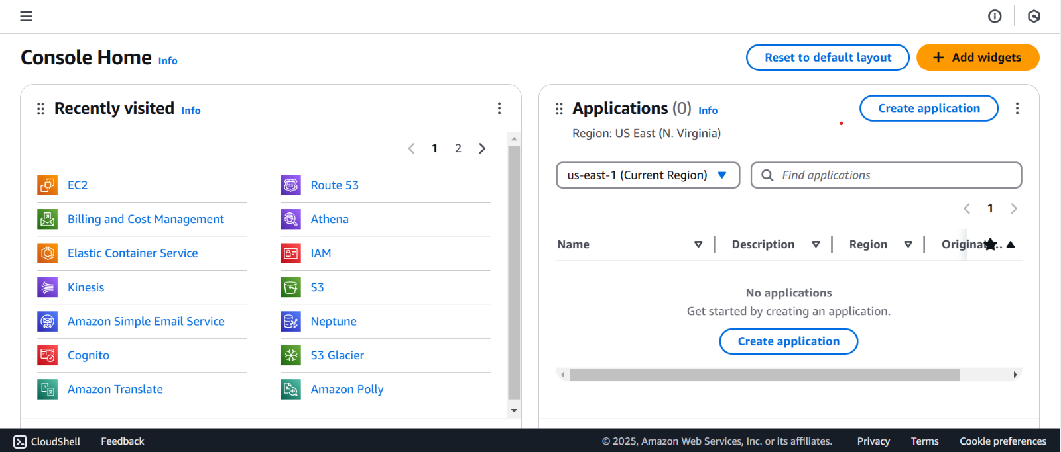

Step 2 :

1.Open the EC2 Dashboard:

* In AWS Console, search for EC2 and open the EC2 Dashboard.

2.Click "Launch Instance".

3.Configure the EC2 Instance:

* Name: Choose a name (e.g., "MyEC2Instance").
* Amazon Machine Image (AMI): Select Amazon Linux 2023 or Ubuntu 22.04 (both are Free Tier eligible).
* Instance Type: Choose t2.micro (1 vCPU, 1GB RAM - Free Tier eligible).
* Key Pair:
* Click Create new key pair.
* Name it (e.g., "my-key").
* Select .pem format and Download Key Pair (store it securely).
* Storage: Keep default (8GB SSD).

4.Click Launch Instance and wait for initialization.

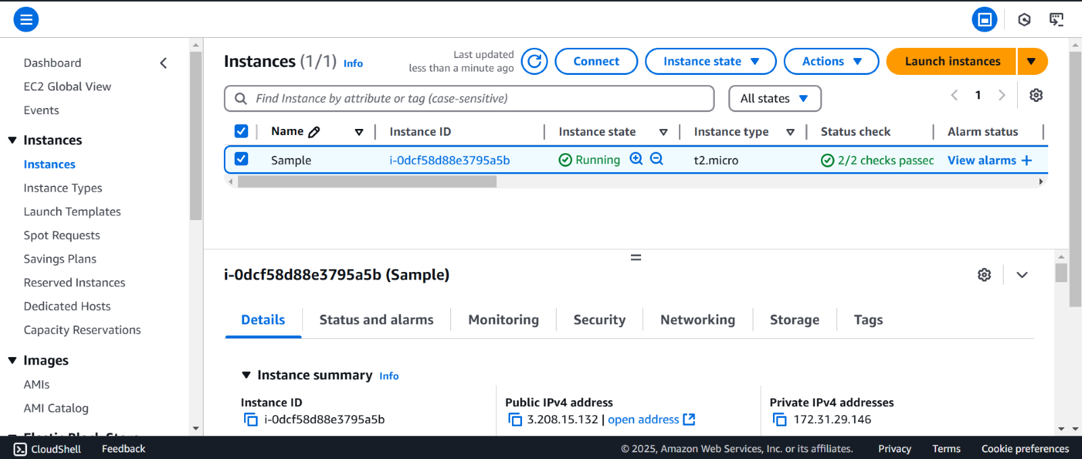

Step 3 :

1. Open a terminal.
2. Navigate to the directory where the .pem key is stored:

cd /path/to/key

3.Set the correct permissions for the key file:

chmod 400 my-key.pem

4.Connect to the instance (replace your-ec2-ip with the actual IP):

5.ssh -i my-key.pem ec2-user@your-ec2-ip # Amazon Linux

ssh -i my-key.pem ubuntu@your-ec2-ip # Ubuntu

For Windows Users (PowerShell)

* Open PowerShell as Administrator.
* Navigate to the .pem file location:

cd C:\Users\YourUser\Downloads

* Connect using SSH:

ssh -i my-key.pem ec2-user@your-ec2-ip

For Windows Users (Using PuTTY)

Connect using PuTTY:

* Open PuTTY.
* Enter Host Name: your-ec2-ip.
* Under Connection → SSH → Auth, load the .ppk key.
* Click Open.

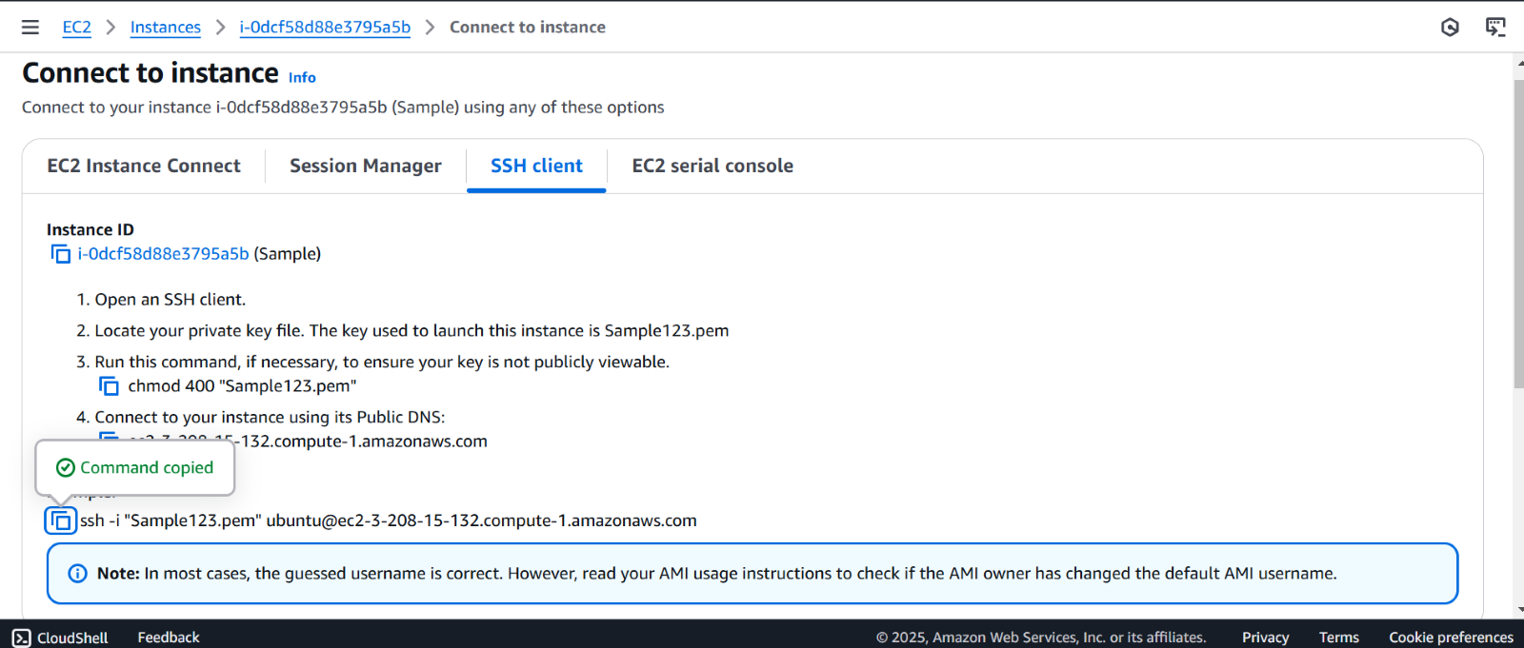

Step 4 :

* Open the Once connected, run:
* username -a   # Check Linux version
* df -h      # Check disk usage

uptime     # Check system uptime

* To **stop** the instance:

aws ec2 stop-instances --instance-ids i-xxxxxxxxxxxxx

* To **terminate** (delete) the instance:

Go to stop instance and then finally delete it.

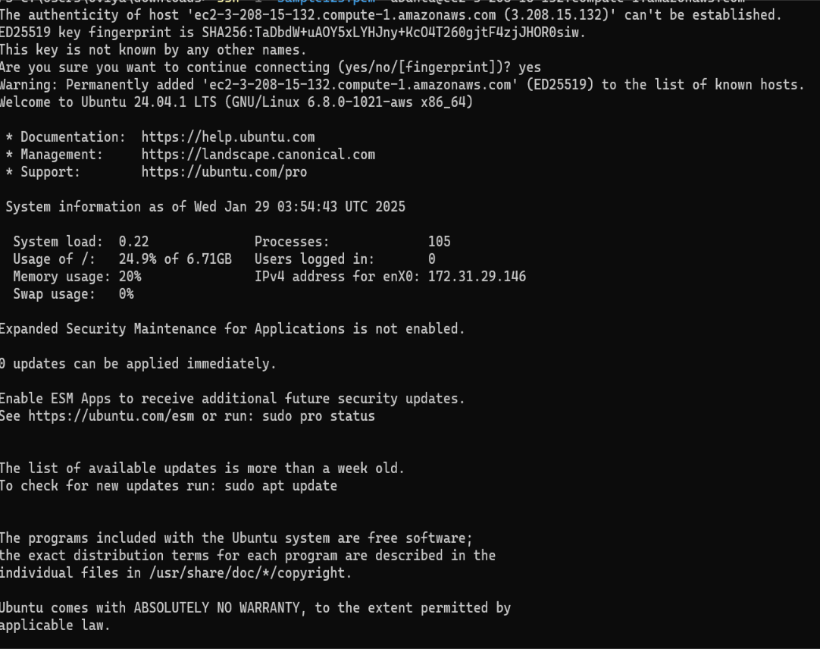

**Expected Outcome**

By completing this POC, you will:

1. **AWS Account Created** – Successfully signed up for a Free Tier AWS account and logged into the AWS Management Console.

2.**EC2 Instance Launched** – A virtual machine (EC2 instance) is running on AWS with the selected OS (e.g., Amazon Linux 2023, Ubuntu).

3.**Key Pair Securely Saved** – Downloaded and stored the .pem file to access the instance via SSH.

4.**Security Group Configured** – Allowed SSH access (port 22) in the EC2 security settings.