 

# Placement Empowerment Program

***Cloud Computing and DevOps Centre***

Host a Static Website on a Cloud VMInstall

Name: Paripurani S P Department : IT



**Introduction and overview**

**Hosting a Static Website on a Cloud VM** is a fantastic way to make your content accessible to the world. By using a Cloud Virtual Machine (VM), you gain flexibility, control, and scalability.

# Step-by-Step Overview

## Step1:

**Launch a Cloud VM Instance**:

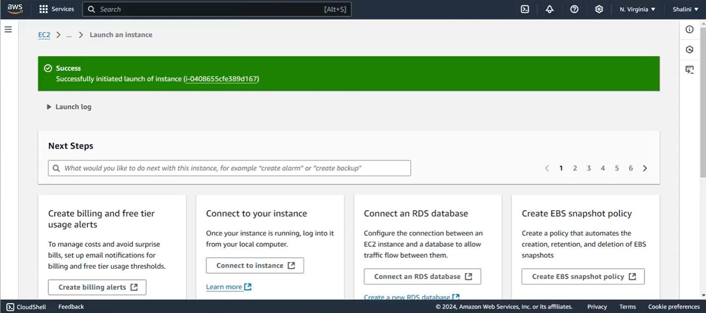

## Step 2 :

Connect to Your VM(instance)

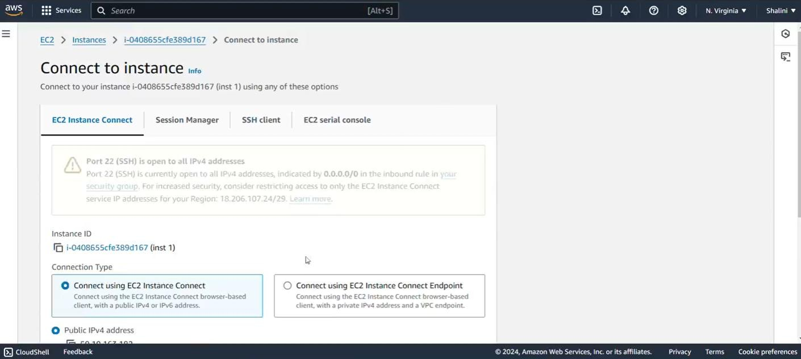

## Step 3 :

**Install a Web Server (Apache or Nginx)**:

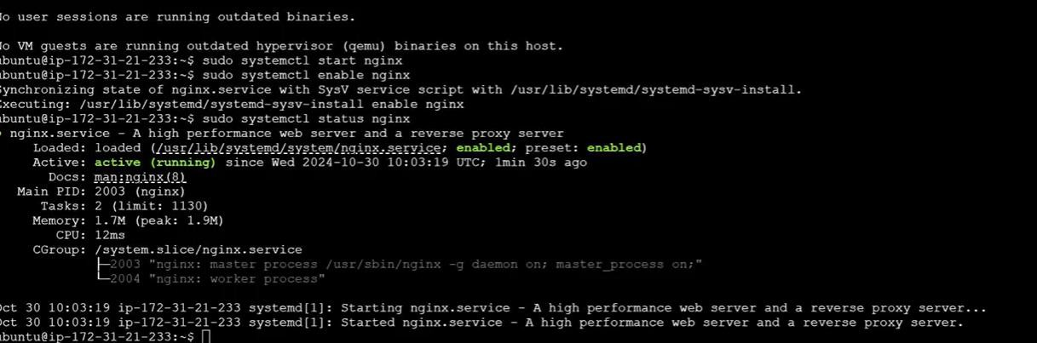

## Step 4 :

Ensure your site is accessible via the VM's IP address.

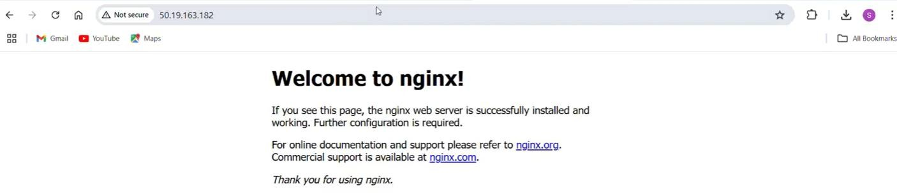

## Step 5 :

Transfer your HTML, CSS, and other static assets to the VM.

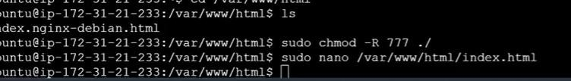

Step 6 :

# Step6:

# Deploy the website



**Expected Outcome**

Hosting a static website on a cloud VM involves creating a VM instance on your chosen cloud platform, connecting to it via SSH, installing a web server (Apache or Nginx), uploading your HTML and static files to the server's root directory, configuring the web server to serve your site, restarting the server to apply changes, and finally testing your website to ensure it's accessible via the VM's external IP address. Optionally, you can secure your site with an SSL certificate to enable HTTPS. This process enables you to have a fully functioning static website live on the internet.