 

# Placement Empowerment Program

***Cloud Computing and DevOps Centre***

**Use Cloud CLI Tools Install the CLI for your cloud provider**

Name: Paripuarni S P Department: IT



# Introduction and Overview

Cloud Command Line Interface (CLI) tools provide developers and system administrators with a powerful way to interact with cloud services using text- based commands. Instead of navigating through graphical interfaces, CLIs allow users to automate tasks, manage cloud resources efficiently, and execute commands quickly from their local machine or terminal.

Each major cloud provider offers its own CLI tool:

AWS CLI – Amazon Web Services Command Line Interface Azure CLI – Microsoft Azure Command Line Interface

Google Cloud SDK (gcloud CLI) – Google Cloud Platform Command Line Interface

# Objective

The objective of using Cloud CLI tools is to provide a streamlined and efficient way to manage and automate cloud resources directly from the command line. By installing the CLI for your chosen cloud provider, you can perform a variety of tasks, such as creating and managing virtual machines, configuring network settings, deploying applications, and monitoring services. This enables you to interact with your cloud infrastructure programmatically, allowing for greater control, flexibility, and automation of your cloud operations. Whether you're managing a single VM or orchestrating complex deployments, Cloud CLI tools are essential for efficient and effective cloud management.

# Step-by-Step Overview

## Step1:

Search for "AWS CLI Installer for Windows" on Google

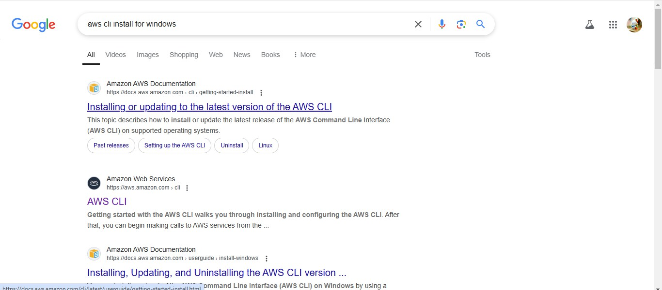

## Step 2:

Click on the "Install/Update" option located on the left-hand side of the Apache Lounge website. Select the link regarding your OS, Install by using the link provided else use the ***msiexec*** command

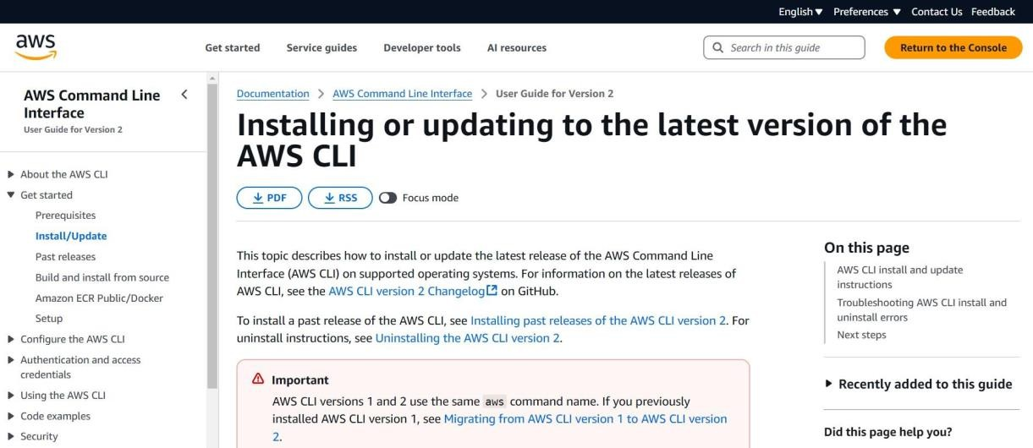

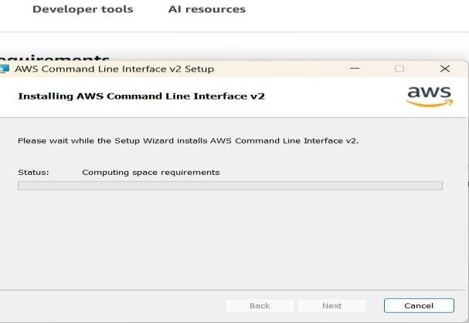

## Step 3:

Once installed, verify the installation by running **aws –version**



## Step 4:

configure it with your AWS credentials.

Open Command Prompt and type **aws configure**





## Step 5:

To see all storage buckets, Type **aws s3 ls** in cmd



## Step 6:

Create an S3 Bucket by typing **aws s3 mb s3://your-unique-bucket-name**

in cmd



Upload a file to S3 Bucket by typing **aws s3 cp yourfile.txt s3://your- unique-bucket-name/** in cm



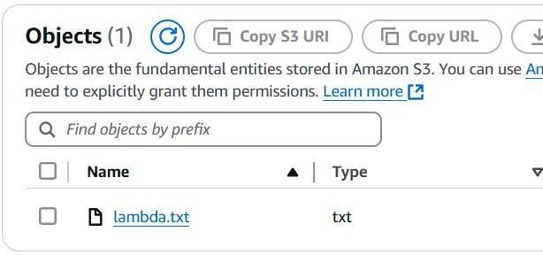

## Step 7:

To Start an EC2 Instance, Type **aws ec2 start-instances --instance-ids**

**<INSTANCE_ID>** in cmd

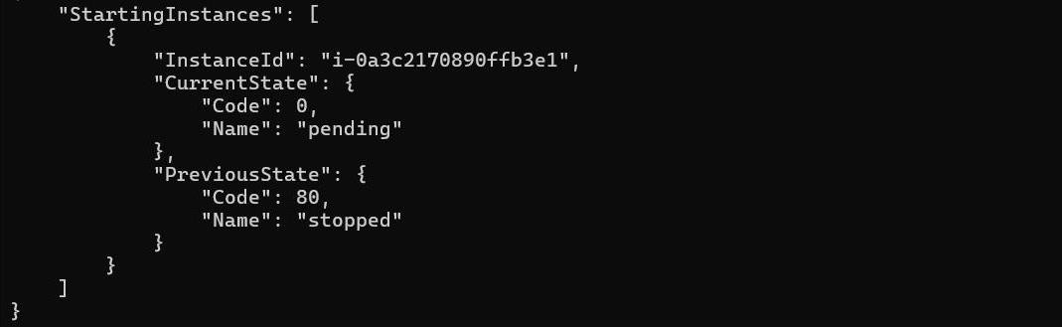

**Expected Outcome**

After successfully installing and configuring the CLI for your cloud

provider, you should be able to verify the installation by running version check commands such as aws --version, az --version, or gcloud -- version. Authentication and configuration can be completed using commands like aws configure, az login, or gcloud auth login, ensuring secure access to your cloud account. Once set up, you can interact with cloud services through the CLI, allowing you to create, manage, and monitor resources efficiently. Commands like aws s3 ls, az vm list, or gcloud compute instances list enable you to list available resources, while others facilitate creating and configuring cloud components.

Additionally, the CLI allows for automating cloud tasks such as infrastructure deployment, backups, and system monitoring through scripts. By completing this setup, you gain the ability to manage cloud environments seamlessly, improving efficiency and workflow automation.