# Placement Empowerment Program Cloud Computing and DevOps Centre

**Write a Shell Script to Monitor Logs**

Name: Paripurani S P Department : IT

**Introduction**

Log files are crucial for tracking system activities, debugging errors, and maintaining security. However, manually monitoring logs can be time-consuming. This document provides a shell script to automatically monitor server logs for specific error patterns and alert the user when issues arise. Here are the key points:

Log Monitoring: Automatically check logs for specific error patterns.

Time-Saving: Reduces the need for manual log checking.

Alert System: Sends alerts when errors are found.

Automation: Uses a cron job to run the script periodically.

Customization: Allows you to define the log file, error pattern, and alert method.

**Overview**

The shell script continuously monitors a specified log file in real time and detects error messages such as "ERROR," "CRITICAL," or "FAIL." Upon detecting an error, the script logs the occurrence and optionally sends an email notification to the system administrator.

**Features**

1.Monitors logs in real-time  
2. Detects specific error keywords  
3. Logs detected errors to a separate alert file  
4. Optionally sends email notifications  
5. Can run in the background continuously.

**Steps to Implement**

**Step 1:**

**Create the Shell Script**

1. Open a terminal and navigate to the directory where you want to create the script:

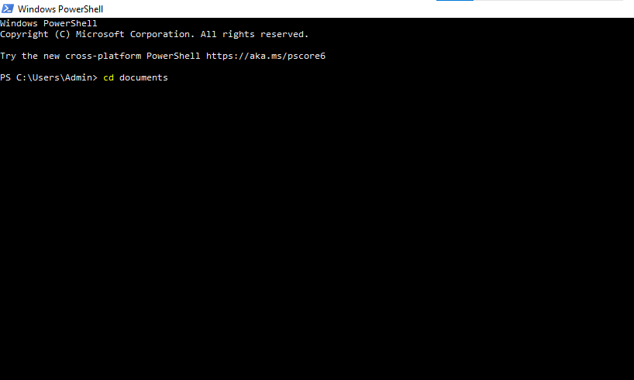

1. Create a new shell script file:

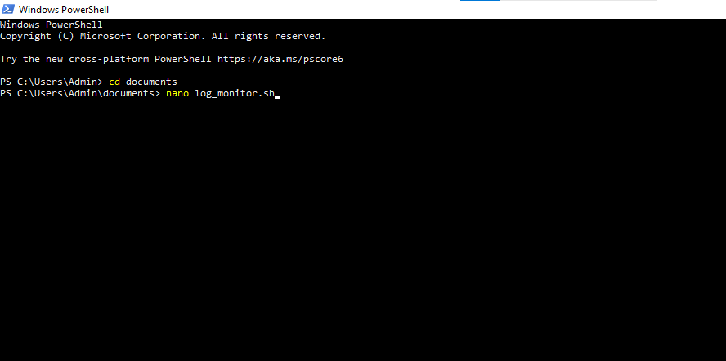

3.Create and save a document file in your documents path.

4.Save and exit:

* Press CTRL + X
* Press Y and then Enter

### **Step 2:**

### **Grant Execution Permission**

Make the script executable:



**Step 3:**

**Run the Script**

Execute the script to start monitoring logs:



**Expected Output**

Once the script detects an error in the log file, it appends an alert message to alert.log:

Wed Jan 31 14:30:01 UTC 2025 - ALERT: CRITICAL - Disk space low

Wed Jan 31 14:35:12 UTC 2025 - ALERT: ERROR - Failed login attempt detected

This shell script automates log monitoring, helping system administrators detect critical issues promptly. By customizing it further, you can enhance server security and reliability.