For -90 degrees :

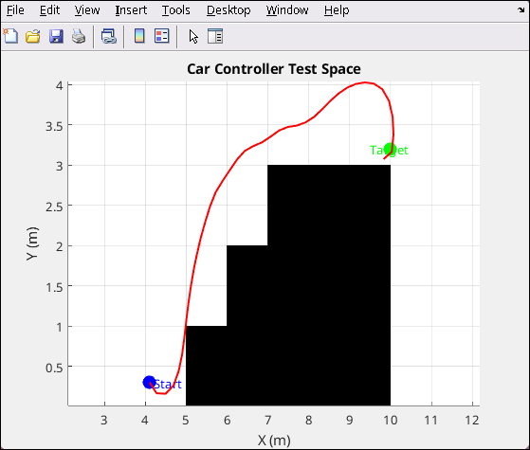 → we can see that it starts to steer away from the obstacle at -90 degrees and barely makes it not to hit the obstacle and after that it is easier to reach the target . We had to modify the output of the FLC controller and amplify it in order to be able to steer in time. Finally we could pass the obstacle without a collision ( Note : the car is depicted as a point , with a rectangle shape further angle signal amplification would be needed )

For -45 degrees :   
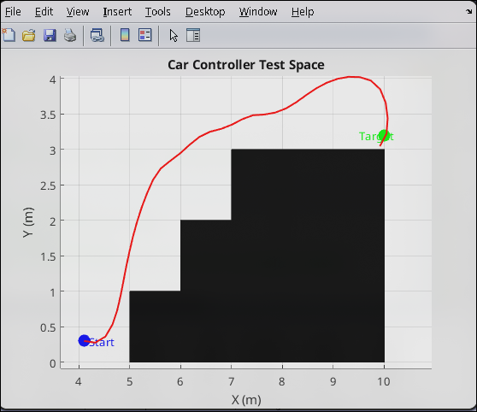

→ The car successfully passes the obstacle , easier and with better clearance than the attempt in the -90 degrees and reaches the target . Approximately the same volume of steering adjustments are made in both tries

→ For 0 degrees :  
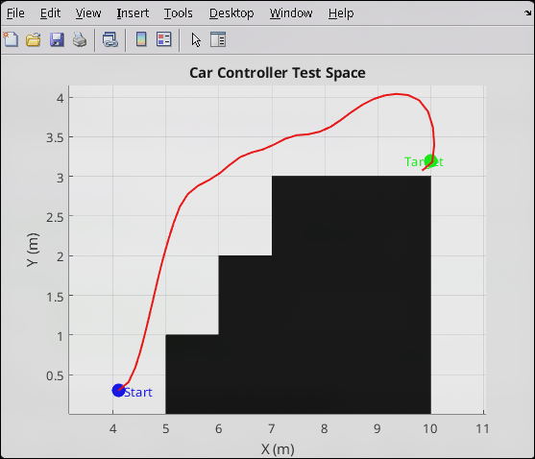

→ The car in 0 degrees does not face a significant problem and the trajectory it travels is pretty much the same with the other attempts . The only change is that in this attempt it does not start facing the obstacle so the controller does not to steer away from it immediately . Time and steps required to reach the target are approximately the same in all attempts.

→ Conclusion :

We can observe that our controller correctly steers away from obstacles and reaches the given target . Even when given harder conditions it can successfully steer away from the obstacles and does not crash . Overall except the last part where the controller steers away from the obstacle

and approaches the target from the top it performs as expected . With further rule tuning that last part could be possibly avoided.