Hydrus-Manual

INPUT DATA
The input data for HYDRUS are given in five separate input files. These input files consist of one or more input blocks identified by the letters from A through M. The input files and blocks must be arranged as follows:
SELECTOR.IN
A. Basic Information
B. Water Flow Information
C. Time Information
D. Root Growth Information
E. Heat Transport Information
K. Carbon Dioxide Transport Information
F. Solute Transport Information
L. Major Ion Chemistry Information
G. Root Water Uptake Information
PROFILE.DAT
H. Nodal Information
ATMOSPH.IN
I. Atmospheric Information
FIT.IN
J. Inverse Solution Information
METEO.IN
M. Meteorological Information
All input files must be placed into one subdirectory (the location of which is indicated in the Project Manager of the HYDRUS GUI). Output files are printed into the same subdirectory. Another file, HYDRUS1D.DAT, which is not read by the executable code, enables communication between particular modules of the user-interface and will be described in part B of this manual. The input files can be created manually or with the graphics-based user-friendly interface HYDRUS1D also described in part B (the manual: (J. Šimůnek, M. Šejna, H. Saito, M. Sakai, 2013) )
Tables 12.1 through 12.13 describe the data required for each input block. All data are read in using list-directed formatting (free format). Comment lines are provided at the beginning of, and within, each input block to facilitate, among other things, proper identification of the function of the block and the input variables. The comment lines are ignored during program execution; hence, they may be left blank but should not be omitted. The program assumes that all input data are specified in a consistent set of units for mass M, length L, and time T. The values of temperature should be specified in degrees Celsius. Several variables in the METEO.IN file must be specified in the requested units.

Output data
The output is organized into 3 groups:
T-level information
- T_LEVEL.OUT
- RUN_INF.OUT
- SOLUTE.OUT
- OBS_NODE.OUT
- CO2_INF.OUT*
- SOLUTEF.OUT+
- SOLUTEM.OUT+
- OBS_NODE_CH.OUT*
- OBS_NODF.OUT+
P-level information
- NOD_INF.OUT
- BALANCE.OUT
- CONC.OUT*
- SOLID.OUT*
- EQUIL.OUT*
- CHEMBAL.OUT*
- NOD_INF_V.OUT†
A-level information
- A_LEVEL.OUT
- METEO.OUT
*Major ion chemistry module output files
+Dual-permeability module output files
†Output file when vapor flow is considered
In addition, some of the input data are printed to files I_CHECK.OUT and PROFILE.OUT. Results of the inverse solution are directed into an output file FIT.OUT.
File I_CHECK.OUT contains a complete description of the space discretization, the hydraulic characteristics, and the transport properties of each soil material.
Output file OBS_NODE.OUT gives transient values of the pressure head, water content, temperature, and solution and sorbed concentrations, as obtained during the simulation at specified observation nodes, timeseries for selected nodes which they explained in the forum in this way:
Although the GUI support only 10 observation nodes, the computational module supports 100 observation nodes. You can thus modify the Profile.dat (and HYDRUS1D.DAT) input file manually, you will get information for up to 100 observation nodes.
So we can have the information for up to 100 nodes. We can edit Profile.dat manually, so for example if you need to have different dz for each level, you can change it in PROFILE.dat, for 100 (or less) node observations also, we can add desired node-number at the bottom of PROFILE.dat and get the time series of those.
NOD_INF.OUT - profile information for selected time steps.

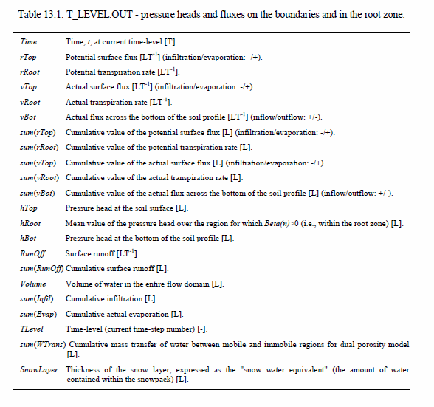
Interception is immediately at the input substracted from Precipitation (the Precipitation considered in the rest of the code is Prec-Interception), as well as from Potential Transpiration (rRoot).
For the rest, the easiest, I guess would be to show the actual calculations.
vTop and vBot (surface and bottom fluxes) are calculated from Darcy's equation (after the Richards equation is solved for given boundary conditions (e.g., rTop). The other fluxes (and corresponding cumulative fluxes after that) is then calculated from the balance of fluxes as follows:
vRunOff=0.
if((.not.WLayer.or.(WLayer.and.hNew(N).ge.hCritS)).and.rTop.lt.0.) vRunOff=abs(rTop-vTop)
if(vRunOff.lt.1.e-5) vRunOff=0.
rInfil=0.
rEvap=0.
if(vTop.lt.0..and.(Prec.gt.0.or.(WLayer.and.hNew(N).gt.0.))) rInfil=-vTop+rSoil
if(vTop.ge.0..and.Prec.gt.0) rInfil=Prec
if(vTop.gt.0.) rEvap=vTop+Prec
if(vTop.le.0..and.rSoil.gt.0.and.Prec.gt.0) rEvap=rSoil
if(vTop.lt.0..and.WLayer.and.hNew(N).gt.0.) rEvap=rSoil
if(vTop.lt.0..and.KodTop.gt.0) rInfil=-vTop
Above, WLayer is logical variable for ponding Surface Layer, rSoil is potential evaporation, rTop (=Evap-Prec).

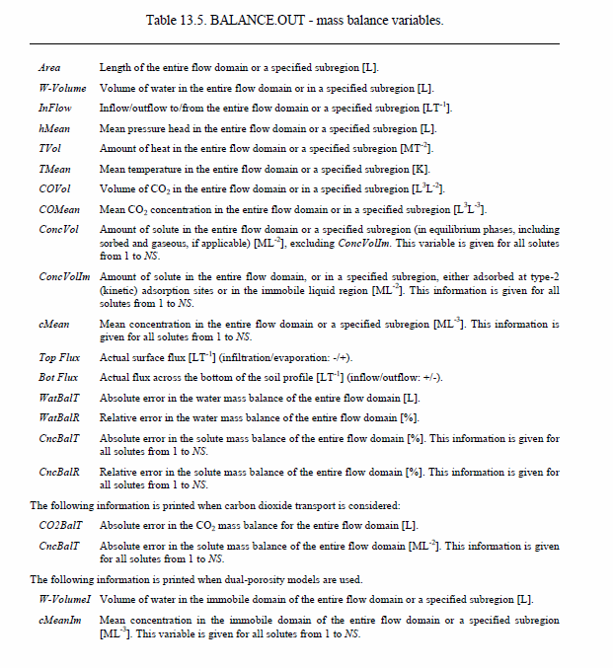
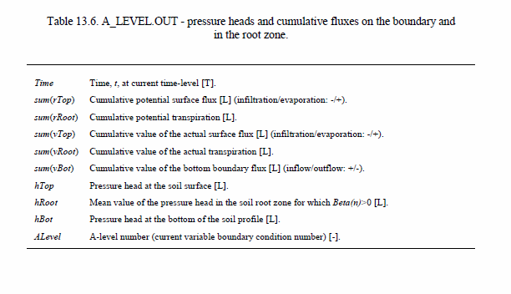
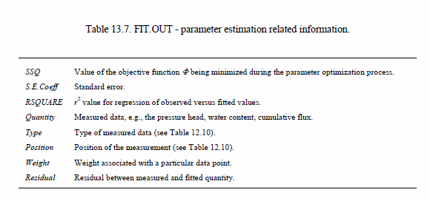
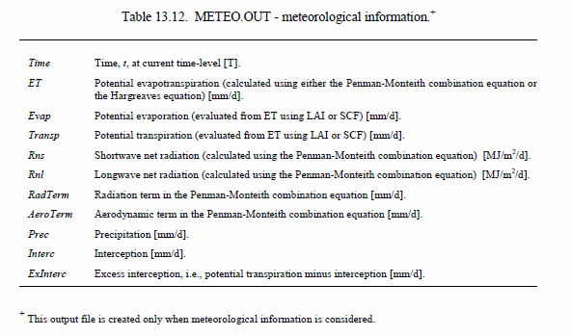
Other output tables can be found on (J. Šimůnek, M. Šejna, H. Saito, M. Sakai, 2013).

PreProcessing

Project Manager
The first step when working with any HYDRUS-1D project involves opening the Project Manager (Fig. 1.1) by clicking on the Project Data Manager Tab in the upper left corner (third button from the left) of the displayed Graphical User Interface (GUI). The Project Manager is a tool to manage data of existing projects and helps to locate, open, copy, delete and/or rename desired projects or their input or output data. A project represents any particular problem to be solved using HYDRUS-1D. The project name, as well as a brief description of the project, helps to locate a particular problem. Input and output data for each project are placed in a folder with the same name as the project. A file project_name.h1d and the project_name folder represent projects.
After that, the Pre-processing window will be opened.
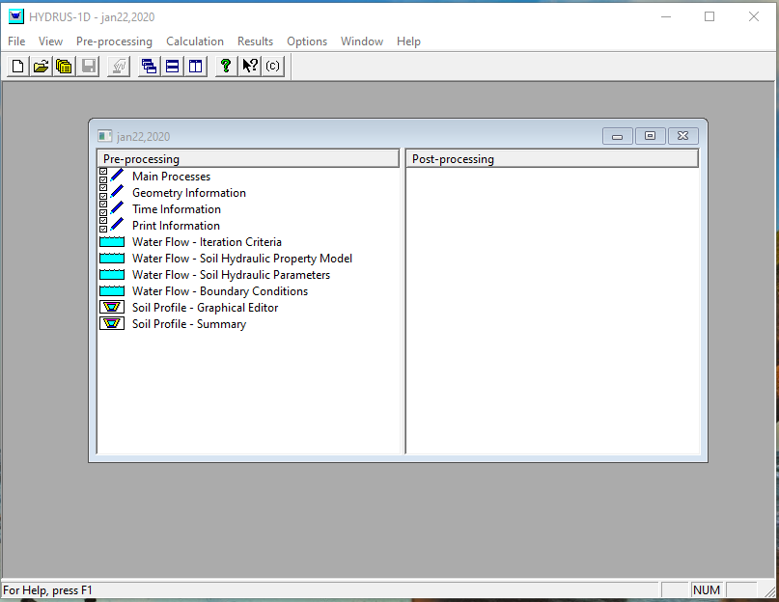

Main process
The Main Processes dialog window is shown below, which is the first window you will encounter when starting a new project.
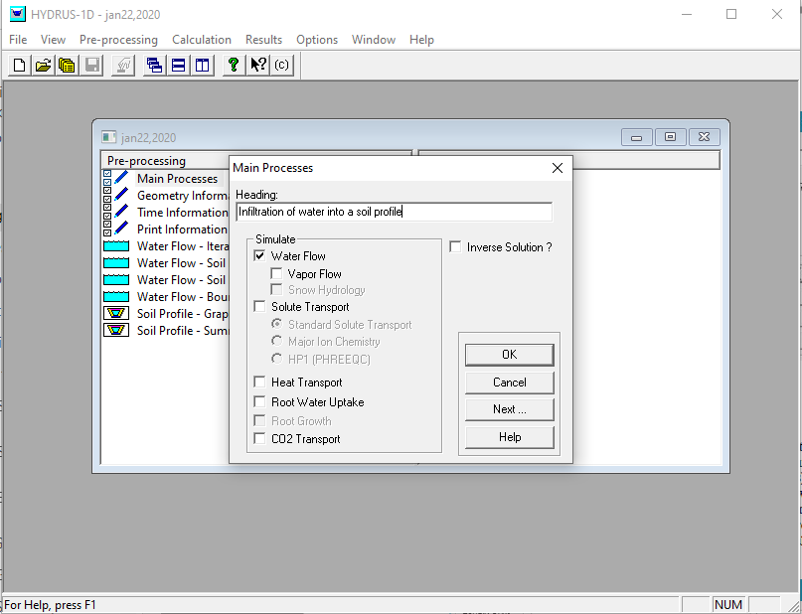
At this step, you can also select whether HYDRUS-1D should be run in for a forward prediction, or in the Inverse Mode, in which case various parameters can be calibrated against experimental data and/or experimental data can be displayed together with the simulation results.
Here, I just select “water Flow”, and forward model run.

Geometry Information
The second dialog window one encounters is called Geometry Information. In this window, one selects the Length Unit (mm, cm, or m), the Number of Soil Materials that are present in the system (i.e., the number of soil horizons), the Number of Layers over which a Mass Balance will be calculated, whether flow is vertical or horizontal (i.e., a Decline from Vertical Axis of 1 indicates flow in a vertical direction, while 0 indicates flow a horizontal direction), and the Depth of the Soil Profile. Note that when the Length Unit is changed later, all input parameters for a particular project will be converted automatically from the original units into the new units.
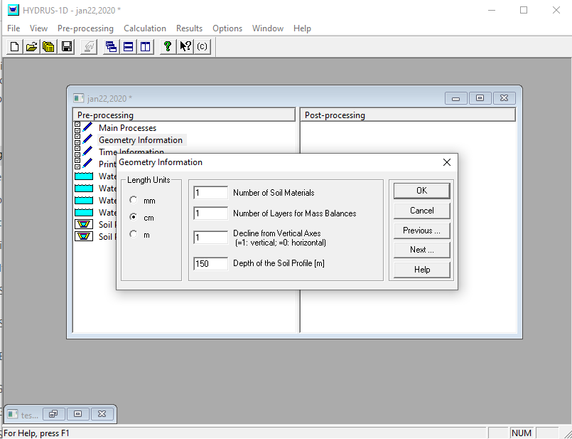
- Number of Soil Materials (typically corresponding to the soil horizons) :1 indicates a homogenous soil profile. The maximum allowed number is 100.
- Number of Layers for Mass Balance: 1 (you may select up to 10 mass balance layers; the default option is a single mass balance layer, which corresponds to the entire soil profile. You may wish to assign individual mass balance layers to each soil material (horizon) or a group of soil materials, or apply separate mass balances the root zone and the remainder of the soil profile.)
- Decline from vertical axis: 1 (vertical flow)

Time Information
The third dialog window users encounter is called Time Information. It is recommend to simply use the default parameters for time stepping in most applications.
The boundary conditions will either be constant in time, or one can specify Time-Variable Boundary Conditions, such as daily values of precipitation, evaporation, and transpiration. Evapotranspiration fluxes additionally can be evaluated from various Meteorological Data using the Penman-Monteith combination equation recommended by FAO (Monteith, 1981, 1990) or the Hargreaves Formula (Jensen et al., 1997). Time-variable boundary conditions can be either constant during specified time intervals or be subject to Daily Variations (of transpiration or meteorological data) to be Generated by HYDRUS-1D using predefined interpolation functions. Finally, a surface Energy Balance can be evaluated from specified meteorological data.
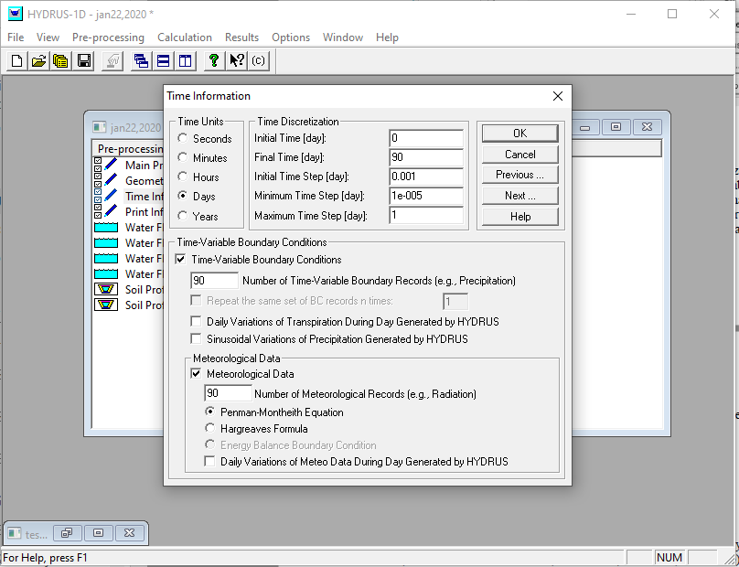

Print Information
The fourth dialog window HYDRUS-1D is called Print Information. In this window, you simply select how often the output of the model should be printed. Output can be printed at every nth Time Step (if 1 then after each time step), at a predetermined Regular Time Interval, or at specified Print Times, which then will be specified in the next dialog window.
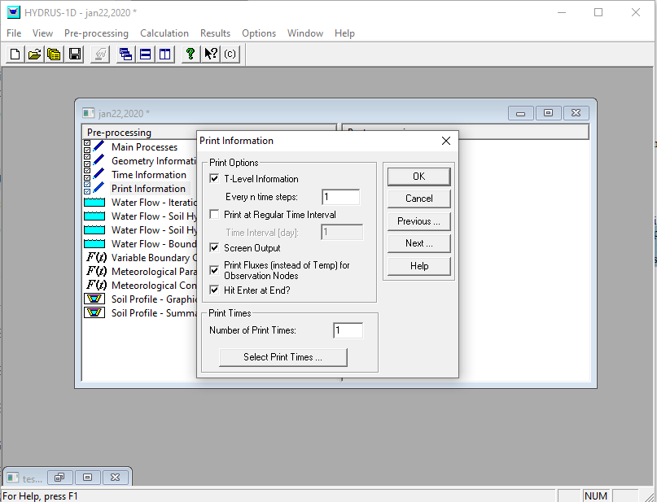

The first four windows are general windows (with general information), which you need for any application of HYDRUS-1D. All of the dialog windows to be discussed next deal with a) water flow, b) heat transport, c) solute transport, d) root water uptake, and/or other information.

Water Flow – Iteration Criteria
The Iteration Criteria dialog window is used to specify iteration criteria, which are required for the numerical solution of the Richards equation (the equation governing water flow in the unsaturated zone) and various Time Step Control factors, which depend on the numerical solution. In general, one should not change any of these values, which control the fully automated self-adjusting time-stepping procedure of the numerical solution. The default values are based on many years of experience using the HYDRUS models and their predecessors for a range of applications.
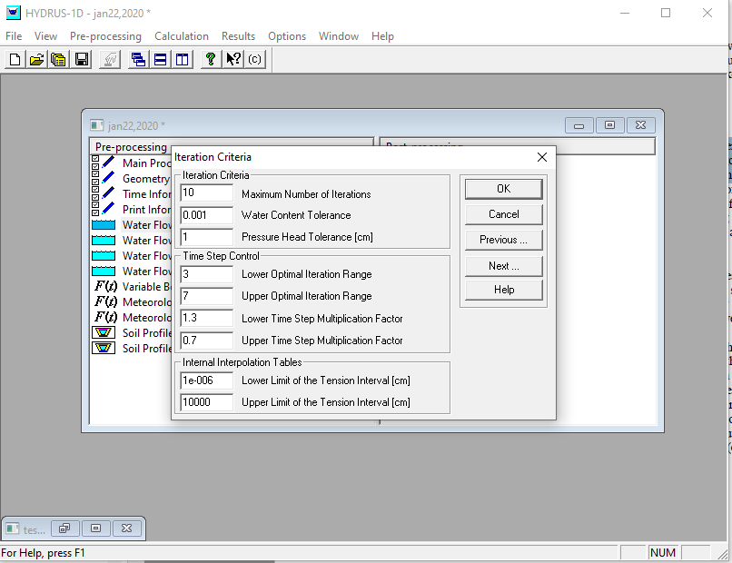

Note: Internal Interpolation Tables of water contents, hydraulic conductivities, and specific water capacities are generated from the specified set of unsaturated soil hydraulic parameters. Values of the hydraulic properties are then computed for all numerical nodes during the iterative solution process using linear interpolation between the entries in these tables. This interpolation approach was found to be much faster computationally than direct evaluation of the hydraulic functions over the entire range of pressure heads. Interpolation tables can be avoided by setting both the Upper and Lower Limits of the Tension Interval to zero. To avoid problems with the numerical solution, the Internal Interpolation Tables should not be used when the dual-porosity model of Durner (1994) is used to describe the soil hydraulic functions since this model does not have a monotonous hydraulic capacity function. When the Brooks and Corey (1964) model is used, either the lower limit should be larger (in absolute value) than 1/α (i.e., the air-entry value) or the tables should be avoided altogether (e.g., by fixing the lower and upper limits at zero).

Water Flow – Soil Hydraulic Model
HYDRUS-1D allows you to consider different analytical models to describe the soil hydraulic properties (i.e., water retention and hydraulic conductivity functions). The unsaturated soil hydraulic properties can be described in HYDRUS-1D using Brooks and Corey (1964), van Genuchten-Mualem (van Genuchten, 1976), modified van Genuchten (Vogel and Císlerová, 1988), Durner (1994), and Kosugi (1996) type analytical functions. The different analytical models can be selected in the Soil Hydraulic Model dialog window.
Hysteresis is a property of soils to have different wetting and drying branches of the soil water retention curve, including scanning curves (Luckner et al., 1989; Lenhard and Parker, 1992; Vogel et al., 1996). One may further limit hysteresis to only the soil water retention curve, or also consider hysteresis in the unsaturated hydraulic conductivity (which generally shows less effects of hysteresis when plotted versus water content).
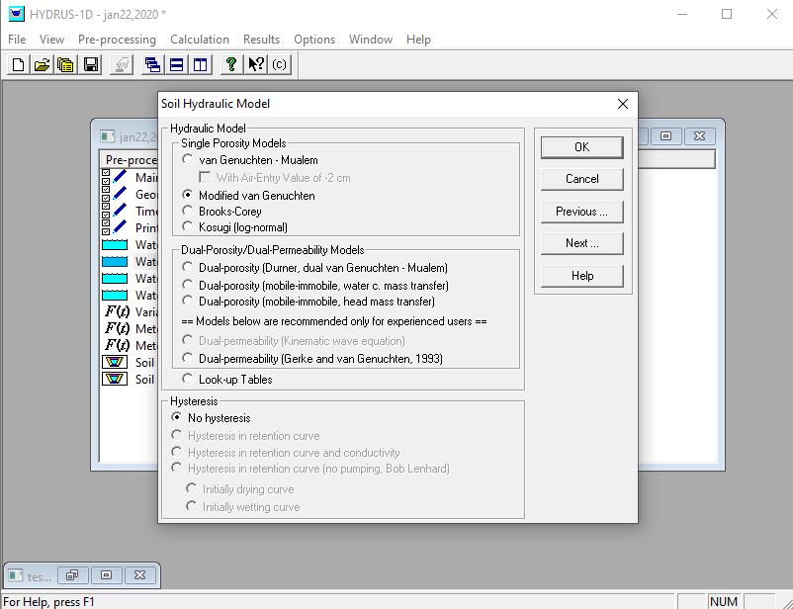

Water Flow – Soil Hydraulic Parameters
The Soil Hydraulic Parameters for the hydraulic property model selected in the previous dialog window can be specified in the dialog window shown below.
Additionally, they also implemented in the Water Flow Parameters window the option of selecting pedotransfer functions, which relate easily measured soil properties such as texture and bulk density with the hydraulic parameters. The pedotransfer functions used in HYDRUS-1D are those developed by Schaap et al. (2001) as incorporated into their Rosetta module (Neural Network Prediction)
Based on the soil texture class which is shown in the table (from Table 3 Mahanama804, Abedeh used this), I let the Hydrus compute parameters by neural network and then I adjusted Ks and θs which I knew their values, but I did that because I did not know the values for α, m and n.
 | W% | W% | W% | m3/m3 | [g/cm3] | m3/m3 | - | m | m/s | m3/m3 | m3/m3
Class | Cl | Sa | OC | θ* | ρb | θs | B | ψs | Ks | WP | fc
31 | 33.33 | 13.33 | 0.26 | 0.46 | 1.34 | 0.47 | 5.68 | -0.44 | 2.75E-06 | 0.168 | 0.33
So the predicted parameters are:
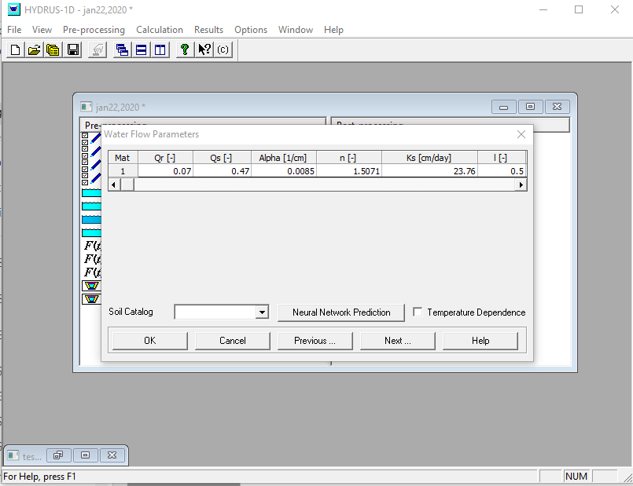
- θr (residual water content, units depend on the selected length unit;
- θs (saturated water content, units depend on the selected length unit)
- Alpha (the hydraulic shape parameter α, units depend on the selected length unit)
- n (the hydraulic parameter n, dimensionless)
- Ks (the saturated hydraulic conductivity, units depend on the selected length and time units)
- l (Mualem’s pore connectivity exponent; the default value of 0.5 is used here)

Water Flow – Boundary Conditions
The Water Flow Boundary Conditions window allows you to select boundary conditions for the top and bottom of the soil profile, depending upon the application.
Various constant or time-variable, pressure heads or water fluxes, as well as atmospheric boundary conditions, can be used at the soil surface. For the bottom of the soil profile, you can additionally select free or deep drainage boundary conditions, a seepage face, or horizontal drain conditions.
Additionally, in the Initial Condition part of the dialog window, you must specify whether the initial conditions for water flow are to be given later in terms of the pressure head or the water content.
The default BC (Free drainage) corresponds to gravity flow (i.e., flow according to a total unit hydraulic gradient).

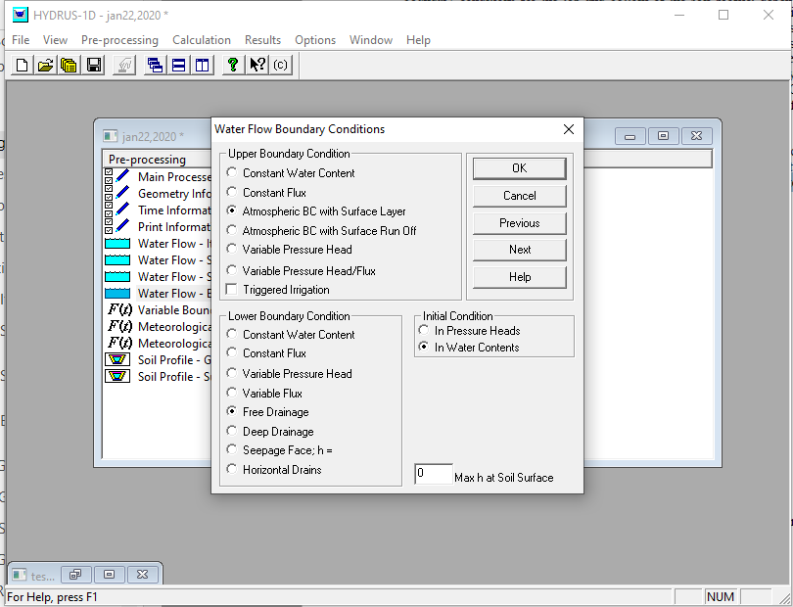

The boundary condition that we used also is $gravitational drainage condition →q_{z_{b}}=K\left(z=z_{b}\right)→ \frac{∂h}{∂z}|_{z_{b}}=0 →\frac{∂θ}{∂z}|_{z_{b}}=0$ so Free Draiage is selected.

Answered by Jirka:
H=h+z
H - total head
h - pressure head
z - graviational head
Free drainage is when
dH/dz=d(h+z)/dz=dh/dz+dz/dz=dh/dz+1=1
then
dh/dz = 0
Thus for free drainage the gradient of total head is equal to 1 and the gradient of the pressure head is equal to zero.

Variable B.C.
Based on the B.C that we defined, it needs Precipitation and h_crit, which is the absolute (positive) value of the minimum allowed pressure head at the soil surface [L]. and we found it by
h_atm_d=8.31*(Temp+273.15)/(0.018*9.8).*log(Hum/100);% page:81 Lu, Ning, and Jonathan W. Godt. Hillslope hydrology and stability. Cambridge University Press, 2013.
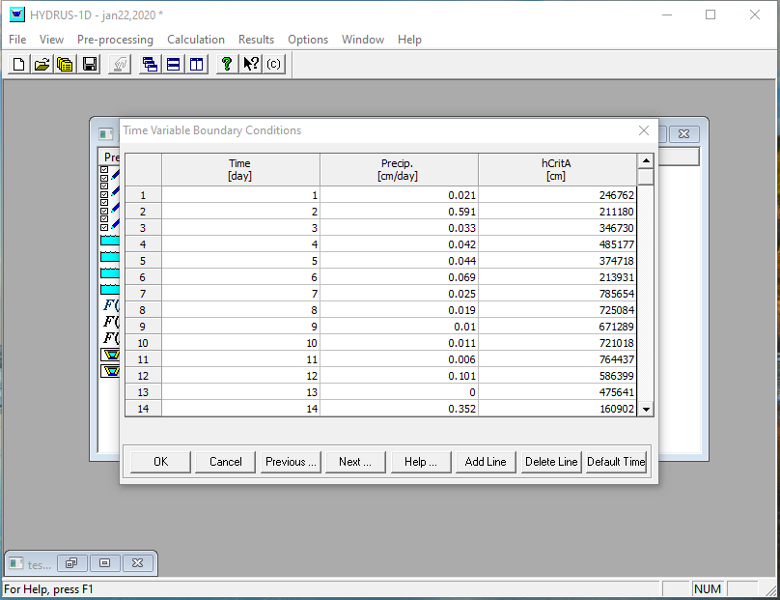

Meteorological parameter
In this dialog window users specify parameters needed to calculate potential evapotranspiration with either the Penman-Montheith or Hargreaves equations, using parameters related to crop growth, LAI and interception.
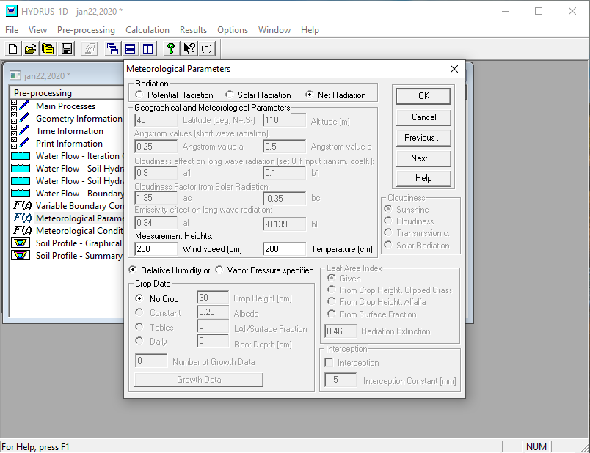
I assumed that there is no vegetation cover, LAI=0

Meteorological conditions
Based on the data that we have from FIFE 87, the table is filled in this way:
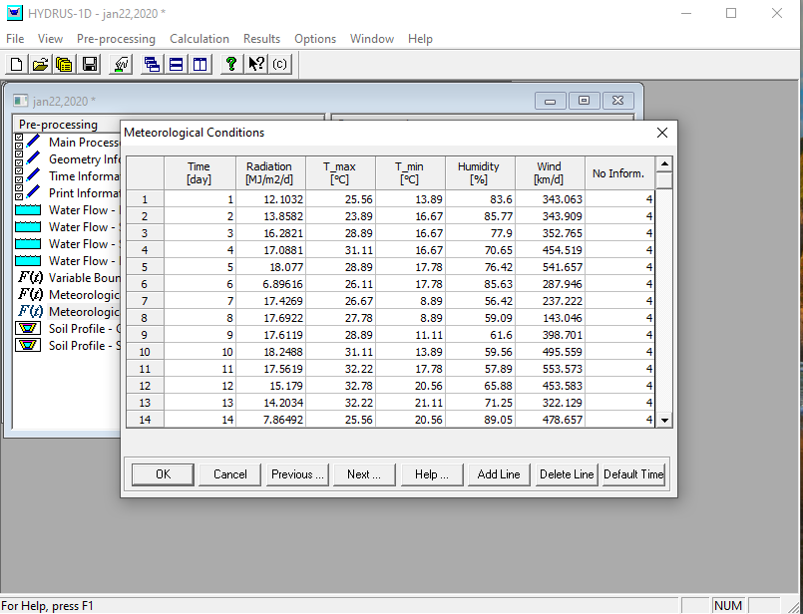
“No Inform” means that no information has to be provided (https://www.pc-progress.com/forum/viewtopic.php?f=4&t=2300#wrap). (So I put it as its default)

Soil Profile-Graphical Editor
Here a uniform initial soil moisture is defined to run the Hydrus. So S0=0.26 is assumed.
The window is like this:
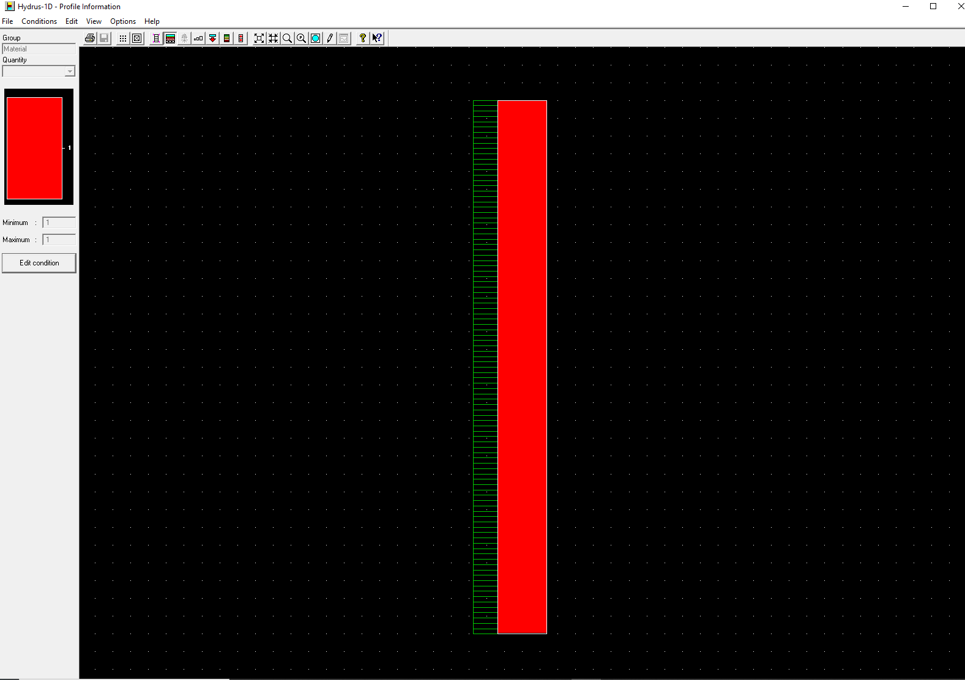

After preprocessing, we can run Hydrus.

Post Processing
Once the calculations are finished and the “Enter” button is pressed, the “Post- Processing” section (the right side) of the main window of the HYDRUS-1D GUI will be populated with commands that can be used to display selected results, which will be discussed below.
The output files are located in the project folder, the location of which is indicated in the Project Manager of the HYDRUS-1D GUI. The output files are in standard text format and as such can be opened by any standard text editing programs, such as Notepad or MS Excel.
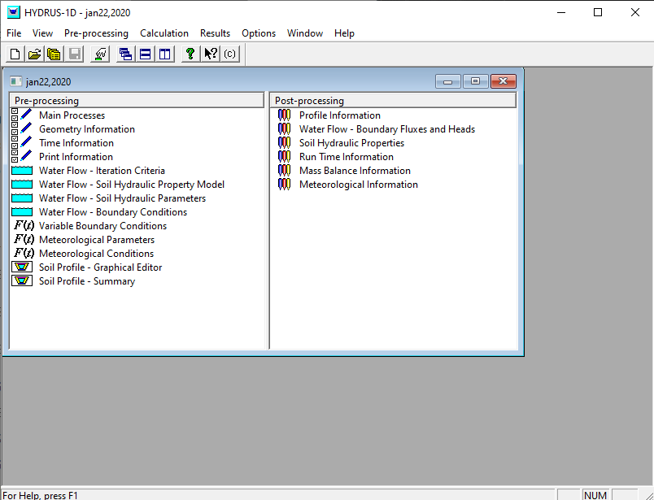

Observation points
Pressure heads (Fig. 1.18), water contents, and water fluxes at selected observation nodes (i.e., at depths of 20, 40, 60, 80, and 100 cm) are displayed under the command “Observation Nodes” at the post-processing section of the HYDRUS-1D GUI (or using the menu command “Results->Observation Nodes).
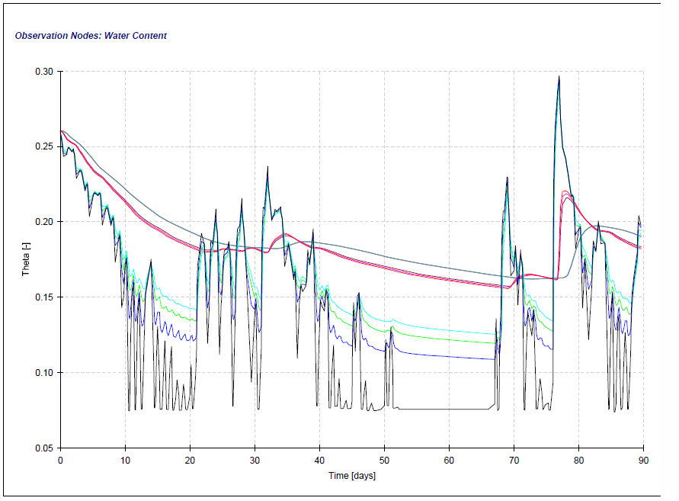

Profile Information
Pressure heads, water contents, water fluxes, hydraulic conductivities, and hydraulic capacities versus depth at selected Print Times (i.e., every day in this example) are displayed using the command “Profile Information” of the post-processing section of the HYDRUS-1D GUI (or using the menu command “Results->Profile Information).
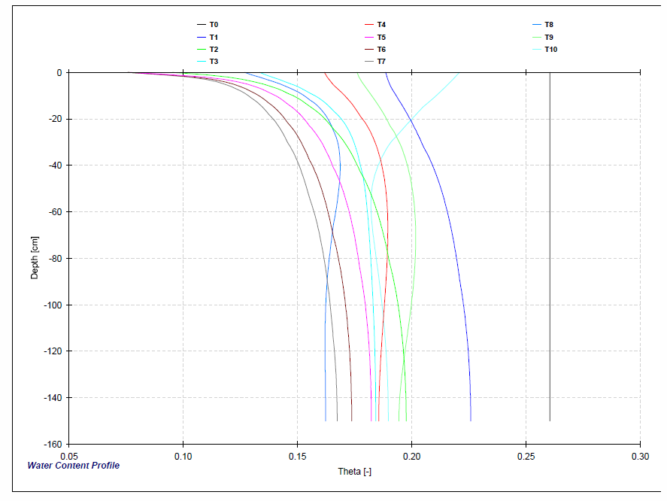

Water Flow - Boundary Fluxes and Heads
Various water fluxes (potential and actual surface fluxes, potential and actual root water uptake rates, and bottom fluxes, as well as their cumulative values), and pressure heads (at the surface and bottom of the profile, and average root zone pressure heads) versus time are displayed under the command “Water Flow - Boundary Fluxes and Heads” of the post-processing section of the HYDRUS-1D GUI; (or using the menu command “Results->Water Flow - Boundary Fluxes and Heads").
Note that HYDRUS-1D reports downward fluxes (against the direction of the z-axis) as negative and upward fluxes (in the direction of the z-axis) as positive. This is due to the convention in the numerical solution that the z-axis is positive upward.
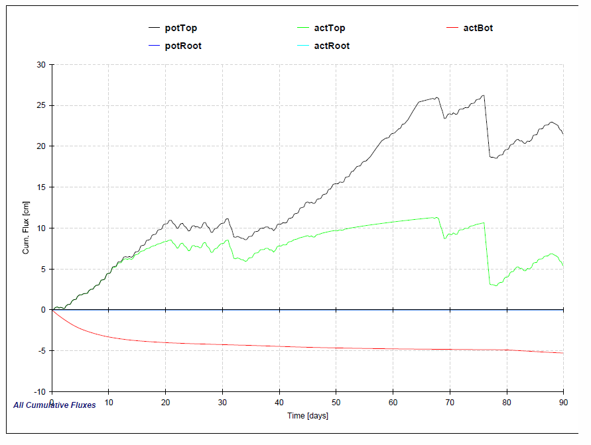
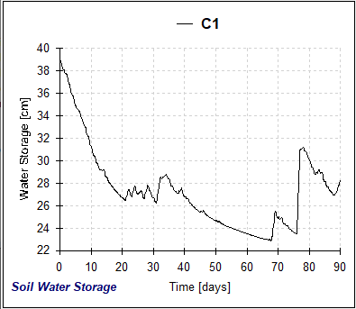
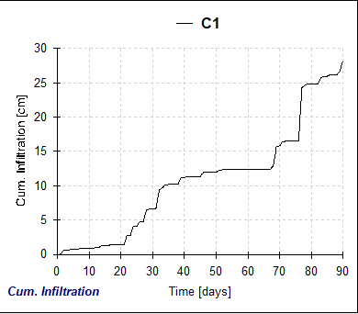
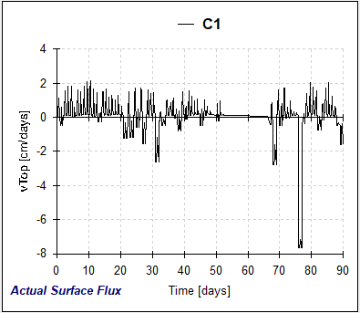
And more other graphs.

Soil Hydraulic Properties
Graphs of the unsaturated soil hydraulic functions (various combinations of pressure heads, water contents, hydraulic conductivities, and soil water capacities) for soils in the soil profile are displayed using the command “Soil Hydraulic Properties” of the post-processing section of the HYDRUS-1D GUI (or using the menu command “Results->Soil Hydraulic Properties").
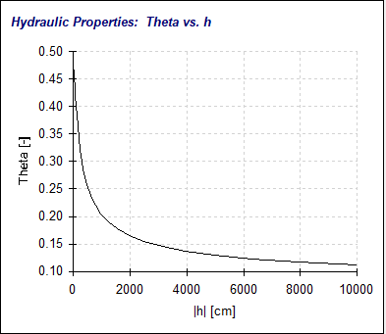
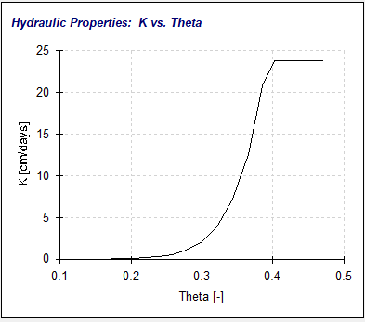
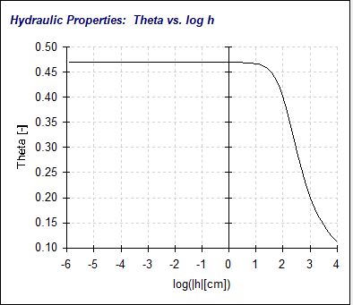

Run Time Information
Selected information about the numerical solution (such as temporal changes in the time step, the number of iterations necessary to solve the Richards equation at any particular time level, the cumulative number of iterations, and the dimensionless Peclet and Courant numbers when solute transport is considered) versus either time or the number of time-steps are displayed under the command “Run Time Information” of the postprocessing section of the HYDRUS-1D GUI. One could for this purpose use the menu command “Results->Run Time Information".

Mass Balance Information
The output file Balance.out containing the mass balance information at selected print times is displayed under the command “Mass Balance Information” of the postprocessing section of the HYDRUS-1D GUI (or, again, also using the menu command “Results->Mass Balance Information").
This manual is prepared with the help of Hydrus Tutorial (Simunek, Van Genuchten, & Sejna, 2011).

Matlab run
When I run hydrus once through GUI, created the Profile.dat, Selevter.IN and atmosph.in, then call it in Matlab by !H1D_CALC (or : system('C:\Users\parisaheidary\Desktop\test\H1D_CALC.EXE')); it is like it is run from matlab instead of windows dos.

! H1D_CALC needs level_01.dir, which includes the directory of input files, (those three inputs).

Some related Matlab functions

To change Profile.dat
fileID = fopen(filename) opens the file, filename, for binary read access, and returns an integer file identifier equal to or greater than 3. MATLAB® reserves file identifiers 0, 1, and 2 for standard input, standard output (the screen), and standard error, respectively.
If fopen cannot open the file, then fileID is -1.

C = textscan(fileID,formatSpec) reads data from an open text file into a cell array, C. The text file is indicated by the file identifier, fileID. Use fopen to open the file and obtain the fileID value. When you finish reading from a file, close the file by calling fclose(fileID).
textscan attempts to match the data in the file to the conversion specifier in formatSpec. The textscan function reapplies formatSpec throughout the entire file and stops when it cannot match formatSpec to the data.

writecell(C) writes cell array C to a comma (it is default, but you can change it) delimited text file. The file name is the workspace name of the cell array, appended with the extension .txt. If writecell cannot construct the file name from the input cell array name, then it writes to the file cell.txt.
Each column of each variable in C becomes a column in the output file. The writecell function overwrites any existing file.

f = fullfile(filepart1,...,filepartN) builds a full file specification from the specified folder and file names. fullfile inserts platform-dependent file separators where necessary, but does not add a trailing file separator. On Windows® platforms, the file separator character is a backslash (\). On other platforms, the file separator might be a different character.
fullfile replaces all forward slashes (/) with backslashes (\) on Windows. On UNIX® platforms, the backlash (\) character is a valid character in file names and is not replaced.
fullfile does not trim leading or trailing separators. fullfile collapses inner repeated file separators unless they appear at the beginning of the full file specification. fullfile also collapses relative directories indicated by the dot symbol, unless they appear at the end of the full file specification. Relative directories indicated by the double-dot symbol are not collapsed.
f = fullfile('myfolder','mysubfolder','myfile.m')
f =

'myfolder\mysubfolder\myfile.m'

copyfile source destination copies source to the file or folder destination.
- If source is a file, then destination can be a file or a folder.
- If source is a folder, then destination must be a folder.
- If source is a folder or specifies multiple files and destination does not exist, then copyfile attempts to create destination.

To create level_0.dir
% to create level_0.dir
fid = fopen('level_01.dir', 'w');
level0DIR=fullfile(path{k}); %%path for run folder which all inputs are there
fprintf(fid, '%s', level0DIR);

References
J. Šimůnek, M. Šejna, H. Saito, M. Sakai, and M. T. van G. (2013). Version 4.16 March 2013. (March).
Simunek, J., Van Genuchten, M. T., & Sejna, M. (2011). The HYDRUS Software Package for Simulating the Two- and Three-Dimensions Movement of Water, Heat, and Multiple Solutes in Variably-Saturated Media. In Technical Manual. https://doi.org/10.1007/SpringerReference_28001

