## **General Information**

One important question about this data set would be what is the purpose of the loans?

Debt consolidation is the number one purpose of loans, the educational purpose is the least

Purpose of loans.

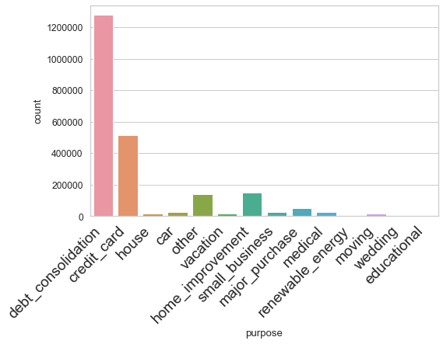

 We continue by exploring the distribution of the loan amounts and see when did the loan amount issued increased significantly.

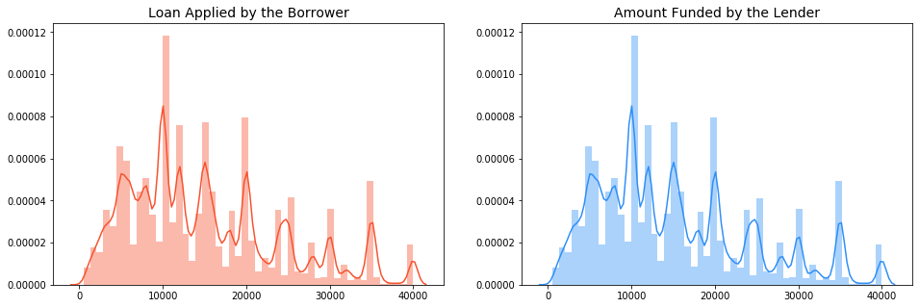

The loans applied by potential borrowers, the amount issued to the borrowers and the amount funded by investors are similarly distributed, meaning that it is most likely that qualified borrowers are going to get the loan they had applied for.

We can see that most of the loans issued were in the range of 10,000 to 20,000 USD. The year of 2018 was the year were most loans were issued.

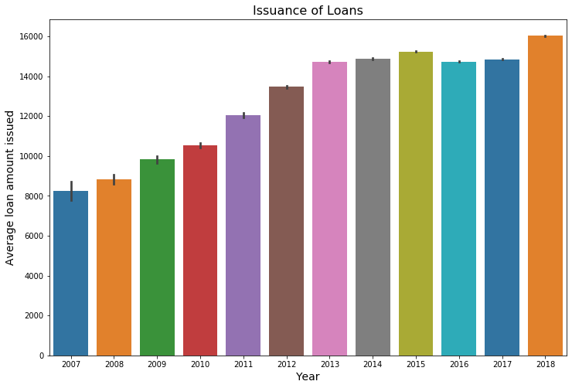

Good Loans vs Bad Loans

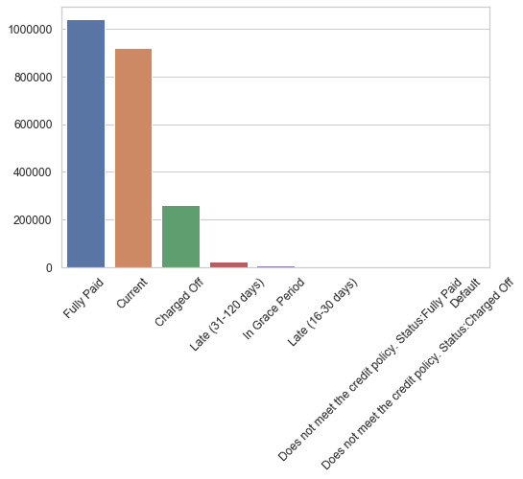Another important question is to see the status of the loans and see how many have been fully paid and how many are current loans. This can give us a very good insight about categorizing loans.

## **Types of Loans**

Next comes to categorizing the loans into good and bad loans, based on their status and do some visualization here.

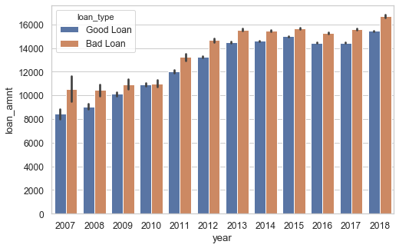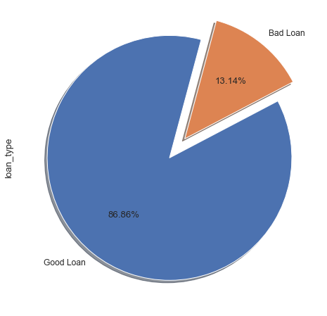

It can be shown that there is a consistency between the loan amount and type of loans, meaning that the increase in loan amount will increase the chance of having bad loans.

## **Loans Issued by Region**

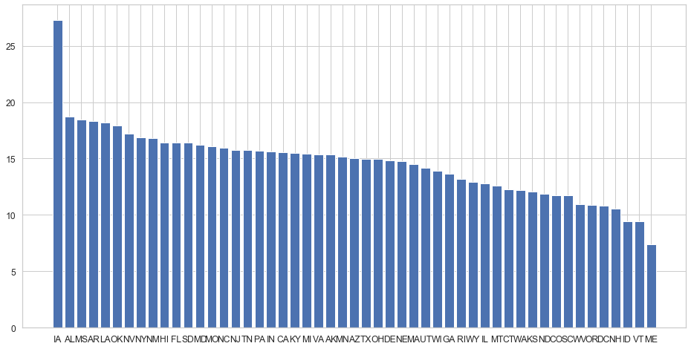In this section we want to analyze loans issued by region in order to see region patters that will allow us to understand which region gives Lending Club.

We then categorize the states to five regions and did the analysis from there. South-east , West and North East regions had the highest amount of loans issued. West and South-west had a rapid increase in debt-to-income starting in 2012. West and South-west had a rapid decrease in interest rates.

