Episode 3:

We start from .net framework not .net core.

Whenever aading a project, check in nuget package manager for updates and do updates first.

App_start -> RouteConfig.cs file is the marriage between mvc and web api

Controller/action/id is from mvc. Its there in case we needed it

WebApiConfig.cs has a different route api/controller/id is the routing engine or route path here

If there is domain/api it will go to api routing if there is nothing it goes to MVC routing

IdentityConfig.cs in same directory is about authentication username and passwords in this system

When u run this app as is, it wil take u to a default page. In api link u can see default api s and u can try to type them in the browser to try them. Api/values at first refuses because of authentication rule set. These api s are set in this project by default and can be foud in controller folder

Create and admin account for db ?? or other beetr solutions

Authorization : u can create a token to last for a while. It a string which is provided once u logged in and authentication has been done. Companies usually do a 30 min one to stay logged in in ur application

How to make: in postman use the base url : localhostxx / token with get method

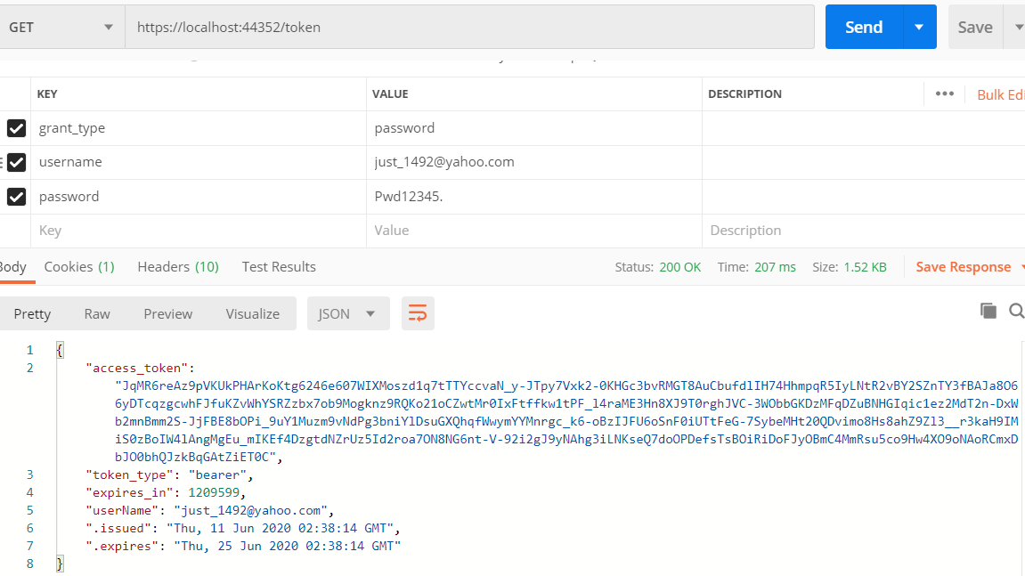

How to use :

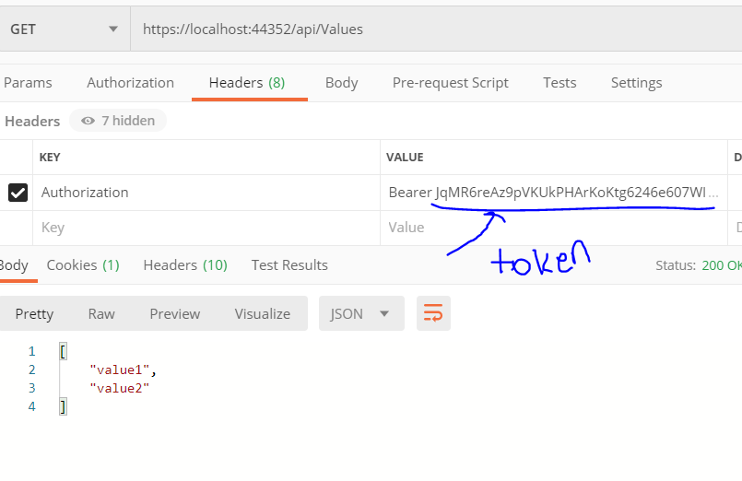

The WPF login is going to store the token and its gonna send back that token as a authorization. That authenticate who is logging in and will be able to tell us who they are.

You can set code in valuesController for example to get id of the user trying to send the request in order to identify them again. The id it provides matches the id column in db for the same user. Its better to use this id if we wanted to authenticate a user uniquely even if their email changes also its secure.

Later on we can put limitations for who they have logged in as. Setup roles

ApiController vs Controller

Note If you have worked with ASP.NET MVC, then you are already familiar with controllers. They work similarly in Web API, but controllers in Web API derive from the ApiController class instead of Controller class. The first major difference you will notice is that actions on Web API controllers do not return views, they return data.