Java Bookstore Web Application

Parisa Khosravi

Student No: GH1027620

Introduction

The Project discussed in this report is a Java Springboot Application for an E-commerce platform which is a book store. The application connects to a SQL database with eight tables, inter

Challenges and Solutions

While trying to join the customer and order tables to write a method for getting a customers orders, I got an error saying the customer id column in the order class was being mapped twice. This was caused because I had the code below to define the Many to one relation

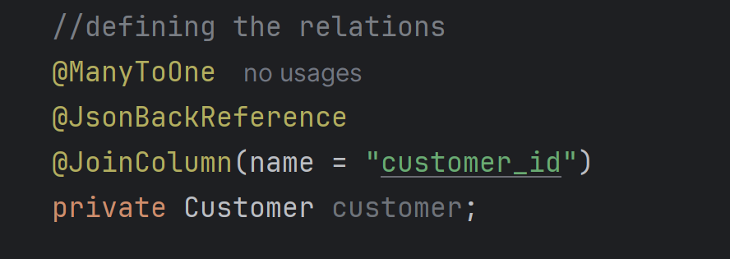

And I had the field “private Integer customer_id’

The solution I found was adding

@Column(name = "customer_id", insertable = false, updatable = false)

to my customer_id field.

However, when I wrote a method to add an order, this was problematic because I could not add the customer id eventhough I made an if statement for this field not to be null. As a result, the order was added to the orders table with null value for customer id



So I removed the joinColumn and it solved the problem.