Otto-von-Guericke-University Magdeburg

Faculty of Electrical Engineering and Information Technology

Chair for Electromagnetic Compatibility

Degree Thesis



Characterization and Automated Alignment Detection of an Additively Manufactured Z-frame Marker to Process Signals for Robotic Control in Interventional MRI

Submitted: August 01, 2018

By: Parisa Parsanejad

Born on June 23, 1991

In Esfahan, Iran

**Abstract**

**Task of the Thesis in the Origin:**

**Declaration by the candidate**

I hereby declare that this thesis is my own work and effort and that it has not been submitted anywhere for any award. Where other sources of information have been used, they have been marked.

The work has not been presented in the same or a similar form to any other testing authority and has not been made public.

Magdeburg, August 01, 2018

**Contents**

**List of Acronyms**

**List of Figures**

**List of Tables**

1. **Introduction**

**1.1 Motivation**

**1.2 Objectives**

1. **Literature Survey**
   1. **Magnetic Resonance Imaging (MRI)**

MRI is a non-invasive imaging technology generating three dimensional anatomical and functional images of the body without the use of ionizing radiation. It is particularly useful for neurological, oncological, cardiovascular, muscular and skeletal imaging. MRI employs a powerful magnetic field that forces the hydrogen atoms in the tissue being imaged to align with its axis. The additional radiofrequency fields are then used to stimulate the protons and alter the alignment of the magnetization. When the radiofrequency fields are turned off, the protons realign with the magnetic field and release the detectable energy by MRI scanner. It defines different MRI parameters such as repetition time and echo time which are the time between two consecutive excitation pulses and the time between the excitation pulse and the recording of the magnetization value, respectively.

**2.1 Pulse sequences**

A pulse sequence is the measurement technique and contains multiple parameters such as RF pulses, gradient pulses, and timing. Depending on the anatomical region under observation, the optimal pulse sequence has to be chosen in order to acquire the data in the desired manner. There are three general criteria that should be considered when modifying the measurement parameters of a pulse sequence through the user interface software: acceptable scan time, adequate spatial resolution, and the sufficient contrast between tissue relative to the background noise (contrast-to-noise ratio). Many pulse sequence parameters are available commonly which can be categorized by their effect on the MRI image as intrinsic and extrinsic parameters. Intrinsic parameters influence only the signal-producing portion of the image such as patient anatomy. Extrinsic parameters affect factors external to the tissue and the structure of the data collection such as voxel size.

Despite the non-ionizing radiation characteristics, MRI imaging experiences different imaging artefacts which generate difficulties for the detection and registration task.

**2.2 Artifacts in MR imaging**

In the MR images, artifacts refer to pixels that do not truly represent the anatomy being studied. Artefacts can be categorized into three groups, according to the cause of the signal misregistration. The first group refers to artefacts that are produced by the patient tissue movement during data acquisition. The second group is a consequence of the measurement technique and parameters. The last group are independent of the patient or measurement technique and are generated from an external source to the patient or scanner.

**2.2.1 Motion artifacts**

The motion artifacts are caused by tissue that is excited at one location, producing signals that are mapped to a different location during detection. The specific appearance of the artifact depends on the nature of the motion and the measurement technique. If the motion is periodic, the produced artefact is discrete, often referred to as “ghosts”. Moreover, the sensitivity of a measurement to tissue motion depends on the amount of frequency and phase variation that occurs between successive echoes due to tissue movement. In abdominal or lumbar spine imaging, respiratory motion is the most common causes of the motion artefacts.

**2.2.2 Sequence/Protocol-related artifacts**

In this class of artifacts, the specific measurement parameters cause the artifact in the image. The source of these artefacts is relatively constant during the measurement.

**2.2.2.1 Aliasing**

The acquisition matrix and FOV in the specific measurement technique are two important factors determining a different phase and frequency to each location in the image. Aliasing artifact occurs both in the readout and phase encoding directions. If the selected FOV in the readout direction is smaller than the anatomical slice, the tissue’s frequencies pass the Nyquist limit, and are mapped to a lower frequency. This situation happens in the readout direction and is called high-frequency aliasing. It can be avoided by enhancing the number of readout data while maintaining the same sampling time. Furthermore, when tissue outside the FOV in the phase encoding direction is excited, the protons experience phase changes and are transformed to a lower phase situation via the Fourier transformation. This is known as phase encoding aliasing that can only be eliminated by increasing the FOV in the phase encoding direction.

**2.2.2.2 Chemical shift artifacts**

Chemical shift artifacts emanate from the inherent 3.5 ppm frequency difference between fat and water protons under the effect of an external magnetic field. One consequence of this frequency difference is a misregistration of fat and water protons from a voxel that are mapped to different pixels. In MRI, the exact magnetic field is dependent on the location inside the magnet according to the equation (1?); consequently, the detected signal from a proton (better voxel) is localized based on its frequency:

Bi=B0+GT ri

Where B0 is the main magnetic field, Bi is the magnetic field at location ri and GT is the total gradient amplitude.

Due to the fact that fat and water protons have a different molecular structure, they resonate at a lower frequency than water protons when exposed to the same gradient field. Accordingly, they will be mapped to a lower frequency pixel in the readout direction by the same GRO within a voxel. This misregistration is not perceivable in tissues with a consistent fat-water content. However, at the borders between tissues with an indicatively different fat-water content chemical shift artifact is visible. The number of pixels resembling chemical shift artifact (CSA) can be estimated according to the equation 2?:

CAS =

Where represents the frequency difference between fat and water protons in a voxel, is the total receiver bandwidth, and shows the number of readout data points spanning the FOVRO.

**2.2.2.3 Phase cancellation artifact**

Phase cancellation artifact is the second type of chemical shift-based artifact which arise from the frequency difference between fat and water protons. This artifact is visualized in out-of-phase gradient echo images. As shown in Figure 2.1, the fat protons cycle in phase relative to the water proton precession at a rate linearly proportional to the measurement time after the initial RF excitation pulse. Combine the net search : http://www.revisemri.com/questions/artefacts/phase_cancellation

**Figure 2.1** precession of fat and water protons. More explanation in book.

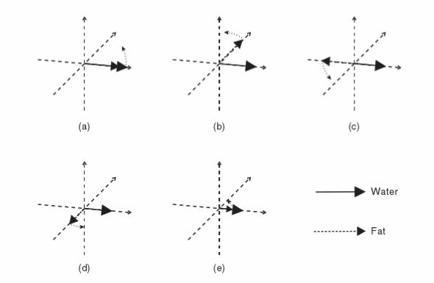

**2.1.0 Signal-to-Noise Ratio and Tradeoffs**

One of the most important characteristics of the MRI image data is the signal-to-noise ratio (SNR). The SNR in MRI images depends on the level of signal and the level of noise present in the data. There are different kinds of factors influence on the level of noise and signal in the MRI images. For instance, larger voxel size increases the SNR because the voxel contains more signal. Longer sampling time decreases the noise, and thus increases the SNR, the receive coil sensitivity and volume and the tissue. In addition, the receive coil volume and sensitivity contribute to the SNR. Furthermore, the tissue characteristics and its relaxation affect the SNR. These effects can be shown as follows:

SNR= V*T1/2 *R(B0, B1,…) * Iseq (T1,T2,TE,TR,…) (1.1)

Where V is the voxel volume, T is the total sampling time for each voxel, R is a factor characterizing the effects of the main magnetic field, the receive coil sensitivity and so force, and Iseq is a factor characterizing the signal intensity form the pulse sequence and the tissue.

**Registration**

Registration is an important operation of surgical guidance and the accuracy of the guidance is based on the registration method. In fact, registration determines a geometrical transformation that aligns different views of an object. A “view” can be an image, such as CT or MR, or it can be the physical object itself. In this work, registration referred as “image-to-physical” registration, where

There are different types of registration. In this section

**Opposite registration approach**

The main strength of this registration system is the ability to achieve concurrent registration in desired target alignment from a single slice image. Conventional registration methods usually …. In robotically assisted surgery, the end-effector of a robot can be registered to the scanner using a rigid body fiducial frame attached to the end-effector. However, this technique has a common problem that robot moves the fiducial frame out of the field of view, causing the image slice to become incomplete for registration. Figure 3? Illustrates an image of Masamun’s device with an incomplete number of fiducial rods. Traditional methods cannot handle this problem without acquiring extra images, which costs time. (numerical algorithm for spatial ...).

The algorithm has following advantageous:

It is resistant to noise in the input data. One of the input to the registration algorithm I the two-dimensional coordinates of the fiducials marks in the cross-sectional image. This information is produced by an image processing program at I not the subject of this investigation. It is conceivable that the locations of fiducial marks are not exactly identified in the medical images, due to suboptimal imaging and image processing techniques. These errors are considered to be “noise” in the input to the registration algorithm.

The algorithms must also run reasonably fast, in order to be useful in intraoperative applications. Computation time longer than one second? Would be prohibitive.

**Mathematical background and notation**

Check If I need mathematical bg or not

1. **Methodology**

The implemented algorithm for automated alignment detection of the Z-frame comprises several stages for the successful accomplishment of the task. The first step is the pre-processing of the images for extracting the Z-marker structures from the image, reducing the noise and enhancing the features of interest for the subsequent detection algorithm. This stage is developed in section 3.1, where different methods in each step are compared. Finally, the method for estimating the centroids of fiducial is introduced. The next section discusses localization and registration techniques. A new registration procedure is proposed, which uses several mathematical calculations to estimate a correct rotation angel of a robotic device to make it parallel with the image plane. All the considered procedures described in this chapter are implemented in Matlab R2017a, and their results are shown and investigated in chapter 4.

* 1. **Image Pre-Processing and Segmentation**

After a single 2D image of the fiducial frame has been obtained, each individual ellipse of the frame should be segmented on the MR image. Therefore, to distinguish the fiducial frame from other anatomical structures, the following filtering steps are applied to the image. The flow chart of the detection and localization algorithm is shown in Fig. ?.

(here you have to add more 2 lines for methology, and for 3.1 u have to talk about the MRI protocol for exmaple as we discussed in section .. , and explain more about the filtering and segmentation problems in MRI for example based on samples.)

Here you put the flow chart as the shape of references and colorful

* + 1. **Automatic detection of Z-frame using Faster R-CNN**

Detection of the Z-marker in different position, orientation and scaling from MRI image is a very important step to determine the marker alignment. One way to separate the Z-marker from the full-screen image is using the mouse to perform the crop operation interactively by defining a movable and resizable bounding box over the region of interest.

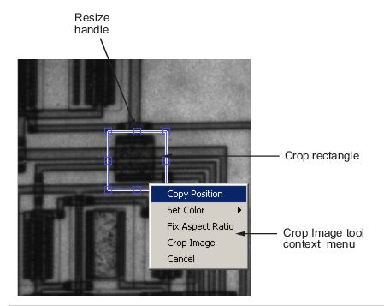

However, this technique requires the user to repeat the process separately for each new image. In this study, a deep CNN framework is implemented with non MRI-system-specific design to perform the detection process automatically. This algorithm is able to detect the marker from the images with different properties and from the different MRI user interfaces.

There are three main frameworks in object detection based on deep CNNs. Regions with CNN features (RCNN), Fast Region-based Convolutional Network (Fast RCNN), and Faster Region-based Convolutional Network (Faster RCNN).

In the snapshot from the MRI monitor, there are many small and big objects, therefore, the use of the Faster RCNN yield a higher precision for real-time object detection.

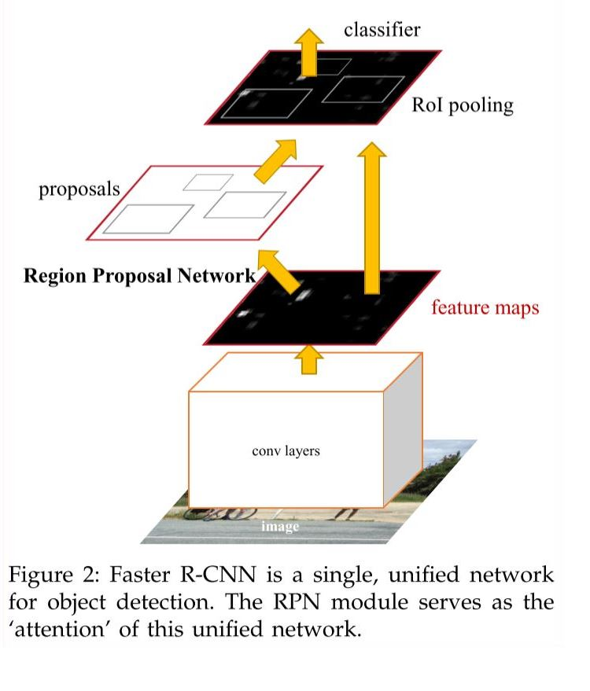

**Principles of convolutional neural network**

Traditional CNN is made of several layers, a convolution layer, a feature pooling layer, and a fully connected (FC) layer.

**Convolution layers:**

At the convolution layer, an activation function determines the output of the neural network when the feature maps from previous layers are convolved with learnable kernels and are added with a trainable bias parameter. This process can be expressed as:

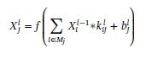

In which, Xil-1 and Kijl are feature map and kernel respectively, bj represents bias parameter, f (.) is the activation function and Mj shows a selection of input maps.

The activation function in convolution layers has a significant effect on the training performance. Rectified Linear Unit (ReLU) activation function is the most successful and widely-used function. As it is shown in Fig. 2, the ReLU is half-rectified and f(z) is zero where z is less than zero and f(z) is equal to z when z is above or equal to zero.

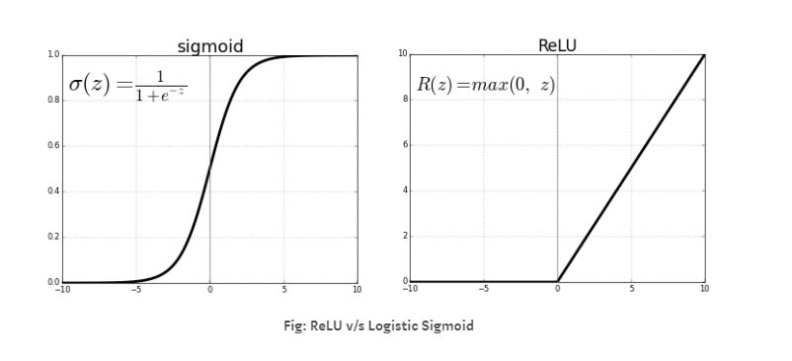

In this work, ReLU is selected, as the activation function in the new layers since it works better than the logistic sigmoid and hyperbolic tangent functions.

**Feature pooling layer:**

The pooling layer aggregates the results of convolutional layers and passes only the strongest signals. For example, a MaxPooling layer simply uses the highest value of a matrix kernel and discards all others. The purpose of pooling is to pass on only the relevant signals to the next layers, to achieve an abstract representation of the content and to reduce the number of parameters of a network. Many CNNs consist of a sequence of two convolutional layers each with the same number of filters, followed by a pooling layer followed by two convolutional layers and one pooling layer. While the size if the input through the convolutions and the pooling is reduced further and further, the number of filters for detecting higher-level signals is increasingly increased. After the last pooling layer, one or more fully connected layers follow.

Source(https://jaai.de/convolutional-neural-networks-cnn-aufbau-funktion-und-anwendungsgebiete-1691/)

The purpose of the pooling layers is to achieve spatial invariance by reducing the resolution of the feature maps. Each pooled feature map corresponds to one feature map of the previous layer. Their units combine the input from a small nxn patch of units, as indicated in Figure 1. This pooling window can be of arbitrary size, and windows can be overlapping.

We evaluate two different pooling operations: max pooling and subsampling.

The subsampling function

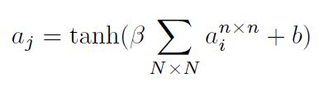

takes the average over the inputs, multiplies it with a trainable scalar β, adds a trainable bias b, and passes the result through the non-linearity. The max pooling function

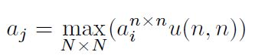

Applies a window function u(x,y) to the input patch, and computes the maximum in the neighborhood. In both cases, the result is a feature map of lower resolution.

Source: Evaluation of Pooling Operations in Convolutional Architectures for Object Recognition

This layer treats each feature map separately. In general, this layer is called the subsampling layer, and it produces down-sampled versions of the input maps. This means that the number of input and output maps is the same, but the output maps are smaller in size. The results are robust to small variations in the location of features in the previous layer. This process can be expressed as:

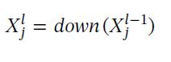

Here, down (.) denotes a down-sampling operation. By means of down-sampling, we reduce the size of the input by summarizing neurons from a small spatial neighborhood.

**Fully connected (FC) layers:**

A fully connected layer is a normal neural network structure in which all neurons are connected to all inputs and outputs. In order to be able to feed the matrix output of the convolutional and pooling layers into a dense a FC layer, it must first be rolled out (flattened). The output signals of the filter layers are independent of the position of an object, therefore, although there are no more position features, but location-independent object information.

This object information is thus fed into one or more fully connected layers and connected to an output layer, which is e.g has exactly the number of neurons corresponding to the number of different classes to be recognized.

Source(https://jaai.de/convolutional-neural-networks-cnn-aufbau-funktion-und-anwendungsgebiete-1691/)

After data processing by several convolutional and subsampling layers, high-level reasoning in the neural network is performed via FC layers. Neurons in an FC layer have full connections to all activations in the previous layer. Their activations can hence be computed with a matrix multiplication followed by a bias offset. The flowchart of a CNN is shown in Fig. 1.

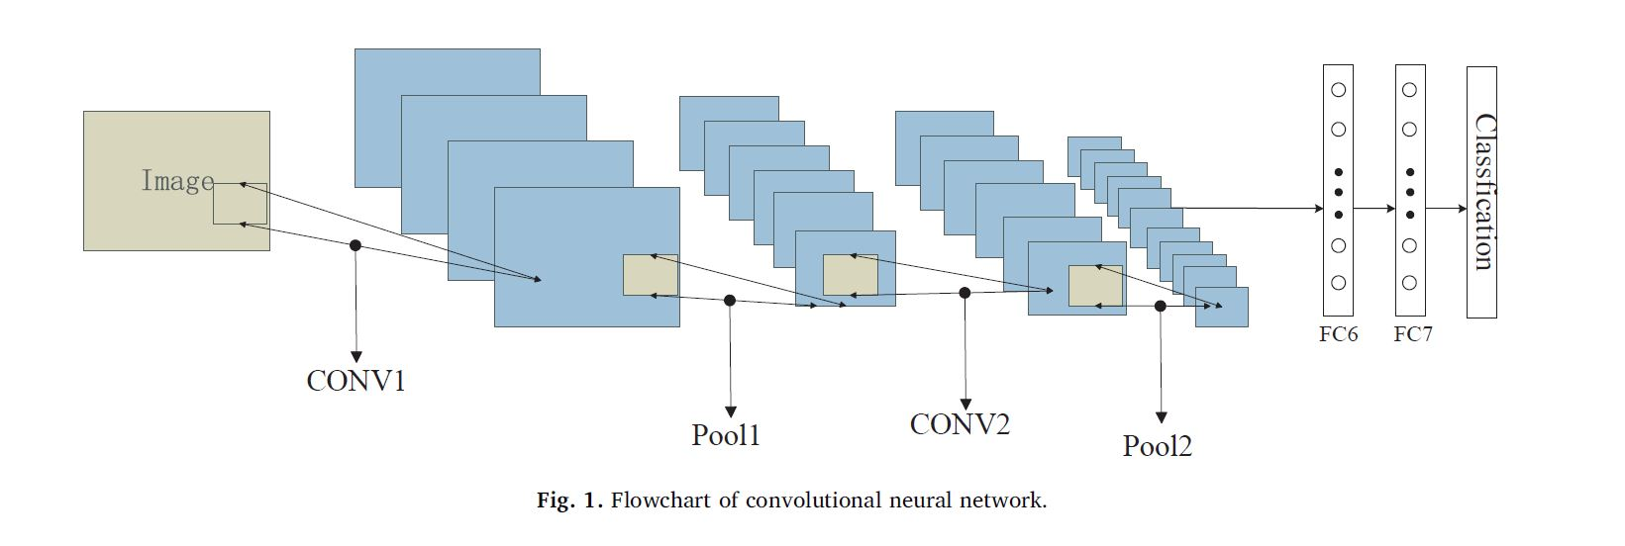

Training is performed by means of the backpropagation algorithm to minimize the aberrations between the ideal output and the actual output of the CNNs. In general, for the purpose of detection, a CNN is followed by a classification module.

The application of RCNNs is considered a remarkable achievement in object detection. The approach combines CNNs and a support vector machine (SVM) as well as bounding boxes to detect objects. RCNNs can be used to detect object with high accuracy. However, the approach is time-consuming for each proposal region of different images to repeatedly undergo CNNs. Moreover, a proposal region needs to be cropped (or wrapped) to a fixed size for the FC layers. However, the cropped region may not contain the entire object and the wrapped content may result in unwanted geometric distortion. Consequently, the spatial pyramid pooling (SPP)-Net model, which uses an SPP layer to remove the fixed-size constraint, was proposed to address this issue. As the fixed-size constraint arises only from the FC layers, the pyramid pooling layer is added on top of the last convolutional layer. Moreover, with the use of SPP-Net, one can run the convolutional layers only once on the entire image. When compared with RCNN, SPP-Net exhibits significant improvements. However, SPP-Net still offers from several disadvantages, as it is unable to update weights before the SPP layer and the training is still under a multistage pipeline. On the basis of SPP-Net, Ross proposed the Fast RCNN. With Fast RCNN, one can update all the network layers. The training now involves only a single stage via the use of multi-task loss. In addition, this model is faster and more precise than SPP-Net and RCNN. Importantly, there is no need of disk storage for feature caching, which is needed for the SVM. The SVM is replaced by the Softmax layer, which can be inserted into the network directly. With this model, we can fine-tune all the networks, which directly aids us in finding reasonable parameters. While Fast RCNN has exhibited considerable improvements in terms of performance, the aspect of region proposal has become the bottleneck for real-time requirements. Consequently, Faster RCNN was proposed to address this problem. In order to overcome the disadvantageous of Fast RCNN, the approach uses a deep fully convolutional network called Region Proposal Network (RPN) to propose regions. Subsequently, Fast RCNN uses the proposed regions to detect objects. RPN and Fast RCNN can share features, and this is speculated to aid in improving accuracy. The flowchart of Faster RCNN is shown in Fig. 2. The layers before ROI-pooling should be labled Conv1-Conv5, but for simplicity, we only depict Conv1, Conv3, and Conv5. This simplification is also used in Figs. 3 and 4.

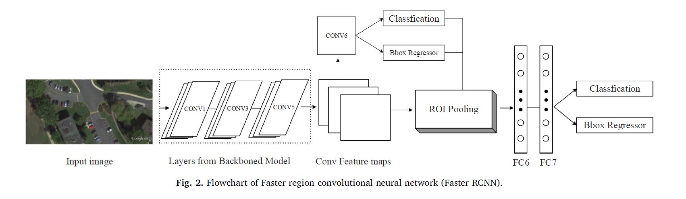

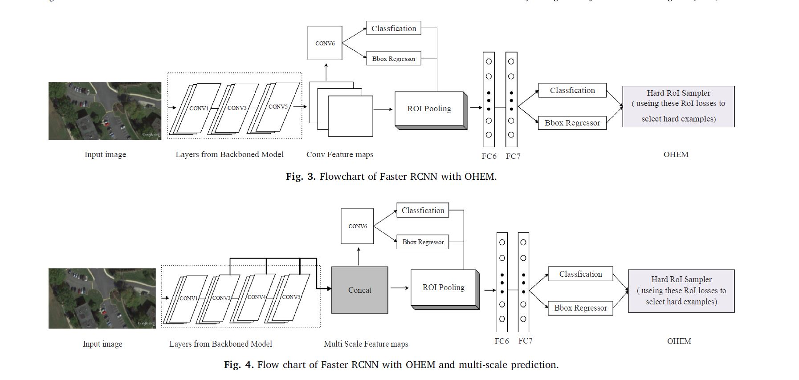

Among the abovementioned frameworks, Faster RCNN (FRCNN) afffords several advantages, and researchers are constantly developing and refining this approach. In this work, we therefore also chose Faster RCNN as our framework.

**Experiment and discussion**

We adopt two commonly used objective criteria of average precision (AP) and recall to evaluate the performance of our approach. These parameters defined as follows:

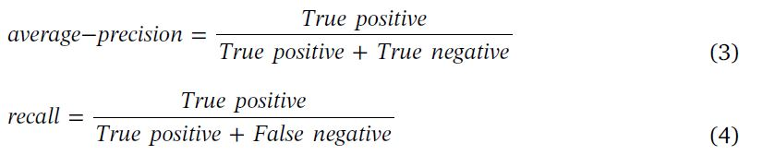

These two criteria are generally used in deep learning. ‘’False negative’’ is a test result indicating that a condition does not hold, while in fact it does. ‘’True negative’’ is a test result indicating that a condition does not hold and in fact it does not. ‘’ True positive’’ is a result indicating that a given condition exists and it does exist. We evaluate all the images in the test set instead of evaluating the objects in a single image. This approach is different from the traditional evaluation that involves evaluation the result with a single image.

**Precision and recall analysis**

Accuracy and recall rate form our foremost priorities. It is meaningful to improve the speed of the convolution network on the basis of precision and recall rate, and therefore, we first analyze the impact of different improvement schemes on accuracy and recall rate.

**Analysis of lighter and faster FRCNN**

Besides the accuracy and recall rates, the detection speed is also an important aspect.

Source: A light and faster regional convolutional neural network for object detection

in optical remote sensing images

**3.1.1 Denoising MRI images using Gaussian Smoothing Filter**

The Gaussian filter is a type of image-smoothing filter that is commonly used to reduce noise in the image. The Gaussian smoothing filter uses a Gaussian function for calculating a transformation to apply to the image. The equation of a two dimensional Gaussian function is the product of two one dimensional Gaussian functions as:

G(x,y)= e-

Where x is the distance from the origin in the horizontal axis, y is the distance from the origin in the vertical axis, and σ is the standard deviation. The Gaussian filter works by using the 2D distribution as a point-spread function. This is achieved by convolving the 2D Gaussian distribution function with the image.

Revising

**3.1.0 Denoising MRI images using wavelets**

One of the important applications of wavelets is image denoising and compression. By computing the Discrete Wavelets transform (DWT) the image content is decomposed in *scaling* coefficient (approximation sub-band) and wavelet coefficients (detail sub-band) at different orientations (horizontal, vertical and diagonal) and resolutions. One of the characteristics of the DWT is that it tends to concentrate the information contained in the analysed signal into a relative small number of coefficients. In the case of a noisy image, the DWT will contain a reduced number of coefficients with high SNR and many coefficients with low SNR. The main noise reduction algorithm based on DWT decomposition is to discard low SNR coefficients and to keep the significant ones. After selecting the desired coefficients, the Inverse Discrete Wavelet Tramsform (IDWT) provides the noise suppressed image. Nevertheless, the DWT is not time space invariant, simple miss-alignments between the signal and the basis function providing artifacts in the denoised image. This drawback is solved by using the Shift-invariant Wavelet Transform (SWT). No development of the wavelet transform analysis will be made in this section. A detailed introduction in the wavelet theory can be found in []. Several properties which make the wavelet transform suitable for the denoising task, are summarized below:

* *Multiresolution*- the multi-level wavelet decomposition allowa the analysis of image details at different scales;
* *Edge detection* – high wavelet coefficients correspond to image edges;
* *Edge evolution across scales* – the wavelet coefficients corresponding to image edges tend to persist across the scales.

The main task is to find a suitable threshold in order to select the coefficients which best describe the information in the analyzed image and to suppress as much noise as possible. In the case the threshold is too low, the noise suppression might be unsatisfactory, but loss of image detail (excessive smoothing) would be visible in the case of a high threshold.

Many techniques have been proposed in the literature with a view to find the best suitable threshold for the wavelets coefficients and for noise level estimation in MRI images.

**3.1.2 Denoising MRI Images Using Nonlinear Anisotropic Filtering**

The main drawback of the linear filtering is that the details in the original image will be destroyed during reducing the noise. Anisotropic diffusion filtering proposed by Perona and Malic [reference] is a technique which reduces the image noise but preserves details and even enhances edges. The suggested filter can be expressed as anisotropic process which uses an adapted diffusion tensor with preference to intra-region instead of inter-region smoothing. The novelty is that the diffusive procedure is an inhomogeneous process that limits the smoothing in areas of interest which have a larger likelihood to be edges.

The Perona-Malik filter is based on the mathematical formulation given in equation 1, where c(x,y,t) is the diffusion coefficient, I(x,y,t) is the image intensity and div and are the divergence and the gradient operators. x and y represent the spatial coordinates of the image in the two-dimensional case, and t corresponds to the iteration number.

An important step in this technique is to define the proper diffusion coefficient which is defined as a function based on the image gradient. Ideally, it should be 0 at the features of interest (edges and boundaries), and 1 when the filter is positioned at the interior of a region. Accordingly, Perona and Malik [] introduced two mathematical equations for estimating the diffusion coefficient.

Perona and Malik [source] proposed two mathematical functions for the diffusion coefficient, where the first one (eq. num) advantages the high contrast edges rather than the low contrast ones, and the second one (eq.4.7) favours the wide areas instead of narrow ones.

In eq. 4.6 and 4.7 k is called conductance parameter, and usually can be selected empirically. It determines the difference between an edge and an intensity value corrupted by noise during anisotropic diffusion filtering process.

The numerical scheme which implements the eq.4.4 defines the intensity change at location (x,y) after one iteration as a sum of contributions of the neighboring pixels weighted by the corresponding directed flow components (defined in eq. 4.8), as shown in eq. 4.9.

**Equations come here**

It has to be mentioned that in eq. 4.8 and 4.9 dx and dy represent the pixel spacing in the intensity image accounting for the anisotropy of the procedure. This suggests that, at a certain location, closer pixels contribute more than ones located at a higher distance. Also, the aforementioned numerical scheme refers to a 4-pixels connectivity. For a better isotropy, it can be easily extended to 8-pixel connectivity, by adding the contribution of the diagonal neighboring pixels (placed at a distance ) or even to 26-pixel connectivity in the case of 3D image datasets. In eq. 4.9 the integration constant dt is introduced. For numerical stability reasons it has to be chosen with respect to a stability criterion. It depends on the number of neighboring pixels/voxels and a full list of integration constants, considering the connectivity structure, is provided in [24]

Anisotropic filter should be carefully checked with my algorithm and just put explanations and formula that match to the algorithm.

Change the sentences

And in this stage you should put small images from other denoising techniques as comparison

**3.1.3 Image Contrast Enhancement**

To adjust the intensity value in the image, the *imadjust* function in MATLAB is implemented, while the range of the input values and the output values are specified in two vectors that pass to the *imadjust* as arguments. The first vector specifies the low- and high-intensity values that must be mapped and the second vector specifies the scale over which the values of the first vector should be mapped to.

More explanation, and add at least one formula

**3.1.4 Image Binarization**

In this step, the filtered image is binarized with a threshold, and the cylindrical markers are extracted from the background. So any pixel for which is bigger than a threshold labeled 1 and corresponds to the fiducial maker; otherwise, the pixel corresponds to the background and labeled 0.

More explanations, formula, advantagous, help from sources

**3.1.5 Binary Image Mask**

At this stage, each segment which is detected as a fiducial marker, is examined based on its volume and dimensions. If the volume in a given segment is lower than a pre-defined range, it does not belong to the Z-frame structures, and should be removed from the image. Therefore, function *bwareaopen* in MATLAB is used to create a binary mask and remove small segments from the image.

More explanations, formula, advantagous, help from sources

* 1. **Localization and Registration**

This section is dedicated to the localization and registration of the Z-frame marker in the MR image space.

* + 1. **Center Detection of the Fiducial Ellipses**

Once all 7 ellipses with the size close to the physical size of the marker were detected, the function *regionprops* in MATLAB is used to calculate the center of each fiducial marker. The result is a 7×2 matrix where the first column represents x coordinate and the second column represents y coordinate of the center of the fiducial mass region. The resulting 7 centroids of the ellipses were ordered as illustrated in Fig.2

* + 1. **Rotation Angle Calculation of the Oriented Z-frame Marker**

Depending on the attachment of the Z-frame on the robotic device, the frame has different position, scale, and orientation in the MR images.

The ordered set of fiducial point coordinates *P’* are then applied to compute the 6-DOF pose of the Z-frame with respect to the image plane. Finally, the computed frame position and orientation is used to compute the required motion of the robotic device to reach the target pose.

* + 1. **Marker Alignment Calculations**
    2. **Angle Calculation of the MR Image Plane and Z-frame Marker**

**3.2.1 Registration error distribution of the z-marker**

An accurate registration of the Z-marker requires the true localization of the fiducials. However, in real world, localizing fiducials usually is not errorless and results in appearing an error known as fiducial localization error (FLE) that results in two registration errors known as fiducial registration (FRE) and target registration error (TRE). FRE is defined as the error in aligning corresponding fiducials after the registration, and TRE is defined as the error in aligning corresponding targets after the registration. TRE is an important measure in defining the accuracy of a fiducial system during the surgery. However, calculating the actual TRE at a target location during a surgery is difficult and time consuming. Instead, measuring FRE during the surgery after localization and registration of the fiducials is simple. Accordingly, FRE determines the accuracy of the fiducial localization. (the distribution… paperr)

1. **Results**
   1. **Implementation**

The automatic alignment detection algorithm which integrates the methods describes in Section 4 has been implemented using a Graphical User Interface in MATLAB R2017a. The use of GUI makes the interaction of the user with the processing steps much easier. A brief description is given here for each of the buttons and panels, for a better understanding of the offered capabilities.

* *Import image data* panel. It includes a popupmenu button for setting the path of the image volume to be analyzed. The user has three options: importing the image from a folder containing the images of the scan, or triggering a webcam or a capturing device.
* *Input parameters* panel:
* *Z-frame segmentation* panel:
* *Image pre-processing* panel: it implements the noise removal, contrast enhancement, binarization, and small object removal.
* *Center detection* panel: Using the binarized image produced in the previous step, an algorithm for computing
* *Calibration* panel: it implements the rotation of the 7 fiducial points detected in the last step and transforming the points to mm by using pixel spacing parameter. In addition, in this step the coordinate system of the points is transformed to the center point of the Z- marker.
* *Alignment detection* panel: in this step, the angles of the Z-marker and image plane is calculated as explained in section?? .
  1. **Test**

In this section, we have investigated the accuracy of the software algorithm for detection markers in data sets used for image-guided surgery.

For this part look at the article “automated fiducial marker detection for patient registration …”.

**4.2.1 Accuracy study**

In order to determine the registration accuracy, a testing platform which was manufactured by … with … was designed. As the ground through, relative positions and orientations were tested in the experiment. Several groups of images were taken at each position and orientation. (2012SPIE_Zframe)

At MRI scan on 10.07 we have tested the Zmarker with a gyroscope manufactured by Lego. The rotation around y axis was tested where the rotation around x axis was fixed. We have test the accuracy of the rotation angle by changing some MR parameters, such as slice thickness and bandwidth. We have started from 0 degree and then increased and decreased the angle by factor 5 ( 7 different angles). The angles close to 0 was calculated more accurate.

For the next test we need to improve the scaling procedure to read the angle better.

**Placement of Fiducial markers**

**Data acquisition**

**Marker detection**

**Influence of marker size**

**Influence of Threshold**

**Conclusion**

this chapter gives a short discussion on the achievements of this work, concluding and avaluating the results and giving suggestions for further work to be undertaken.

6.1 conclusion

In this thesis, an application is developed to facilitate the tool registration in MR imaging. The main purpose of developing a standalone application, which interacts with the user for an accurate registration, has been accomplished.