AI-Powered SOC Triage System – Project Report
This document summarizes the full lifecycle of the SOC Triage AI project, including dataset analysis, modeling, evaluation, explainability, threshold optimization, and the integration of an AI-assisted triage agent.

1. Dataset Overview
This project uses the UNSW-NB15 dataset, a publicly available cybersecurity dataset created by the Australian Centre for Cyber Security at the University of New South Wales. It contains modern network traffic records designed to support intrusion detection and security analytics research.
The dataset represents network flow-level telemetry, where each row corresponds to a summarized network connection with engineered features extracted from raw packet captures.
Key characteristics:
- Two datasets are provided: a training set and an independent testing set
- Approximately 175,000+ records in total
- Each record includes 40+ structured features, such as:
  - connection duration
  - packet and byte counts
  - protocol information
  - TCP flags
  - service types
  - statistical flow properties
Target Variable
- label
  - 0 = normal (benign network activity)
  - 1 = attack (malicious activity)

For this project, the modeling task is formulated as a binary classification problem: predicting whether a network event represents a security incident that should be escalated.
Define the Modeling Target and Why It Matters
p(incident = 1 | structured security features)
where:
- incident = 1 represents a malicious or high-severity security event
- incident = 0 represents normal or low-risk activity
Security Operations Center (SOC) teams must decide which alerts to investigate under strict time constraints. Analysts cannot manually review every alert, so a prioritization system is required.
The model is designed to support this workflow:
- If p ≥ t, the alert is escalated for investigation
- If p < t, the alert is deprioritized
Here, t represents an operational decision threshold chosen based on business tradeoffs.

2. Data Quality and Exploratory Analysis
- The dataset contains structured network flow features with no critical missing values.
- The target variable label is highly imbalanced, with attacks representing a minority of events.
- Both numeric and categorical features are present, requiring appropriate preprocessing.
- No duplicates or corrupted rows were detected.
- Feature distributions are heavily skewed, which motivates the use of tree-based models.
- Train and test sets share identical schema, allowing clean reproducible evaluation.
These observations directly inform the modeling approach:
- preference for PR-AUC over ROC-AUC
- need for cost-sensitive learning
- inclusion of threshold optimization
- importance of calibration

Class Imbalance Analysis
The dataset exhibits significant class imbalance, as shown in the class distribution plot. The majority of records correspond to normal network activity (label = 0), while only a smaller fraction represent actual security incidents (label = 1). This imbalance closely mirrors real-world SOC environments, where true malicious events are rare compared to the volume of benign traffic.
This characteristic has important implications for modeling:
- Traditional metrics like accuracy would be misleading, since a model could achieve high accuracy by simply predicting the majority class.
- Evaluation will therefore focus on precision-recall metrics (PR-AUC) rather than ROC-AUC.
- Models must explicitly account for imbalance using techniques such as:
  - class weighting
  - cost-sensitive learning
  - calibrated probability thresholds
As a result, model selection and evaluation will prioritize algorithms that perform well under skewed distributions (e.g., tree-based models like XGBoost) and allow flexible threshold optimization aligned with SOC operational needs.

Handling Class Imbalance
Aspect | How it’s handled
Training bias | class_weight / scale_pos_weight
Evaluation | PR-AUC instead of accuracy
Decision policy | Cost-based threshold optimization
CV strategy | StratifiedKFold
Model choice | Algorithms robust to skew (XGB/LGBM)

Train/Test Strategy and Leakage Prevention
In real security telemetry, events are typically time-dependent, and models should ideally be evaluated using a time-based split to avoid information leakage. However, the UNSW-NB15 dataset does not include timestamps, host identifiers, or other grouping variables that would enable temporal or group-based splitting.
Instead, the dataset provides an official predefined split:
- UNSW_NB15_training-set.csv – used exclusively for model development
- UNSW_NB15_testing-set.csv – reserved as a final holdout set
This predefined separation is treated as the authoritative train/test boundary.
To prevent leakage:
- All preprocessing, cross-validation, and threshold optimization are performed only on the training set.
- The testing set is used strictly for final evaluation after all model decisions are fixed.
- No information from the test set is used during feature engineering, scaling, or calibration.
This approach ensures an unbiased estimate of real-world performance while respecting the limitations of the available data.

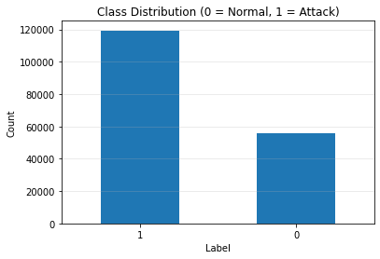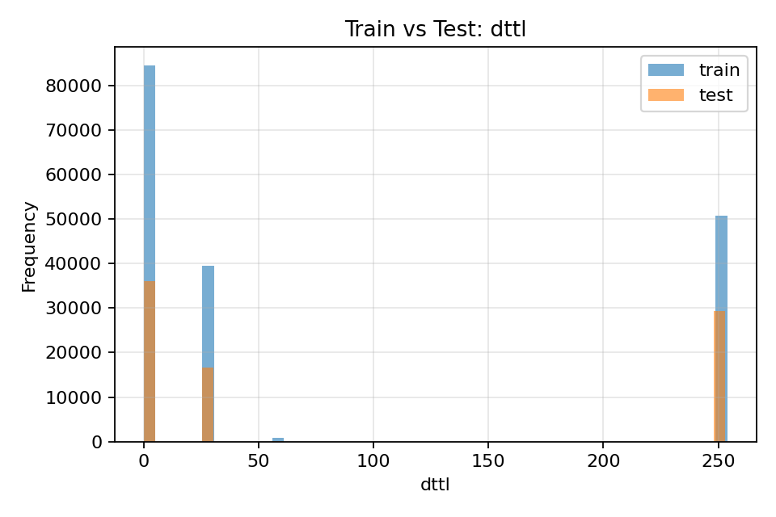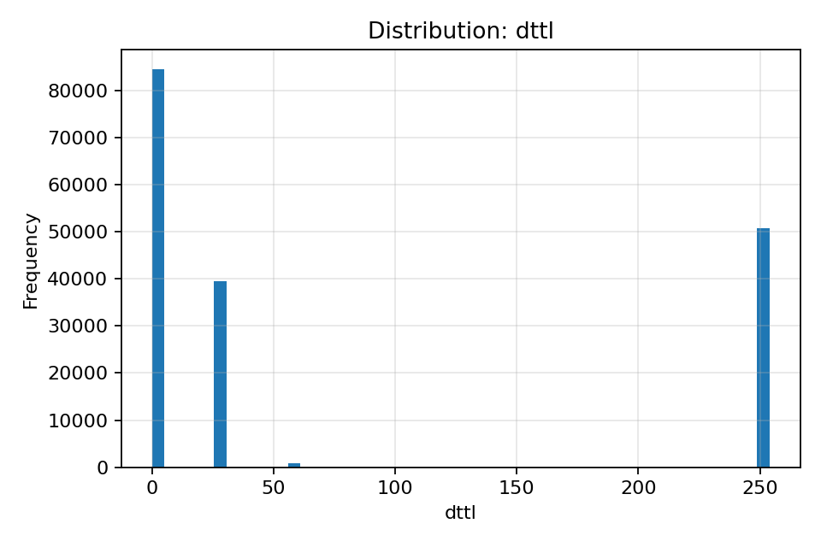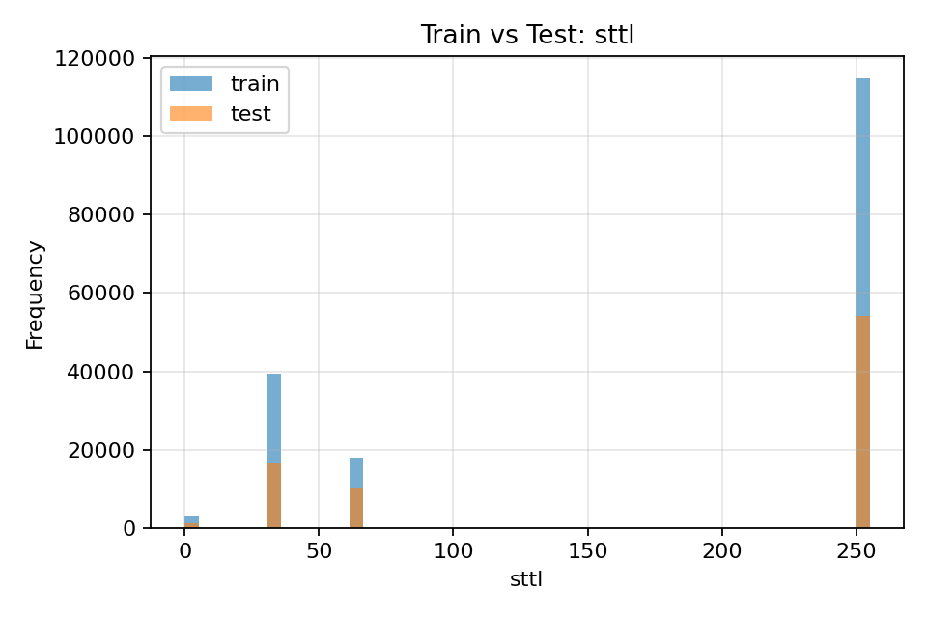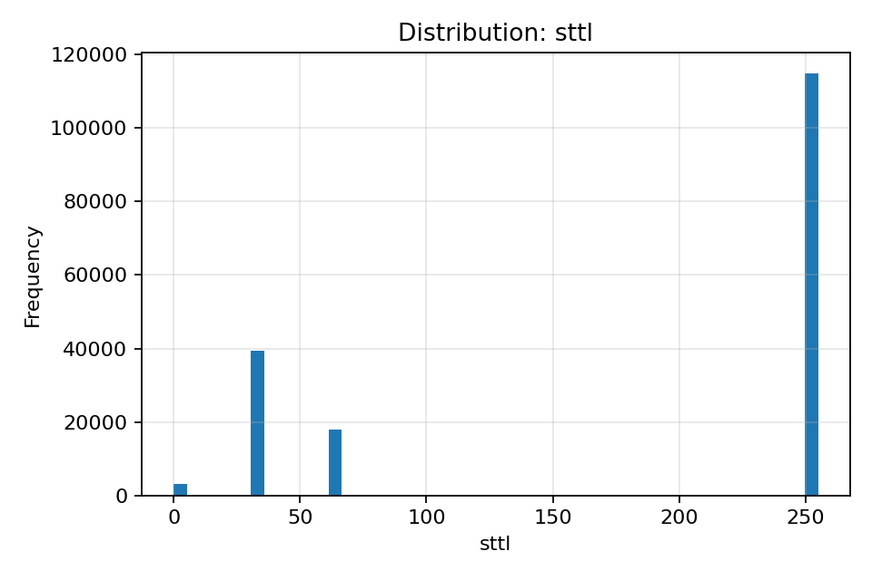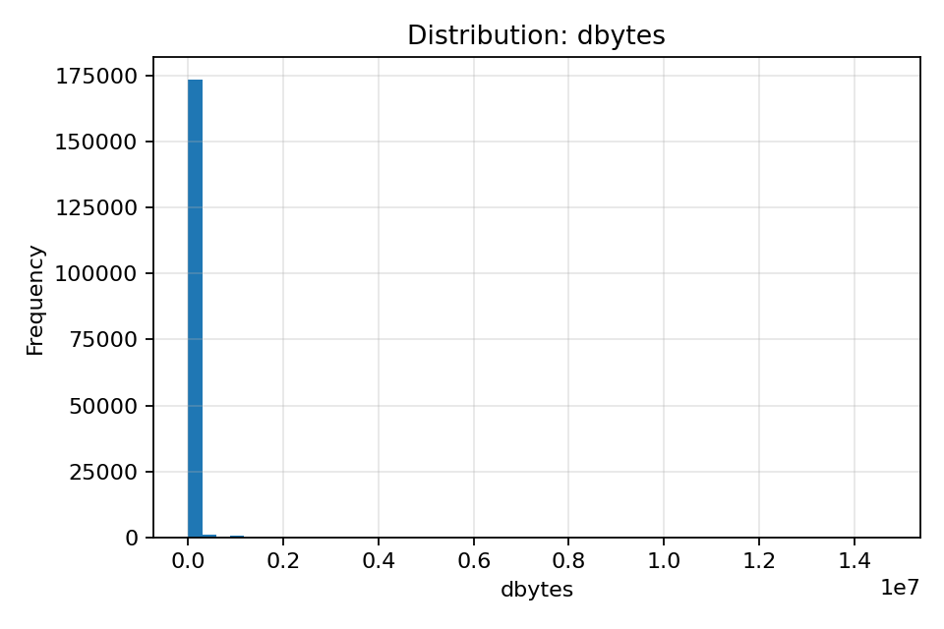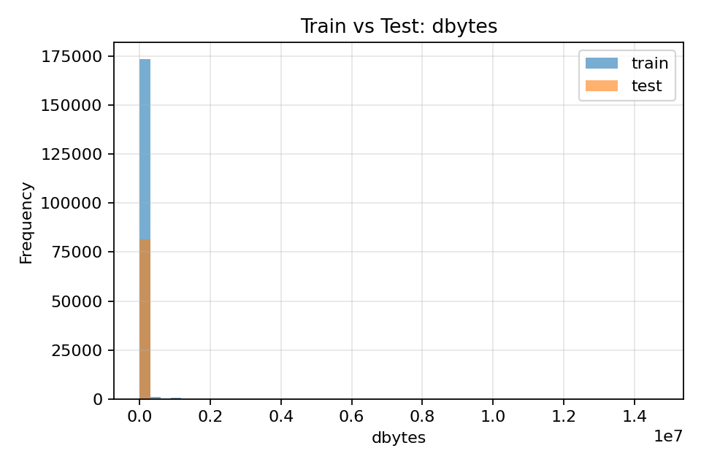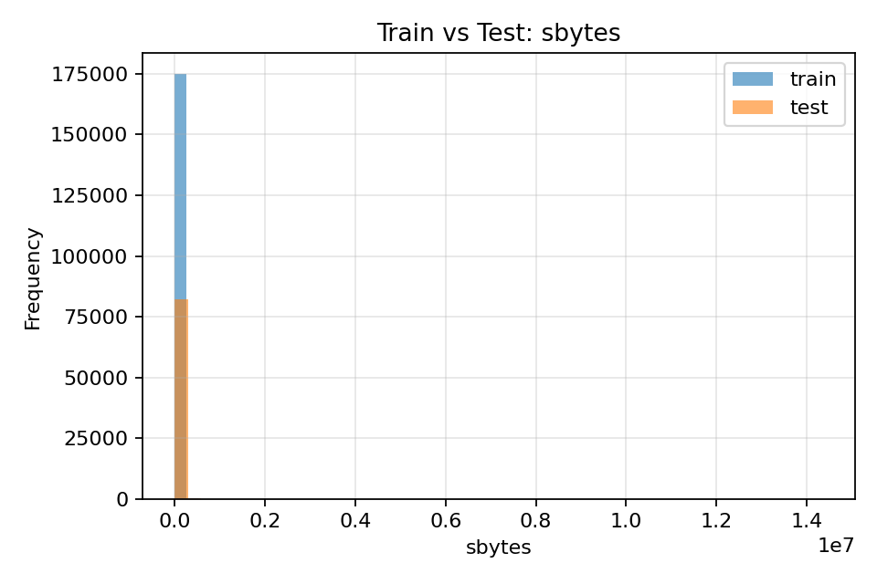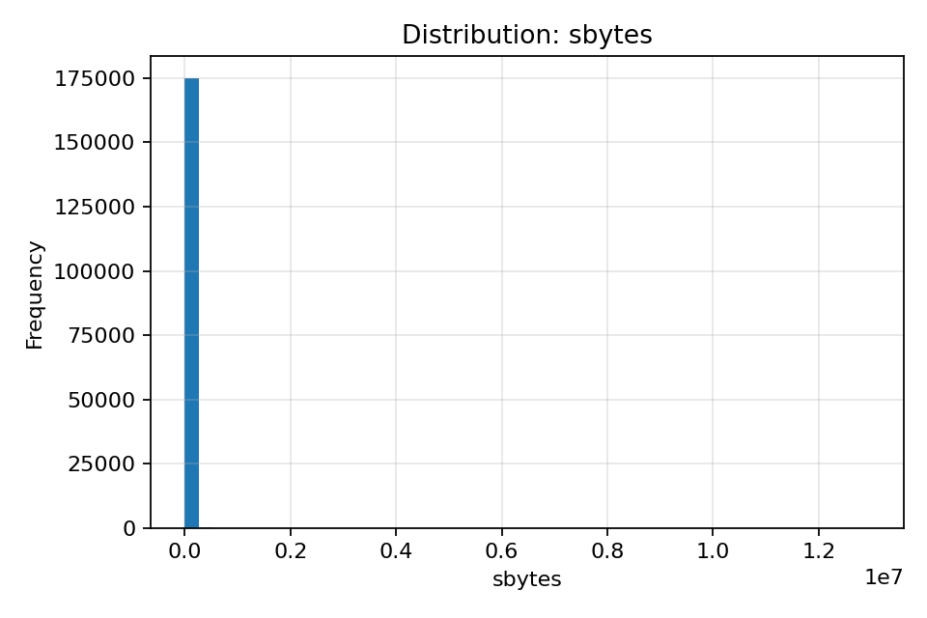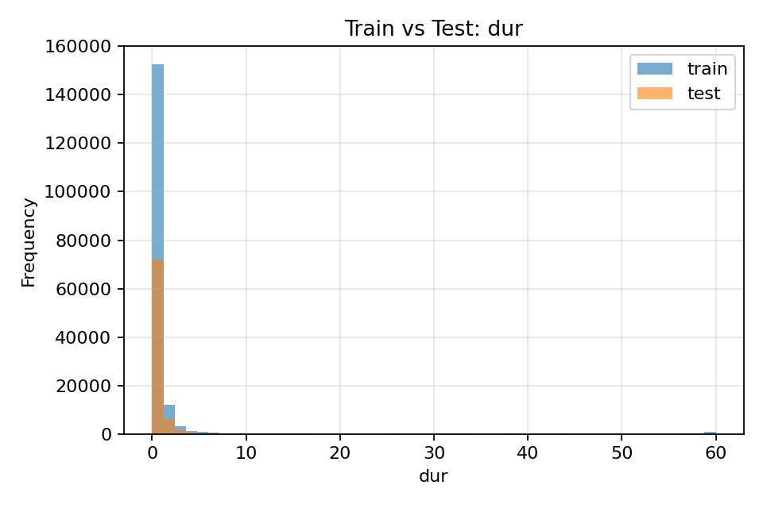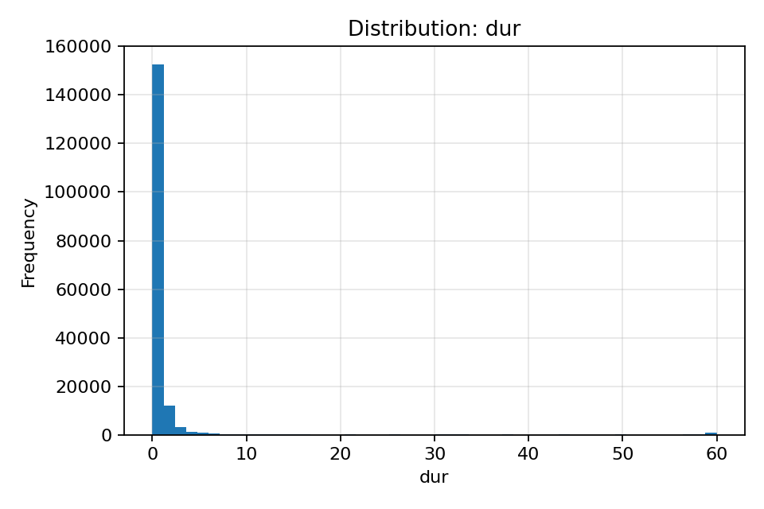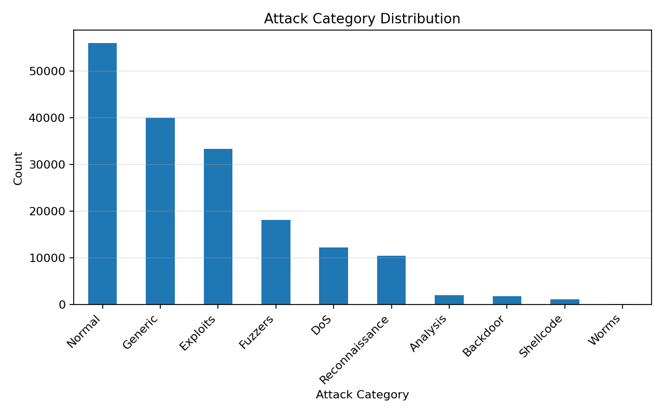

3. Modeling Approach
Models evaluated:
- Logistic Regression
- Linear SVM
- XGBoost
- LightGBM
- PCA + Nonlinear SVM (exploratory)
Evaluation metrics used: PR-AUC, ROC-AUC, Brier Score.
Overall conclusion:
Tree boosting wins: XGBoost and LightGBM deliver the best PR-AUC and ROC-AUC and also the best calibration (low Brier).
- Linear baseline is strong: Logistic regression performs surprisingly well, which suggests the dataset has strong separability even with simple decision surfaces.
- SVM tradeoff: Calibrated linear SVM is slower and weaker here (and RBF SVM is impractical at this scale). This is a real-world enterprise lesson: some models are theoretically appealing but operationally inefficient.) (See appendix B)
- Thresholding matters: The best thresholds are far from 0.5, and the chosen thresholds reflect the cost model (C_FN much larger than C_FP), pushing toward very high recall—appropriate for “don’t miss incidents.”
- Distribution shift is real: Train vs test positive rate differs materially, which is a realistic production concern and strengthens the case for monitoring, calibration, and cost-aware decision policies.
(See appendix A for the final outputs)

4. Threshold Optimization Strategy
Thresholds were optimized using a cost-based objective:
Cost(t) = C_FP * FP(t) + C_FN * FN(t)
where false negatives are weighted more heavily to reflect SOC priorities.

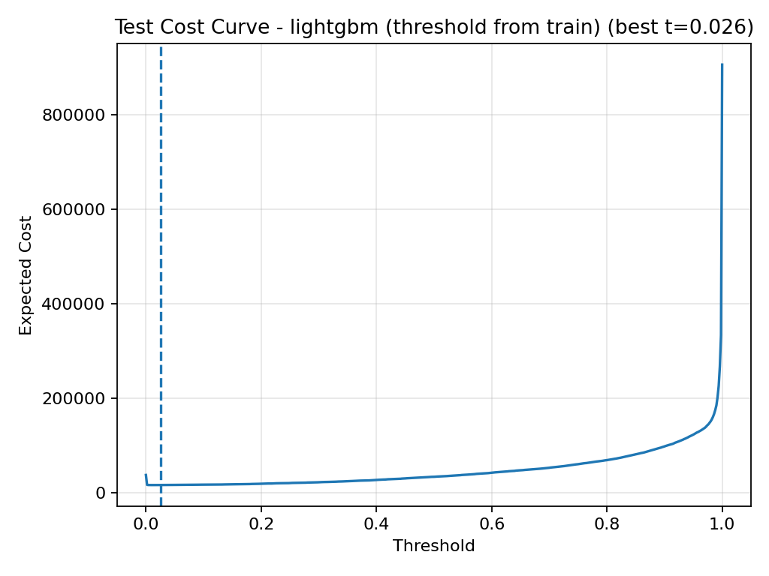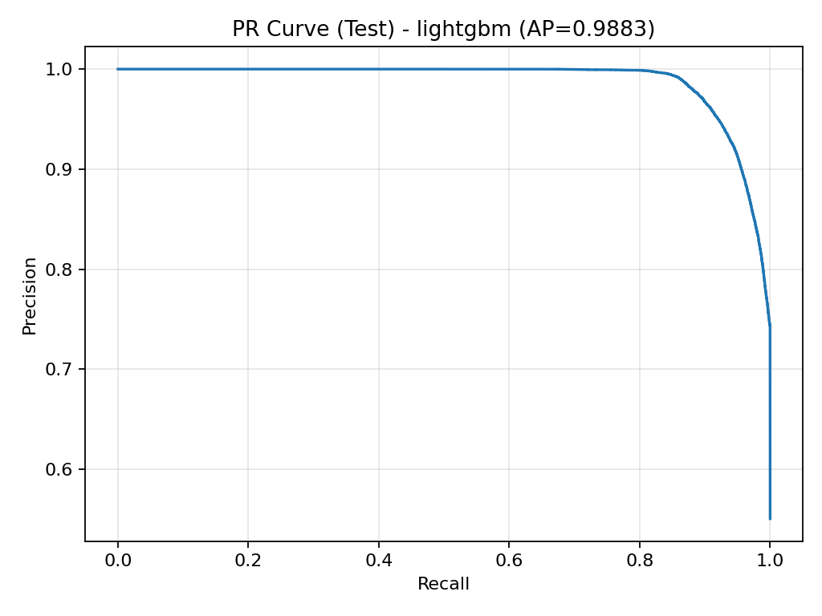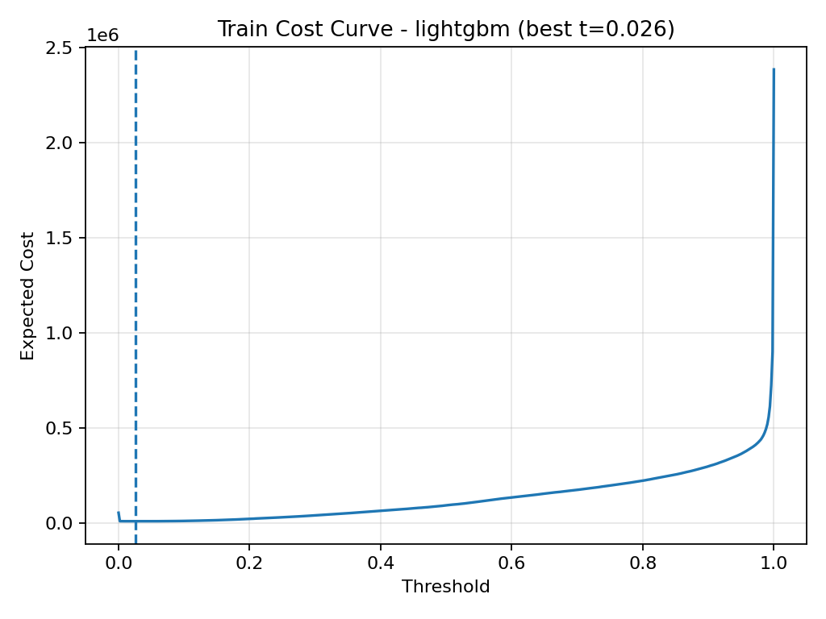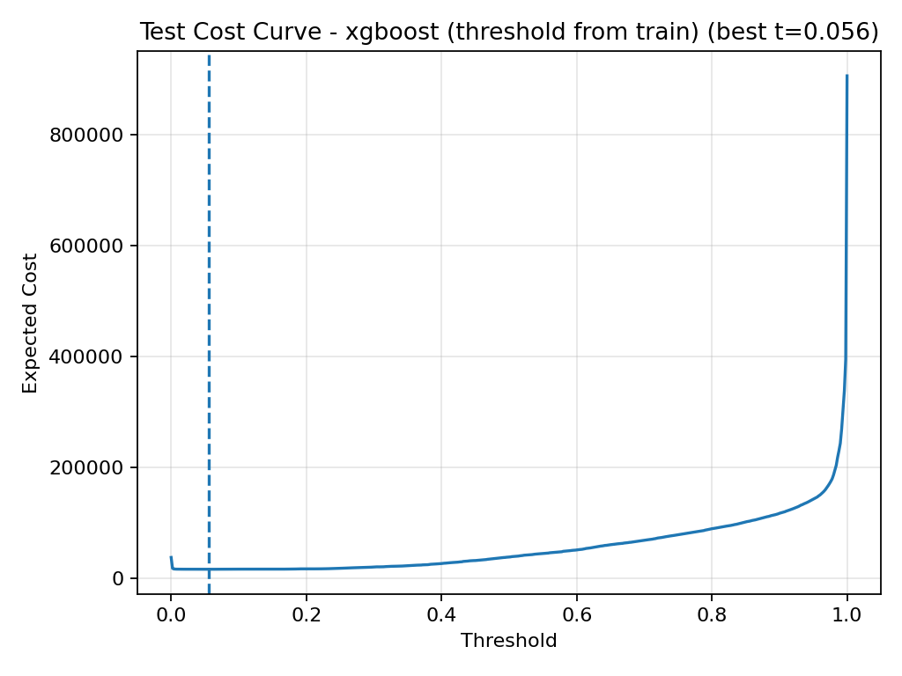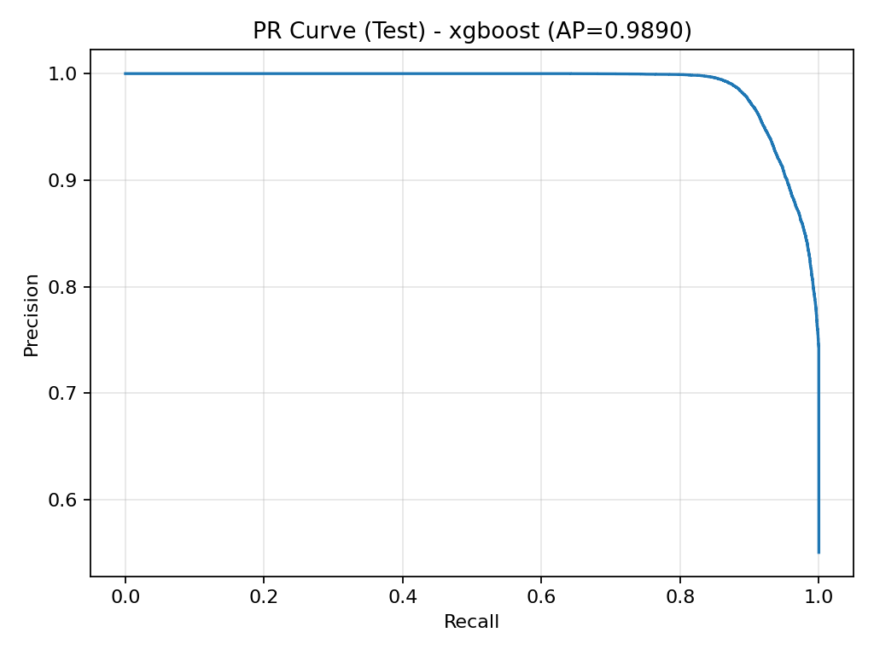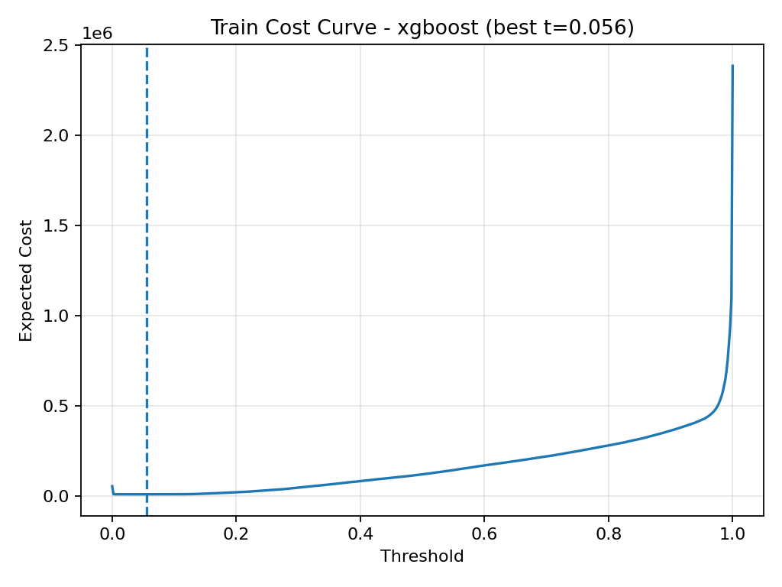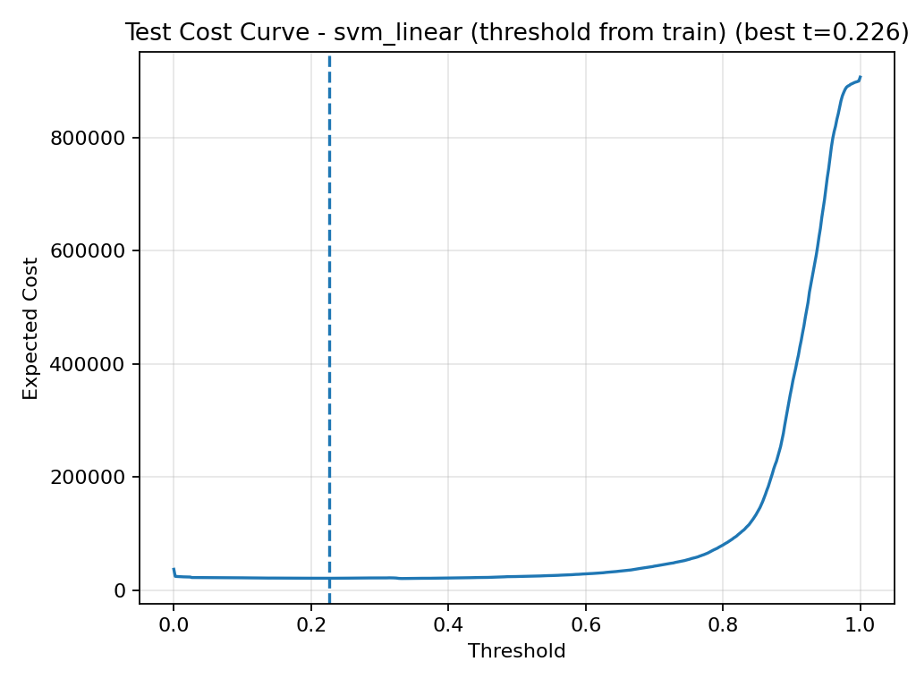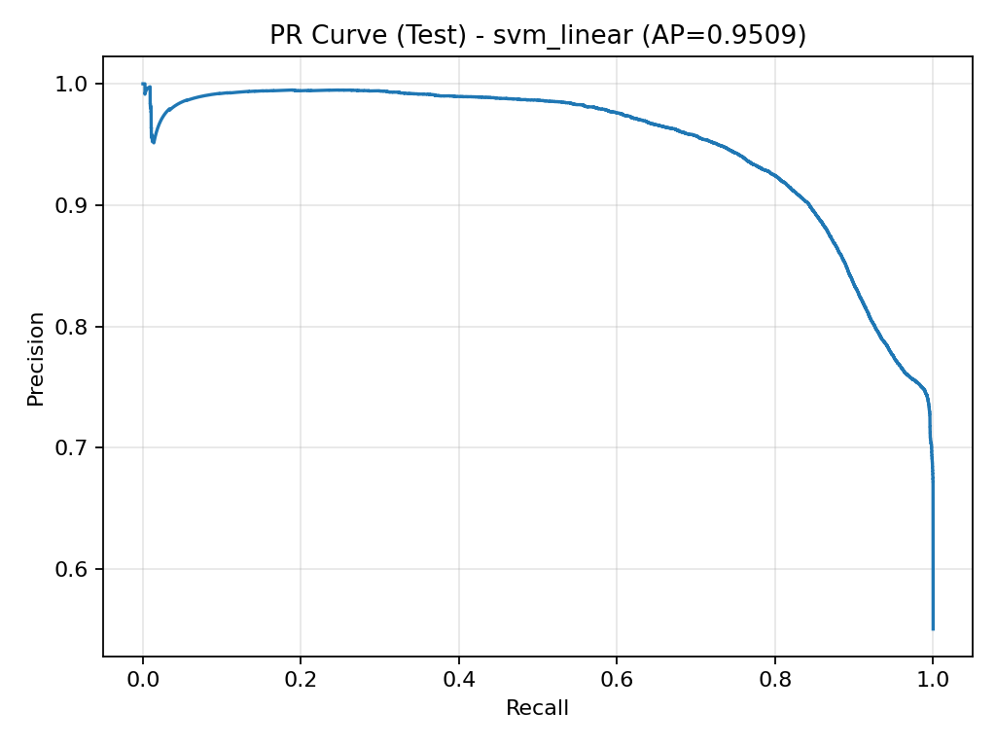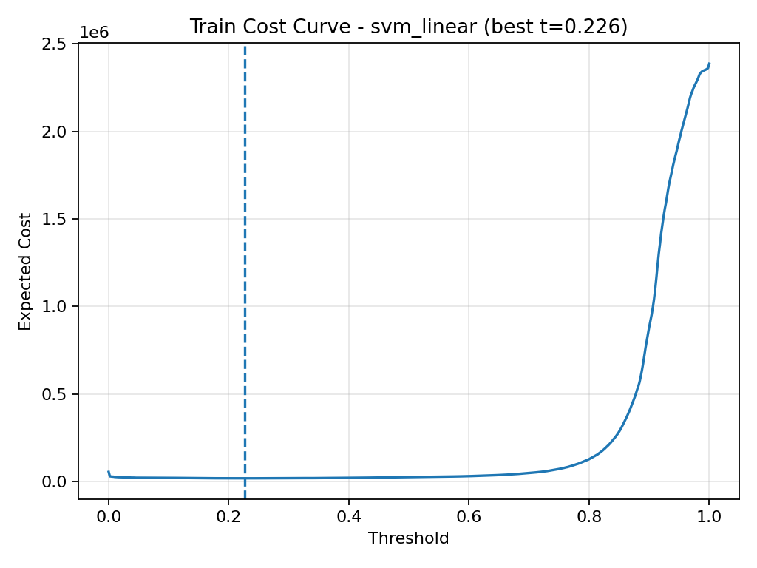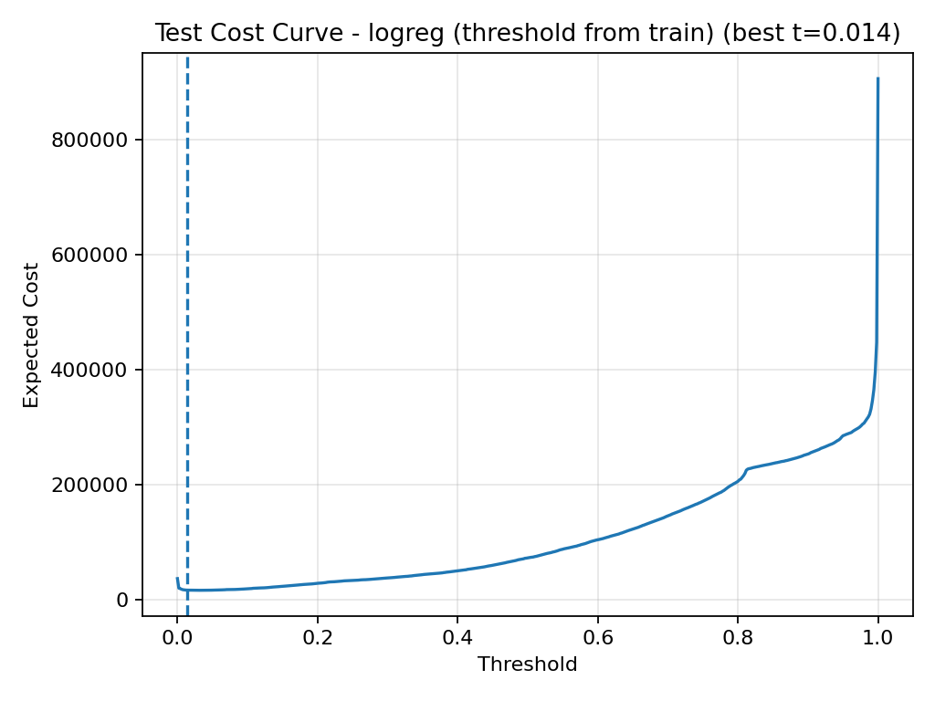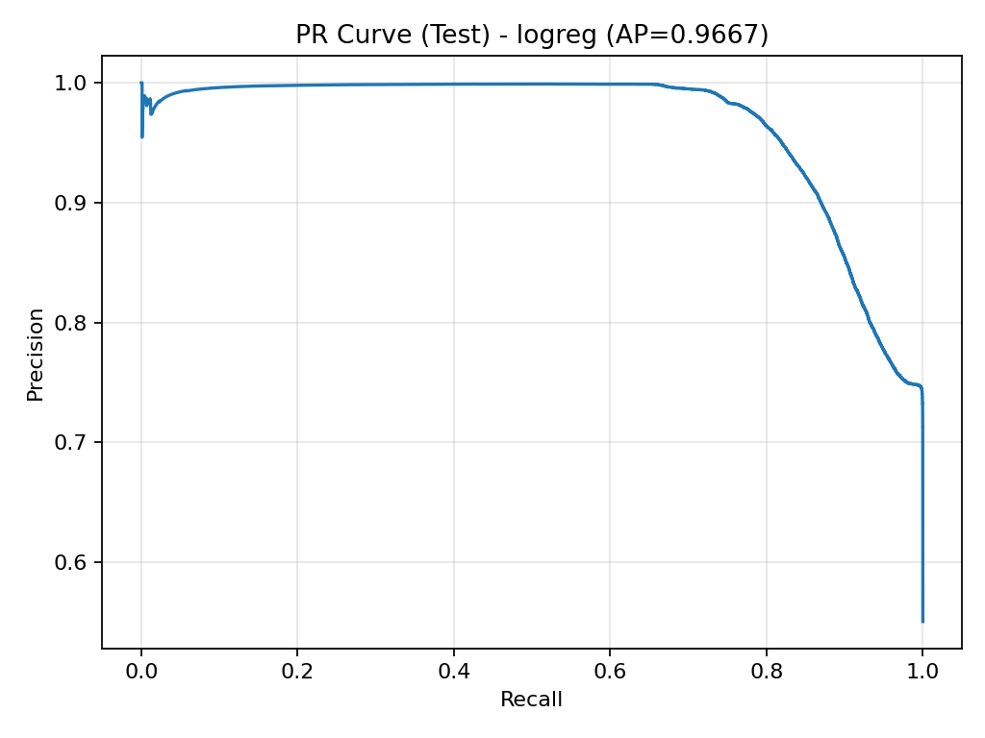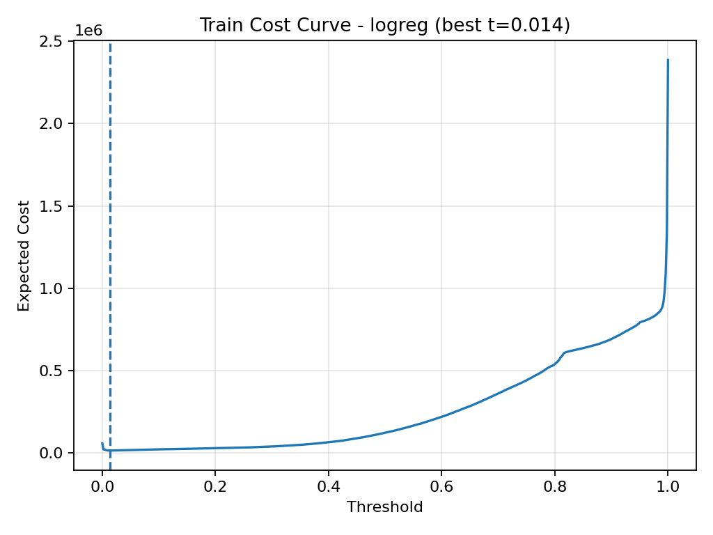

5. Results Summary
- Tree-based gradient boosting models clearly outperform linear and kernel methods.
- Logistic Regression provides a surprisingly strong and interpretable baseline.
- Nonlinear SVM with PCA did not meaningfully improve performance despite added complexity.
- Cost-aware thresholding is essential; optimal thresholds are far from 0.5.
- The final recommended model family for this task is XGBoost or LightGBM.
Model | PR-AUC | ROC-AUC | Brier | Notes
Logistic Regression | 0.9667 | 0.9559 | 0.0921 | Strong linear baseline
Linear SVM (calibrated) | 0.9509 | 0.9419 | 0.1395 | Slower and weaker than LR
PCA + RBF SVM (exploratory) | 0.9647 | 0.9577 | 0.1041 | Added complexity with no gain
XGBoost | 0.9890 | 0.9850 | 0.0599 | Best overall
LightGBM | 0.9883 | 0.9841 | 0.0679 | Comparable to XGB

2. Observed Limitations

Distribution Shift
A notable difference exists between train and test class priors:
- Train positive rate: 68%
- Test positive rate: 55%
This indicates real-world-like distribution shift, which can impact:
- Probability calibration
- Threshold stability
- Operational performance

6. Explainability Findings

SHAP analysis revealed that the most important features included:
- sttl (source TTL)
- ct_state_ttl
- sbytes
- ct_srv_src
- ct_dst_sport_ltm
Interpretation
The model primarily relies on:
- TTL anomalies
- Traffic volume metrics
- Burst or repetitive connection behavior
- Service/port usage patterns
These are all well-established indicators of malicious activity in network security contexts, confirming that the model is learning meaningful cybersecurity patterns rather than spurious correlations.

Directionality of Impact
The SHAP summary plot shows how feature values influence risk:
- High TTL values (sttl) strongly increase predicted attack likelihood
- Higher connection counts to the same ports/services increase risk
- Large outbound byte volumes push predictions toward malicious
- Lower activity levels and normal TTL ranges reduce predicted risk
This aligns closely with SOC domain intuition: automated scans, bot traffic, and exfiltration-like behaviors are associated with higher risk.

Local Explainability
Waterfall plots demonstrate that individual predictions can be fully decomposed:
- Each alert can be explained in terms of contributing features
- Analysts can see exactly which attributes drove a high-risk decision
- Predictions are transparent and auditable
This makes the system operationally viable for real SOC workflows.
SEE APPENDIX C FOR THE charts

Improvements Through Use of AI-Assisted Development Tools
Throughout the project, AI-powered development tools—including Cursor AI, VS Code Copilot, and ChatGPT—were actively used to accelerate progress, improve code quality, and enhance the overall robustness of the system. Their contributions can be summarized in the following areas:
Code Debugging and Error Resolution
AI tools were heavily used to diagnose runtime errors, resolve dependency issues, and fix type mismatches across multiple scripts. This significantly reduced troubleshooting time and helped stabilize the pipeline.
Refactoring and Code Quality Improvements
Suggestions from Copilot and ChatGPT were used to reorganize code into modular components, standardize function structures, and improve readability and maintainability. Redundant logic was removed, and shared utilities were centralized.
Performance Optimization
AI assistance helped identify inefficient code patterns, improve data processing steps, and streamline model training workflows. This resulted in faster execution times and more reliable runs.
Consistency Across Python Files
The tools were used to harmonize coding style and structure across all project files (model.py, preprocessing.py, utils.py, agent code, etc.), ensuring uniform imports, documentation style, and error handling.
Methodological Enhancements
ChatGPT was used as a thought partner to refine evaluation methodology, improve threshold optimization logic, and design cost-sensitive decision frameworks aligned with SOC operations.
Explainability and Interpretability Integration
AI tools assisted in implementing SHAP-based interpretability, generating explanation logic, and improving how model insights are communicated to analysts.
Agentic AI Integration
Cursor and ChatGPT were instrumental in designing and implementing the SOC Triage Agent layer, adding automated explanations, operational recommendations, and LLM-powered summarization.
UI and Reporting Development
VS Code Copilot helped accelerate the creation of the Streamlit dashboard and reporting artifacts, enabling better visualization and presentation of model outputs.

7. SOC Triage Agent
An operational agent was built to:
- Rank alerts by risk
- Apply optimized decision thresholds
- Generate explanations and analyst actions
- Optionally produce LLM-generated executive summaries

SOC Triage Agent (soc_triage_agent.py) — What it does
This script implements a lightweight SOC triage workflow that turns a binary incident-risk model into an operational decision tool.

Core pipeline
- Loads the official UNSW-NB15 train/test split (training CSV used for model fit; test CSV used as a holdout “triage queue”).
- Trains a selected model pipeline (logreg, svm_linear, xgboost, or lightgbm) using the project’s shared preprocessing utilities:
  - separates numeric vs categorical features
  - applies imputation + one-hot encoding
  - applies scaling where appropriate
  - uses class-imbalance weighting for tree models via scale_pos_weight
- Scores every event in the holdout test set with a probability:
  - prob_test[i] = p(incident = 1 | features_i)

Decision logic (thresholding)
The script converts probabilities into actionable triage decisions using one of two modes:
- Min-cost mode (--mode min_cost)
Sweeps thresholds from 0→1 and selects the threshold t* that minimizes the SOC cost function:
Cost(t)= C_{FP}\cdot FP(t) + C_{FN}\cdot FN(t)
It also reports cost reduction vs a baseline threshold (default t=0.5) and prints precision/recall/FPR at t*.
- Policy-precision mode (--mode policy_precision)
Selects the threshold that maximizes recall subject to a precision constraint (e.g., precision ≥ 0.70). This supports “policy-driven ML” where alert volume/quality constraints matter.

SOC-facing outputs
After choosing a threshold, the script:
- Ranks alerts by risk score (highest prob_test first)
- Prints the top-N alerts with an action:
  - ESCALATE if p >= t
  - DEPRIORITIZE otherwise
- Generates per-alert explanations + suggested actions using a heuristic template based on high-signal telemetry fields (TTL, volume, repeated connection counts, etc.). This works even when SHAP is not available.

Optional LLM “Agentic Brief”
If run with --use_llm and an API key is set (OPENAI_API_KEY), the script compiles a structured JSON context (threshold, metrics, top alerts + explanations) and calls an LLM to produce:
- an executive SOC summary
- prioritized recommended analyst actions
- escalation criteria
- next questions / data to pull
The LLM is used only for summarization and drafting; all decisions (thresholding + triage) remain deterministic and model-driven.

Guardrails
The script explicitly documents limitations:
- thresholds should be re-optimized if distribution shifts
- probabilities should be calibrated for enterprise use
- LLM output is advisory (not ground truth)

8. Limitations and Future Improvements
- Use a dedicated validation set for threshold selection
Instead of choosing alert thresholds only from training data, tune them on a separate validation set that better represents real operational conditions.
- Adjust predictions when class distributions change
If the proportion of attacks in production differs from the training data, update predicted probabilities to reflect the new prior distribution and maintain reliable decisions.
- Continuously monitor for data drift
Track changes in feature distributions over time and trigger recalibration or retraining when significant shifts are detected.
- Add probability calibration to the final model
Apply calibration methods such as Platt scaling or isotonic regression so that predicted probabilities better match real-world event likelihoods.

9. Conclusion
The project successfully demonstrated an end-to-end AI-powered SOC triage workflow, combining machine learning, cost optimization, explainability, and agentic AI assistance.

APPENDIX A
Model results (final holdout test)

1) Logistic Regression (baseline, scaled)
- PR-AUC: 0.9667
- ROC-AUC: 0.9559
- Brier: 0.0921 (decent calibration)
- Chosen threshold (from train OOF): 0.014
- At threshold:
  - Precision: 0.7310
  - Recall: 0.9997
  - FPR: 0.4508
Interpretation: Strong linear baseline. Very high recall with moderate precision; a low threshold makes sense given your cost setup (C_FN ≫ C_FP).

2) Linear SVM + calibration (scaled)
- PR-AUC: 0.9509
- ROC-AUC: 0.9419
- Brier: 0.1395 (worse calibration than LR)
- Chosen threshold: 0.226
- At threshold:
  - Precision: 0.7013
  - Recall: 0.9979
  - FPR: 0.520
Interpretation: Underperforms logistic regression here and yields higher false positive rate at its optimized threshold. Still a valid “large-scale SVM family” reference model, but not the best choice to carry forward.

3) XGBoost (tree model)
- PR-AUC: 0.9890 (best)
- ROC-AUC: 0.9850 (best)
- Brier: 0.0599 (best calibrated of the set)
- Chosen threshold: 0.056
- At threshold:
  - Precision: 0.7435
  - Recall: 1.0000
  - FPR: 0.4226

Interpretation: Best overall. Near-perfect ranking (PR-AUC) plus strong probability quality (Brier). Great candidate to carry into the later “ML → AI” phases.

4) LightGBM (tree model)
- PR-AUC: 0.9883 (very close to XGB)
- ROC-AUC: 0.9841
- Brier: 0.0679
- Chosen threshold: 0.026
- At threshold:
  - Precision: 0.7434
  - Recall: 0.9999
  - FPR: 0.4228
Interpretation: Essentially tied with XGBoost. Slightly higher Brier than XGB, but still excellent. Also a great “enterprise-grade” choice.

Appendix B
To evaluate whether additional nonlinear modeling capacity could improve performance, an exploratory pipeline was implemented using:
- standard scaling
- one-hot encoding
- PCA for dimensionality reduction
- an RBF-kernel SVM with probability calibration
key findings:

1. Nonlinear SVM with PCA did NOT improve over simple linear models
The PCA + RBF SVM result:
- PR-AUC = 0.9647
is essentially:
- Slightly worse than Logistic Regression (0.9667)
- Slightly better than Linear SVM (0.9509)
- Far below XGBoost / LightGBM (~0.989)
So:
Adding nonlinearity + dimensionality reduction did not yield a meaningful gain.

2. Dimensionality reduction helped speed – not performance
Using PCA allowed the RBF SVM to:
- Train in a reasonable time
- Become computationally feasible
But it did not unlock any additional predictive power.
This strongly suggests:
- The dataset is already well-structured
- Important signal is mostly linear or easily captured by trees
- Complex kernel methods are not necessary

3. Calibration got worse, not better
Look at Brier scores:
- Logistic Regression: 0.092
- PCA + RBF SVM: 0.104
- Linear SVM: 0.139

The nonlinear SVM is:
- Worse calibrated than logistic regression
- Only modestly better than linear SVM
So from a probability-quality perspective, it is not an upgrade.

4. Tree models remain clearly superior
Compared to the boosting models:
- XGBoost PR-AUC: 0.989
- LightGBM PR-AUC: 0.988
The PCA + RBF SVM is almost 2.5 percentage points worse, which is very significant at this performance level.

APPENDIX C
