databse_steps{i,j} includes the information about the i-th pedestrian at the j-th step. In other words lines identify pedestrians and columns identify the steps of the given pedestrian.

Each cell include information about force and time of the step.

Sampling frequency is 50 Hz.

The first column includes more information.

databse_steps{i,j}.x and databse_steps{i,j}.y denote the position measured through the path, one row for each plate.

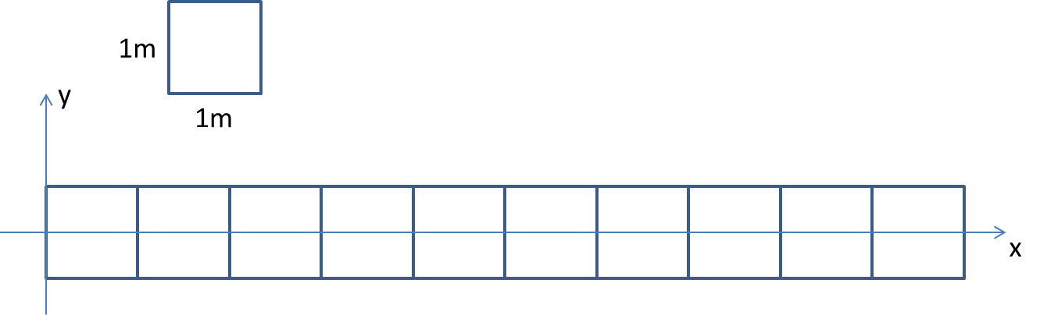

Note that two steps on the same plate are currently “fused” in the xy position.

databse_steps{i,j}.Ptot represents the sum of the measurements acquired by all the force sensors beneath the instrumented floor. It includes raw data and you can ignore it.

databse_steps{i,j}.P_div collects the signals acquired by all the force sensors (10 plate, 4 sensors for each plate, for a total of 40 measurements for each clock cycle).