GUVI | HCL - Capstone Project Report
Global Immunization and
Vaccination Data Analysis
A Comprehensive Power BI Dashboard & Analytics Report

Name | Parisha Sharma
Domain | Public Health and Epidemiology
Tools Used | Python, SQL (MySQL), Power BI
Data Source | WHO / UNICEF Vaccination Dataset (1980-2023)
Dashboard Pages | 5 Interactive Pages

Abstract / Executive Summary

This capstone report presents a comprehensive analysis of global immunization and vaccination data spanning four decades, from 1980 to 2023. The project was undertaken as part of the GUVI | HCL Data Science program and involved applying a full-stack analytics pipeline — from raw data cleaning in Python, to relational database structuring in MySQL, and finally to the creation of a multi-page interactive dashboard using Microsoft Power BI.

The dataset, sourced from WHO and UNICEF vaccination records, contains five interrelated tables covering vaccination coverage by country and antigen, disease incidence rates, reported case counts, vaccine introduction timelines, and vaccination schedule data. Across these tables, the dataset spans 245 countries and territories, 86 unique vaccine antigens, and over 293 million total reported disease cases.

The resulting Power BI report consists of six pages: a Global Overview, a secondary Global Overview with category-level breakdowns, a Disease and Incidence Analysis (including two sub-pages with deeper visual breakdowns), a Vaccine Program and Coverage Analysis, and a final Insights and Conclusions page. Each page was designed with a specific analytical question in mind, using an intentional layout and a consistent dark-themed aesthetic.

Key findings from the analysis include: (1) global vaccination coverage has plateaued around 82-85%, falling short of the WHO target of 90%; (2) measles accounts for nearly half of all vaccine-preventable disease cases globally, making it the single biggest ongoing threat; (3) significant inequalities persist between countries, with some nations reporting coverage above 100% (a data reporting artifact) while others languish below 60%; (4) a strong inverse relationship exists between coverage improvements and disease burden reduction, confirming vaccination effectiveness; and (5) coverage volatility observed after 2010 suggests vulnerability to disruptions like the COVID-19 pandemic and conflicts.

The report also reflects on the project journey, the challenges encountered in dashboard design and data interpretation, and concludes with strategic policy recommendations aimed at strengthening global immunization systems.

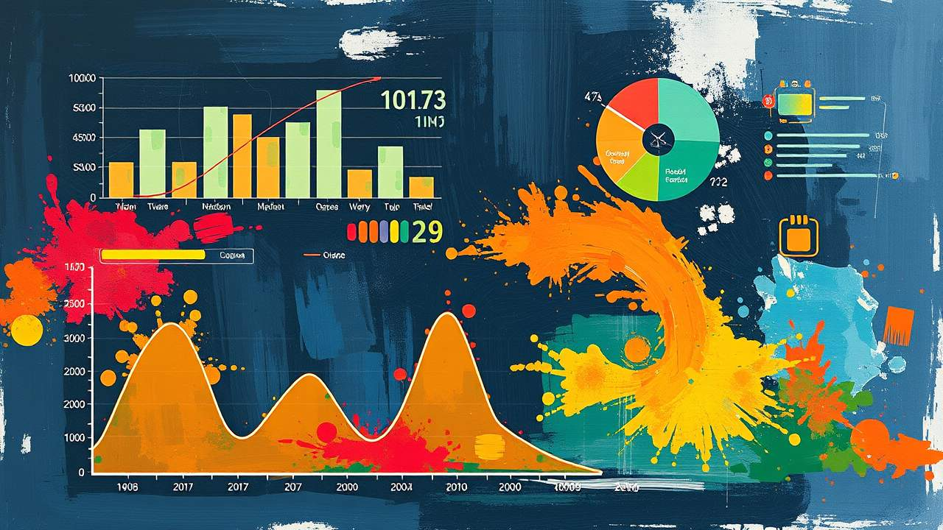

Table of Contents

1. | Introduction | 4
2. | Objectives of the Project | 5
3. | Dataset Description | 6
4. | Data Preparation and Modeling | 8
5. | Dashboard Design and Visualization Approach | 10
6. | Global Vaccination Coverage Analysis | 13
7. | Country-Level Vaccination Analysis | 15
8. | Disease Incidence Analysis | 17
9. | Top Diseases by Global Case Load | 19
10. | Disease Spread vs Severity Analysis | 20
11. | Vaccine Program and Coverage Analysis | 21
12. | Vaccination Inequality Across Countries | 23
13. | Trend Analysis Over Time | 24
14. | Key Insights from the Dashboard | 25
15. | Policy Implications and Recommendations | 27
16. | Limitations of the Study | 28
17. | Future Improvements | 29
18. | Project Journey and Challenges Faced | 30
19. | Learning Outcomes | 34
20. | Conclusion | 36
21. | References | 37

1. Introduction

Vaccination stands as one of the most consequential public health interventions in recorded history. From the near-elimination of smallpox in the 1970s to the dramatic reduction of polio worldwide, the evidence has consistently shown that organized immunization programs can drastically reduce — and in some cases eliminate — the burden of infectious diseases that once devastated entire populations. Yet despite these remarkable achievements, significant gaps persist. Millions of children around the world still do not receive basic vaccines, and coverage rates in many low-income countries remain far below internationally accepted thresholds.

The World Health Organization (WHO) and UNICEF jointly track immunization coverage across countries, collecting data from national governments, administrative records, and official reporting channels. This data forms one of the most comprehensive public health surveillance datasets available, and it contains within it a rich story about how the world has changed over the past four decades, where progress has been made, where it has stalled, and where it has even reversed.

The motivation behind this project was to take that raw, complex dataset and transform it into a visual, interactive, and interpretable form — one that a public health official, a policy maker, or even a curious student could use to understand vaccination patterns around the world. Data in its raw form, spread across five tables with hundreds of thousands of rows, tells us nothing without the right framework for exploration. That framework, in this case, is a Power BI dashboard.

Power BI is a business intelligence and data visualization platform developed by Microsoft. It allows analysts to connect to databases, clean and model data, define calculated measures, and then build rich, interactive visual reports. For a dataset as large and multidimensional as the WHO immunization records, Power BI offers the ideal environment for storytelling through data.

This report documents the full journey of the project: from understanding the dataset and cleaning the data, through the design decisions made during dashboard creation, to the analytical insights uncovered along the way. It also honestly discusses the challenges faced during the project and how those challenges were resolved. The goal is not just to present a polished final product, but to illuminate the thought process behind it.


2. Objectives of the Project

The project was guided by a set of clearly defined objectives, each targeting a specific dimension of the global vaccination landscape. These objectives were formulated after an initial reading of the project brief and a review of the dataset structure.

2.1 Coverage Analysis
The first objective was to understand the state of vaccination coverage globally and at the country level. Specifically, the aim was to calculate average coverage percentages, identify how coverage has changed over time, determine how many countries have achieved the WHO target of 90% coverage, and flag those countries that remain significantly below this threshold. This objective required not just descriptive statistics but trend analysis and comparison.

2.2 Disease Burden Understanding
The second objective focused on the disease side of the equation. The project aimed to analyze how many cases of various vaccine-preventable diseases have been reported globally, which diseases carry the heaviest burden, and how incidence rates have changed over time. This objective was essential for connecting vaccination data with real-world health outcomes.

2.3 Country-Level Comparison
A key objective was to enable meaningful comparisons between countries. Not all countries have the same resources, infrastructure, or political commitment to vaccination. By building a heatmap and ranking tables, the project sought to make these disparities visible and to identify patterns across regions. This comparison helps policy makers understand where targeted intervention is most needed.

2.4 Trend Analysis
Understanding trends over time was a fourth major objective. The 1980-to-2023 timeline in the dataset captures not just growth in vaccination programs, but also disruptions, reversals, and stagnation. Charting these trends allows stakeholders to distinguish between genuine progress and temporary improvements.

2.5 Vaccine Program Assessment
Finally, the project aimed to assess the vaccine portfolio itself: how many vaccines are deployed globally, which ones have low coverage, how adoption differs across countries, and which antigens target high-risk populations. This gave a supply-side perspective to complement the demand-side and outcome-side analyses.

3. Dataset Description

The dataset for this project consists of five distinct tables, all sourced from WHO and UNICEF vaccination surveillance records. Each table captures a different facet of the global immunization ecosystem. Together, they provide a comprehensive picture of vaccination programs, coverage levels, disease incidence, and the structure of vaccination schedules.

3.1 Table 1: Coverage Data
This is the primary table and the backbone of the analysis. It contains vaccination coverage information recorded at the country-antigen-year level. Each record describes what percentage of a target population received a specific vaccine in a given year and country.

Column Reference
Column Name | Data Type | Description
GROUP | VARCHAR | Country classification category (e.g., COUNTRIES, REGIONS)
CODE | VARCHAR | ISO Alpha-3 country code (e.g., IND, USA, GBR)
NAME | VARCHAR | Full country or region name
YEAR | INT | Year the data was recorded (1980 – 2023)
ANTIGEN | VARCHAR | Short vaccine code (e.g., BCG, MCV1, DTP3)
ANTIGEN_DESCRIPTION | VARCHAR | Full descriptive name of the vaccine
COVERAGE_CATEGORY | VARCHAR | Reporting type: ADMIN, OFFICIAL, WUENIC, PAB, HPV
COVERAGE_CATEGORY_DESCRIPTION | VARCHAR | Expanded description of the coverage category type
TARGET_NUMBER | BIGINT | Number of individuals in the target population
DOSES | BIGINT | Actual number of vaccine doses administered
COVERAGE | FLOAT | Percentage of the target population vaccinated (can exceed 100%)

Dataset Overview - Raw vs Clean
Dataset Overview - Coverage Data
Metric | Raw Dataset | Cleaned Dataset
Total Rows | 399,859 | 399,858
Total Columns | 11 | 11
Missing Values -TARGET_NUMBER | 320,829 nulls | 0 nulls
Missing Values - DOSES | 320,532 nulls | 0 nulls
Missing Values - COVERAGE | 169,382 nulls | 0 nulls
Missing Values - NAME | 1,275 nulls | 0 nulls
Coverage > 100% (known anomaly) | Present (retained) | Capped measure created
Country Code too long (>20 chars) | 1,109 rows affected | Truncated to 20 chars
Duplicate Rows | 1 duplicate | 0 duplicates

Before vs. After Cleaning - Column Level
Data Cleaning Summary - Coverage Data
Column | Before Cleaning | After Cleaning
TARGET_NUMBER | 320,829 nulls - filled with median | 0 nulls - median imputed
DOSES | 320,532 nulls - filled with median | 0 nulls - median imputed
COVERAGE | 169,382 nulls - filled with median | 0 nulls - median imputed
NAME | 1,275 nulls - filled with mode | 0 nulls - mode filled
CODE (country_code) | Some values > 20 characters (regional codes) | Truncated to 20 chars
All column names | ALL_CAPS (e.g., GROUP, CODE, NAME) | snake_case (e.g., group_name, country_code)
Rows | 399,859 rows (1 duplicate) | 399,858 rows - deduplicated
COVERAGE (display) | Values up to 105.9% - distorts visuals | Capped DAX measure MIN(coverage, 100) created

The Coverage Category field is particularly important for interpretation. WUENIC (WHO/UNICEF Estimates of National Immunization Coverage) is generally considered the most reliable figure, as it reconciles administrative data with survey data. The ADMIN category reflects government-reported doses administered, which can sometimes be inflated. This distinction became critical during data analysis, as some countries reported coverage exceeding 100%, which required special handling.

3.2 Table 2: Incidence Rate Data
This table records the rate of disease occurrence per specified population unit. It allows analysts to measure how prevalent a disease is in a given country and year, independent of population size. The incidence rate serves as a normalized measure that enables fair comparisons across countries of different sizes.

Column Reference
Column Name | Data Type | Description
GROUP | VARCHAR | Classification category - represents countries or regions
CODE | VARCHAR | ISO Alpha-3 country code
NAME | VARCHAR | Full country name
YEAR | INT | Year the incidence data was recorded
DISEASE | VARCHAR | Short disease code (e.g., MEASLES, PERTUSSIS, POLIO)
DISEASE_DESCRIPTION | VARCHAR | Full descriptive name of the disease
DENOMINATOR | VARCHAR | Population basis used (e.g., per 100,000 population, per 10,000 live births)
INCIDENCE_RATE | FLOAT | Number of disease cases per specified population unit

Dataset Overview - Raw vs Cleaned

Dataset Overview - Incidence Rate Data
Metric | Raw Dataset | Cleaned Dataset
Total Rows | 84,946 | 84,945
Total Columns | 8 | 8
Missing Values - INCIDENCE_RATE | 23,362 nulls | 0 nulls
Missing Values - Other Columns | 0 nulls | 0 nulls
Duplicate Rows | 1 duplicate | 0 duplicates
Data Type - INCIDENCE_RATE | Object (mixed types) | Float64 (numeric)

Before vs. After Cleaning - Column Level
Data Cleaning Summary - Incidence Rate Data
Column | Before Cleaning | After Cleaning
INCIDENCE_RATE | 23,362 nulls present | Filled with 0 (no cases recorded = 0 rate)
All column names | ALL_CAPS format | snake_case (e.g., incidence_rate, disease_description)
Rows | 84,946 rows (1 duplicate) | 84,945 rows - deduplicated
GROUP, CODE, NAME, YEAR | 0 nulls - no issues | No changes needed
DISEASE, DISEASE_DESCRIPTION | 0 nulls - no issues | No changes needed
DENOMINATOR | 0 nulls - consistent format | No changes needed

Key fields include the Disease code and description, the Denominator (e.g., per 100,000 population or per 1,000 live births), and the Incidence Rate itself. This table was joined with coverage data to assess whether higher vaccination rates correspond with lower disease incidence — a central analytical question in the project.

3.3 Table 3: Reported Cases
While the incidence table deals with rates, the Reported Cases table provides absolute counts of disease cases. This is essential for understanding the raw burden of disease — how many people were actually affected. The table includes fields for Country, Year, Disease code and description, and the number of Cases reported.

Column Reference
Column Name | Data Type | Description
GROUP | VARCHAR | Country classification category
CODE | VARCHAR | ISO Alpha-3 country code
NAME | VARCHAR | Full country name
YEAR | INT | Year the cases were reported
DISEASE | VARCHAR | Short disease code (e.g., MEASLES, MUMPS, TYPHOID)
DISEASE_DESCRIPTION | VARCHAR | Full descriptive name of the disease
CASES | INT | Number of confirmed reported cases of the disease for that year and country

Dataset Overview - Raw vs Cleaned
Dataset Overview - Reported Cases Data
Metric | Raw Dataset | Cleaned Dataset
Total Rows | 84,870 | 84,869
Total Columns | 7 | 7
Missing Values - CASES | 19,400 nulls | 0 nulls
Missing Values - Other Columns | 0 nulls | 0 nulls
Duplicate Rows | 1 duplicate | 0 duplicates
Total Cases (sum) | ~293 million | ~293 million (preserved)

Before vs. After Cleaning - Column Level
Data Cleaning Summary — Reported Cases Data
Column | Before Cleaning | After Cleaning
CASES | 19,400 nulls present | Filled with 0 (no report = 0 cases)
All column names | ALL_CAPS format | snake_case (e.g., cases, disease_description)
Rows | 84,870 rows (1 duplicate) | 84,869 rows - deduplicated
GROUP, CODE, NAME, YEAR | 0 nulls - no issues | No changes needed
DISEASE, DISEASE_DESCRIPTION | 0 nulls - consistent | No changes needed

This table forms the basis of several key visualizations, including the Total Reported Disease Cases KPI, the Disease Trend Over Time line chart, the Top Diseases by Global Case Load bar chart, and the disease burden donut chart. A total of 293 million cases were reported across all diseases and years in this dataset.

3.4 Table 4: Vaccine Introduction
This table tracks the timeline of vaccine adoption across countries. For each country, it records which vaccines have been officially introduced into the national vaccination program and in which year. This is crucial for before-and-after analysis: comparing disease incidence in the years before a vaccine was introduced versus the years after.

Column Reference
Column Name | Data Type | Description
ISO_3_CODE | VARCHAR | Unique 3-letter ISO country code (e.g., IND, USA, NGA)
COUNTRYNAME | VARCHAR | Full country name
WHO_REGION | VARCHAR | WHO region the country belongs to (e.g., AFRO, EURO, SEARO)
YEAR | INT | Year the vaccine introduction status was recorded
DESCRIPTION | VARCHAR | Vaccine name or type (e.g., aP acellular pertussis vaccine)
INTRO | VARCHAR | Whether the vaccine has been introduced into the national program (Yes / No)

Dataset Overview - Raw vs Cleaned
Dataset Overview - Vaccine Introduction Data
Metric | Raw Dataset | Cleaned Dataset
Total Rows | 138,321 | 138,320
Total Columns | 6 | 6
Missing Values - All Columns | 0 nulls in all columns | 0 nulls - no change needed
Duplicate Rows | 1 duplicate | 0 duplicates
Column Names | ALL_CAPS (ISO_3_CODE, COUNTRYNAME) | snake_case (iso_3_code, country_name)

Before vs. After Cleaning - Column Level
Data Cleaning Summary - Vaccine Introduction Data
Column | Before Cleaning | After Cleaning
All columns - nulls | 0 nulls in every column | No imputation needed
All column names | ALL_CAPS (ISO_3_CODE, COUNTRYNAME, WHO_REGION) | snake_case (iso_3_code, country_name, who_region)
Rows | 138,321 rows (1 duplicate) | 138,320 rows - deduplicated
INTRO values | 'Yes' / 'No' - consistent | No changes needed
WHO_REGION | 6 standard WHO regions - consistent | No changes needed

Key fields include ISO country code, Country Name, WHO Region, Year, Vaccine description, and an Intro indicator (whether the vaccine has been introduced). This table also reveals significant disparities in how quickly new vaccines are adopted across WHO regions — a finding that forms one of the key insights in the report.

3.5 Table 5: Vaccine Schedule Data
The fifth table provides detailed information about how vaccines are scheduled within national immunization programs. It includes the dose or round number (e.g., first dose, booster), the target population for each dose, the geographic area of administration, and the recommended age of administration.

Column Reference
Column Name | Data Type | Description
ISO_3_CODE | VARCHAR | Unique 3-letter ISO country code
COUNTRYNAME | VARCHAR | Full country name
WHO_REGION | VARCHAR | WHO region (AFRO, EURO, AMRO, SEARO, WPRO, EMRO)
YEAR | INT | Year the schedule data was recorded
VACCINECODE | VARCHAR | Short code for the vaccine (e.g., DTAPHIBIPV, BCG)
VACCINE_DESCRIPTION | VARCHAR | Full name and details of the vaccine
SCHEDULEROUNDS | VARCHAR | Dose number or round in the vaccination schedule (e.g., 1, 2, Booster)
TARGETPOP | VARCHAR | Specific population group targeted for this dose
TARGETPOP_DESCRIPTION | VARCHAR | Detailed description of the target population (e.g., General/routine, High risk)
GEOAREA | VARCHAR | Geographic area where the dose is administered (e.g., NATIONAL, SUBNATIONAL)
AGEADMINISTERED | VARCHAR | Recommended age or timing for vaccine administration (e.g., M2 = 2 months)
SOURCECOMMENT | VARCHAR | Additional context or notes about the schedule entry

Dataset Overview - Raw vs Cleaned
Dataset Overview - Vaccine Schedule Data
Metric | Raw Dataset | Cleaned Dataset
Total Rows | 8,053 | 8,052
Total Columns | 12 | 12
Missing Values - TARGETPOP | 4,258 nulls | 0 nulls
Missing Values - SOURCECOMMENT | 2,914 nulls | 0 nulls
Missing Values - AGEADMINISTERED | 1,046 nulls | 0 nulls
Missing Values - GEOAREA | 31 nulls | 0 nulls
Missing Values - Other Columns | 0 nulls | 0 nulls
Duplicate Rows | 1 duplicate | 0 duplicates
VARCHAR limit - SOURCECOMMENT | VARCHAR(255) - too short | Altered to VARCHAR(1000)

Before vs. After Cleaning - Column Level
Data Cleaning Summary - Vaccine Schedule Data
Column | Before Cleaning | After Cleaning
TARGETPOP | 4,258 nulls | Filled with 'Not Specified'
SOURCECOMMENT | 2,914 nulls | Filled with 'Not Specified'
AGEADMINISTERED | 1,046 nulls | Filled with 'Unknown'
GEOAREA | 31 nulls | Filled with 'Unknown'
SOURCECOMMENT (SQL) | VARCHAR(255) - values truncated | Altered to VARCHAR(1000) via ALTER TABLE
All column names | ALL_CAPS (VACCINECODE, SCHEDULEROUNDS) | snake_case (vaccine_code, schedule_rounds)
Rows | 8,053 rows (1 duplicate) | 8,052 rows - deduplicated
ISO_3_CODE, COUNTRYNAME, WHO_REGION, YEAR | 0 nulls - clean | No changes needed

This table was particularly useful for understanding multi-dose vaccine schedules and for analyzing potential drop-off rates between doses. It also provides a granular view of which populations are being targeted by different vaccine programs, including children under one year of age, school-age children, pregnant women, and healthcare workers.

3.6 Dataset Limitations
While the dataset provided a strong foundation for analyzing global vaccination trends, it had certain limitations that affected the scope of analysis. Specifically, the data did not include demographic attributes such as gender, education level, or urban versus rural classification. Initially, this created some confusion when attempting to answer questions related to population-specific vaccination behavior — questions like whether girls and boys are vaccinated at equal rates, or whether people in cities receive vaccines more consistently than those in rural areas, simply could not be answered from the available data.
After carefully reviewing the dataset structure, it became clear that the analysis needed to focus primarily on country-level and disease-level trends rather than individual or demographic-level patterns. Recognizing these limitations early helped in refining the scope of the project and avoiding incorrect assumptions during analysis. Rather than treating this as a failure, it was treated as a boundary condition — something that defined what the project could and could not answer honestly, and something worth documenting transparently so that any reader of this report understands exactly what the data does and does not support.

4. Data Preparation and Modeling

Before a single chart could be built, the data needed a lot of work. Five separate Excel files, hundreds of thousands of rows, missing values all over the place, and column names in all caps — this was the starting point. The pipeline that turned that raw mess into a clean, connected Power BI dashboard had five distinct stages, and each one came with its own set of surprises.

4.1 Step 1: Data Loading and Cleaning in Python (Jupyter Notebook)
The project started inside a Jupyter Notebook using Python. Three libraries were imported right at the top — pandas for data handling, matplotlib and seaborn for visualizations. All five Excel files were loaded using pd.read_excel(), and the very first thing done was calling .head() on each one just to see what was actually sitting in the data. That first look was eye-opening.
The coverage dataset had 399,859 rows. The incidence table had 84,946. Reported cases had 84,870. Vaccine introduction had 138,321 rows, and the schedule data had 8,053. Running .info() on each dataframe told a very different story from what the row counts suggested. The coverage table alone had 320,829 missing values in TARGET_NUMBER, 320,532 in DOSES, and 169,382 in the COVERAGE column itself. That is not a small gap — that is over 40% of the most important column being blank.
The incidence table had 23,362 missing incidence rates. The reported cases table had 19,400 missing case values. The vaccine schedule had missing values spread across TARGETPOP (4,258 missing), AGEADMINISTERED (1,046), GEOAREA (31), and SOURCECOMMENT (2,914). All of this was discovered before any cleaning had even started. The plan was formed based on what the data actually looked like, not what it was supposed to look like.
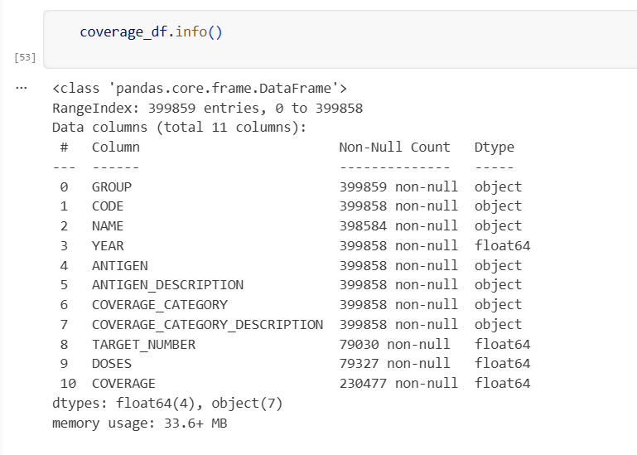
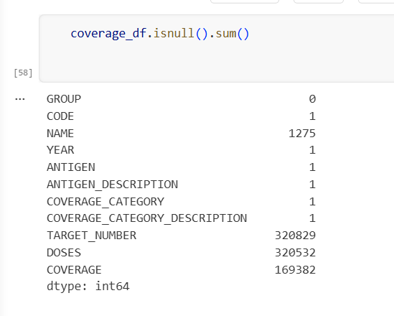
The cleaning decisions were straightforward once the problem was clear. For the coverage table, TARGET_NUMBER, DOSES, and COVERAGE were all filled using their median values rather than the mean, because coverage data has extreme outliers (some entries exceeded 100%) and the median is far more robust in that situation. The NAME column had 1,275 missing entries and was filled using the most frequent value. For incidence_rate, missing values were filled with 0, since a missing incidence rate most likely means no recorded cases rather than unknown data. The CASES column in reported cases was handled the same way. For vaccine introduction and vaccine schedule, categorical fields like TARGETPOP, GEOAREA, AGEADMINISTERED, and SOURCECOMMENT were filled with ‘Not Specified’ or ‘Unknown’ as appropriate.
After filling missing values, drop_duplicates() was run across all five dataframes. Then a null check was run again on each table to confirm the cleaning had worked. The second isnull().sum() came back clean across all critical columns — that was a satisfying moment. The cleaned dataframes were then exported back to Excel files ready for the next step.
One challenge that deserves a separate mention is dealing with vaccination coverage values that exceeded 100%. When these were first spotted, the instinct was to flag them as errors and remove them. But after reading into the WHO documentation and understanding how administrative coverage estimates are calculated, it became clear that these values can legitimately occur when the number of doses administered exceeds the estimated target population — usually because the population denominator was undercounted. Removing them outright would have meant losing real data points that reflect genuine reporting behavior in the field. Instead, they were retained in the raw data and a separate capped measure was created for visualization, so the analysis preserved the authenticity of the dataset while preventing visual distortion in charts.

4.2 Step 2: EDA and Visualizations in Jupyter Notebook
With the data cleaned, the next step was to actually understand it before building any dashboard. EDA — Exploratory Data Analysis — is not about making pretty charts. It is about asking the data questions and seeing what comes back. This stage used matplotlib and seaborn inside the same Jupyter Notebook to explore patterns, distributions, and relationships.
The first EDA visual was a line plot of average vaccination coverage by year, grouped from the coverage dataframe. This immediately showed the steep climb from the 1980s through the 1990s, the plateau around 82–86% post-2000, and the slight drop after 2020. That single chart shaped the entire narrative of the dashboard — the three-phase story visible in Power BI later was first discovered right here in the notebook.
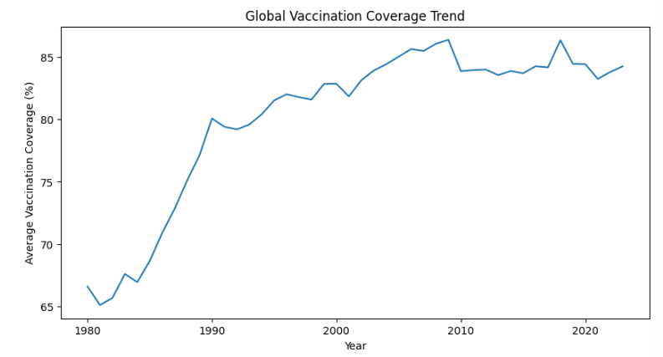A bar chart of top diseases by total reported cases was plotted next using the reported_cases dataframe. Measles shot to the top immediately, far above everything else. That finding was not expected going in — it was assumed the disease burden would be more evenly spread. Seeing measles so dramatically dominate the bar chart was one of those moments where the data tells you something you did not already know.
A seaborn heatmap was created using a pivot table of coverage values — countries on the Y-axis, years on the X-axis, with color representing average coverage. Only the first 15 countries were included to keep it readable. The viridis colormap made it easy to see which countries had consistently high coverage (bright colors) versus patchy or declining coverage (dark regions). This EDA heatmap directly inspired the matrix heatmap used later in Power BI.
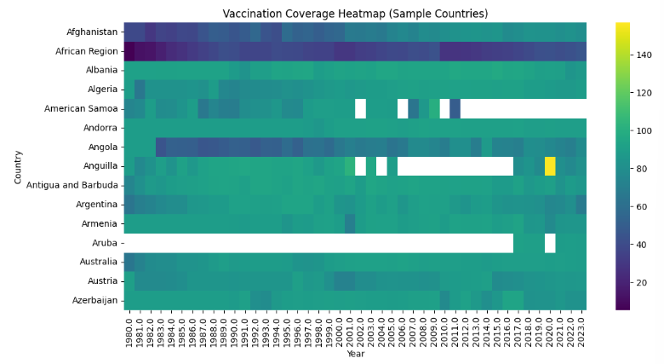Additional EDA plots explored disease trends over time, the distribution of coverage values across countries, and the correlation between coverage levels and reported case counts. These plots were not polished — they were working tools. Their purpose was to identify what was worth investigating further in the dashboard, and they did exactly that. By the end of the EDA phase, there was a clear picture of the key stories hiding in the data, and the dashboard structure was planned around them.
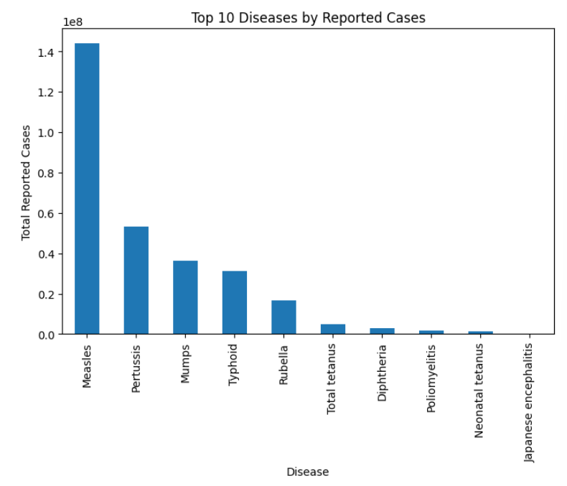

4.3 Step 3: Loading and Storing Data into MySQL
With clean data in hand, the next step was building a proper SQL database. A MySQL database called vaccination_analysis was created, and five tables were set up using a dedicated create_tables.sql script. Each table was designed carefully — data types were chosen to match what the data actually contained, column lengths were sized appropriately, and each table was given an auto-incrementing primary key. The coverage_data table used BIGINT for target_number and doses (since these are very large numbers), FLOAT for coverage, and VARCHAR for categorical fields. The incidence_rate and reported_cases tables followed similar logic.
One issue came up early: the country_code column in coverage_data was defined as VARCHAR(10) initially, but the actual data contained entries like ECONOMY_IN_TRANSITION and UNICEF_REGIONS_CEE_CIS — values far longer than 10 characters. There were 1,109 such rows. Rather than dropping them, the column was widened using ALTER TABLE to VARCHAR(100), and the codes were also truncated to 20 characters before loading. This preserved the regional grouping data without breaking the database.
Loading was done from a separate Python notebook (04_python_to_sql.ipynb) using SQLAlchemy’s create_engine() to establish a connection to the local MySQL instance. Before loading, all column names were renamed from uppercase (GROUP, CODE, NAME) to lowercase snake_case (group_name, country_code, country_name) to match the SQL table schema. Each dataframe was then pushed using .to_sql() with if_exists=‘append’ and chunksize=10000 for the large coverage table. The row counts confirmed successful loading: 399,858 rows into coverage_data, 84,945 into incidence_rate, 84,869 into reported_cases, 138,320 into vaccine_introduction, and 8,052 into vaccine_schedule. A final isnull().sum() run on each loaded dataframe confirmed zero remaining nulls across all key columns.
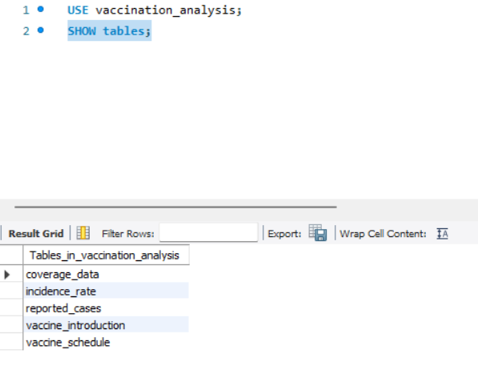

4.4 Step 4: Connecting MySQL to Power BI
Once the database was loaded and verified, Power BI Desktop was opened and the connection was set up using Get Data → MySQL Database. The server address was set to localhost, the database name to vaccination_analysis, and after entering the credentials, Power BI pulled up the list of all five tables. Each table was selected and loaded into the Power BI data model.
In the Model view, relationships were defined between tables. The coverage_data table was linked to the other tables through the country_code and year fields. Power BI did not auto-detect all relationships correctly — some had to be drawn manually, and the cardinality (one-to-many vs many-to-many) had to be set deliberately. Getting these relationships right was important because any error here would cause DAX measures to produce wrong aggregations silently, without any error message.
After the relationships were in place, the key DAX measures were written. The most important ones were: Average Coverage (%) as a simple AVERAGE of the coverage column, Capped Coverage (%) using MIN(coverage, 100) to prevent values above 100% from distorting the heatmap, Total Reported Cases in millions as a SUM divided by 1,000,000, Total Doses Administered in billions, and the Measles Share measure using CALCULATE and ALLEXCEPT to compute measles cases as a proportion of total cases regardless of active filters. These measures became the backbone of every KPI card and most of the charts in the dashboard.
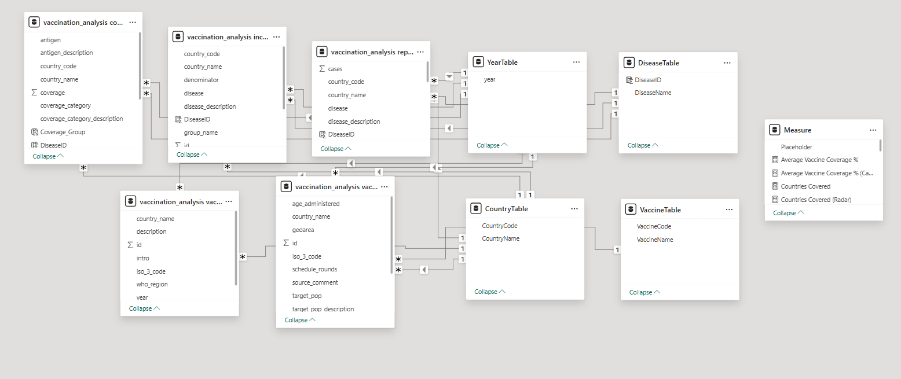

4.5 Step 5: Building the Visualizations in Power BI
With the data model solid and the measures verified, the actual dashboard building began. A dark theme was applied first — black background, gold text for KPI values, and a color palette that used green for high coverage, red for low coverage, and gold for trend lines and charts. This color language was consistent across all six pages so that a viewer could move between pages without having to re-learn what the colors mean.
Page 1 was built first as the global overview. KPI cards were placed at the top. The line chart for coverage trend (1980–2023) went in the left panel with a dotted reference line added manually at 90% to show the WHO target. The bar chart for top 10 countries went on the right. The donut chart for reporting sources and the horizontal bar for coverage split were placed at the bottom. Slicers for Year and Coverage percentage were added and configured to filter across all visuals on the page.
Pages were added one by one, each built around a specific analytical question. The Disease and Incidence Analysis pages used the reported_cases and incidence_rate tables. The Vaccine Program page used coverage_data and vaccine_introduction. The Insights and Conclusions page was built last, pulling summary visuals from earlier pages and adding the Key Strategic Conclusions and Policy Implications text panels manually. Each page went through at least two rounds of layout revision before reaching its final form.
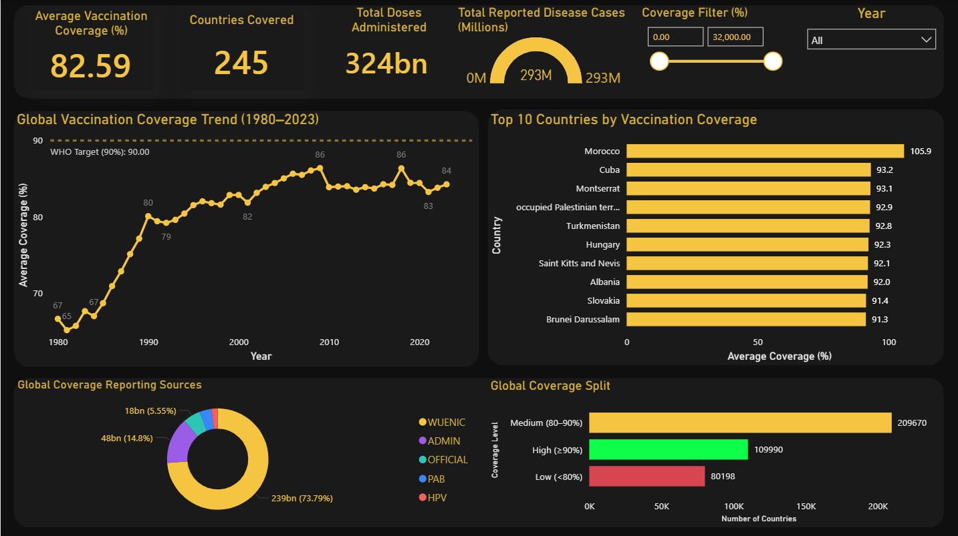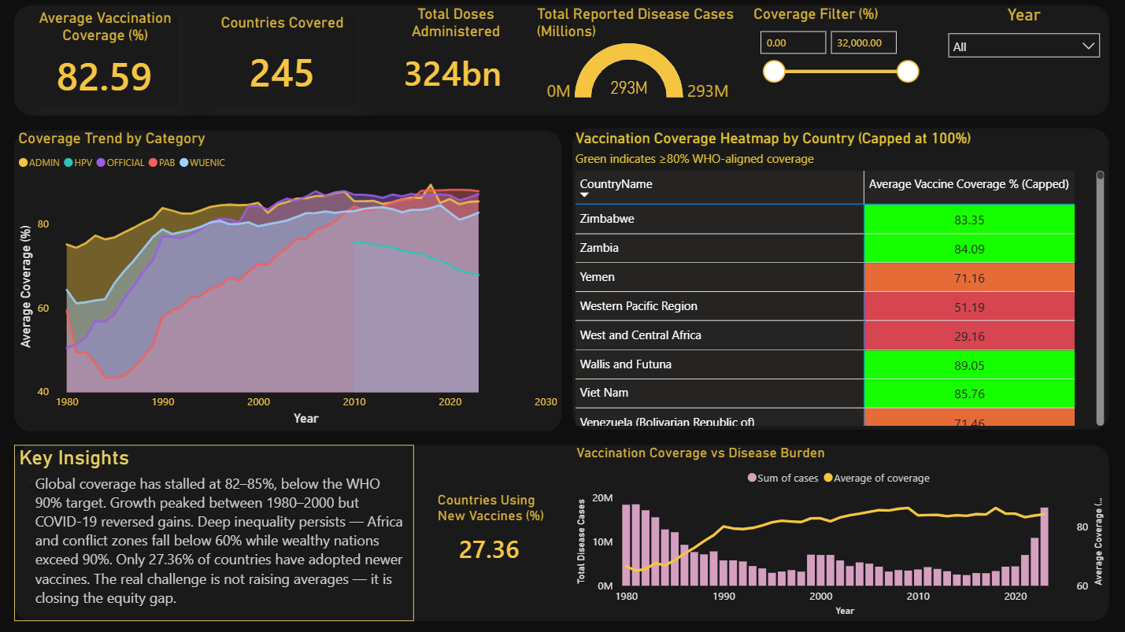
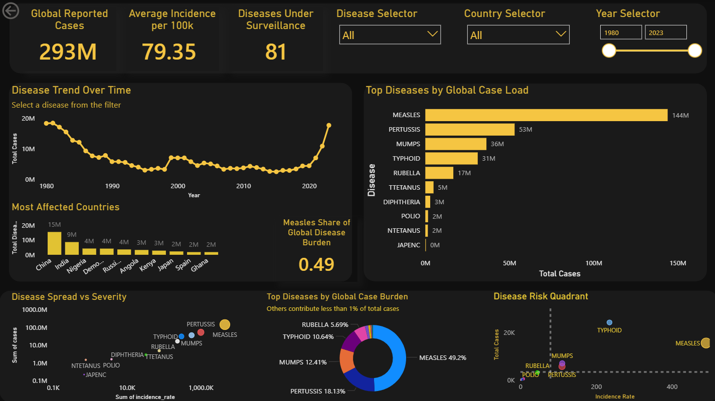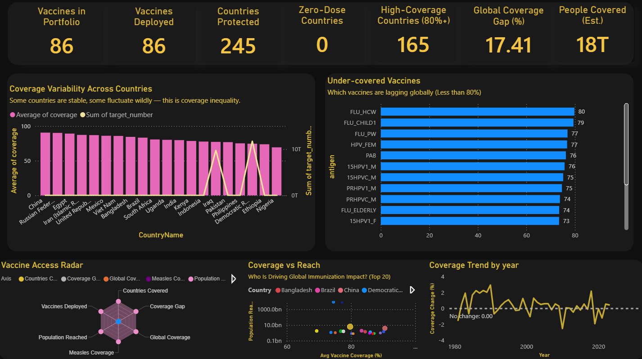
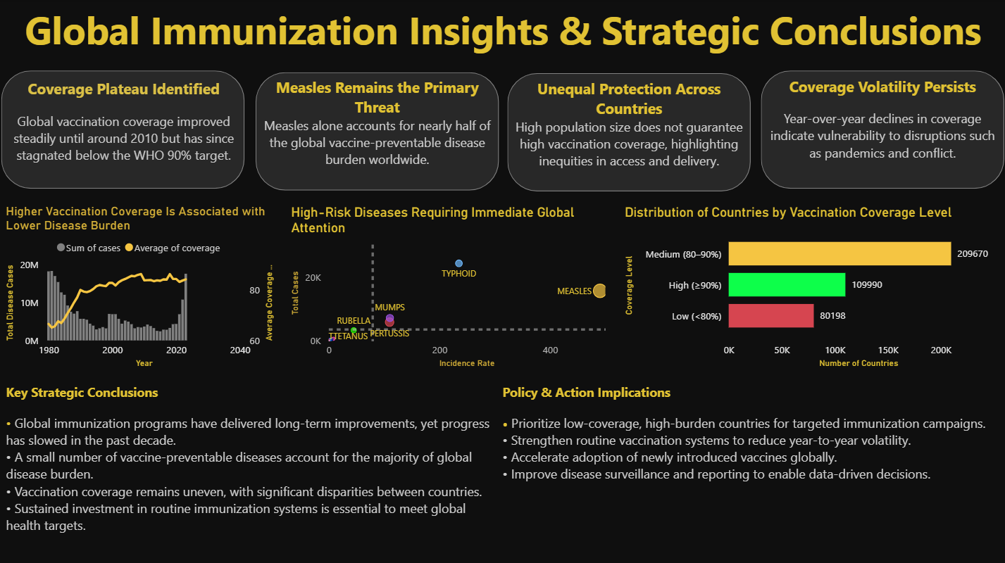
4A. Project Journey and Development Process

This project was not developed in a single step but evolved gradually through multiple stages of experimentation, learning, and refinement. Initially, the objective was straightforward — create an analytical dashboard to study global vaccination trends. But as the work progressed, it became clear that the dataset offered much deeper insights than first anticipated, which required a more structured and thoughtful approach at every stage.
The first phase focused entirely on understanding and cleaning the dataset. At this early stage, several inconsistencies were identified — missing values scattered across multiple columns, irregular country naming conventions that prevented clean joins between tables, and unusually high vaccination percentages in certain records that initially looked like data entry errors. These issues required careful preprocessing to ensure the analysis would be reliable and meaningful rather than built on shaky foundations.
Once the data was cleaned and loaded into MySQL, the next step was designing the data model and creating calculated measures in Power BI. This stage required multiple iterations because initial calculations did not always produce meaningful results. Some early DAX measures aggregated incorrectly due to filter context issues that took time to diagnose and fix. Over time, more refined measures were developed — average vaccination coverage, total reported cases, capped coverage percentages, and incidence rate comparisons — and these formed the foundation that every visualization in the dashboard rested on.
The dashboard development phase was particularly iterative. Different visualization types were tested to determine which ones best represented each aspect of the data. One of the more frustrating experiences was the heatmap — the original plan was to use a geographic map visual to show vaccination coverage by country, shaded from red to green. After trying Power BI’s built-in Map visual, the Filled Map visual, and three separate custom visuals from the marketplace, none of them worked reliably with this dataset. Country name mismatches, external server dependencies, and broken filter integration all caused failures at different stages. The solution that finally worked was a matrix-based table with conditional formatting — simpler than a geographic map but ultimately more complete, more interactive, and more readable.
Another challenge during development was balancing the amount of information displayed on each page. Early dashboard versions were either too cluttered — every chart crammed onto two pages — or too sparse, with individual pages feeling underdeveloped. Through multiple rounds of revision, a balance was achieved by organising visuals into logical groups: KPI cards at the top for immediate orientation, trend charts in the middle for historical context, and comparison visuals like bar charts and scatter plots at the bottom for deeper analysis. This structure made each page easier to read and gave the overall dashboard a sense of narrative direction.
The project also required continuous validation of insights. Observations such as the stabilisation of vaccination coverage around 82–85% and the dominance of measles in the global disease burden were cross-checked against multiple visualisations to confirm consistency before being stated as conclusions. This process of verifying patterns across different charts rather than trusting any single visual helped build genuine confidence in the findings rather than relying on coincidences in the data.
Overall, the journey of this project reflects what a realistic data analysis process actually looks like — not a smooth path from problem to solution, but a series of attempts, failures, adjustments, and gradual improvements. Each challenge along the way contributed to a better understanding of both the data and the tools, and the final dashboard is genuinely different from — and better than — what was imagined at the start.

5. Dashboard Design and Visualization Approach

The dashboard design process was iterative and involved multiple rounds of revision. The final result consists of six pages, each with a specific focus and a consistent visual language. This section documents the design philosophy and the specific visualization choices made.

5.1 Overall Design Philosophy
A dark theme was chosen deliberately. Healthcare dashboards often use light themes, but a dark background creates a sense of seriousness and focus that is appropriate for a topic as weighty as global disease burden and immunization equity. The color palette centers on deep navy (#1F3864) and gold (#B8860B), with green used to indicate high coverage and red to signal low coverage. This traffic-light approach makes it immediately intuitive to read the coverage heatmap.
Designing the dashboard was not a straightforward process and required multiple iterations before arriving at the final layout. In the beginning, visuals were placed without a clear grouping strategy, which made the dashboard feel cluttered and difficult to read. Charts competed for attention, KPIs were buried among trend lines, and someone looking at the page for the first time would not know where to start. After stepping back and reviewing the layout with fresh eyes, the approach was completely rethought. Visuals were reorganized based on their purpose — KPI cards were grouped at the very top as an orientation layer, trend charts were placed in the middle to provide historical context, and comparative visuals like bar charts and scatter plots were aligned at the bottom for deeper analysis. This restructuring made a significant difference to readability and gave the dashboard a natural top-to-bottom flow that tells a story rather than just displaying numbers.

The layout follows a top-down hierarchy: KPI cards at the top summarize the highest-level numbers, followed by trend charts that contextualize them historically, and then more granular breakdowns at the bottom. This ensures that a viewer can understand the big picture within seconds of loading the page, and then drill down into specifics as needed.

5.2 KPI Cards
Four main KPI cards appear across the dashboard pages: Average Vaccination Coverage (%), Countries Covered, Total Doses Administered, and Total Reported Disease Cases (Millions). These are implemented using Power BI's Card visual with a dark background. Each card shows a single, bold number that immediately communicates scale.

The choice to display doses in billions (324bn) and cases in millions (293M) was a deliberate formatting decision to avoid unwieldy numbers that confuse rather than inform.

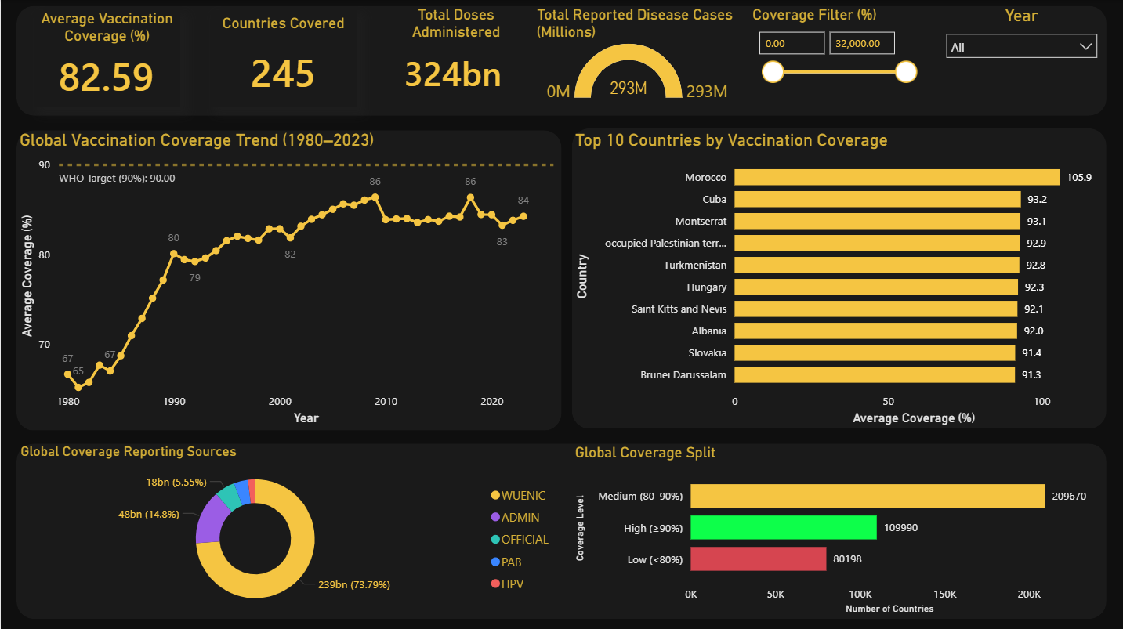

5.3 Line Charts for Trend Analysis
The Global Vaccination Coverage Trend (1980-2023) line chart is the most prominent visualization on the first page. It uses a dotted reference line at 90% to indicate the WHO target, making the gap between actual performance and the target visually obvious. Year-labeled data points make it easy to identify when coverage accelerated (1980-2010) and when it plateaued (post-2010).

On the second page, the Coverage Trend by Category chart decomposes this trend by reporting source (ADMIN, HPV, OFFICIAL, PAB, WUENIC) using an area chart. This reveals that the dominant source, WUENIC, has been the most stable, while administrative data shows more volatility.

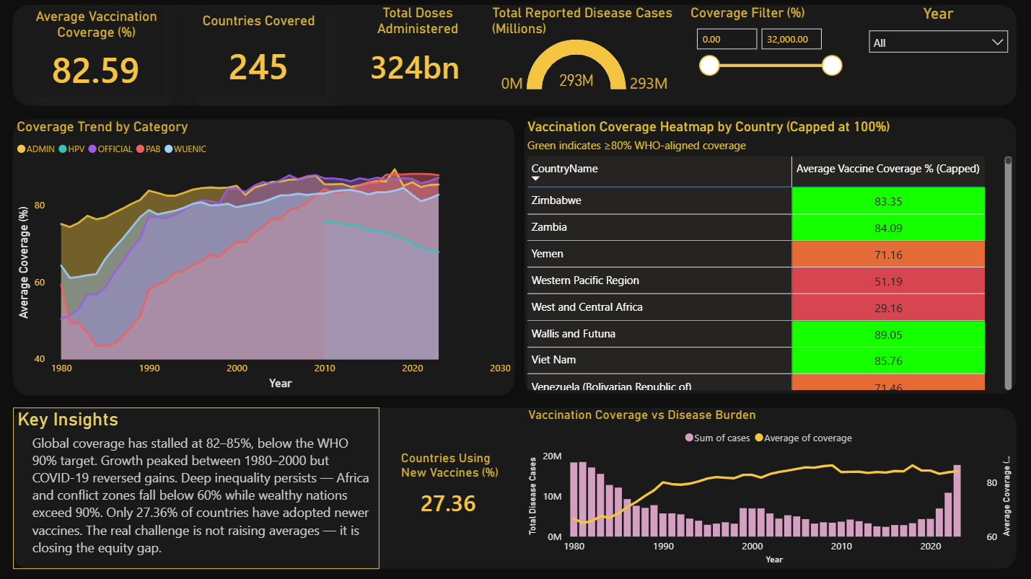

5.4 Bar Charts
Bar charts are used extensively throughout the dashboard. On the first page, a horizontal bar chart shows the Top 10 Countries by Vaccination Coverage, making Morocco's 105.9% (before capping) and the other high-performers immediately visible. On the Vaccine Program page, bar charts show under-covered vaccines and coverage variability across countries. Horizontal orientation was chosen for country and disease names because these labels are long and would be truncated in a vertical bar format.

5.5 Matrix Heatmap
One of the most significant design decisions in the project was choosing to use a matrix-style heatmap rather than a geographic map. This decision is discussed in detail in the Challenges section (Chapter 18), but in brief: Power BI's built-in Map visual requires Bing Maps API access which has restrictions in some environments, and custom map visuals from the marketplace were unreliable with this dataset's country name formats. The matrix heatmap — using a table with conditional formatting applied to the Average Coverage column — proved to be a highly effective substitute. Green cells (coverage >= 80%) and red/orange cells (coverage < 80%) provide exactly the visual differentiation that a geographic heatmap would, and the table format also allows the viewer to quickly find a specific country by name.
It is worth being honest about how this solution came about. Initially, both the built-in Map visual and several external custom visuals from the Power BI marketplace were explored. None of them worked reliably with this dataset. Some dropped countries silently due to geocoding mismatches. Others required external server connections that were unavailable in the working environment. One custom visual rendered correctly but did not respond to the dashboard’s filter slicers at all, making it useless for interactive analysis. After multiple failed attempts, the matrix approach was tried almost as a last resort — and it turned out to be better than any of the map visuals would have been. It shows every country without dropping a single entry, sorts by performance instantly, handles regional groupings cleanly, and responds perfectly to all filters. The lesson here was a valuable one: sometimes the simpler, more practical solution genuinely is the right answer, even if it looks less impressive on the surface.

5.6 Scatter Plots
Two scatter plots are used in the Disease and Incidence Analysis pages. The Disease Spread vs. Severity scatter plot plots diseases on axes of total cases (Y) against incidence rate (X) on a logarithmic scale, revealing which diseases have high spread (many cases) versus high severity (high incidence per population). The Disease Risk Quadrant uses a simpler scale to classify diseases into high/low spread and high/low incidence quadrants, making it easy to identify which diseases require the most urgent attention.

5.7 Donut and Pie Charts
Donut charts are used to show proportional breakdowns, including the Global Coverage Reporting Sources breakdown (WUENIC dominates at 73.79%) and the Top Diseases by Global Case Burden. These charts were chosen over pie charts because the donut format allows a central space for labeling the total value, and the visual distinction between segments is slightly cleaner.

5.8 Radar Chart
A radar (spider) chart appears on the Vaccine Program and Coverage Analysis page as the Vaccine Access Radar. It visualizes five dimensions simultaneously: Countries Covered, Vaccines Deployed, Coverage Gap, Global Coverage, Measles Coverage, and Population Reached. This allows a holistic, at-a-glance assessment of the immunization program's reach and depth. The radar chart is particularly effective here because it communicates trade-offs — high deployment does not necessarily mean high coverage.

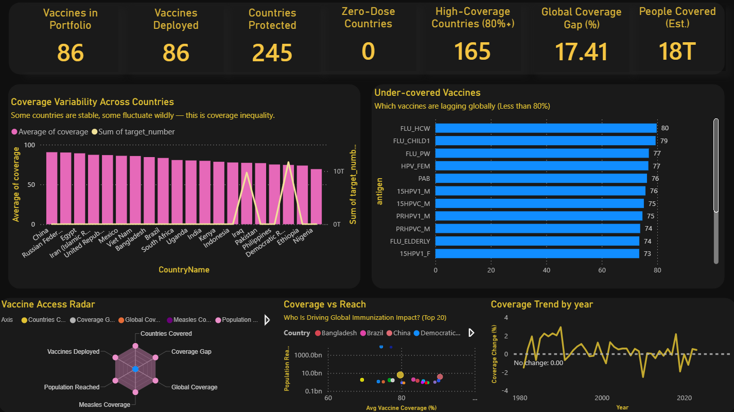



5.9 Gauge Chart
A gauge (semicircular) chart is used to display Total Reported Disease Cases in millions, providing a sense of scale relative to the maximum possible value. At 293M out of a maximum of 293M (the full dataset range), the gauge is completely full, which dramatically communicates the sheer scale of vaccine-preventable disease burden.

5.10 Filters and Slicers
Each dashboard page is equipped with interactive filters. The Coverage Filter (%) slider allows users to narrow results to countries within a specific coverage range. The Year slicer allows filtering by year or year range. The Disease Selector and Country Selector dropdowns on the Disease Analysis page allow focused analysis on a specific disease or country. These filters are synchronized across visuals within each page through Power BI's built-in filter interactions.

5.11 Visualization Selection and Design Justification
The selection of visualizations in this dashboard was not random. Every chart type was chosen deliberately, based on the nature of the data it needed to represent and the type of insight it needed to communicate. Choosing the wrong chart type for a given dataset is one of the most common mistakes in dashboard design — it can make data look misleading or simply confusing — so considerable thought went into each choice.
KPI cards were chosen to present top-level metrics because they communicate scale instantly without requiring interpretation. A viewer who opens the dashboard for the first time can read the global average coverage, total countries, and total doses in under five seconds — and that orientation is what allows everything else on the page to be understood in context. Line charts were used for trend analysis because time-series data is most naturally read as a continuous movement — the rise, plateau, and dip in coverage from 1980 to 2023 are impossible to miss in a line chart and would be far less obvious in any other format. Bar charts were used for country and disease comparisons because ranking entities against each other is exactly what a bar chart does most effectively — the eye immediately identifies the longest and shortest bars without any cognitive effort. Horizontal orientation was specifically chosen for country and disease name labels because these names are long and would be cut off in a vertical bar chart.
Scatter plots were used for the disease risk analysis because they are uniquely suited to showing the relationship between two continuous variables simultaneously — in this case, total case count and incidence rate. A bar chart could show one or the other, but only the scatter plot reveals how diseases cluster and differ when both dimensions are considered together. The donut chart was chosen for reporting source breakdown because the proportional story — WUENIC contributing nearly 74% of all data — is most intuitively communicated as a part-of-a-whole visual. The radar chart on the vaccine program page was chosen to show five dimensions of immunization performance simultaneously, which would require five separate charts in any other format.
As discussed earlier, the geographic map was considered and attempted multiple times before being replaced by the matrix heatmap. The matrix was not the glamorous choice, but it was the right one — it showed all countries completely, responded correctly to all filters, and used color coding that communicated the same green-red performance signal that a geographic map would have. Overall, every visualization in the final dashboard has a clear reason for existing, and no visual was kept simply because it looked interesting.

6. Global Vaccination Coverage Analysis

The first page of the Power BI dashboard — Pg 1 Global Overview — establishes the high-level picture of global immunization. It answers the question: where does the world stand today on vaccination coverage, and how did we get here?

6.1 KPI Interpretation
The four KPIs at the top of the page provide an immediate quantitative orientation. The average vaccination coverage of 82.59% tells us that across all countries and vaccines in the dataset, roughly five out of every six targeted individuals have been vaccinated. While this sounds impressive at first glance, it sits below the WHO threshold of 90%, which is considered the minimum level needed to achieve herd immunity for most vaccine-preventable diseases.

The figure of 245 countries covered is notable because it represents virtually the entire recognized international community. This breadth means the dataset is genuinely global — not limited to wealthy or well-documented nations. However, data quality varies significantly across countries, with lower-income nations often relying on less reliable administrative estimates.

Total Doses Administered at 324 billion represents the cumulative effort of immunization programs worldwide across more than four decades. When considered alongside the 293 million total reported disease cases, it underscores the sheer magnitude of the challenge — even with billions of doses delivered, hundreds of millions of disease cases still occurred, highlighting the ongoing gap between effort and outcome.

6.2 Global Coverage Trend (1980-2023)
The line chart tracing global average coverage from 1980 to 2023 is the most narratively rich visualization in the dashboard. It tells a clear, three-phase story.

In the first phase (1980-2000), global coverage rose steeply from approximately 67% to around 82%. This period coincides with the expansion of the Expanded Programme on Immunization (EPI), which WHO launched to systematically scale up vaccine delivery in low- and middle-income countries. The near-doubling of coverage in two decades reflects the extraordinary success of organized, globally coordinated vaccination campaigns.

In the second phase (2000-2010), coverage continued to rise but at a slower pace, eventually reaching approximately 86% — the highest point in the dataset. This slowdown reflects the fact that the easiest-to-reach populations had already been covered, and further gains required reaching more remote, poorer, and harder-to-access communities.

The third phase (post-2010) is the most concerning. Coverage plateaued and then began to fluctuate, settling around 83-84% by the early 2020s. The COVID-19 pandemic, which disrupted health services globally between 2020 and 2022, is visible as a notable dip in this period. But the stagnation began before the pandemic, suggesting structural issues in immunization delivery that predated it.

The WHO target of 90% appears as a dotted line at the top of the chart. The gap between the actual trend line and this target has persisted for more than a decade, and if current trends continue, it may not be closed without deliberate, targeted policy intervention.

6.3 Global Coverage Split
The horizontal bar chart on the right of the first page's lower section categorizes countries by coverage level: High (>=90%), Medium (80-90%), and Low (<80%). The counts show that 209,670 records fall in the Medium band, 109,990 in the High band, and 80,198 in the Low band. This means that while most country-vaccine-year combinations achieve medium coverage, a substantial portion — particularly in low-income regions — still falls below 80%.

This distribution reveals that the global average of 82.59% is pulled down by a significant tail of low-coverage records, and that the path to reaching 90% globally requires dramatically improving the performance of this bottom tier.

6.4 Global Coverage Reporting Sources
The donut chart on the lower left of the first page shows the breakdown of coverage records by reporting source. WUENIC contributes 73.79% (239 billion doses), making it by far the dominant source. ADMIN contributes 14.8% (48 billion), and Other sources including PAB and HPV account for the remaining 3.86% (12 billion).

This distribution matters because WUENIC estimates are generally considered more accurate and comparable than administrative data, which is self-reported by governments and may not account for population estimation errors. The fact that most of our data comes from WUENIC is reassuring from an analysis standpoint.

7. Country-Level Vaccination Analysis

Moving beyond global aggregates, the country-level analysis reveals the enormous variation that exists beneath the surface of the global average. The second page of the dashboard — Pg 2 Global Overview — zooms into country-level performance through two primary visualizations: the Coverage Trend by Category area chart and the Vaccination Coverage Heatmap by Country.

7.1 Top 10 Countries by Vaccination Coverage
The horizontal bar chart on the first page's right side highlights the ten highest-performing countries by average vaccination coverage. Morocco leads with 105.9%, followed by Cuba at 93.2%, Montserrat at 93.1%, occupied Palestinian territories at 92.9%, Turkmenistan at 92.8%, Hungary at 92.3%, Saint Kitts and Nevis at 92.1%, Albania at 92.0%, Slovakia at 91.4%, and Brunei Darussalam at 91.3%.

Several observations stand out from this list. First, Morocco's figure of 105.9% is a data quality artifact rather than a real achievement — it reflects administrative overcounting where reported doses exceed the estimated target population. This is addressed by the capped measure in the heatmap. Second, the diversity of countries in the top 10 is striking: small island states like Montserrat and Saint Kitts sit alongside middle-income countries like Cuba and Turkmenistan, and European nations like Hungary and Slovakia. High coverage is not exclusively the domain of wealthy nations.

Cuba's consistently high coverage, for example, reflects decades of investment in primary healthcare infrastructure, particularly at the community level. Its inclusion in the top 10 alongside European nations is a testament to what strong public health systems can achieve regardless of absolute economic output.

7.2 Vaccination Coverage Heatmap by Country
The matrix heatmap on the second page displays coverage percentages for each country, color-coded green for coverage at or above 80% (WHO-aligned) and red/orange for below 80%. This provides an immediate visual differentiation that allows a viewer to scan the list and identify underperforming countries at a glance.

Looking at the visible entries in the heatmap, Zimbabwe shows 83.35% (green), Zambia 84.09% (green), Yemen 71.16% (red, underperforming), Western Pacific Region 51.19% (red, severely underperforming), West and Central Africa 29.16% (deep red, crisis-level), Wallis and Futuna 89.05% (green), Viet Nam 85.76% (green), Venezuela 71.46% (orange, below threshold), Vanuatu 78.87% (borderline), Uzbekistan 90.11% (green), Uruguay 88.00% (green), Upper middle income group 52.95% (red), and the United States 85.68% (green).

The regional groupings included in the heatmap, such as West and Central Africa at 29.16% and the Western Pacific Region at 51.19%, are particularly alarming. These aggregated figures suggest that in some of the world's most vulnerable regions, barely one in three people in the target population is being vaccinated. This is not a marginal gap — it is a fundamental failure of coverage that leaves entire communities at risk.
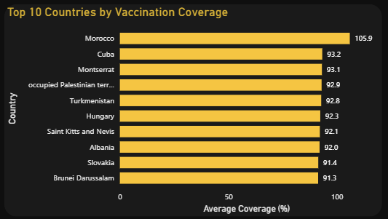
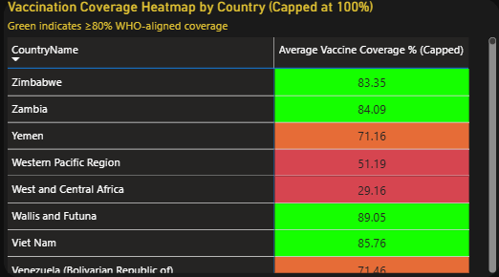

7.3 Key Insights Panel
The second page also includes a styled insights box that summarizes four key analytical conclusions: (1) global coverage has stabilized around 82-85%; (2) some regions remain below 60% coverage; (3) strong growth was observed post-1990; and (4) inequality across countries remains high. These conclusions are derived directly from the data and serve as a useful orientation for viewers who want a quick summary before diving into the detailed charts.

The Countries Using New Vaccines (%) figure of 27.36% is also displayed on this page. This metric indicates that fewer than one in three countries have adopted new or recently introduced vaccines into their national programs. This adoption gap is a significant finding, as newly introduced vaccines often target diseases for which coverage has historically been low or inconsistent.



8. Disease Incidence Analysis

The third page of the dashboard — Disease and Incidence Analysis — shifts focus from vaccination supply to disease outcomes. It provides a comprehensive picture of the diseases that vaccination programs are intended to prevent, and asks the key question: how have disease case counts changed over time, and which diseases continue to pose the greatest threat?
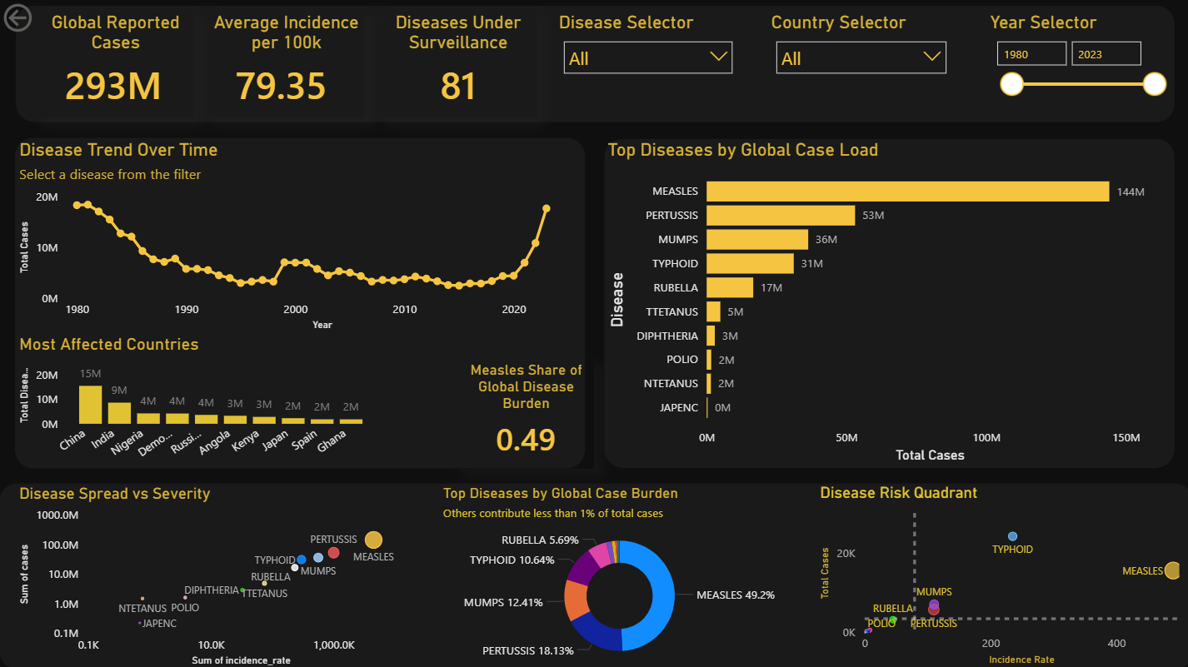

8.1 KPI Summary
Three KPIs anchor this page: Global Reported Cases at 293 million, Average Incidence per 100,000 at 79.35, and Diseases Under Surveillance at 81. The incidence figure of 79.35 cases per 100,000 population globally is significant. It means that across all vaccine-preventable diseases and all years in the dataset, nearly 80 people in every 100,000 contracted a reportable disease on average. Given that many of these diseases are highly preventable with existing vaccines, this incidence rate represents a preventable human cost.

8.2 Disease Trend Over Time
The Disease Trend Over Time line chart shows total reported cases from 1980 to approximately 2023. The trend line descends sharply from about 18-20 million cases per year in the early 1980s to approximately 5-7 million by the late 1990s, reflecting the success of expanded vaccination programs during this period. However, the line then shows an uptick in the 2020-2023 period, reaching approximately 16-18 million, which likely reflects the disruption of routine immunization services during the COVID-19 pandemic, leading to a resurgence of preventable diseases including measles.

This V-shaped pattern is a warning signal. It demonstrates that decades of progress in disease reduction can be rapidly reversed when vaccination programs are disrupted. The resurgence is not merely a statistical artifact — it represents real outbreaks, real hospitalizations, and real deaths that occurred because vaccination programs were paused or interrupted.

8.3 Most Affected Countries
The horizontal bar chart showing the most affected countries by total disease cases places China at the top with 15 million cases, followed by India at 9 million, Nigeria at 4 million, the Democratic Republic of Congo at 4 million, Russia at 4 million, Angola at 3 million, Kenya at 3 million, Japan at 2 million, Spain at 2 million, and Ghana at 2 million.

The presence of China and India at the top is expected given their enormous populations, but the inclusion of Nigeria, DRC, Angola, and Kenya — all sub-Saharan African nations — is a more sobering finding. These countries have relatively smaller populations compared to China and India, yet their total case counts are disproportionately high, reflecting inadequate vaccine coverage rather than mere demographic scale. Japan and Spain's presence in the list is somewhat surprising for high-income nations but likely reflects high case counts for specific diseases like mumps or pertussis that periodically resurge in otherwise well-vaccinated populations.

8.4 Measles Share of Global Disease Burden
A standalone KPI on the Disease Analysis page shows the Measles Share of Global Disease Burden at 0.49 — meaning measles alone accounts for 49% of all reported disease cases in the dataset. This single statistic is perhaps the most powerful and alarming finding in the entire project. Measles is a highly contagious respiratory disease that is entirely preventable with a safe, affordable, and effective two-dose vaccine. Yet it is responsible for nearly half of all global vaccine-preventable disease cases. This indicates that despite decades of vaccination efforts, the world has still not achieved the sustained high coverage needed to eliminate measles transmission.

9. Top Diseases by Global Case Load

The bar chart on the right side of the Disease and Incidence Analysis page ranks the ten diseases by their total global case count across the full 1980-2023 dataset. This ranking provides important context for understanding where the greatest disease burden lies and where vaccination programs need to be most strongly maintained.

9.1 Disease Rankings
Measles leads by an enormous margin at 144 million cases — nearly three times the burden of the next highest disease. Pertussis (whooping cough) follows at 53 million, then Mumps at 36 million, Typhoid at 31 million, Rubella at 17 million, Tetanus (neonatal) at 5 million, Diphtheria at 3 million, Polio at 2 million, Neonatal Tetanus at 2 million, and Japanese Encephalitis at approximately 0 million (very low in this dataset).

9.2 Why Measles Dominates
Measles' dominance in this list deserves deeper examination. Measles is among the most contagious infectious diseases known — its reproduction number (R0) is estimated at 12-18, meaning a single infected person can infect up to 18 susceptible individuals. This means that achieving herd immunity requires approximately 93-95% coverage of the population with two doses of measles-containing vaccine. Most countries have not consistently achieved this level, which means measles transmission persists in pockets of susceptible individuals.

Additionally, measles outbreaks tend to accumulate susceptible individuals over time. When coverage dips even temporarily, a cohort of unvaccinated children builds up, and the next introduction of the virus can ignite a large outbreak. This explains why, even in countries with generally good vaccination programs, measles outbreaks can occur.

9.3 Pertussis and Mumps
Pertussis at 53 million cases is noteworthy because it highlights a challenge that is not simply about lack of vaccination, but about waning immunity. The pertussis vaccine is effective, but immunity diminishes over time, and booster doses are needed throughout life. Many national vaccination schedules do not include adult booster programs, leading to sustained transmission in adults who transmit the disease to unvaccinated infants — the most vulnerable group.

Mumps at 36 million reflects similar dynamics. Even in highly vaccinated populations, mumps outbreaks occur in densely congregated settings like university campuses, partly because vaccine-induced immunity is not lifelong and partly because the vaccine's efficacy against mumps is somewhat lower than against measles or rubella.

9.4 Donut Chart: Disease Burden Share
The donut chart on the lower middle of the Disease page shows the proportional share of each disease in the global case burden. Measles accounts for 49.2%, Pertussis 18.13%, Mumps 12.41%, Typhoid 10.64%, and Rubella 5.69%. Together, these five diseases account for over 96% of all reported cases, while all other diseases collectively contribute less than 4%. This concentration of burden in a small number of diseases has clear policy implications: targeted, sustained effort against measles, pertussis, and mumps would have an outsized impact on global disease burden reduction.

10. Disease Spread vs Severity Analysis

Two scatter plots on the Disease Analysis sub-pages (Pg 2.1 and 2.2) provide a more sophisticated analytical lens than simple case counts. By mapping diseases on dual-axis plots, they help classify diseases by both their breadth and their depth of impact.


10.1 Disease Spread vs Severity Scatter Plot
The Disease Spread vs Severity scatter plot plots each disease as a bubble, with the X-axis representing the Sum of Incidence Rate (a proxy for severity or clinical burden per unit of population) and the Y-axis representing the Sum of Cases (a proxy for spread or epidemiological reach). Both axes use logarithmic scales, which compress the wide range of values into a more interpretable visual space.

In this chart, Measles appears in the upper right quadrant — high spread, moderately high incidence — confirming its status as the most globally significant disease. Pertussis and Typhoid appear in the middle right, indicating high incidence rates but somewhat less absolute case volume than measles. Mumps appears mid-chart, with high case counts but a lower incidence rate, reflecting its concentration in specific age groups and settings. Diseases like Diphtheria, Polio, and JAPENC (Japanese Encephalitis) appear in the lower left, indicating both relatively low spread and low incidence — a reflection of the near-elimination of these diseases through sustained vaccination.

The scatter plot layout makes immediately clear why policy attention must focus on measles, pertussis, and typhoid as the highest-priority diseases, while also maintaining vaccination programs for nearly eliminated diseases like polio and diphtheria to prevent their resurgence.

10.2 Disease Risk Quadrant
The Disease Risk Quadrant on the lower right of the page uses a simpler, non-logarithmic scatter plot to divide diseases into four quadrants based on total cases (Y-axis) and incidence rate (X-axis). Vertical and horizontal dashed reference lines divide the chart into quadrants representing: high cases/high incidence (top right - highest risk), high cases/low incidence (top left - widespread but mild), low cases/high incidence (bottom right - rare but severe), and low cases/low incidence (bottom left - controlled diseases).

Measles falls firmly in the top right quadrant, confirming it as the highest-risk disease by both measures. Typhoid appears in the bottom right (low cases but high incidence), meaning it is clinically severe when it occurs but not as widespread as measles. Mumps sits in the top left (high cases but lower incidence), reflecting its widespread but generally milder clinical presentation. Pertussis straddles the boundary between high and low, while diseases like Rubella, Polio, and Tetanus cluster near the origin — low on both axes, indicating effective control.


11. Vaccine Program and Coverage Analysis

The fourth page of the dashboard — Vaccine Program and Coverage Analysis — examines the supply side of immunization: the portfolio of vaccines being deployed, how coverage varies across countries and antigens, and which vaccines are underperforming globally.



11.1 Top-Level KPIs
This page opens with six KPIs that together paint a comprehensive picture of the global vaccine program. The Vaccines in Portfolio and Vaccines Deployed are both 86, indicating that every vaccine developed and included in the program has been deployed in at least one country — a positive finding suggesting no shelf-stagnation. Countries Protected stands at 245, matching the coverage data breadth.

Zero-Dose Countries is listed as 0, meaning no country in the dataset has absolutely zero vaccination coverage — a reassuring finding, though it does not preclude zero-dose children within countries that do have programs. High-Coverage Countries (80%+) stands at 165, representing about 67% of the 245 countries covered. The Global Coverage Gap of 17.41% quantifies how far below 100% the average coverage stands. And People Covered (Estimated) at 18 Trillion reflects the cumulative population reached by vaccination across all vaccines and all years — an almost incomprehensibly large number that speaks to the scale of the global immunization enterprise.

11.2 Coverage Variability Across Countries
The Coverage Variability chart shows average coverage (pink bars) alongside the sum of target population (line) for a selection of large countries. Countries like China, Russia, Egypt, Iran, and Mexico show relatively stable, moderate coverage bars, while the target population line spikes dramatically for China, India, and a few other high-population nations. This visual clearly separates countries that are difficult to cover because of sheer population size from those where coverage is low due to system or access failures.

Nigeria and Ethiopia, appearing at the right end of the chart, show relatively short coverage bars despite appearing later in the sequence, suggesting that even within this group of large countries, some are significantly underperforming on coverage relative to their target populations.

11.3 Under-covered Vaccines
The bar chart showing which vaccines are lagging globally (below 80% coverage) lists a striking set of antigens. FLU_HCW (influenza vaccine for healthcare workers) and FLU_CHILD1 (influenza for children) both stand at around 79-80% — just below the threshold. HPV_FEM (HPV vaccine for females), PAB (protection at birth), 15HPV1_M (HPV for males), 15HPVC_M, PRHPV1_M, PRHPVC_M, FLU_ELDERLY, and 15HPV1_F follow closely.

The pattern here is notable: influenza vaccines and HPV vaccines dominate the under-coverage list. This reflects structural challenges specific to these vaccine types. Influenza vaccines require annual reformulation and delivery, making sustained coverage difficult. HPV vaccines are newer, require multi-dose schedules, and face cultural and informational barriers in some communities. The presence of both male and female HPV vaccine codes in this list also reflects that HPV vaccination programs for males are newer and less universally adopted.

11.4 Coverage vs Reach Scatter Plot
The Coverage vs Reach chart plots the top 20 countries by immunization impact on axes of Population Reached (Y, in billions) and Average Vaccine Coverage percentage (X). Bangladesh, Brazil, China, and other large countries appear as distinct colored dots. China has the highest population reach but moderate coverage percentage. Smaller, high-performing countries cluster in the upper right, indicating both high reach and high coverage. The scatter pattern confirms that population size and coverage rate are not correlated — large countries do not automatically achieve high coverage.

11.5 Coverage Trend by Year
The Coverage Trend by Year line chart on the lower right of this page shows year-on-year change in coverage (positive or negative) from 1980 to 2023. The chart is deliberately centered on zero change (the dotted reference line). What stands out is the erratic, volatile nature of coverage changes, particularly after 2000. While early years showed mostly positive changes (coverage improving), the later period shows a pattern of alternating small gains and losses, with no clear upward trend. This volatility is a sign of systemic instability — programs that grow and then shrink, year to year, depending on funding, conflict, political will, or health system disruptions.

12. Vaccination Inequality Across Countries

One of the most persistent and troubling themes running through the entire dashboard is the deep inequality in vaccination coverage between countries. This inequality exists along multiple dimensions: geographic, economic, and systemic.

12.1 Geographic Inequality
The heatmap on the second page makes geographic inequality starkly visible. West and Central Africa shows an average coverage of only 29.16% — barely one in three people in the target population being vaccinated. This is not a marginal underperformance; it represents a fundamental failure to deliver a basic public health service to hundreds of millions of people. Yemen, at 71.16%, is also significantly below the global average, reflecting the devastating impact of ongoing conflict on health infrastructure.

By contrast, countries in Western Europe, small island states with strong healthcare systems, and a few middle-income countries consistently report coverage above 90%. The disparity between the best and worst performers — spanning from above 90% to below 30% — is greater than 60 percentage points. No other major health metric shows such extreme variation.

12.2 Economic Inequality
The heatmap also includes economic groupings such as Upper Middle Income, which shows a coverage of 52.95%. This seems counterintuitive — why would upper-middle-income countries show lower coverage than some low-income nations? The answer lies in the heterogeneity within income groups. A grouping like Upper Middle Income includes a wide range of countries with very different health system capacities. Some have highly effective programs; others have invested less in public health infrastructure despite rising incomes.

Low-income countries that receive substantial external support from organizations like Gavi, the Vaccine Alliance, often show surprisingly good coverage for childhood vaccines, because Gavi's funding and technical assistance specifically targets the vaccination programs that save the most lives. This suggests that external support can, to some extent, compensate for domestic resource constraints — but not indefinitely, and not for all vaccines.

12.3 New Vaccine Adoption Inequality
The figure showing that only 27.36% of countries have adopted newly introduced vaccines is another dimension of inequality. New vaccines — such as the HPV vaccine, the rotavirus vaccine, and the pneumococcal conjugate vaccine — were designed to address diseases that disproportionately affect children in low-income countries. Yet adoption of these vaccines is slowest precisely in the countries where they would save the most lives. This adoption gap reflects supply chain challenges, cold chain requirements, cost, and the lag between vaccine development and program implementation in resource-limited settings.

13. Trend Analysis Over Time

Trend analysis is one of the most powerful analytical tools in the vaccination context because immunization programs operate on decadal timescales. Understanding how coverage and disease burden have evolved over 43 years provides context that a single snapshot cannot offer.

13.1 Phase 1: Rapid Growth (1980-2000)
The period from 1980 to 2000 represents the golden era of global vaccination expansion. The launch of WHO's Expanded Programme on Immunization in 1974, which gained momentum through the 1980s, drove an unprecedented increase in childhood vaccination rates. By 1990, DTP3 coverage (three doses of the diphtheria-tetanus-pertussis vaccine) had risen to approximately 80% globally from near-negligible levels in many developing countries just fifteen years earlier.

The area chart on the second page shows that WUENIC coverage (the most reliable estimate) grew steadily during this period, while ADMIN coverage showed more volatility, reflecting inconsistent reporting rather than actual performance fluctuations. The strong post-1990 growth is clearly visible in the chart, with coverage accelerating through the 1990s.

13.2 Phase 2: Deceleration and Plateau (2000-2015)
After the rapid gains of the 1980s and 1990s, growth began to slow in the early 2000s. Coverage reached approximately 86% for some vaccines but stalled there. The reasons for this plateau are well-documented in public health literature: the remaining unvaccinated populations are harder to reach (geographically remote, in conflict zones, or resistant to vaccines), program funding grew more slowly, and new vaccines were being introduced at a faster rate than programs could absorb.

The introduction of new vaccines — HPV, rotavirus, pneumococcal — during this period actually complicated the picture. National vaccination calendars became more complex, requiring more clinic visits, more cold chain capacity, and more trained health workers. In some settings, this expanded burden on health systems led to slight dips in coverage for traditional vaccines even as new vaccines were being introduced.

13.3 Phase 3: Volatility and COVID Disruption (2015-2023)
The most recent period in the dataset is characterized by volatility rather than sustained progress or clear decline. Coverage for many vaccines fluctuates year to year, with small gains in some years offset by losses in others. The net effect is stagnation around 82-84%.

The COVID-19 pandemic (2020-2022) introduced the most severe disruption to immunization programs in recent decades. With health workers redeployed to pandemic response, clinics closed or unsafe to visit, supply chains disrupted, and parents hesitant to bring children for routine visits, vaccination rates dropped sharply in 2020 and 2021. The subsequent uptick in disease cases visible in the Disease Trend chart (the sharp rise toward 2023) is directly attributable to this disruption, as large cohorts of unvaccinated children became susceptible to diseases like measles and pertussis.

14. Key Insights from the Dashboard

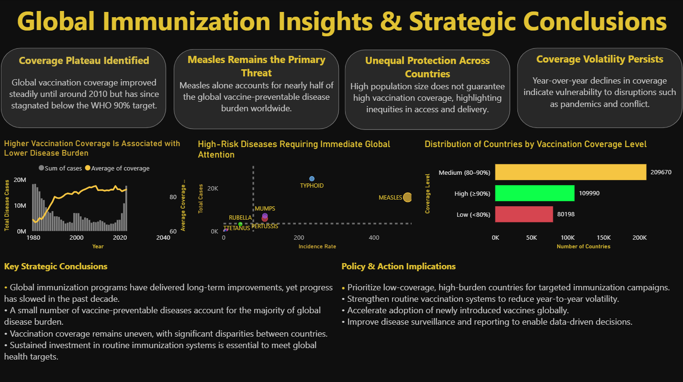
The final dashboard page — Insights and Conclusions — synthesizes the findings from all previous pages into four thematic insight boxes and two strategic summary panels. This chapter unpacks each of those insights in detail.
It is worth explaining how these insights were actually formed, because they did not arrive neatly or all at once. Initially, each chart was built and read in isolation — the trend line showed one thing, the bar chart showed another, and the scatter plot showed something else entirely. The insights only emerged when those separate observations were placed side by side and compared. For example, the coverage plateau on the trend chart meant little until it was viewed alongside the disease case resurgence in the late 2010s and early 2020s — at that point the connection between stagnating coverage and rising cases became impossible to ignore. Similarly, the measles dominance in the case load chart only became truly alarming when cross-referenced with the countries that appear red in the heatmap. The process of connecting multiple data points across different visuals was what turned surface-level observations into genuinely meaningful conclusions.

14.1 Coverage Plateau Identified
The first insight box notes that global vaccination coverage improved steadily until around 2010 but has since stagnated below the WHO 90% target. This is perhaps the most important macro-level finding of the project. The world made extraordinary progress in the first 30 years of organized immunization, but the last 15 years have seen that progress halt.

What makes this finding particularly important is that the plateau has occurred not because the problem is solved, but because it has become harder. The populations that remain unvaccinated are not simply forgotten — they are often actively difficult to reach, whether due to geographic remoteness, conflict, poverty, distrust of health authorities, or a combination of factors. Overcoming this last-mile challenge requires fundamentally different strategies from those that drove earlier success.

14.2 Measles Remains the Primary Threat
The second insight box states that measles alone accounts for nearly half of the global vaccine-preventable disease burden worldwide. As analyzed in Sections 8 and 9, this finding reflects measles' extreme transmissibility, the high coverage threshold needed to break transmission, and the consequences of any gap in vaccination.

The public health implication is clear: measles cannot be controlled with mediocre vaccination programs. Even a coverage rate of 80% — which sounds high — leaves 20% of the population susceptible, which is more than enough to sustain ongoing transmission and periodic outbreaks. The path to measles elimination requires not just high average coverage but elimination of geographic and demographic gaps in coverage.

14.3 Unequal Protection Across Countries
The third insight notes that high population size does not guarantee high vaccination coverage, highlighting inequities in access and delivery. This finding is demonstrated by the Most Affected Countries chart (China and India lead in absolute cases despite having large vaccination programs) and the Coverage vs Reach scatter plot (large countries show moderate, not excellent, coverage).

More profoundly, it reflects a structural reality of global health: the countries with the greatest need for vaccination often have the weakest systems to deliver it. This is the fundamental challenge of global health equity — not just having the tools to save lives, but having the infrastructure and resources to deploy them effectively.

14.4 Coverage Volatility Persists
The fourth insight identifies that year-over-year declines in coverage indicate vulnerability to disruptions such as pandemics and conflict. The Coverage Trend by Year chart confirms this, showing a pattern of fluctuating annual changes that leaves no room for complacency.

This finding has important implications for how immunization programs are designed and funded. Programs that depend on year-to-year budget cycles, are staffed by temporary workers, or lack redundant supply chains are inherently fragile. Building resilience into immunization systems — through multi-year funding commitments, community-based delivery, and diversified supply chains — is essential for maintaining coverage in the face of inevitable disruptions.

14.5 Detailed Insights and Interpretations
Looking across all six dashboard pages together, a few deeper patterns emerge that are worth spelling out clearly, because they go beyond what any single chart communicates on its own.
The most significant finding is the stabilisation of global vaccination coverage. While there was rapid growth in coverage from the 1980s through the late 1990s, the rate has plateaued at around 82–85% in recent years. This is not simply a case of progress slowing naturally — it reflects a structural problem. The populations that remain unvaccinated are not easy to reach, and the same approaches that drove coverage gains in the first three decades of global immunization are no longer enough to reach them.
The dominance of measles in the disease burden data is a striking finding, but it becomes even more meaningful when read alongside the coverage data. Measles requires approximately 93–95% population coverage to break transmission chains. The global average sitting at 82–85% means the world is almost certainly below the measles herd immunity threshold in aggregate, and significantly below it in many specific regions. This is not a coincidence — the gap between current coverage and the measles elimination threshold is precisely why measles keeps resurging.
The country-level disparities visible in the heatmap reveal that the coverage gap is not evenly distributed. Regions like West and Central Africa show averages below 30%, while high-income nations comfortably exceed 90%. This uneven distribution reflects differences in healthcare infrastructure, policy commitment, and external support rather than differences in the effectiveness of vaccines themselves. The vaccines work — the systems delivering them do not reach everyone equally.
The relationship between vaccination coverage and disease incidence broadly confirms the expected pattern — countries with higher coverage generally report lower disease rates. But this relationship is not perfectly clean or linear. Some high-coverage countries still show disease cases, reflecting waning immunity for certain vaccines and the need for booster programs. Some low-coverage countries show fewer cases than expected, possibly due to underreporting rather than genuine disease control. These nuances are important because they prevent oversimplified conclusions and remind us that data always carries the limitations of how it was collected.
Collectively, these insights reinforce a simple but important message: the world has made remarkable progress in vaccination, but remarkable progress is not enough. The remaining gap — in coverage, in equity, in new vaccine adoption, in system resilience — carries real human consequences, and closing it will require more targeted, more sustained, and more creative effort than anything that has been done before.

15. Policy Implications and Recommendations

The analytical insights from the dashboard translate naturally into a set of evidence-based policy recommendations. These are organized around the four key themes identified in the Insights and Conclusions page.

15.1 Prioritize Low-Coverage, High-Burden Countries
The most immediately actionable recommendation is to direct resources — funding, vaccines, health workers, technical assistance — to countries and regions with both low coverage and high disease burden. The heatmap and Most Affected Countries chart together identify these as primarily sub-Saharan African nations and conflict-affected states. International health bodies like Gavi, WHO, and UNICEF should use coverage data of this kind to guide resource allocation decisions in real time, rather than relying on annual assessments.

15.2 Strengthen Routine Vaccination Systems
The Coverage Trend by Year chart reveals that much of the global coverage volatility is not caused by catastrophic failures but by small, year-to-year fluctuations in routine service delivery. Strengthening the backbone of immunization programs — the cold chain, the supply chain, the training of health workers, and the registration of births — would reduce this volatility and make coverage more consistent over time.

15.3 Accelerate New Vaccine Adoption
The finding that only 27.36% of countries have adopted new vaccines is a call to action for both the pharmaceutical industry and international health agencies. Accelerating the pathway from vaccine development to national program inclusion — particularly for HPV, rotavirus, and other newer vaccines — requires regulatory harmonization, pre-qualification processes, and financing mechanisms that make new vaccines accessible to low-income countries within years rather than decades.

15.4 Improve Disease Surveillance and Reporting
Several challenges in this project arose from data quality issues — coverage values exceeding 100%, inconsistent country name formats, and gaps in reporting from certain regions. These issues are not just analytical problems; they represent real weaknesses in the global disease surveillance infrastructure. Improving the timeliness, accuracy, and completeness of vaccination data reporting would enable faster, more targeted responses to coverage gaps and outbreak risks. Investment in digital health infrastructure, including real-time reporting systems, should be a priority.



16. Limitations of the Study

No analytical project is without limitations, and being transparent about these is both an ethical and academic responsibility. Several limitations were encountered in this project.
While attempting to address all the analytical questions provided in the project brief, it became evident that certain questions simply could not be fully answered due to the absence of specific data fields. Questions related to gender differences in vaccination rates, the impact of education level on coverage, and urban versus rural vaccination disparities all required demographic-level data that was not present anywhere in the five dataset tables. Rather than making assumptions or fabricating trends to fill these gaps, these questions were acknowledged as limitations of the dataset. This approach ensured that the analysis remained accurate, transparent, and honest about its boundaries. Acknowledging what the data cannot tell you is just as important as presenting what it can.

16.1 Absence of Demographic Disaggregation
The dataset does not include demographic variables such as age, gender, income level, or urban/rural classification at the individual record level. This means it is impossible to directly answer questions such as whether girls are vaccinated at the same rate as boys, or whether urban children receive vaccines more consistently than rural children. These are important equity questions that the data simply cannot address in its current form.

16.2 Coverage Values Exceeding 100%
The presence of coverage values above 100% is a known artifact of administrative data. It occurs when the number of doses administered exceeds the estimated target population, which can happen if population estimates are too low, if vaccines are given to people outside the nominal target group (e.g., older children receiving a catch-up dose), or if doses are counted multiple times. The capped measure created for the heatmap addresses this visually, but the underlying data issue remains.

16.3 Uneven Data Quality Across Countries
Data quality varies significantly across countries. High-income countries with well-funded statistical systems report more complete and accurate data than low-income countries with weaker systems. This creates a paradox: the countries where understanding vaccination coverage is most critical are also the countries where the data is least reliable.

16.4 No Causal Claims
The analysis is observational and correlational — it can show that higher vaccination coverage is associated with lower disease incidence, but it cannot definitively prove that vaccination caused the reduction. Other factors, such as improvements in sanitation, nutrition, and healthcare access, also contribute to disease reduction. The analysis acknowledges this confounding but does not attempt to control for it.

16.5 Static Dataset
The dataset is a fixed snapshot of vaccination records through 2023. As new data becomes available — particularly post-COVID recovery data for 2024 and beyond — the patterns observed may shift. The dashboard would need to be connected to a live, regularly updated data source to remain relevant as a real-time policy tool.

17. Future Improvements

This project represents a solid foundation for vaccination data analysis, but several enhancements could significantly increase its analytical power and practical utility.

17.1 Real-Time Data Connection
The most impactful technical improvement would be connecting the Power BI dashboard to a live data source — for example, WHO's public API for immunization data. This would allow the dashboard to refresh automatically with the latest data, making it useful not just for retrospective analysis but for real-time monitoring. Power BI's scheduled refresh feature supports this capability.

17.2 Geographic Visualization
The most significant visual limitation of the current dashboard is the absence of a true geographic heatmap. Future development should explore Power BI's ArcGIS Maps integration, which provides more flexible geographic rendering than the built-in Map visual. Alternatively, a custom Mapbox integration via Power BI Embedded could create a beautiful, interactive geographic coverage map that would make regional patterns immediately visible.

17.3 Predictive Modeling
Adding forecasting capabilities to the Coverage Trend charts using Power BI's built-in analytics (or integration with Python/R scripts) would allow the dashboard to project future coverage levels based on current trends. This would be particularly valuable for WHO's 2030 targets — the dashboard could show whether current trajectories are on track to meet those targets or require course correction.

17.4 Drill-Through Pages
Power BI supports drill-through pages that allow users to click on a country or disease in one visual and navigate to a dedicated page with detailed analysis for that entity. Implementing drill-through pages for individual countries (showing coverage by antigen, disease trend, and comparison to regional average) would make the dashboard much more useful for country-level decision making.

17.5 Machine Learning Integration
Integrating Python-based machine learning models through Power BI's Python scripting support could enable more sophisticated analysis, such as clustering countries by coverage profile, detecting anomalies in coverage data that might indicate reporting errors, or building predictive models for disease outbreak risk based on coverage gaps. These capabilities would elevate the dashboard from a descriptive reporting tool to a predictive analytics platform.



18. Project Journey and Challenges Faced

This project involved a continuous process of learning, experimentation, and refinement from start to finish. At the initial stage, understanding the dataset structure itself was a challenge — five interconnected tables, each with dozens of columns, and no immediately obvious way to link them meaningfully. Once the data was loaded and the cleaning phase began, new problems emerged: large volumes of missing values, coverage figures above 100%, and country name inconsistencies that threatened to break the joins between tables. Each of these issues required stopping, researching, and making a deliberate decision rather than just applying a quick fix.
The dashboard building phase brought its own set of challenges. Deciding how to organize visuals across six pages was harder than expected. The initial design attempts were either too crowded, trying to fit everything onto two pages, or too sparse, spreading information so thinly that individual pages felt incomplete. Multiple restructuring attempts were made before arriving at a layout that felt balanced. The heatmap problem — trying three different approaches before landing on the matrix solution — consumed more time than any other single task in the project. DAX measures produced wrong results until the filter context logic was properly understood. Colors, font sizes, and spacing were adjusted repeatedly in the final polishing phase.
What made this project genuinely educational was that every single one of these challenges contributed something. The dataset confusion led to a much deeper understanding of WHO vaccination data structure. The cleaning decisions led to appreciation for data quality and its real-world implications. The layout struggles led to a better instinct for visual communication. The heatmap failure led to discovering that a simpler visual can sometimes outperform a technically complex one. The final dashboard looks quite different from the very first version, and that gap — between what was built on day one and what was submitted — is a direct measure of how much was learned. The subsections below document specific stages and challenges in more detail.

18.1 Initial Understanding of the Dataset

This chapter offers a reflective account of the project from start to finish. It documents not just what was done, but how decisions were made, what went wrong, and how problems were solved. This kind of honest reflection is, in many ways, more educational than the polished final product.

18.1 Initial Understanding of the Dataset
When the dataset was first opened, the sheer volume of data was initially overwhelming. Five tables, hundreds of thousands of rows, dozens of columns — and the relationships between tables were not immediately obvious. The first task was simply to understand what each table represented and how they connected to each other.

A significant early confusion arose around the Coverage Category column. It was initially unclear what the difference was between WUENIC, ADMIN, OFFICIAL, PAB, and HPV estimates. After reviewing WHO documentation, it became clear that these represent different methodological approaches to estimating coverage, with WUENIC being the gold standard. This distinction shaped how the data was filtered in many visualizations.

Another initial challenge was understanding why some coverage values exceeded 100%. This was unexpected and raised questions about data quality. After researching the issue, it became clear that this is a known phenomenon in vaccination surveillance data, explained by denominator estimation errors. The decision to create a capped measure was made at this point.

18.2 Planning the Dashboard Structure
The second stage involved deciding how to organize the analysis into pages. The initial instinct was to create a single, comprehensive page — but it quickly became apparent that one page could not contain all the necessary information without becoming visually cluttered and analytically shallow.

The decision to use six pages emerged from a content-mapping exercise: identifying the key questions to be answered, grouping related questions, and assigning each group to a page. The resulting structure — Global Overview, Secondary Overview, Disease Analysis (with sub-pages), Vaccine Program Analysis, and Insights/Conclusions — reflected a natural analytical narrative arc, moving from the big picture to increasing specificity and ending with synthesis.

18.3 The Heatmap Struggle — What Really Happened (Real Struggle)
If there was one single part of this project that consumed the most time, caused the most frustration, and ultimately taught the most valuable lesson — it was the heatmap. What looked like a straightforward task on paper turned into a multi-day troubleshooting exercise that forced a complete rethink of the visualization approach. The honest account below documents every step of what went wrong before something finally worked.

The Original Plan
The original plan was simple and visually compelling: create a world map where each country was shaded in a gradient from deep red (low vaccination coverage) to bright green (high coverage). This kind of choropleth or filled map is standard in public health reporting and immediately communicates geographic patterns. The idea was to drag the country name field onto a Map visual in Power BI, bind the coverage measure to the color saturation, and let Power BI handle the rest. It sounded like a 10-minute task.

Attempt 1: Built-in Map Visual ❌
Power BI’s built-in Map visual was the first thing tried. The country name column was dragged in, the coverage measure was set as the color value, and the visual rendered — partially. Several countries simply did not appear. Others were plotted in the wrong location. Some entries in the dataset were not individual countries at all but regional groupings, such as “West and Central Africa” or “Western Pacific Region.” Bing Maps, which powers Power BI’s Map visual, could not geocode these entries and silently dropped them from the visual entirely.
Additionally, country name formats in the dataset did not always match Bing Maps’ expected formats. “Occupied Palestinian territories” was unrecognized. “Viet Nam” was sometimes misread as a different location. The Democratic Republic of Congo appeared inconsistently. Trying to fix these individually through manual text replacement in the dataset was time-consuming and ultimately incomplete. After spending considerable time on this approach, it was abandoned.

Attempt 2: Filled Map (Choropleth) Visual ❌
Power BI also includes a dedicated Filled Map visual specifically designed for choropleth-style geographic shading. This was tried next, with the hope that it would handle country-level coloring more robustly than the basic Map visual. The result was worse. The Filled Map visual requires a very specific format for location data and was even more sensitive to name mismatches than the Map visual. It rendered some countries correctly but left large portions of the world blank. In some test configurations, the entire map rendered as a blank gray canvas with no shading at all.
Adding the ISO Alpha-3 country codes to the location field was attempted as a workaround, since ISO codes are standardized and should theoretically be recognized more reliably than full country names. This helped somewhat — more countries appeared — but the regional groupings in the dataset (entries that are not countries but WHO regional aggregates) still had no valid ISO code and continued to drop out. The visual was technically rendering, but it was misleading: it showed a partial map that a viewer might mistake for complete data.

Attempt 3: Custom Marketplace Visuals ❌
The Power BI AppSource marketplace offers a wide variety of third-party custom visuals, including several dedicated map visuals designed for exactly this kind of geographic coverage display. Three different custom map visuals were downloaded and tested one by one.
The first custom visual loaded but showed a compatibility warning indicating it was built for an older version of the Power BI API. It rendered, but the color formatting options were severely limited — only a single fixed color scheme was available, not the green/red gradient that the dashboard design required. The second custom visual required an internet connection to a third-party mapping server to render. In the environment being used, this external connection was blocked, so the visual simply showed a loading spinner indefinitely. The third custom visual appeared to work initially, but when the coverage filter slicer was applied, the map did not respond — it was rendering static data and not connected to the Power BI filter context at all, making it useless for an interactive dashboard.
At this point, after three failed attempts across two different built-in visuals and three custom visuals, a decision was made to stop trying to force a geographic map and rethink the problem entirely. The real question was: what does a heatmap actually need to accomplish? It needs to show which countries have high coverage (green) and which have low coverage (red/orange), and it needs to allow the viewer to look up a specific country. A geographic map is one way to do that — but it is not the only way.

Final Solution: Matrix Table + Conditional Formatting ✅
The solution that finally worked was a Power BI Matrix (table) visual with conditional formatting applied to the Average Vaccine Coverage % column. The setup was straightforward: country names in one column, the capped coverage percentage in the second column, and a background color rule applied to the coverage column — green for values at or above 80%, orange for values between 60% and 80%, and red for values below 60%. This created a scrollable, sortable table where the color immediately communicates performance, just as a geographic map would, but with none of the geocoding complications.
What was initially felt as a compromise turned out to be an improvement in several respects. Every single country in the dataset is visible — none are dropped due to geocoding failures. The viewer can scroll through the full list or search for a specific country. The sorting feature allows immediate ranking from highest to lowest coverage, which a geographic map cannot do. Regional groupings, which caused so many problems in the map visuals, appear cleanly in the table without any issues. And the conditional color formatting responds correctly to the dashboard slicers — when a filter is applied, the table updates and the colors update with it.
The label on the page — “Green indicates >=80% WHO-aligned coverage” — was added to make the color coding self-explanatory without requiring a separate legend. The matrix heatmap became one of the cleanest and most functional visuals in the entire dashboard, and it would not have existed without the failure of the three previous attempts.

📌 Decision Justification
“Instead of persisting with marketplace visuals that introduced external dependencies, rendering inconsistencies, and filter context failures, a Power BI Matrix with conditional formatting was chosen as the final solution. This approach prioritizes simplicity, full data compatibility, native filter responsiveness, and visual clarity over the visual appeal of a geographic map. A dashboard that shows all 245 countries accurately with correct filtering is always more valuable than a partial map that drops data silently. In data analytics, completeness and reliability of information must always come before aesthetic preference.”
Lesson learned: The best visualization is not always the fanciest one. It is the one that shows the data correctly.

18.4 Confusion in Selecting Appropriate Visuals
Throughout the design process, there were repeated moments of uncertainty about which visual type best served a given analytical question. Some early decisions that were later revised included:

- Initially using a pie chart for reporting source breakdown — switched to donut chart for cleaner central labeling.
- Initially using a clustered bar chart for country coverage comparison — switched to horizontal bars for better readability of long country names.
- Initially using a plain line chart for disease trends — enhanced with data point labels on key years to highlight important milestones.
- Attempted a treemap for vaccine coverage breakdown — abandoned because the hierarchy was not meaningful at the granularity available in the data.

Each of these revisions involved testing the visual, assessing whether it communicated the intended insight clearly, and iterating. This iterative process was time-consuming but ultimately produced a much cleaner and more communicative final result.

18.5 Balancing Visual Density and Clarity
A recurring tension throughout the design process was between wanting to show more information and maintaining visual clarity. Each page at some point became too crowded, with too many visuals competing for attention. The solution involved a series of editorial decisions: what is the single most important question this page answers, and which visuals are essential to answering it versus merely interesting additions?

For example, the first page originally included seven visuals. Through editing, two were moved to the second page, and the remaining five were given more breathing room. The final page layouts benefit from this disciplined editing process.

18.6 DAX Measure Development
Writing DAX measures was another area of iterative struggle. Several initial measures produced incorrect results due to filter context errors — a common challenge in Power BI where the same measure produces different values depending on what filters are applied. The Measles Share of Global Disease Burden measure, for example, required careful use of CALCULATE and ALLEXCEPT functions to ensure it was computing the right proportion regardless of what country or year filter was active.

Similarly, the capped coverage measure initially created unexpected results in some visuals due to row-level versus aggregate-level evaluation. These issues were resolved through testing, documentation review, and, when needed, asking for assistance through community forums and the project support sessions.

18.7 Final Refinements
The final stage of the project involved polishing details that make a significant difference to the viewer experience. This included: standardizing font sizes across all pages, ensuring all chart titles were consistently formatted, adjusting color shading so the dark theme remained readable on both screen and when printed, testing all slicers and filters to confirm cross-page filtering worked as intended, and writing the Key Insights panel text to be concise, accurate, and non-technical enough for a non-expert audience.

The Insights and Conclusions page was created last and represents the most time-intensive single page in the project. Selecting which four insights to highlight, drafting the Key Strategic Conclusions and Policy Implications text, and selecting appropriate supporting visuals for this summary page required synthesizing all the work from the previous five pages into a coherent, compelling narrative.
Throughout the project, several practical challenges were encountered that went beyond what any tutorial or course exercise typically prepares you for. Handling missing and inconsistent data required careful, case-by-case decision-making rather than a single blanket rule — the right approach for the coverage table was different from the right approach for the schedule table, and applying the same logic everywhere would have introduced errors. On the visualization side, certain limitations in the tools available restricted the use of advanced visuals, which pushed toward creative problem-solving rather than giving up on the analytical goal. Maintaining a balance between visual appeal and analytical clarity was an ongoing challenge throughout — it is surprisingly easy to make a dashboard that looks attractive but communicates little, or one that is analytically rich but visually exhausting to read. Getting both right at the same time required constant iteration and honest self-evaluation. Despite all of these difficulties, each problem was approached systematically, and the process of working through them — rather than around them — is what made the final output genuinely representative of the data.

19. Learning Outcomes

Completing this project provided a rich and multifaceted learning experience that extended well beyond any single technical skill. The following sections document what was learned across several dimensions.

19.1 Technical Skills Gained
On the Python side, the project reinforced skills in data loading with Pandas, handling missing values, string standardization, and exporting cleaned data to both CSV and SQL. Working with a multi-table dataset required more sophisticated Pandas operations than typical single-table projects, including multi-column deduplication and cross-table consistency checks.

On the SQL side, writing CREATE TABLE statements with appropriate constraints, managing primary and foreign keys, and formulating JOIN queries that correctly link tables across different granularities were all practiced and reinforced. The experience of managing a database for a real, large dataset made abstract SQL concepts feel concrete and meaningful.

In Power BI, the project covered the full workflow from data connection to published report. Specific technical competencies developed include: defining relationships in the Model view, writing DAX measures using CALCULATE, ALLEXCEPT, DISTINCTCOUNT, and time intelligence functions, configuring conditional formatting for matrix visuals, using cross-filtering and drill-through features, designing custom color themes, and formatting reports for both screen and printed presentation.

19.2 Understanding the Role of Storytelling in Data Visualization
One of the most valuable learning outcomes was developing an appreciation for storytelling in data visualization. Technical proficiency in building charts is not enough — a dashboard must tell a story. It must guide the viewer from a broad, orienting question (what is the state of global vaccination?) through increasingly specific answers, and arrive at clear, actionable insights.

This project taught that every design decision — the order of pages, the placement of visuals, the choice of chart type, the color palette, the titles and captions — contributes to or detracts from the narrative flow. A chart that accurately represents the data but confuses or overwhelms the viewer has failed, regardless of its technical correctness.

19.3 Real-World Healthcare Analytics Understanding
Working with WHO vaccination data provided genuine insight into the complexity of global public health. Before this project, it was easy to assume that vaccination coverage was a straightforward problem: produce vaccines, deliver them, count the recipients. The data reveals a far more complex reality.

Coverage varies by antigen within the same country in the same year — a country might achieve 90% coverage for measles but only 65% for HPV. Coverage figures can exceed 100% due to denominator issues. Some diseases resurge even in highly vaccinated populations due to waning immunity. Conflict and poverty create pockets of complete non-coverage within otherwise well-covered nations. These nuances, discovered through engaging directly with the data, deepened understanding of global health far beyond what any textbook description could provide.

19.4 Analytical Thinking and Problem Framing
Perhaps the most transferable skill developed during this project was learning how to frame an analytical problem. Given a large, complex dataset and a broad mandate to analyze it, the challenge was to identify which questions were most important, which analyses were feasible with the available data, and how to present findings in a way that is both accurate and useful.

This required constant movement between the micro level (is this specific DAX formula producing the right output?) and the macro level (does this page, as a whole, answer the question I set out to address?). Developing the ability to zoom in and out — to debug a measure and simultaneously consider whether that measure serves the larger analytical narrative — is a genuinely sophisticated analytical competency that this project helped to build.

19.5 Importance of Data Quality
A final learning outcome was a deep appreciation for data quality. Many hours of the project were spent not on visualization or analysis, but on cleaning, standardizing, and validating data. The downstream impact of data quality issues — coverage values above 100%, country name mismatches, missing values — on the accuracy and credibility of the final analysis was direct and significant.

This experience reinforced the principle that data analysis is only as good as the data it rests on. Investing time in understanding the data, documenting its quirks, and addressing its inconsistencies is not a detour from the real work — it is the foundation of the real work.

19B. Real-World Relevance of the Analysis

The findings of this analysis do not exist in a vacuum. They connect directly to some of the most pressing challenges in global public health, and understanding that connection is what gives this kind of data work its real purpose.
The plateau in vaccination coverage observed after 2010 is not just a statistical pattern — it represents a real-world bottleneck in global health. Reaching the remaining unvaccinated populations often means overcoming geographic isolation, lack of community awareness, distrust of health systems, and fragile or absent healthcare infrastructure. These are not problems that spreadsheets and dashboards can solve on their own, but they are problems that data can make visible and quantify — which is the first step toward addressing them.
The COVID-19 pandemic, which disrupted routine immunization services globally between 2020 and 2022, provides the starkest recent illustration of how fragile vaccination coverage can be. The sharp uptick in disease cases visible in the Disease Trend chart in the final years of the dataset is a direct consequence of those disruptions — millions of children who missed scheduled vaccinations during the pandemic have since formed a large pool of susceptible individuals, and outbreaks of measles and pertussis have occurred as a result. This is not a hypothetical risk; it is something that has already happened and continues to unfold.
The persistence of measles as the dominant vaccine-preventable disease is a reminder that achieving high coverage on average is not the same as achieving high coverage everywhere. A national average of 85% can hide subnational pockets where coverage is 40% or lower — and those pockets are where outbreaks start. Continuous monitoring, subnational data collection, and rapid response to coverage gaps are therefore not optional extras in an immunization program; they are core requirements.
More broadly, this analysis demonstrates how data-driven insights can genuinely support policymakers and healthcare organisations. Identifying which countries have low coverage, which diseases are resurging, which vaccines are being left behind in adoption, and where inequalities are most severe — all of this can be read from the dashboard in minutes. The value of that kind of visibility, made accessible through well-designed visualisation, is difficult to overstate in a field where decisions directly affect lives.

20. Conclusion

This project provides a comprehensive analysis of global vaccination coverage and disease incidence using a full data pipeline — from raw Excel files through Python cleaning, MySQL storage, and finally a multi-page Power BI dashboard. What started as an exercise in data preparation evolved into a genuine exploration of one of the most important questions in global public health: how well is the world actually protecting its populations from vaccine-preventable diseases, and where are the gaps?
The findings reveal that while significant progress has been made over the past four decades, the job is far from complete. Global coverage has stalled at 82–85%, well below the WHO’s 90% target. Measles continues to dominate the disease burden, accounting for nearly half of all reported cases despite the existence of a safe, affordable, two-dose vaccine. Deep inequalities persist between countries, with some regions reporting coverage below 30% while high-income nations comfortably exceed 90%. And the COVID-19 pandemic has demonstrated just how quickly hard-won gains can be reversed when routine health services are disrupted.
The project also demonstrates the importance of effective data visualisation in making complex healthcare information accessible. By transforming over 700,000 rows of raw data across five tables into an interactive, six-page dashboard, it becomes possible to identify trends, spot anomalies, compare countries, and communicate findings in a format that a policymaker or health official could act on without needing a statistics background. That accessibility is not a minor detail — it is the entire point of building a dashboard rather than writing a SQL report.
In addition to the analytical outcomes, the project reflects a genuine learning experience. The challenges faced — missing data decisions, heatmap failures, DAX debugging, layout redesigns, and the honest acknowledgment of what the dataset could not answer — were not obstacles to the project. They were the project. Working through them carefully and transparently is what gives the final analysis its credibility and the final dashboard its integrity.
Overall, this analysis reinforces the critical role of vaccination in global health and emphasises the need for sustained, targeted, and equitable efforts to reach universal immunisation coverage. The data shows what is possible when vaccination programs work well — diseases controlled, lives saved, and populations protected. And it shows, with equal clarity, what is at stake when those programs fall short.

The analysis revealed a world that has made remarkable progress in expanding vaccination coverage — progress that has saved hundreds of millions of lives over the past four decades — but that has also stalled in the past 15 years, falling short of the WHO's 90% coverage target and leaving vast inequalities between the best and worst-covered populations. Measles remains the single greatest vaccine-preventable disease burden, accounting for half of all reported cases. And coverage volatility, driven by conflict, pandemics, and resource constraints, threatens to reverse the gains made in earlier decades.

These are not abstract statistical findings. Behind every percentage point gap in vaccination coverage are real children who did not receive vaccines that could protect them from preventable illness. Behind every spike in the disease trend chart are real outbreaks, real hospitalizations, and real deaths. The purpose of analytics in public health is to make these realities visible — to transform data into insight and insight into action.

The dashboard created in this project is a step toward that purpose. It provides a platform for exploring vaccination data at multiple levels of granularity, identifying underperforming countries, tracking disease trends, and communicating key insights to stakeholders in an accessible, visual format. With the additions recommended in Chapter 17 — real-time data, geographic visualization, and predictive modeling — it could become a genuinely powerful tool for public health decision-making.

On a personal level, this project was one of the most challenging and most rewarding undertakings of the data science program. It required integrating skills from multiple domains — Python programming, SQL database design, and Power BI visualization — into a single coherent deliverable, while simultaneously developing analytical judgment about what the data means and how to communicate it effectively. The challenges encountered, from heatmap failures to DAX debugging to layout decisions, all contributed to a learning experience that felt real and consequential rather than merely academic.

Vaccination is one of humanity's greatest public health achievements. Analytics has a role to play in ensuring that achievement continues to advance, that no child is left unvaccinated due to preventable system failures, and that the resources of the global health community are directed where they can do the most good. This project is a small contribution to that larger mission.
Beyond the analytical outcomes, this project also provided valuable personal learning in ways that are difficult to fully capture in a report. It highlighted the importance of understanding data limitations before making any claims, of iterating on design decisions rather than sticking with the first attempt, and of focusing on clarity in communication rather than complexity for its own sake. There were moments of real frustration — particularly during the heatmap struggles, the DAX debugging sessions, and the layout redesigns that felt endless. But working through those frustrations rather than around them made the final result something genuinely earned. The habits built through this project — checking data before trusting it, questioning every visual choice, being honest about what the data cannot answer, and approaching every problem systematically — will carry forward into every future analysis task. That is perhaps the most lasting outcome of all.



21. References

The following sources were consulted during the preparation of this report and informed the analysis, interpretation, and recommendations presented throughout.

Primary Data Sources
- World Health Organization (WHO). (2023). WHO/UNICEF Estimates of National Immunization Coverage (WUENIC). World Health Organization. https://www.who.int/immunization/monitoring_surveillance/data/en/
- United Nations Children's Fund (UNICEF). (2023). Immunization Coverage Data. UNICEF Data Warehouse. https://data.unicef.org/topic/child-health/immunization/
- World Health Organization. (2023). WHO Global Health Observatory: Vaccination Coverage. https://www.who.int/data/gho/data/themes/immunization

Public Health and Epidemiology References
- Andre, F. E., Booy, R., Bock, H. L., et al. (2008). Vaccination greatly reduces disease, disability, death and inequity worldwide. Bulletin of the World Health Organization, 86(2), 81-160.
- Greenwood, B. (2014). The contribution of vaccination to global health: past, present and future. Philosophical Transactions of the Royal Society B, 369(1645), 20130433.
- World Health Organization. (2021). Immunization Agenda 2030: A Global Strategy to Leave No One Behind. WHO Press.
- Gavi, the Vaccine Alliance. (2023). Annual Progress Report 2023. Gavi. https://www.gavi.org/vaccinating-world/our-impact
- UNICEF. (2023). State of the World's Children 2023: For Every Child, Vaccination. UNICEF.

Data Analytics and Visualization References
- Tableau, Microsoft. (2023). Power BI Documentation: DAX Reference Guide. Microsoft Learn. https://learn.microsoft.com/en-us/dax/
- Few, S. (2012). Show Me the Numbers: Designing Tables and Graphs to Enlighten (2nd ed.). Analytics Press.
- Knaflic, C. N. (2015). Storytelling with Data: A Data Visualization Guide for Business Professionals. Wiley.
- McKinney, W. (2022). Python for Data Analysis: Data Wrangling with pandas, NumPy, and Jupyter (3rd ed.). O'Reilly Media.

Methodological References
- WHO/UNICEF. (2023). Guide to WHO/UNICEF Joint Reporting on Immunization. World Health Organization. https://www.who.int/immunization/monitoring_surveillance/routine/reporting/en/
- Cutts, F. T., Hanson, M. (2016). Methodologies for measuring vaccine coverage in low- and middle-income countries. Vaccine, 34(35), 4126-4129.

All dashboard data and visualizations were created using the Vaccination Analysis Project dataset provided by GUVI | HCL as part of the Capstone Project program. Images 1-5 referenced throughout this report correspond to Power BI dashboard screenshots produced by the author.

End of Report
Global Immunization and Vaccination Data Analysis | GUVI | HCL Capstone Project | 2026

