|  |  |
| --- | --- |
| **NAME** | **Paryusha Shah** |
| **ROLL NO.** | **22BCE234** |
| **COURSE NAME** | **Principles Of Compiler Design** |
| **COURSE CODE** | **4cs501cc25** |

***Practical 4:***

**Error recovery in validate the grammar of the input program..**

**Code::**

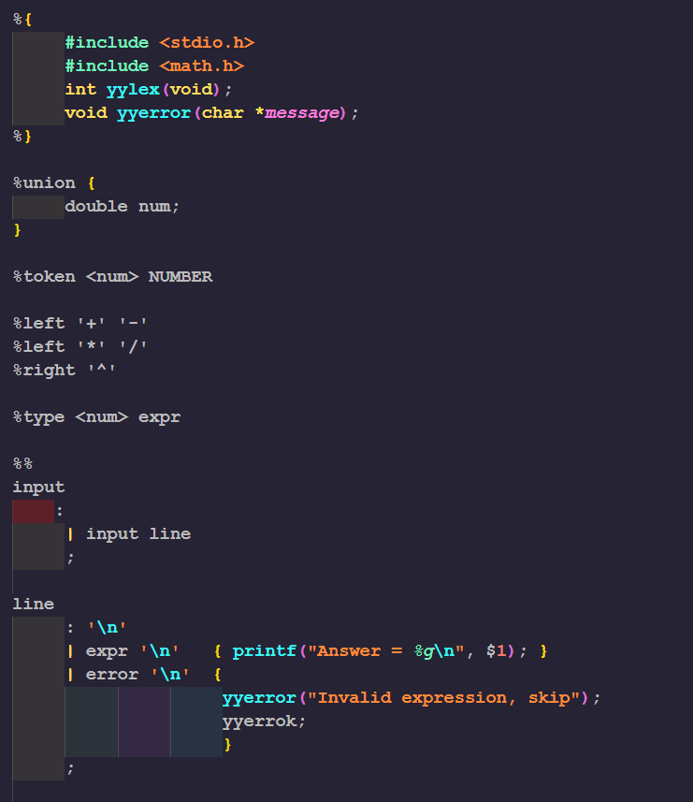

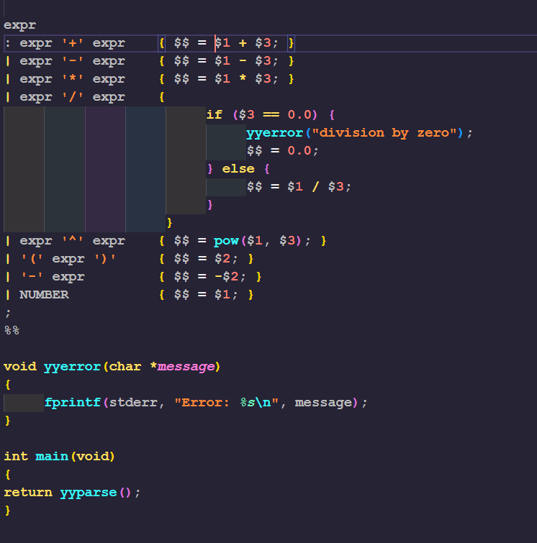

**o/p::**

