NAME: PARYUSHA SHAH
22BCE234
Prometheus
Lab 1
Task 1 create docker repository
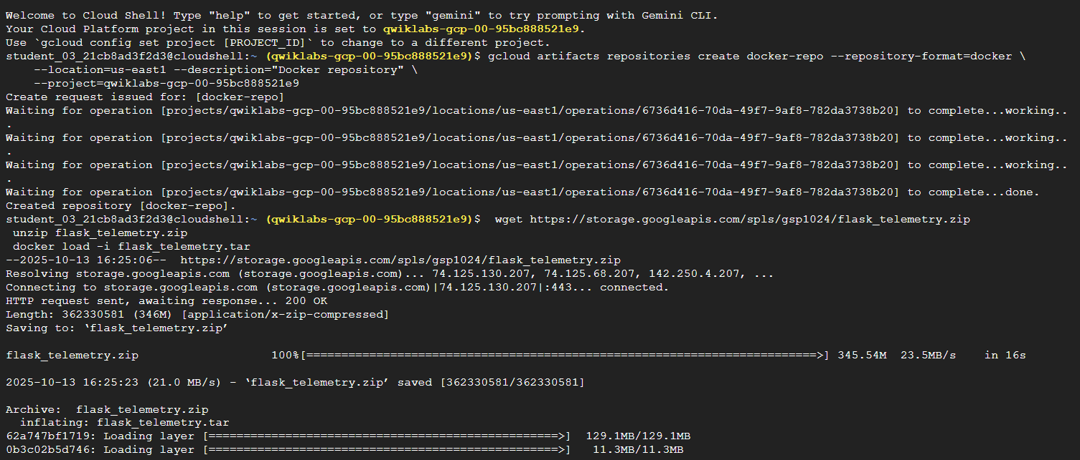
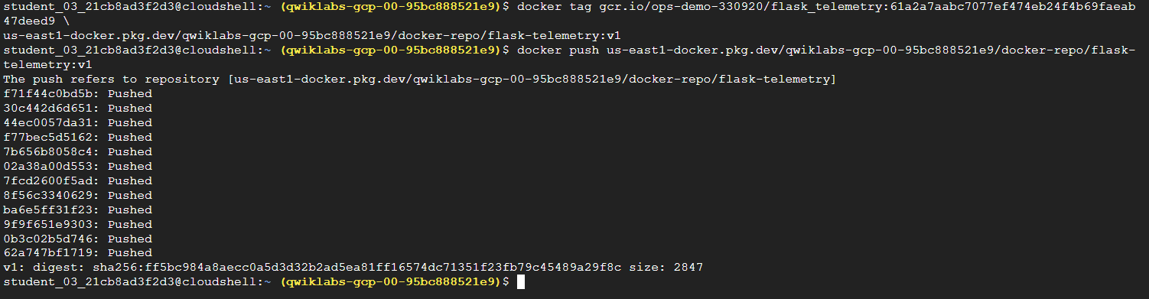
Task 2 setup google container cluster with Prometheus enabled
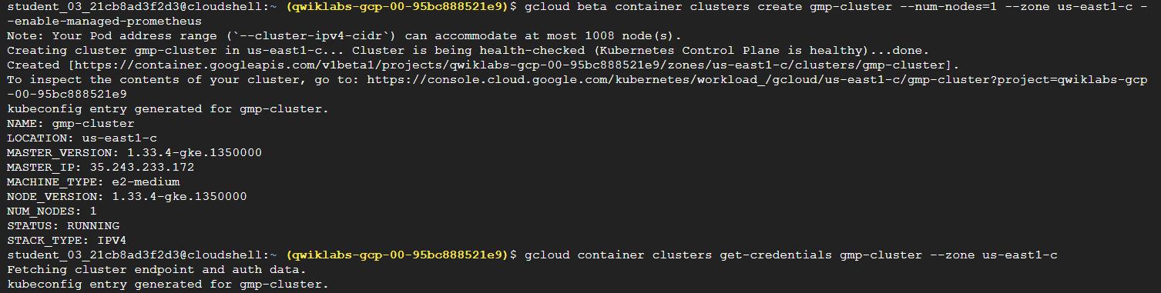
Task 3 deploying Prometheus and cfreating a namespacef
Task 4 deploy application
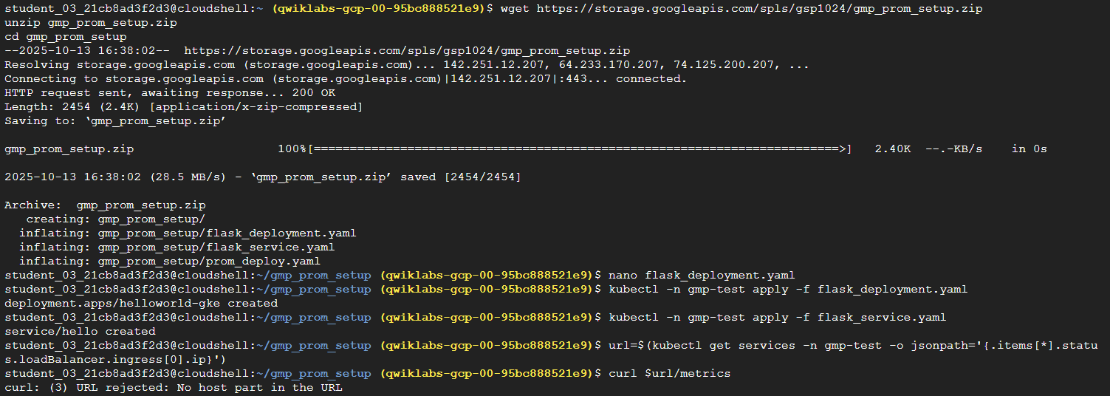
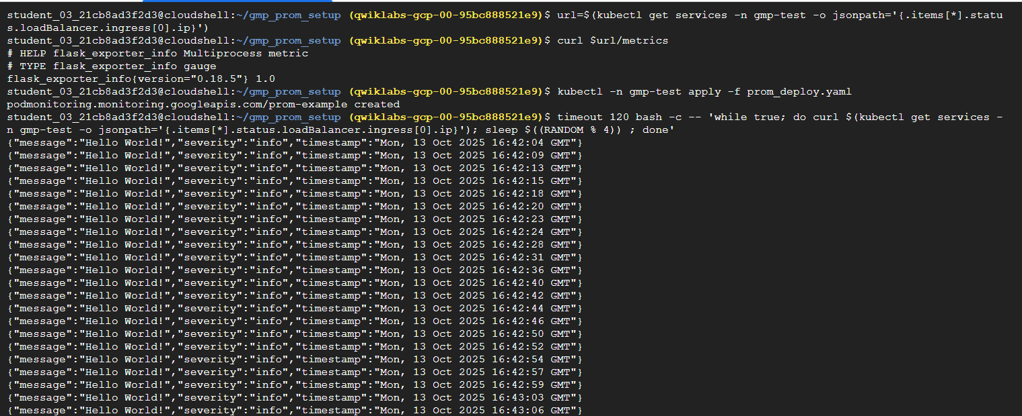
Task 5 view dashboard
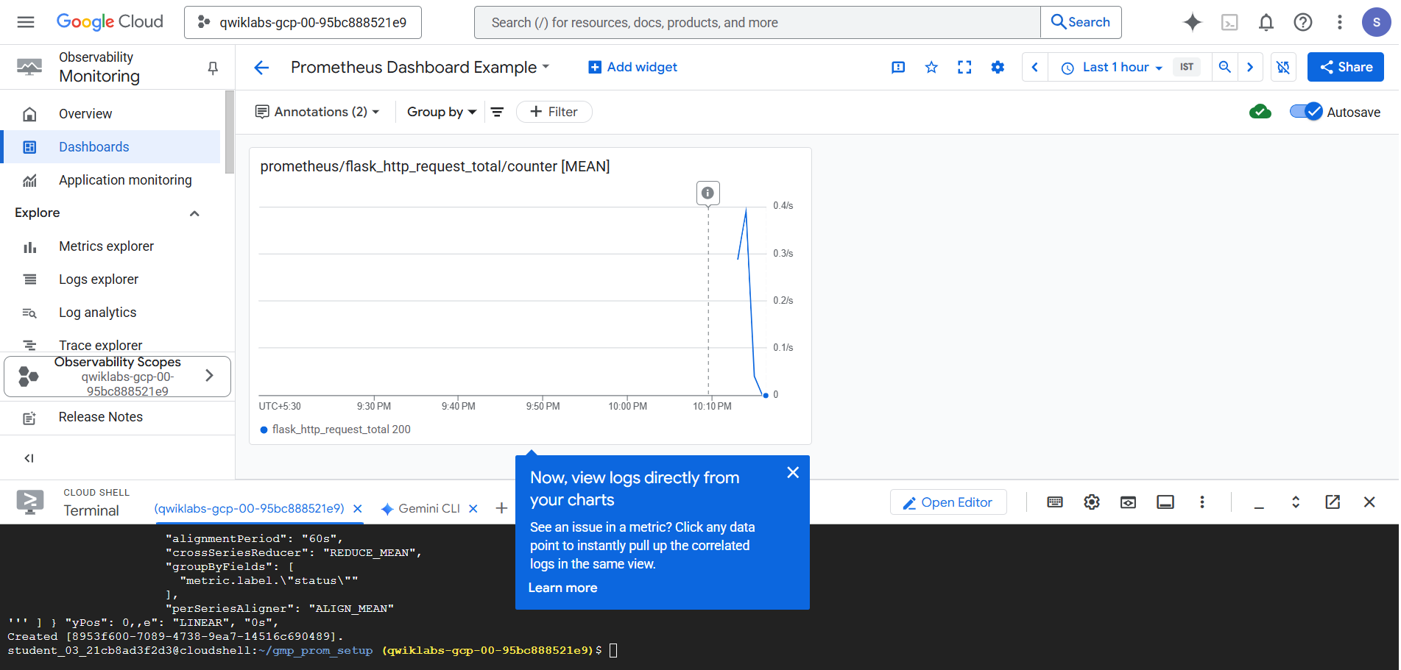

Lab 2 Migrating Prometheus workloads to google cloud and use querying with Grafana
Task 1 deploy the GKE cluster
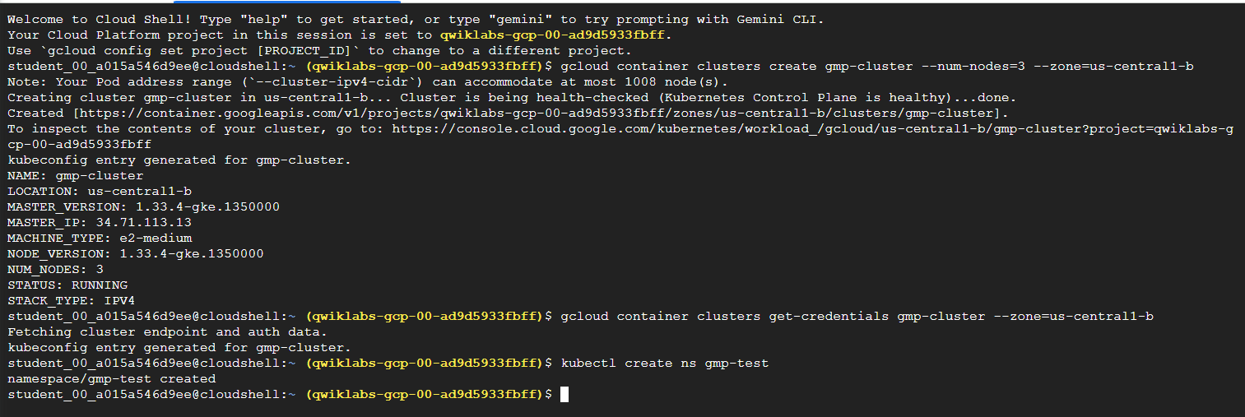
Task 2 deploy the application
Task 3 deploy Prometheus
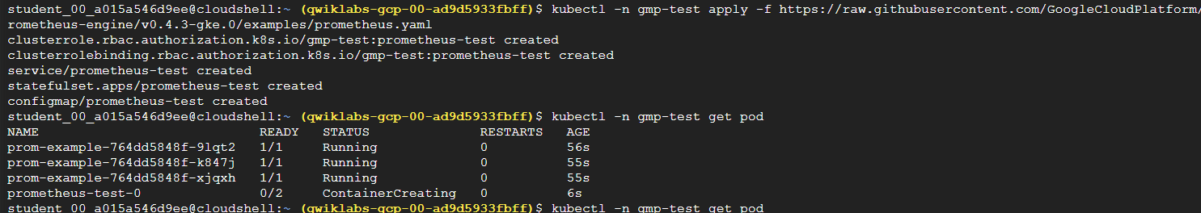
Task 4 Prometheus metrics
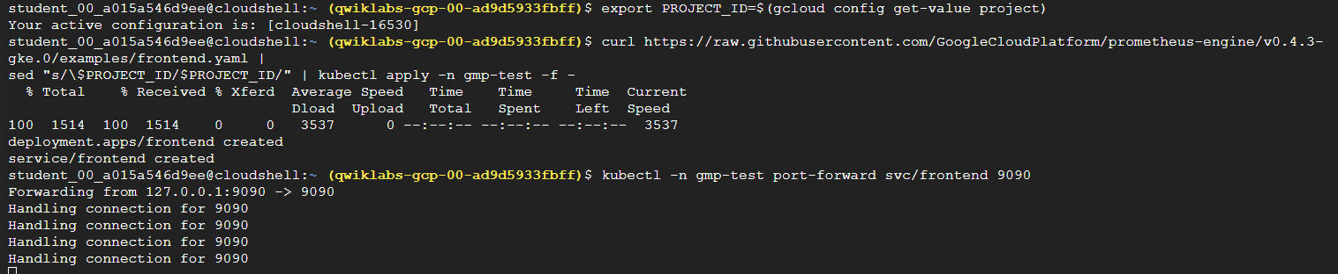
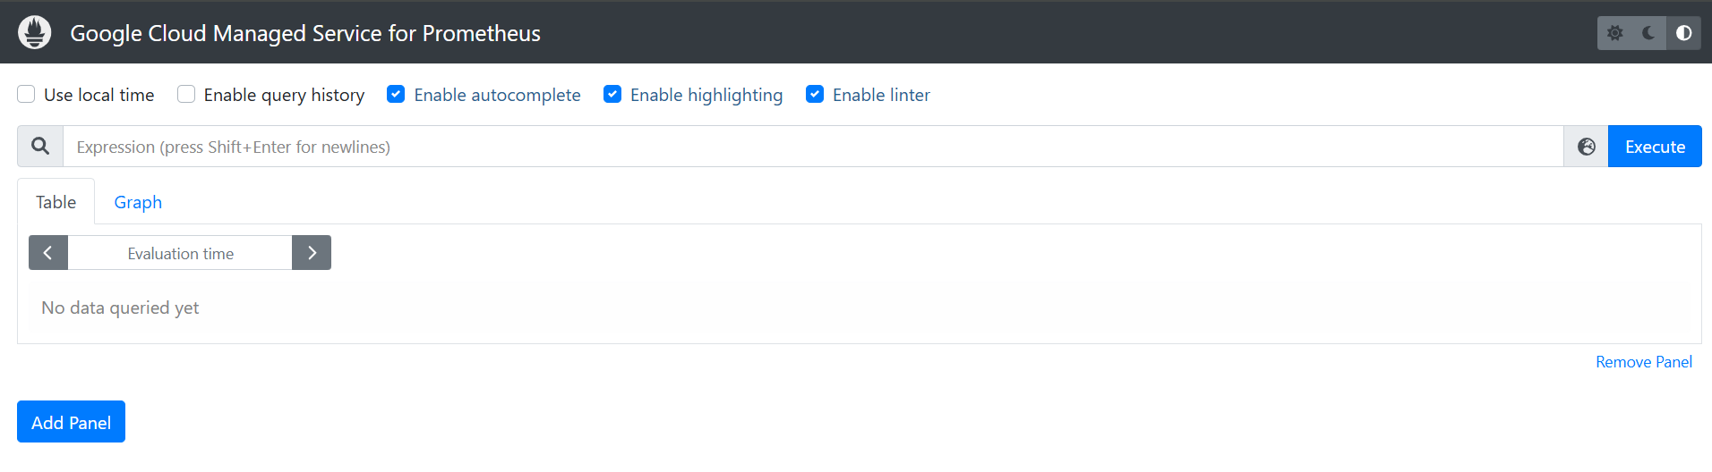
Task 5 Grafana deploy
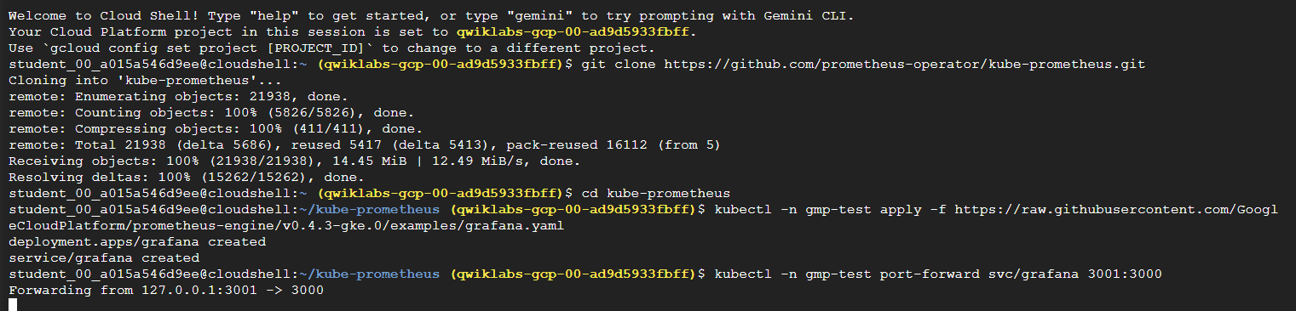
Task 6 log in into Grafana
Task 7 configure data source
