

Training report on

**“Front-End Development Using Bootstrap5”**

**Under the guidance of**

**Ms. Sheetal Sharma**

**(AM-IT)**

**Submitted by:**

**Parisheelan Negi**

**B. Tech**

**2nd year (CSE)**

**Gautam Buddha University, Greater Noida**

**Acknowledgement**

*I would like to express my gratitude towards all the people who have contributed their precious time and efforts to help me in completing this report, without them, it would not have been possible to understand and analyze the practical aspect of my theoretical knowledge.*

*Firstly, I would like to offer my sincere gratitude to* ***Mr. Pushpender Yadav (Sr. DGM)*** *for granting me the permission to work as a trainee and support me throughout the training period.*

*I would like to thank* ***Ms. Sheetal Sharma, (AM-IT)****, my training mentor, for their guidance, support, motivation and encouragement throughout the period of work carried out. Their readiness for consultation at all times, educative comments, concern and assistance have been invaluable.*

**Content**

1. About Rites Ltd.
2. Tools and Technology Used
3. Abstract
4. Login Page
5. Registration Page
6. Forgot Password
7. Data Entry
8. Conclusion

**About RITES Ltd.**

**Multidisciplinary Consultant**

RITES Limited, a Miniratna (Category-I) and Schedule 'A' Central Public Sector Enterprise under the Ministry of Railways, incorporated on April 26, 1974, is a multidisciplinary engineering and consultancy organization, providing a comprehensive range of services from concept to commissioning in all facets of transport infrastructure and related technologies.

**Diversified Operations**

RITES is a leading player in the transport consultancy and engineering sector in India and uniquely placed in terms of diversification of services and geographical reach in various sectors such as railways, highways, urban engineering (metros) & sustainability, airports, ports, ropeways, institutional buildings, inland waterways, and renewable energy. The company is the only export arm of Indian Railways for providing rolling stock, other than Thailand, Malaysia, and Indonesia.

RITES' success story spans over 48 years covering more than 55 countries across Asia, Africa, Latin America, South America, and Middle East regions.

RITES became a listed company in July 2018, and it has made it to the Top-500 listed Indian companies based on its market capitalization.

**Tools and Technologies**

**HTML5: HTML5** is a [markup language](https://en.wikipedia.org/wiki/Markup_language) used for structuring and presenting content on the [World Wide Web](https://en.wikipedia.org/wiki/World_Wide_Web). It is the fifth and final[[3]](https://en.wikipedia.org/wiki/HTML5#cite_note-W3C_transfer_ZDNet-3) major [HTML](https://en.wikipedia.org/wiki/HTML) version that is a [World Wide Web Consortium](https://en.wikipedia.org/wiki/World_Wide_Web_Consortium) (W3C) recommendation. The current specification is known as the [HTML Living Standard](https://en.wikipedia.org/wiki/HTML_Living_Standard). It is maintained by the [Web Hypertext Application Technology Working Group](https://en.wikipedia.org/wiki/Web_Hypertext_Application_Technology_Working_Group) (WHATWG), a consortium of the major browser vendors ([Apple](https://en.wikipedia.org/wiki/Apple_Inc.), [Google](https://en.wikipedia.org/wiki/Google), [Mozilla](https://en.wikipedia.org/wiki/Mozilla), and [Microsoft](https://en.wikipedia.org/wiki/Microsoft)).

**Bootstrap5: Bootstrap** is a [free and open-source](https://en.wikipedia.org/wiki/Free_and_open-source) [CSS framework](https://en.wikipedia.org/wiki/CSS_framework) directed at responsive, [mobile-first](https://en.wikipedia.org/wiki/Responsive_web_design#Mobile_first,_unobtrusive_JavaScript,_and_progressive_enhancement) [front-end web development](https://en.wikipedia.org/wiki/Front-end_web_development). It contains [HTML](https://en.wikipedia.org/wiki/HTML), [CSS](https://en.wikipedia.org/wiki/CSS) and (optionally) [JavaScript](https://en.wikipedia.org/wiki/JavaScript)-based design templates for [typography](https://en.wikipedia.org/wiki/Web_design#Typography), [forms](https://en.wikipedia.org/wiki/Form_(HTML)), [buttons](https://en.wikipedia.org/wiki/Button_(computing)#HTML), [navigation](https://en.wikipedia.org/wiki/Web_navigation#Local_website_navigation), and other interface components.

**CSS3: Cascading Style Sheets** (**CSS**) is a [style sheet language](https://en.wikipedia.org/wiki/Style_sheet_language) used for describing the [presentation](https://en.wikipedia.org/wiki/Presentation_semantics) of a document written in a [markup language](https://en.wikipedia.org/wiki/Markup_language) such as [HTML](https://en.wikipedia.org/wiki/HTML) or [XML](https://en.wikipedia.org/wiki/XML) (including XML dialects such as SVG, MathML or XHTML).[[1]](https://en.wikipedia.org/wiki/CSS#cite_note-1) CSS is a cornerstone technology of the [World Wide Web](https://en.wikipedia.org/wiki/World_Wide_Web), alongside HTML and [JavaScript](https://en.wikipedia.org/wiki/JavaScript).[[2]](https://en.wikipedia.org/wiki/CSS#cite_note-2)

**VS Code: Visual Studio Code**, also commonly referred to as **VS Code**,[[9]](https://en.wikipedia.org/wiki/Visual_Studio_Code#cite_note-9) is a [source-code editor](https://en.wikipedia.org/wiki/Source-code_editor) made by [Microsoft](https://en.wikipedia.org/wiki/Microsoft) for [Windows](https://en.wikipedia.org/wiki/Windows), [Linux](https://en.wikipedia.org/wiki/Linux) and [macOS](https://en.wikipedia.org/wiki/MacOS).[[10]](https://en.wikipedia.org/wiki/Visual_Studio_Code#cite_note-TechCrunch-10) Features include support for [debugging](https://en.wikipedia.org/wiki/Debugging), [syntax highlighting](https://en.wikipedia.org/wiki/Syntax_highlighting), [intelligent code completion](https://en.wikipedia.org/wiki/Intelligent_code_completion), [snippets](https://en.wikipedia.org/wiki/Snippet_(programming)), [code refactoring](https://en.wikipedia.org/wiki/Code_refactoring), and embedded [Git](https://en.wikipedia.org/wiki/Git). Users can change the [theme](https://en.wikipedia.org/wiki/Theme_(computing)), [keyboard shortcuts](https://en.wikipedia.org/wiki/Keyboard_shortcut), preferences, and install [extensions](https://en.wikipedia.org/wiki/Plug-in_(computing)) that add additional functionality.

**Fon**t: System-UI

**Colors**:

Black: #000

White: #fff

Bootstrap5 Primary: #0d6efd

**Abstract**:

To design a responsive website template using Bootstrap 5 latest version along with CSS3. Below mentioned are the screens which needs to be designed:

1. Login

2. Registration /Signup

3. Forgot password

4. Multiple data entry web forms featuring all the controls like Input Textbox, Text-area, Radio Button, Checkbox, Dropdown list/Multiple Selection listing, Buttons, file uploads, date etc.

**Login Page:**

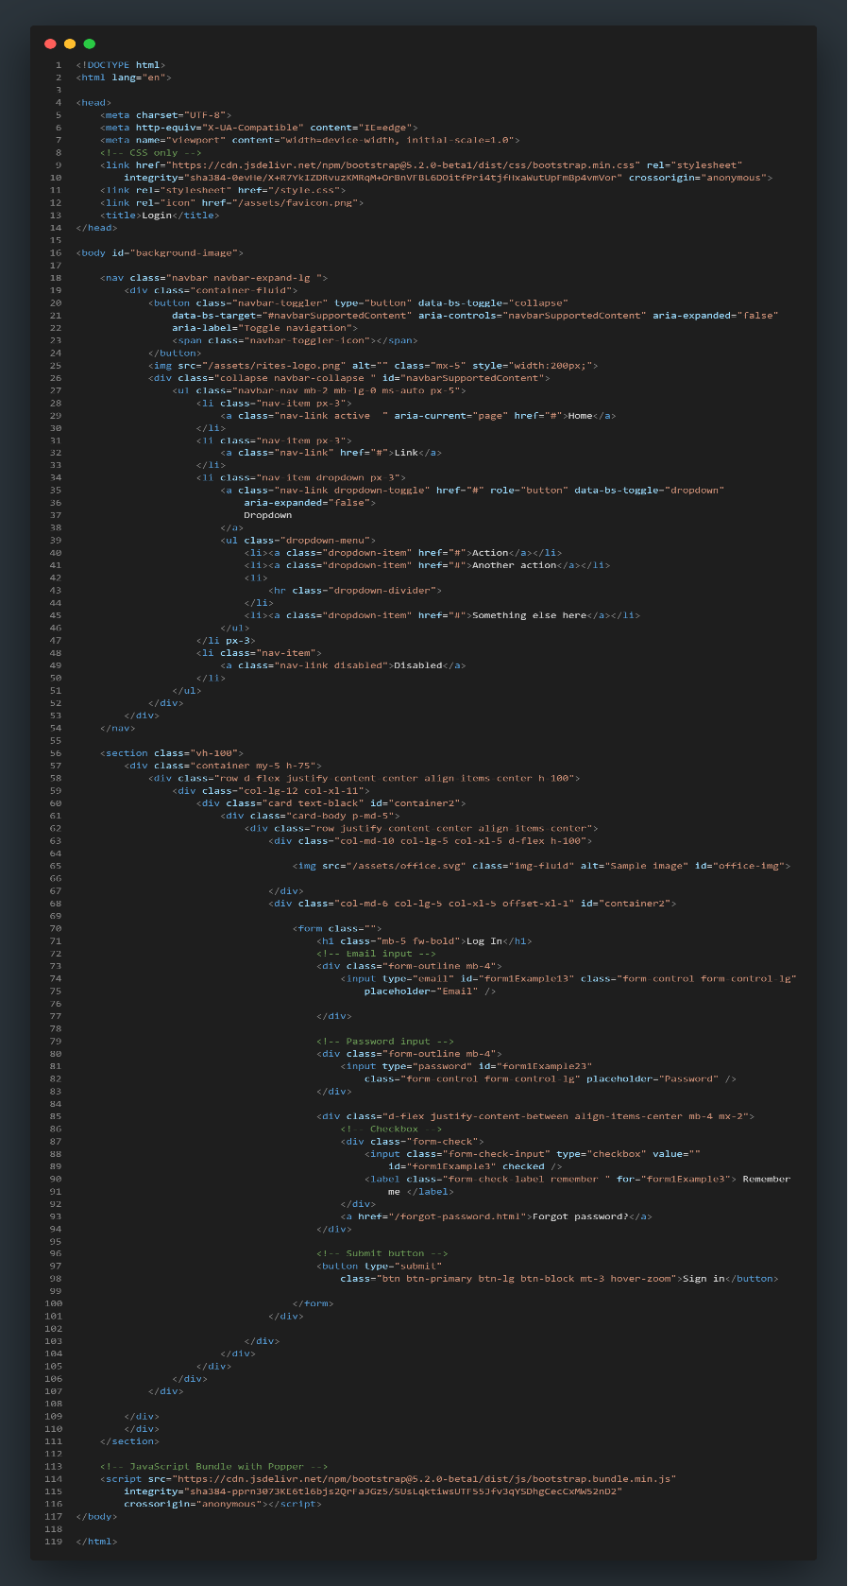

**Desktop:**

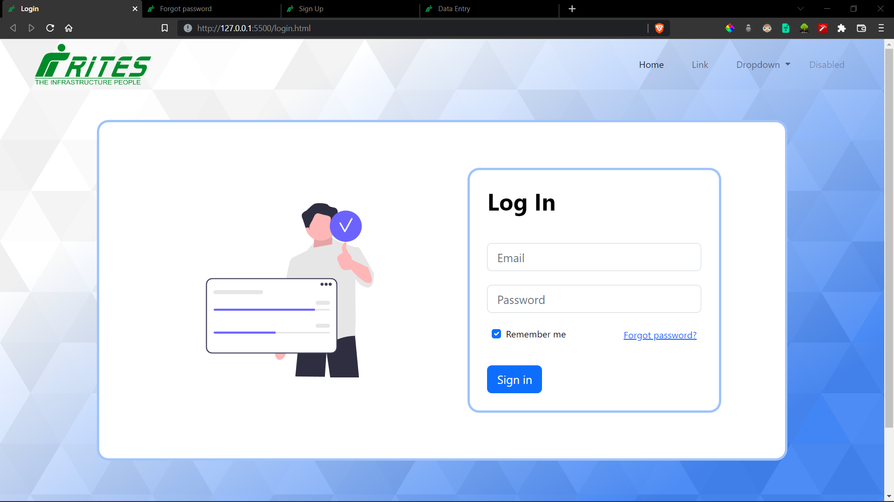

**Responsive:**

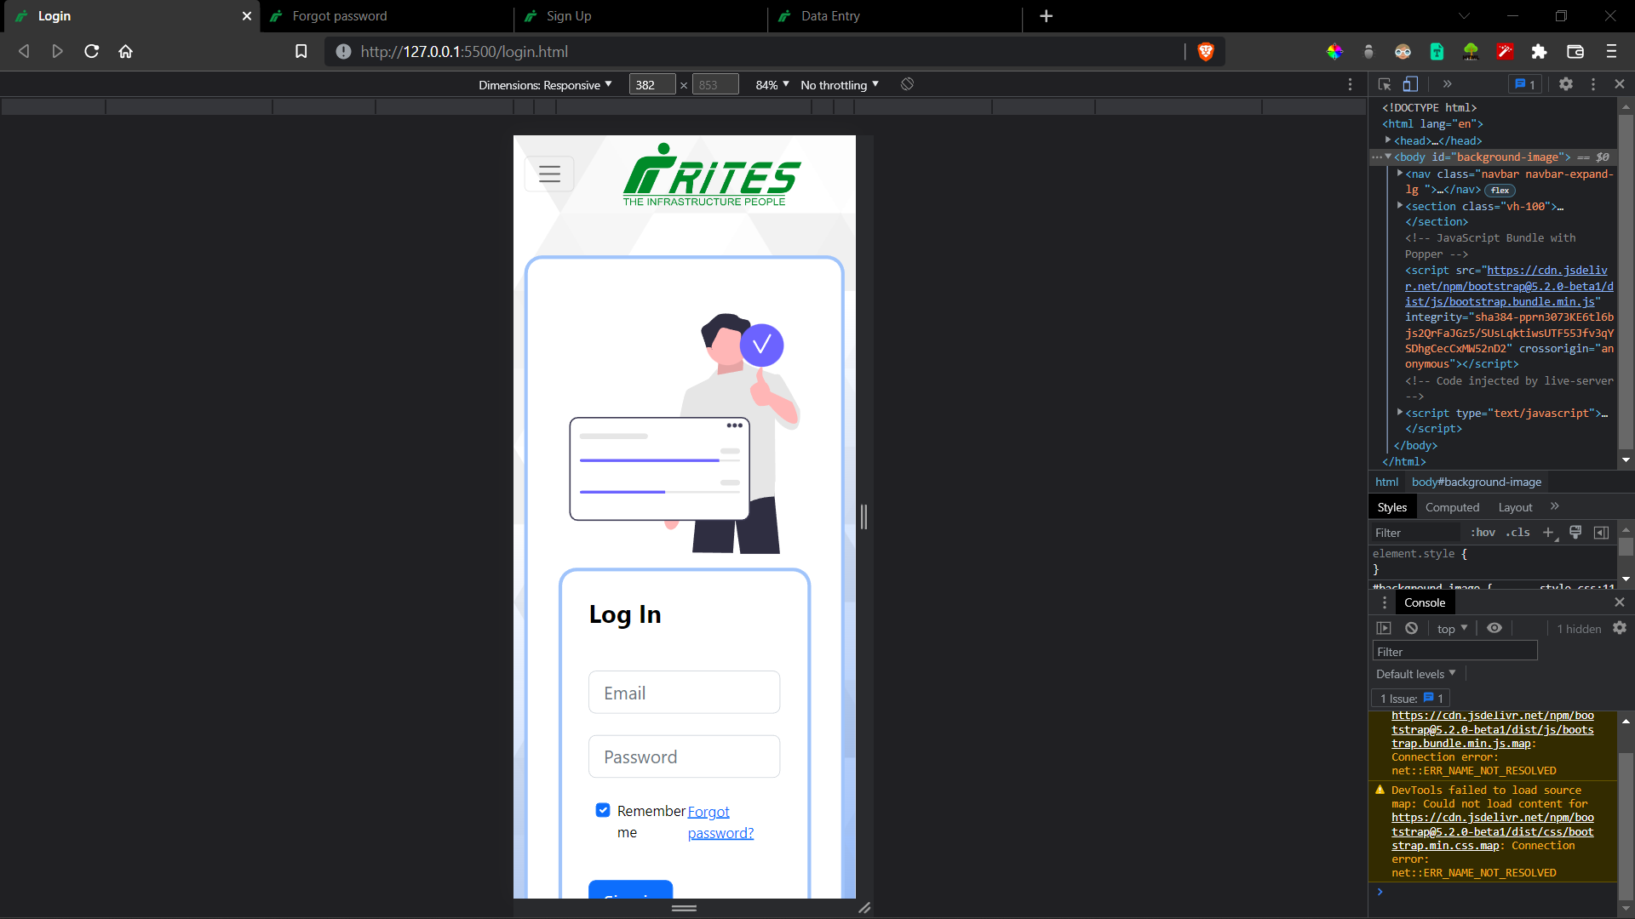

**Forgot Password Page**

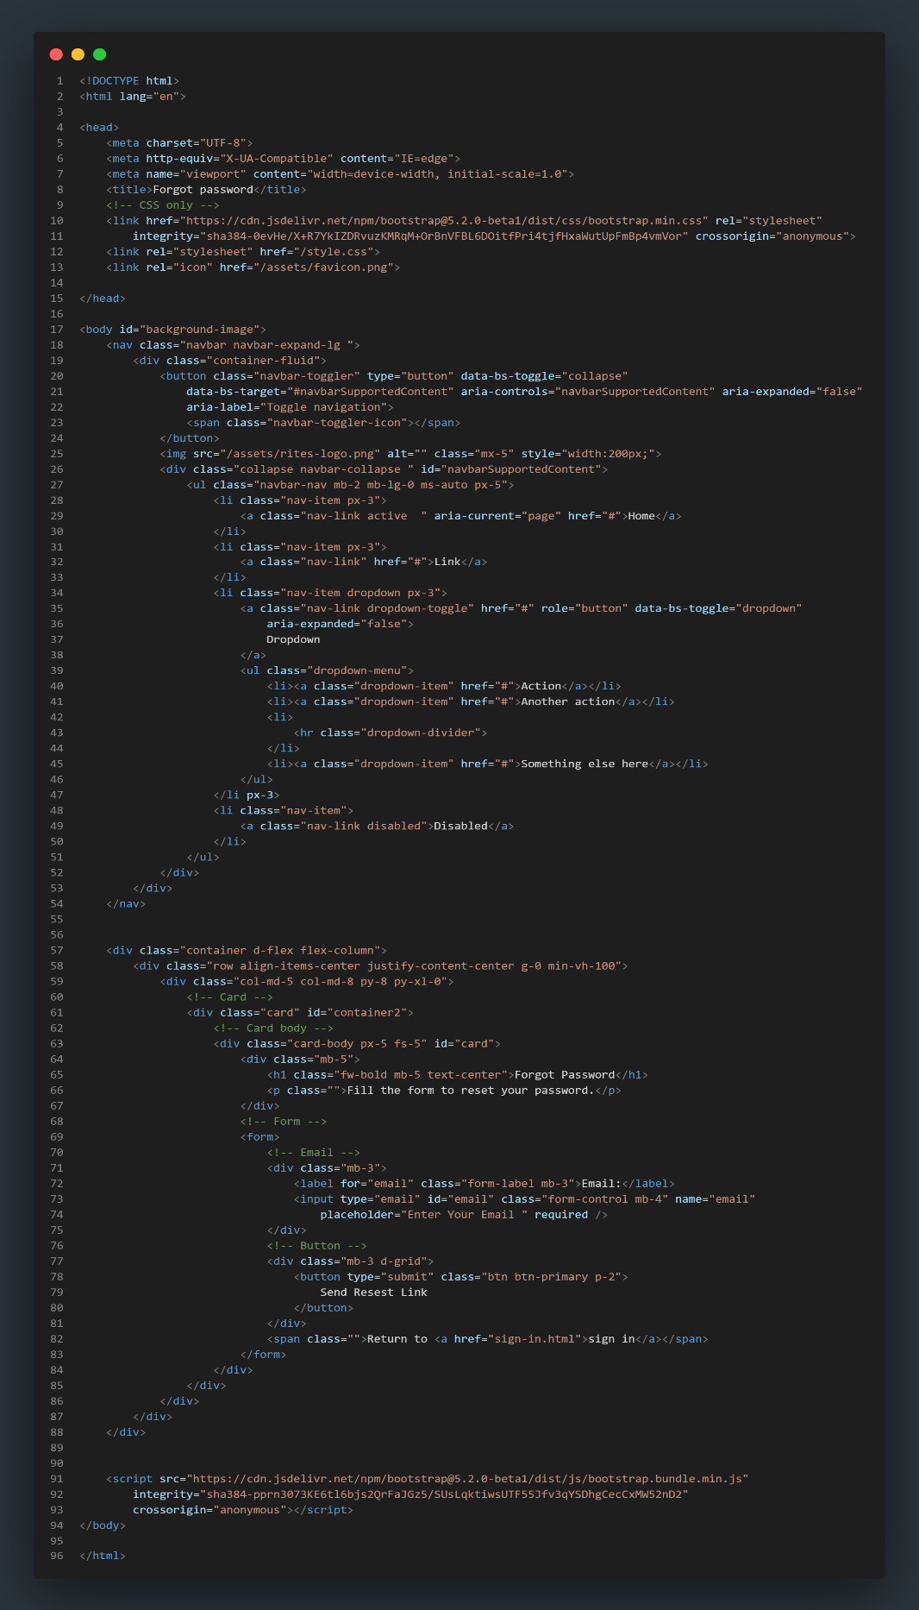

**Desktop:**

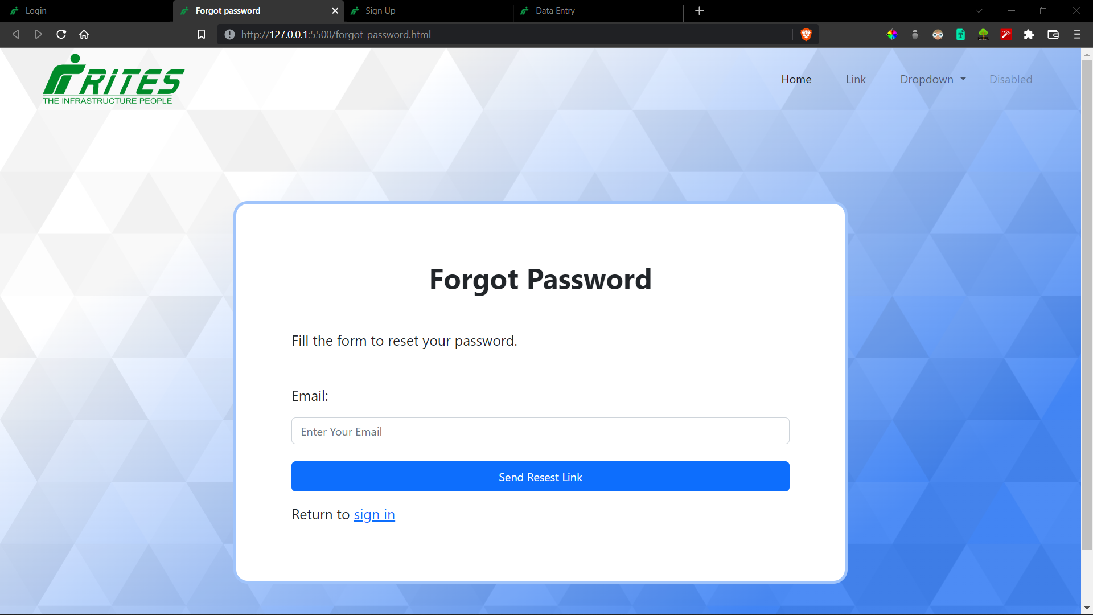

**Responsive:**

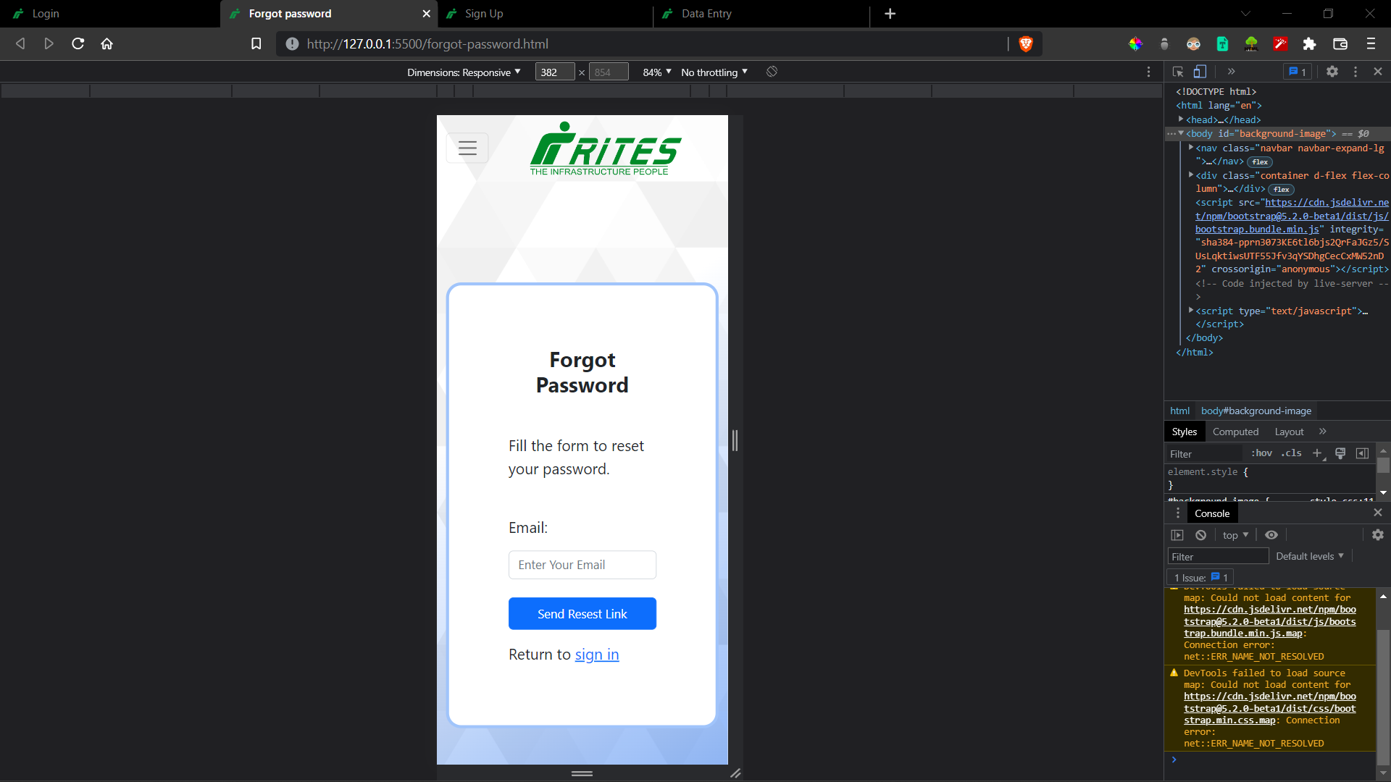

**Sign-Up Page:**

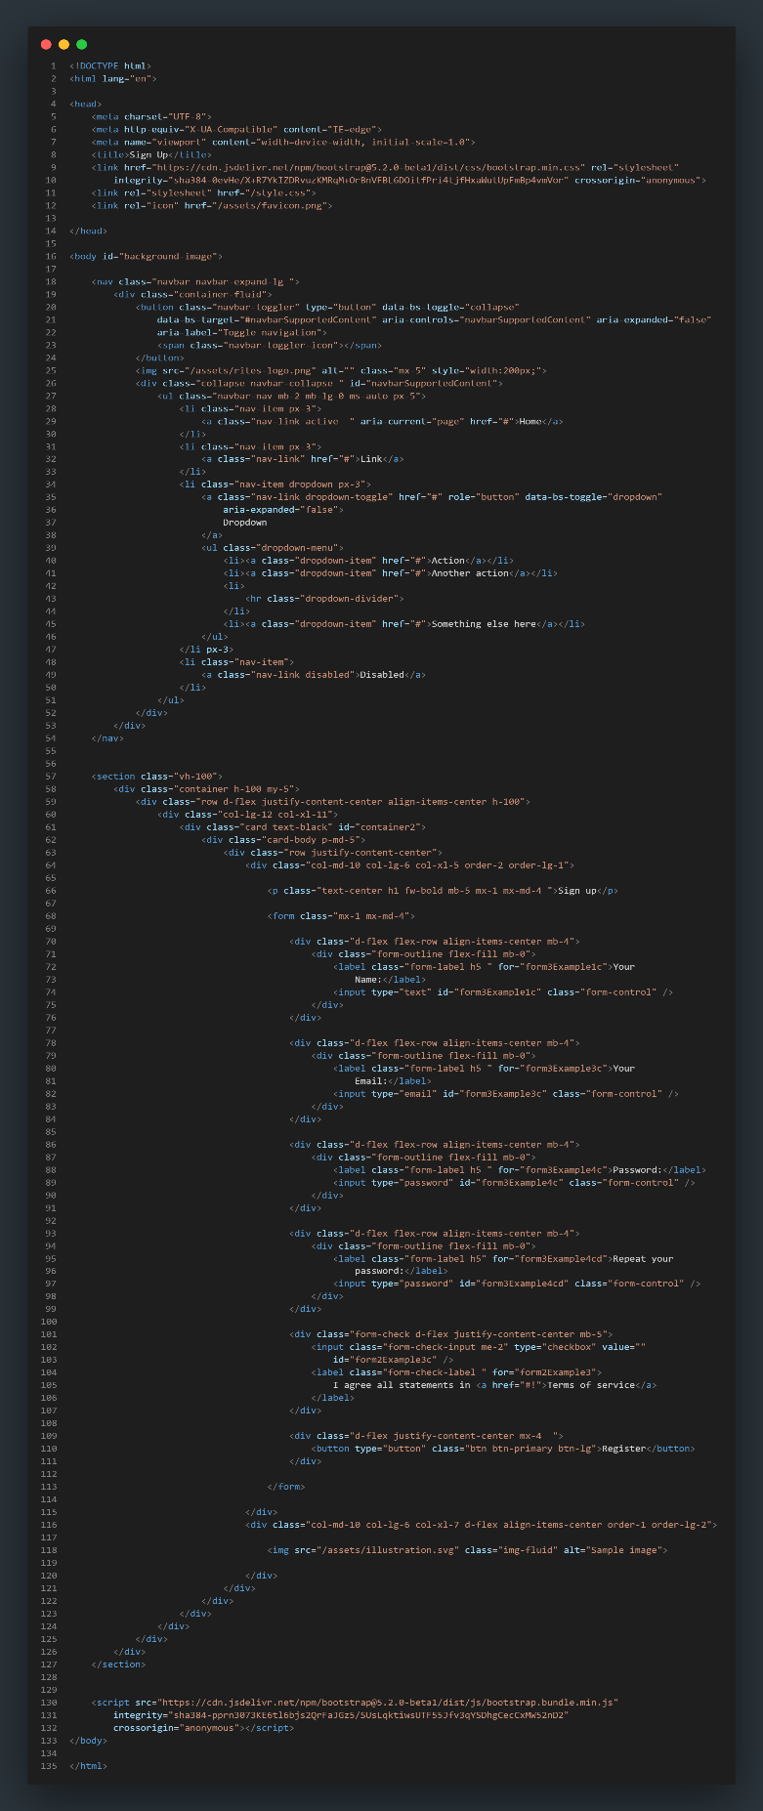

**Desktop:**

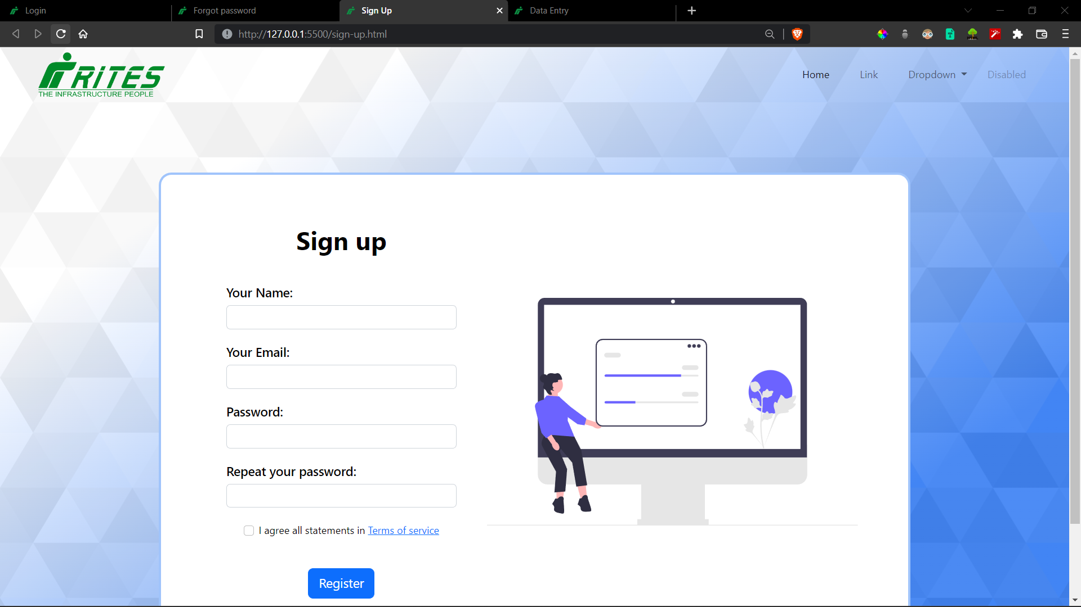

**Responsive:**

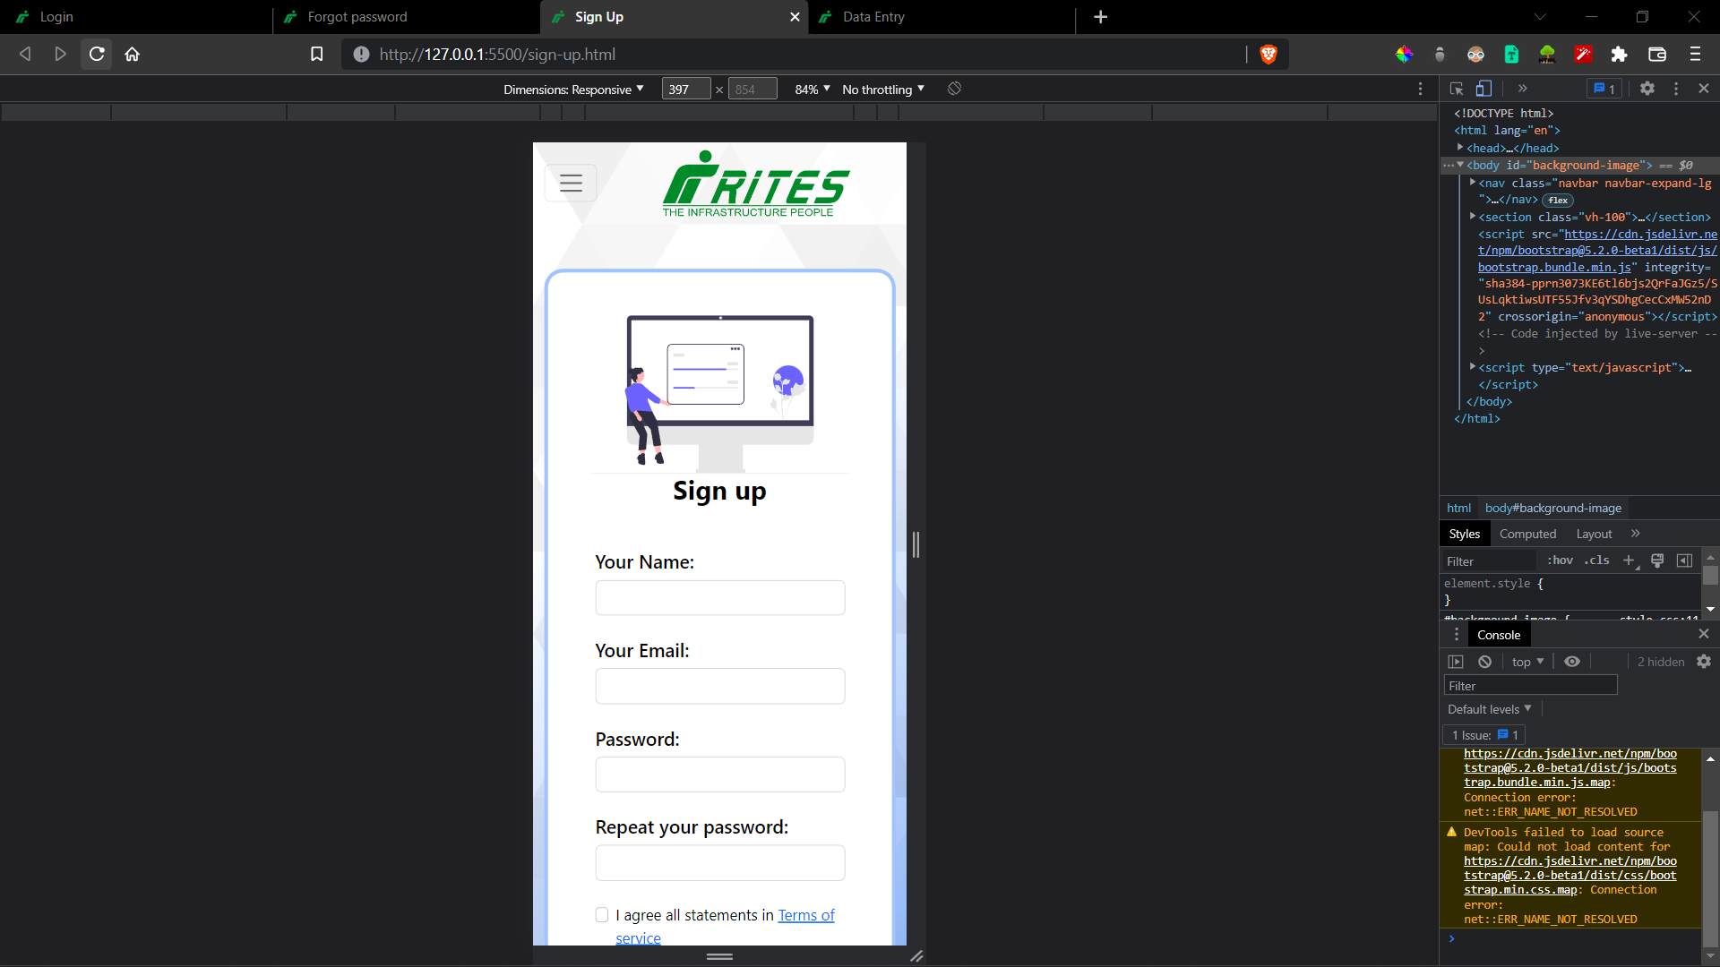

**Data-Entry Page:**

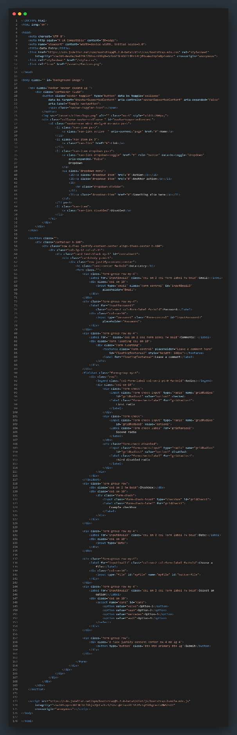

**Desktop:**

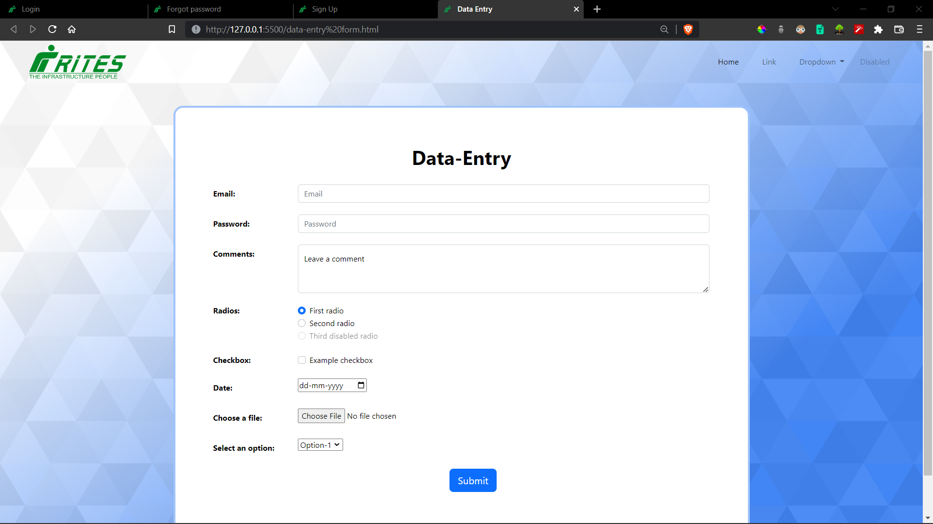

**Responsive:**

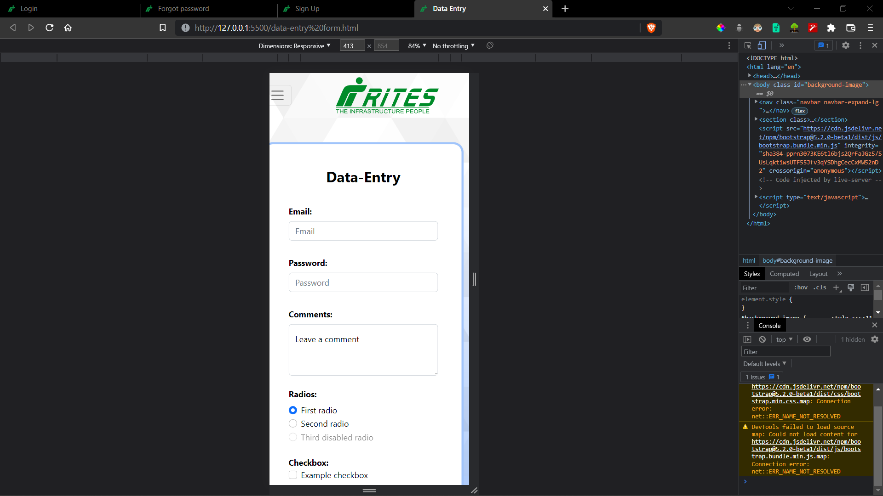

**Conclusion**

Front-End development became much more convenient using Bootstrap5. I have learned a lot of new things and solved various problems involving positioning, responsiveness and UI/UX consistency.

I started this project with a very simple scope, and I created Wireframes that met my needs at that time. But over time, my needs changed, the project evolved and I started including more complexities.