## ASSIGNMENT - III

## NAME : PARISHKAR SINGH

## USN : 2GI20CS081

## DATE - 4- June-2022

## DIV: 4-B

## *Q1. Create a list of all odd numbers between 100 to 200 using list comprehension* odd=[i for i in range(101,200,2)] for i in odd: print (i,end=' ')

## 

## *Q2. Create a list of squares of integers from 1 to n, where n is read through keyboard and find the sum of squares of these numbers and print the result.*

*def* sumSquares(n):  
 sq=0  
 *for* i *in* range(1, n+1):  
 sq = i**2+sq  
 *return* sq  
  
  
*if* __name__ == '__main__':  
 n = int(input('Enter N to find the sum of squares upto it--> '))  
 print(sumSquares(n))

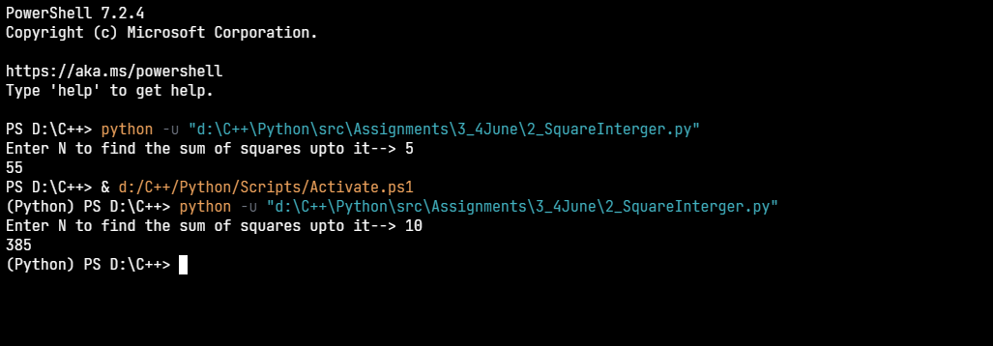

## *Q3. Demonstrate through an appropriate code, how you would handle multiple exceptions.*

*import* math  
  
  
*if* __name__ == '__main__':  
 *while True*:  
 x = input(  
 'Choose Exception To Throw 1.Name Error 2. Type Error 3.Value Error 4.File Not Found Error 5.Index Error 6.Division Error ')  
 *try*:  
 *if* x == '1':  
 print(hey)  
 *elif* x == '2':  
 Int = 100  
 Str = "10"  
 myResult = Int/Str  
 *elif* x == '3':  
 print(math.sqrt(-1))  
 *elif* x == '4':  
 f = open('D:\\C++\\Python\\src\\parishkar2.txt')  
 *elif* x == '5':  
 list = []  
 print(list[10])  
 *elif* x == '6':  
 print(10/0)  
  
 *except* (NameError, FileNotFoundError, ValueError, TypeError, IndexError, ZeroDivisionError) *as* e:  
 print(e)

output:->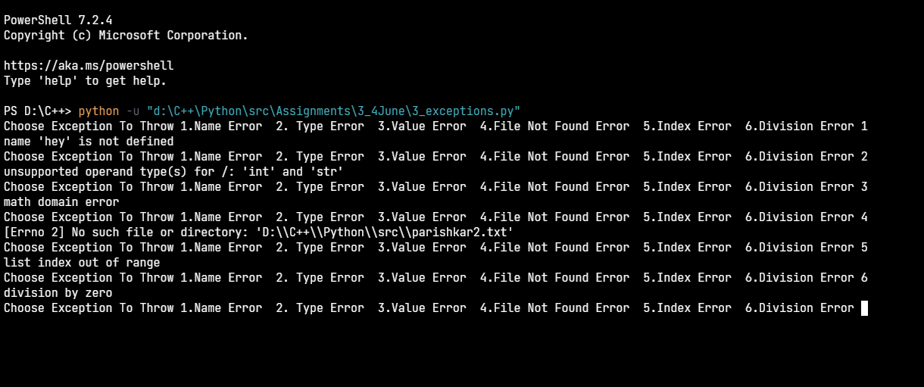

## *Q4. Open a text file and count all the words whose first letter is s and last letter is r.*

*with* open('D:\\C++\\Python\\src\\Assignments\\3_4June\\Story.txt') *as* f:  
 words = f.read().split(' ')  
 count = 0  
 srWords = []  
 *for* i *in* words:  
 *if* i[0].lower() == 's' *and* i[len(i)-1].lower() == 'r':  
 count += 1  
 srWords.append(i)  
 print('The words which contains first letter `s` and last letter `r` are: -> ', end=' ')  
 *for* i *in* srWords:  
 print(i, end=' ')  
 print()  
 print('Number of words which start with s and r --> ', count)  
 print('The Total Number of words is ---> ', len(words))

story.txt->

Once upon a time, in a field not too far from you, there was an energetic and happy hare and a sleepy tortoise.

The happy hare was called silver and the sleepy tortoise was called Spencer. Sir the tortoise liked to sit and munch his dinner slowly, whilst spear the hare would gobble up his dinner and run round and round Spencer until he was dizzy.

Noel the hare looked very unhappy and sulky. Archibald the tortoise felt sorry for him and tried to cheer him up.

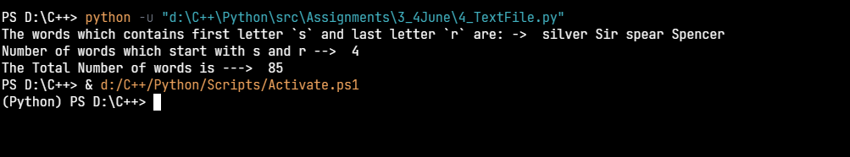

## Q5. 5. Download a sales data file from Kaggle that is in csv format and write a python program to open the file and

## 1. List output in the following form with option to filter data based on PurchageValue

## 2. find number of customers spending amount in 1000-2000, 2001-5000, 5001-10000 and

## plot the graph.

import csv  
from tabulate import tabulate  
import matplotlib.pyplot as plt  
  
# list that will store data between 1000-2000 || 2001-5000 || 5001-10000  
l1, l2, l3 = [], [], []  
# list that containes ranged data  
l4 = []  
  
if __name__ == '__main__':  
 with open('D:\\C++\\Python\\src\\Assignments\\3_4June\\SALES.csv') as f:  
 rs = csv.reader(f)  
 header = next(rs)  
 record = list(rs)  
 while True:  
 x = input(  
 "Enter Choice 1.Show All data 2.Show Data in Purchase Range 3.Plot Graph--> ")  
 if x == '1':  
 print('-' * 100)  
 print('\nSales data-->\n\n', tabulate(record, headers=header), end='\n\n')  
 print('-' * 100)  
  
 elif x == '2':  
 l4.clear()  
 a, b = map(int, (input('Enter the Lower & Upper range--> ').split()))  
 a, b = min(a, b), max(a, b)  
 print('-' * 100)  
 print(f"Purchase's done in range ${a} to {b} are---> ")  
 for x in record:  
 pointer = int(float(x[6]))  
 if pointer in range(a, b):  
 l4.append(x)  
 print('\nSales data-->\n\n', tabulate(l4, headers=header), end='\n\n')  
 print('-' * 100)  
  
 elif x == '3':  
 for x in record:  
 pointer = int(float(x[6]))  
 num = float(x[6])  
 if pointer in range(1000, 2000):  
 l1.append(num)  
 elif pointer in range(2001, 5000):  
 l2.append(num)  
 elif pointer in range(5001, 10000):  
 l3.append(num)  
 customers = [len(l1), len(l2), len(l3)]  
 purValue = [f'1000-2000--{len(l1)}', f'2001-5000--{len(l2)}', f'5001-10000--{len(l3)}']  
 plt.bar(purValue, customers)  
 plt.ylabel(f'No of Customers {len(l1)+ len(l2)+ len(l3)} ')  
 plt.xlabel('Purchase Value')

plt.show()

output-> showing all data

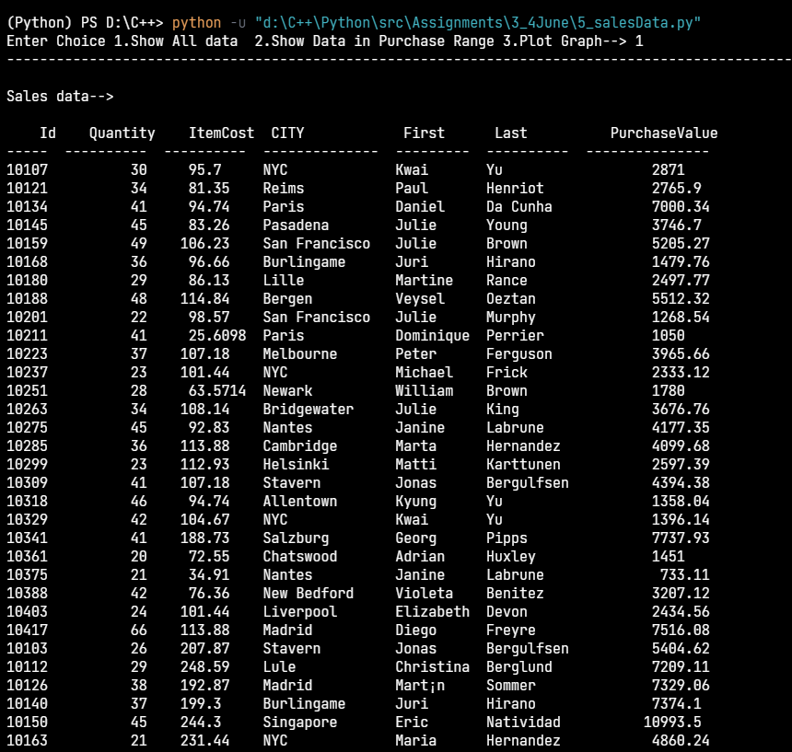

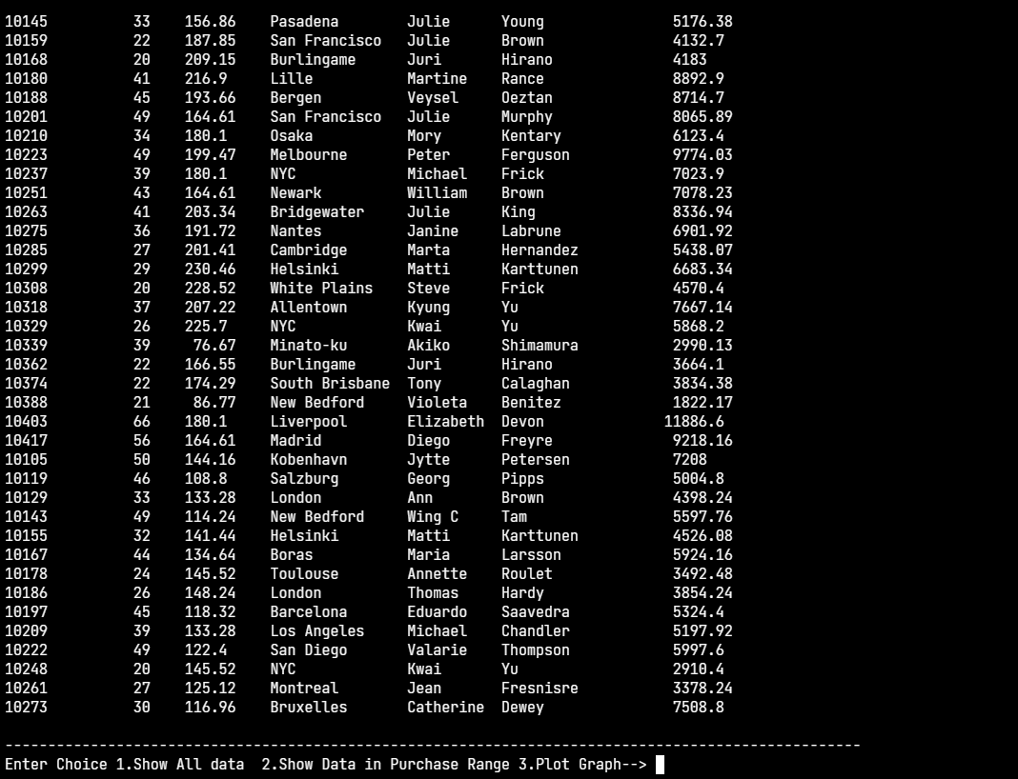

2.showing data in the purchase range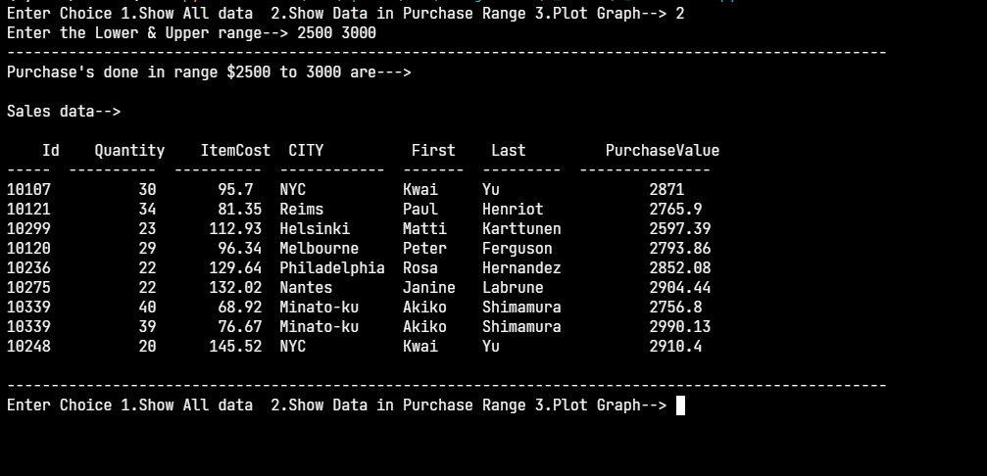

3.showing the bar graph

